Thursday, 07/17/25- Wagon extension: Done!! Even though we had a few nay-sayers, the amazing team of 10 diggers along with Jena and Chris (SRD) were able to push through the finish line on Thursday and finish the Wagon extension work.
The weather was reasonable and the rain held off until we finished working. The completed extension with parking lot connectors looks amazing and we heard several nice comments from hikers as we worked on Thursday. Thunder started rumbling as we were putting on the finishing touches.

Volunteers: Sim Cook, Courtnee Bennett, Bill Perkins, Eric Russell, Mike Madden, John McNett, Bruce Hansche, Jim Houle, Luis Cuadros and Laura Leon

Pictures: Laura Leon

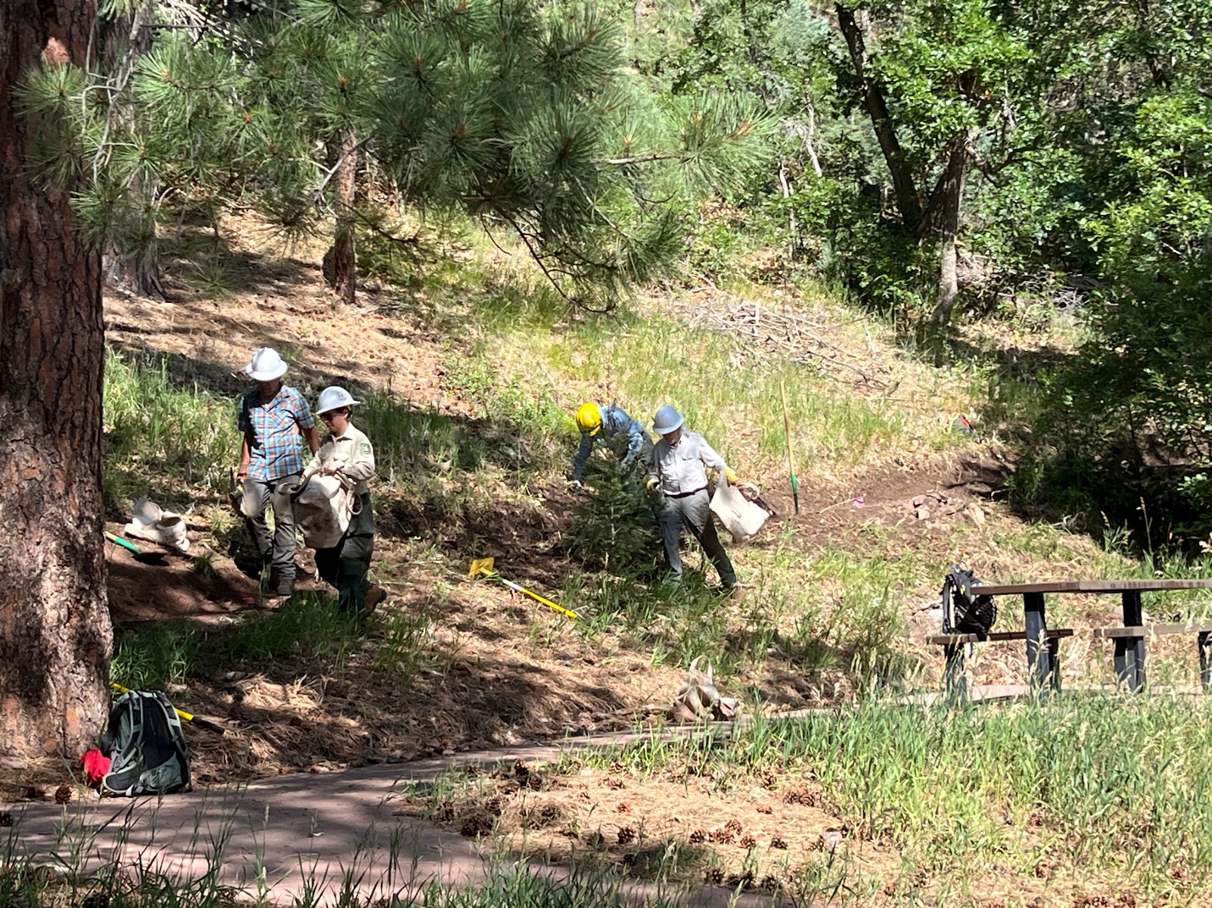

Because of the picnic area, we had to move soil and rocks using bags and buckets instead of just slinging it downhill. Eric, Bill, Luis and Jen set to work.

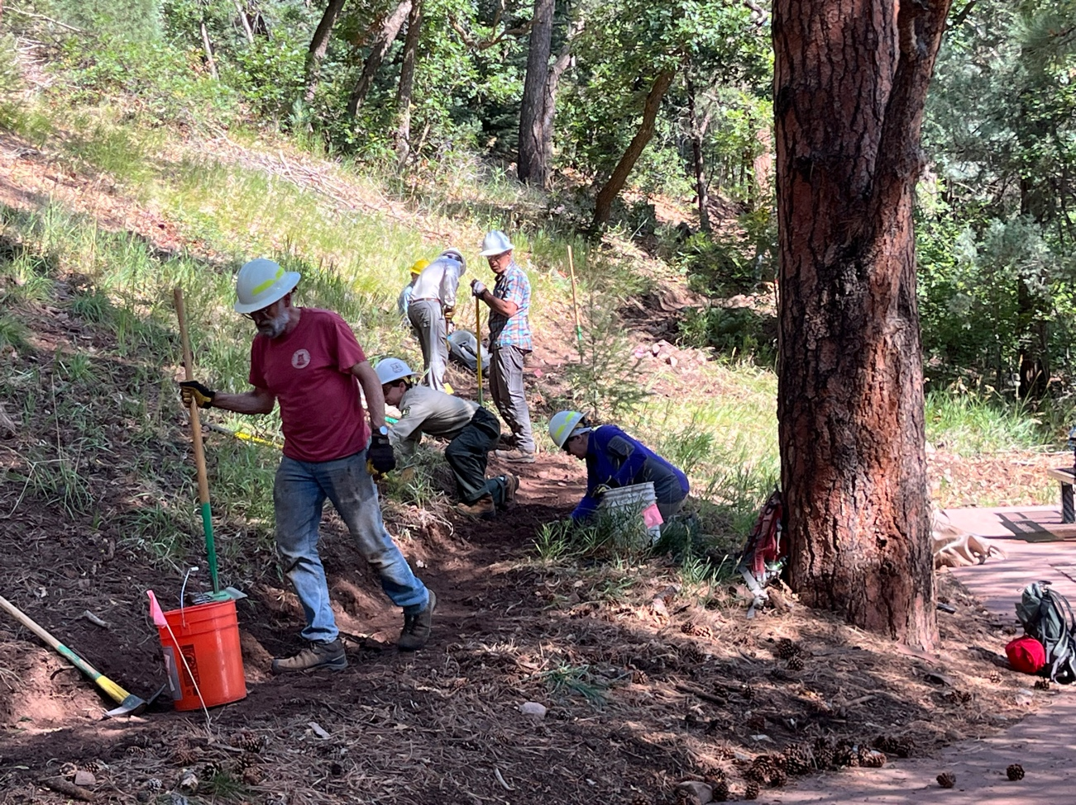

Lots of on-all-fours work. Jim, Courtnee, Jen, Luis and Bill dig and moved debris. Mike worked around a ponderosa.
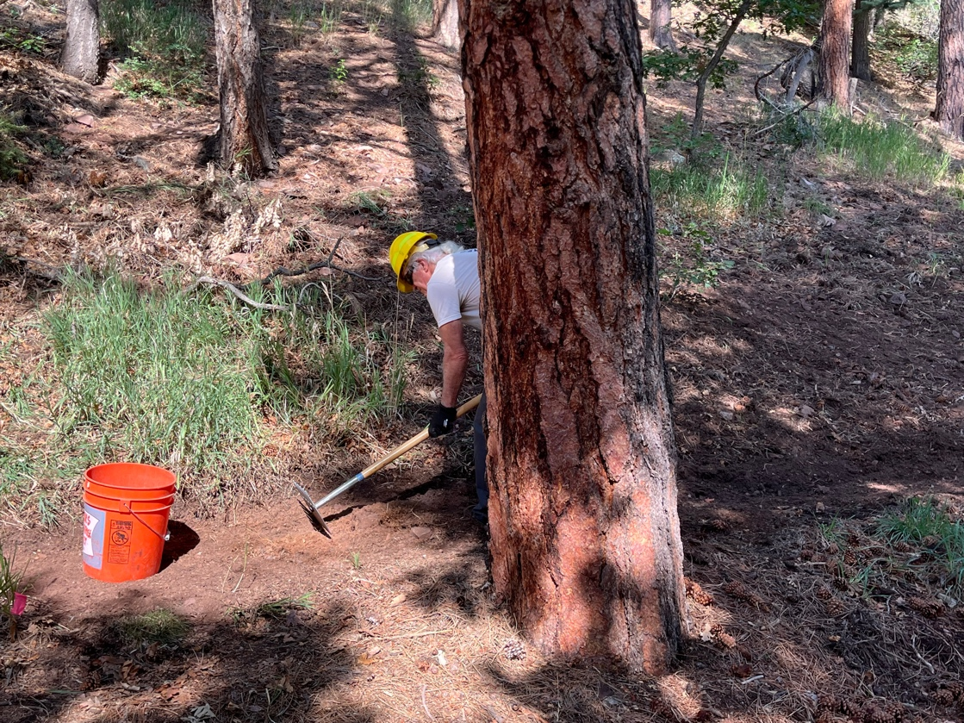
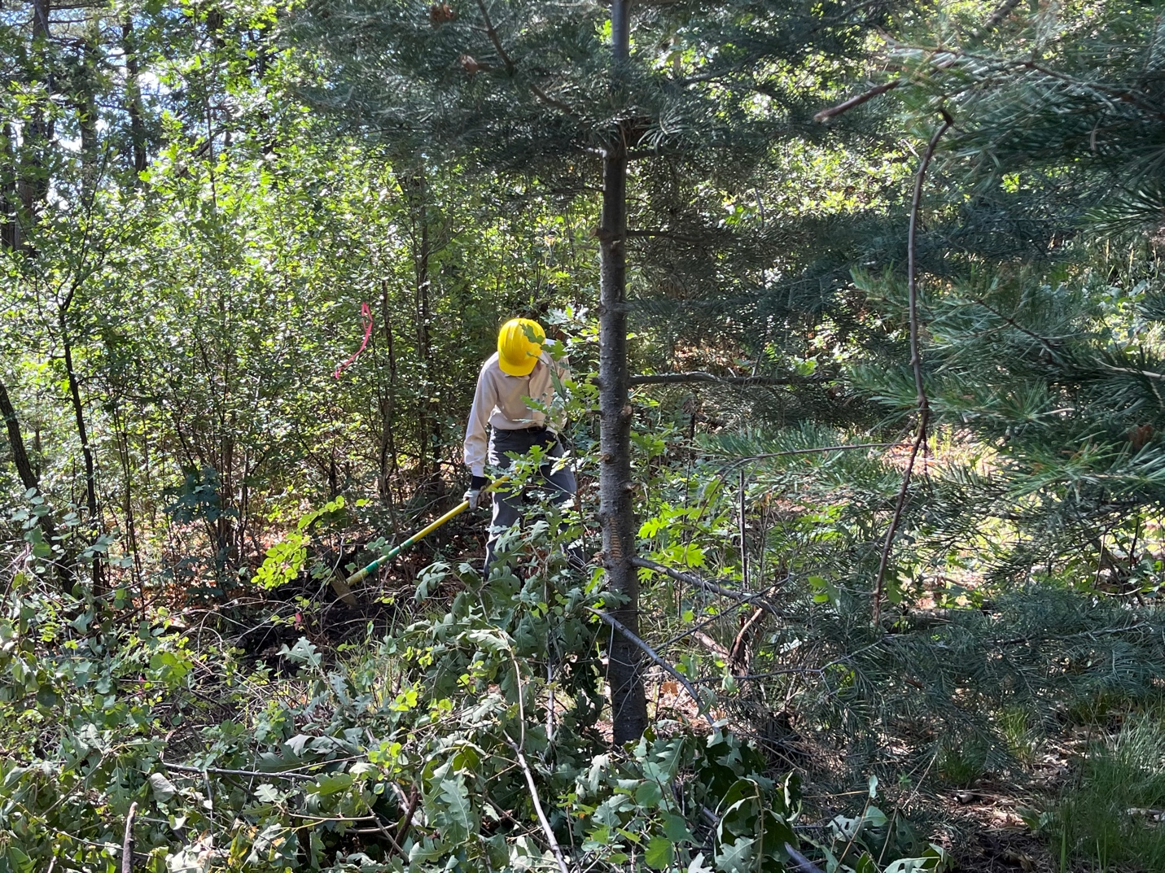

Sim was lost in the brush but we found him by lunchtime! Actually, the rocks turned out to be more of an issue than the green stuff.

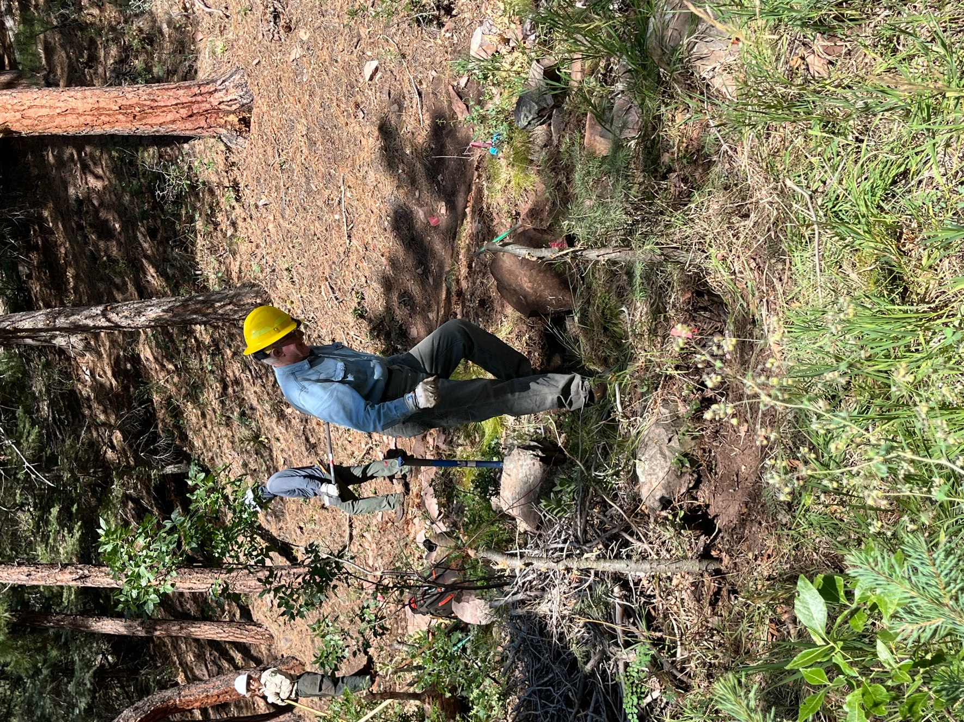

For example, Eric found really large boulders, but as we headed up slope to connect to the existing trail, the rocks became smaller and more numerous.

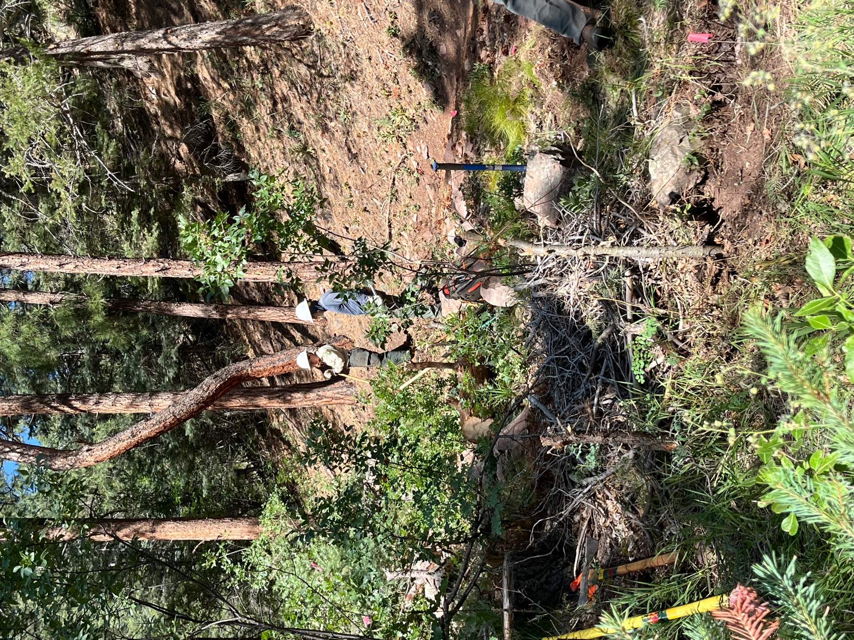

Jen and John stand on the old trail, aka a gully wash, and survey one of the serpentine curves that needs digging.

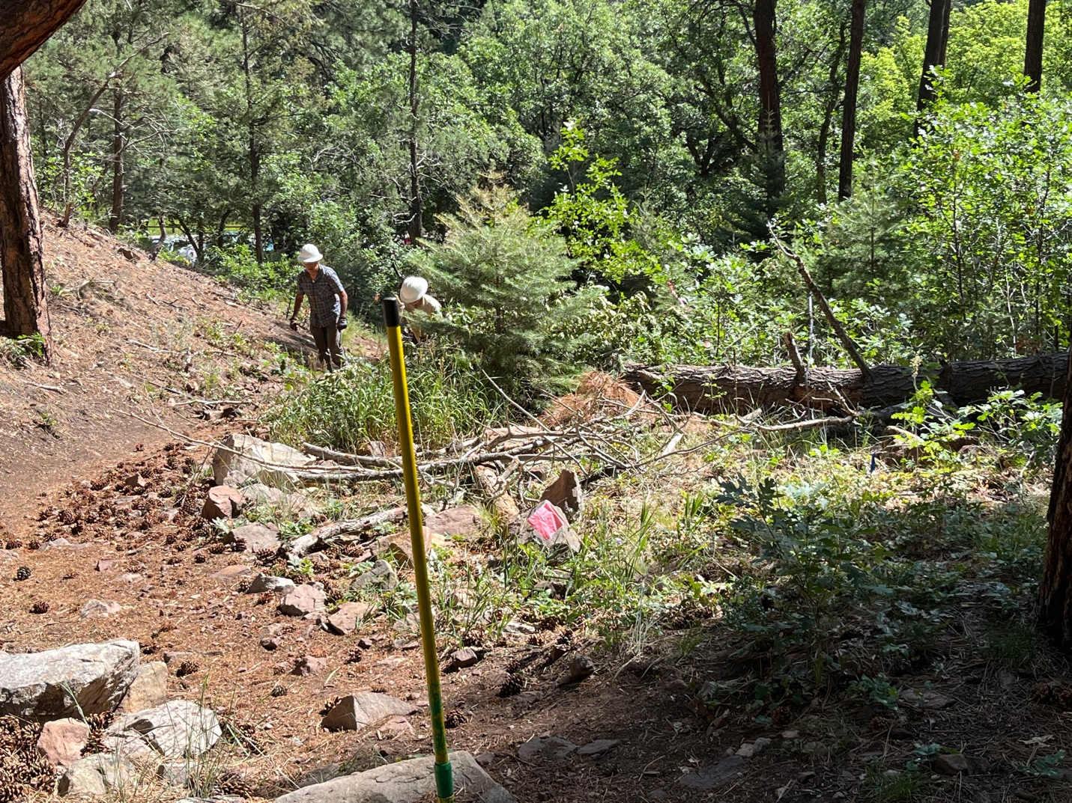

You can see the slope is steep. Luis is walking up the old trail and Jen is working at a point where the new trail heads into a C shaped curve and comes out at the flag and McLeod.

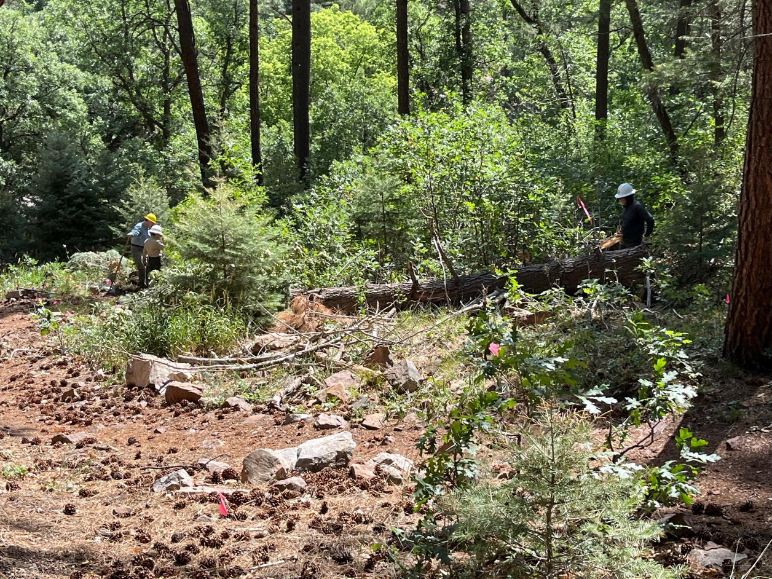

John had lots of stumps and felled tree sections to move around.
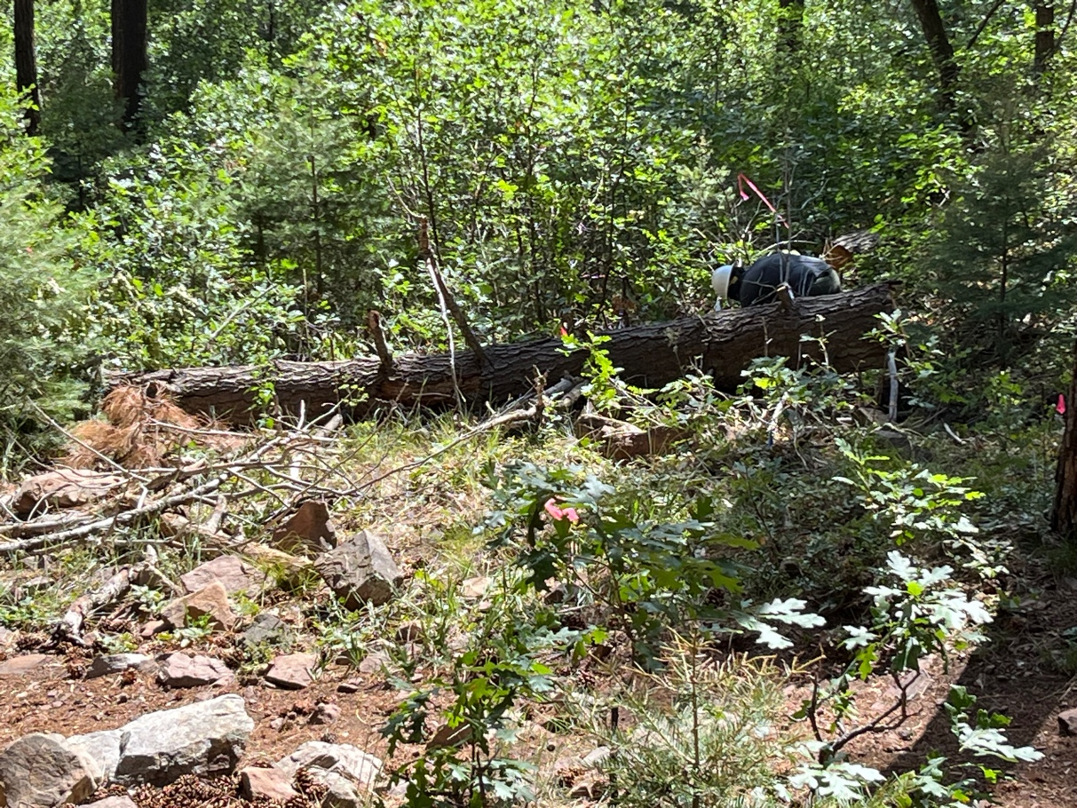
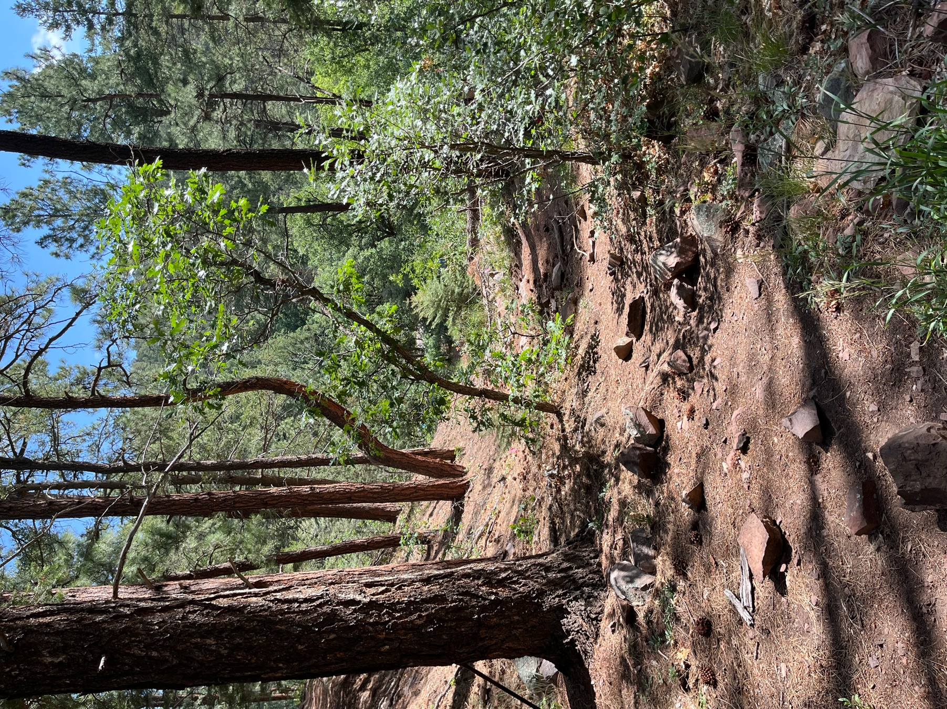

One last look at the old trail before we obliterated it.

