Report of FOSM Project to Fell Hazard Trees along Rocky Point Trail

on Wednesday, July 23

Sam Beard

On Wednesday, July 23, six FOSM volunteers felled hazard trees along Rocky Point Trail. Earlier, volunteers had selected 72 hazard tree that were defined by Canyon Young, SRD Trails and Wilderness Program Manager as dead trees leaning toward the trail and within one and one-half tree lengths of the trail.

The crew of Jerry Carroll, Michael Arndt, and Steve Roholt felled 11 trees starting at Ellis Trailhead. The diameters ranged from 3 inches to 20 inches. The crew of Dan Benton, Cliff Giles, and Sam Beard felled 10 trees from Ellis Trailhead until late morning when the Husqvarna Model 372 chain saw would no longer start. This crew walked back to the Ellis Trailhead, picked up a Husqvarna Model 572 and then drove to the south end of Rocky Point Trail. They then start working back toward Ellis TH and felled 4 hazard trees.

Project photos are presented below. The photos show that the hazard trees along this trail are mostly located in dense groves of trees and that felling them to the ground without hang ups will be difficu

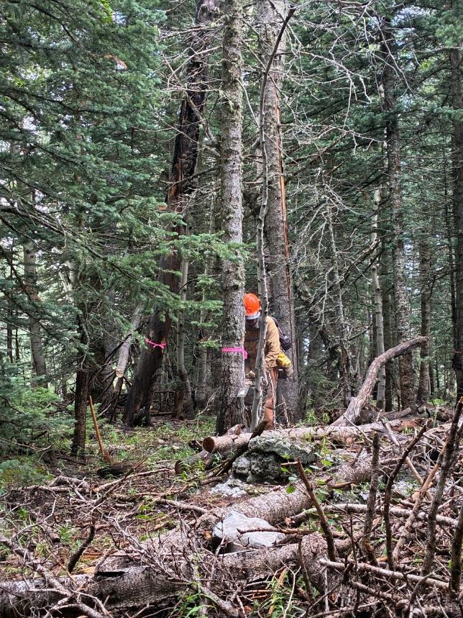

Dan Benton making the face cut on first tree felled by his crew. All photos by Cliff Giles

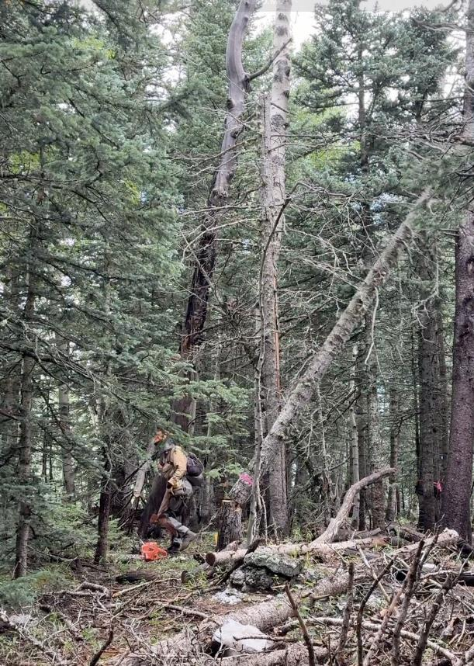

Dan running away as Tree 1 falls.

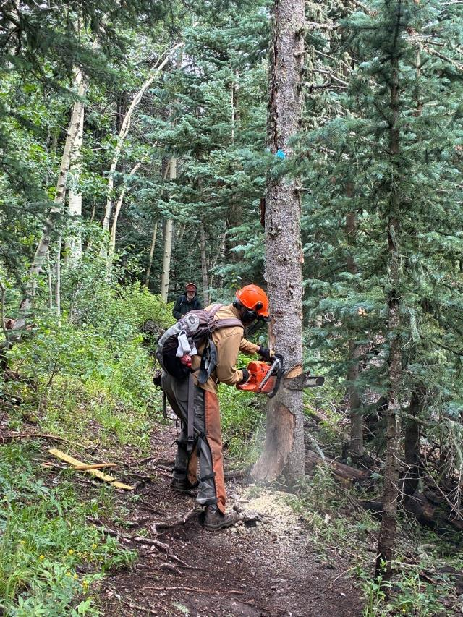

Dan making the face cut on Tree 2

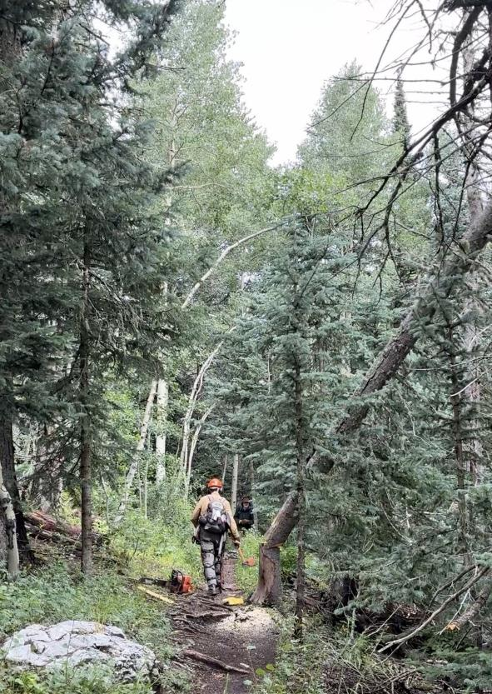

Dan running away as Tree 2 falls.

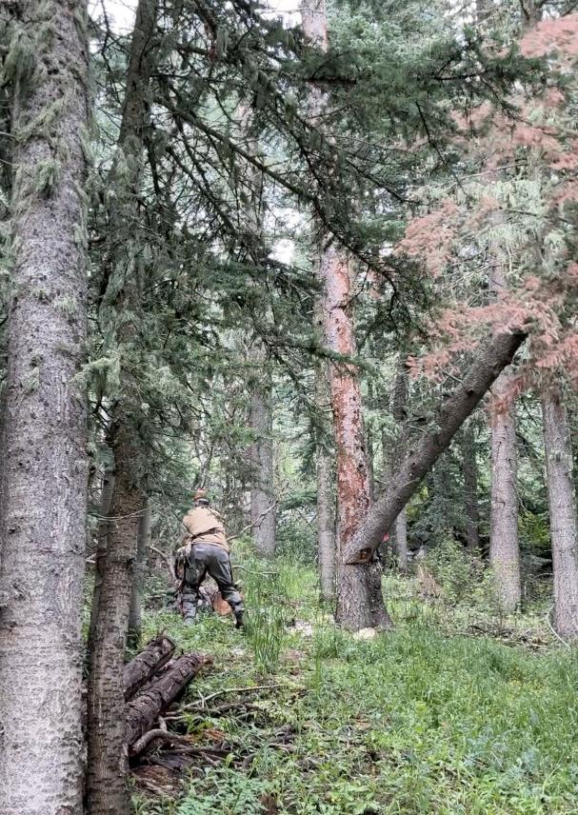

Dan running away as Tree 5 falls.

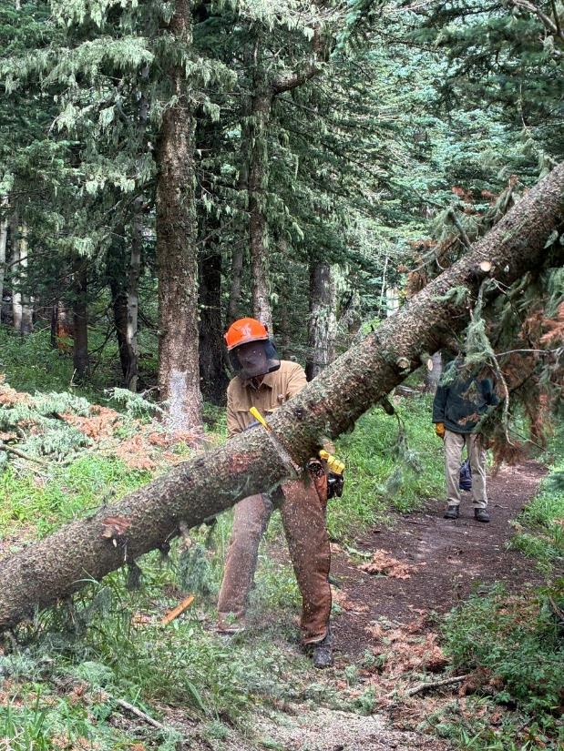

Dan bucking Tree 5 which hung up on nearby trees.

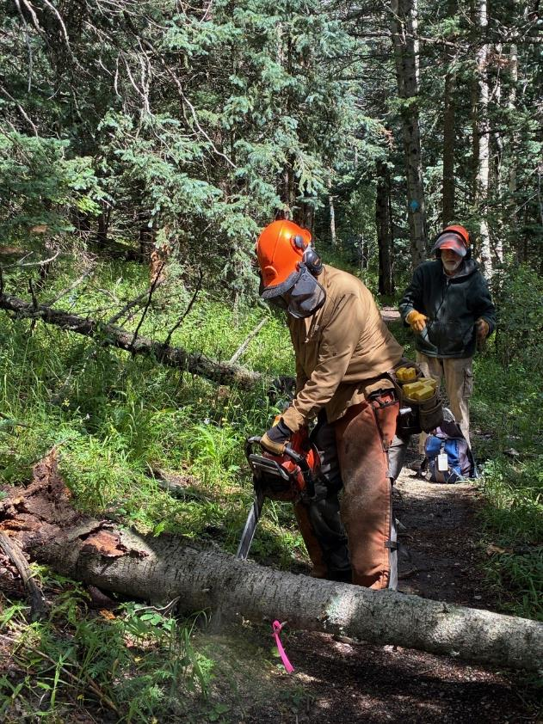

Dan bucking Tree 8 which fell to the ground.

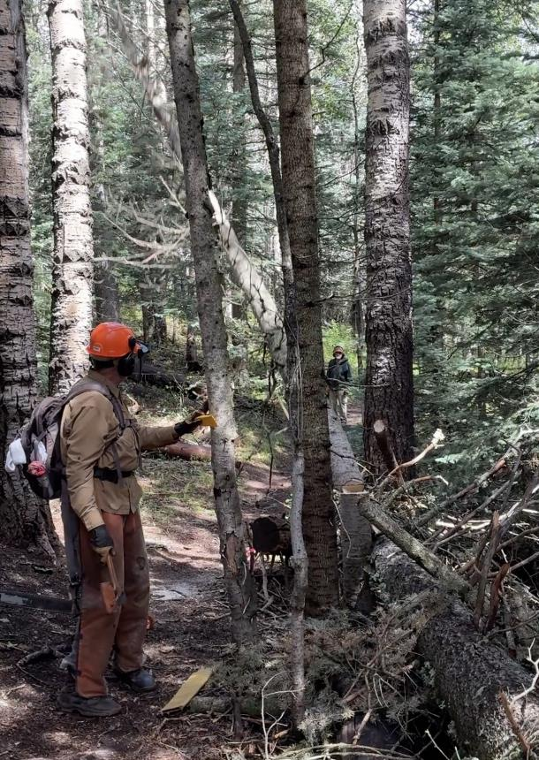

Dan watches Tree 9 falling as he stands behind neighboring trees.

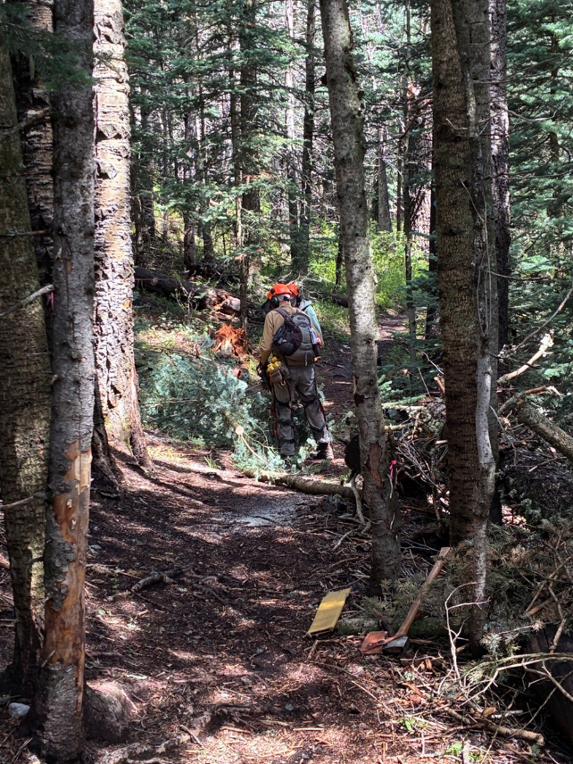

Dan limbing Tree 9 so that it does not block the trail.

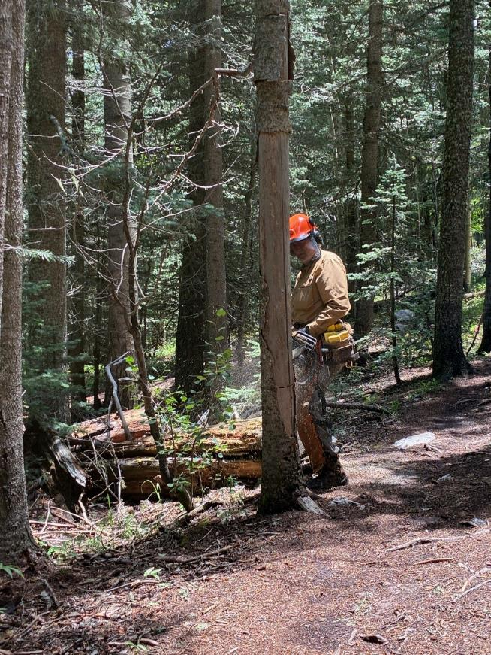

Dan making the face cut on Tree 12 near the south end of Rocky Point Trail.

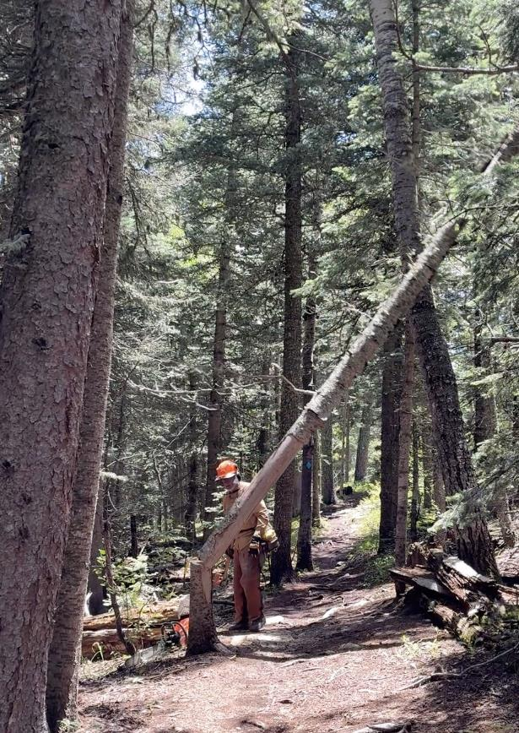

After making the back cut, Dan used a wedge and axe to fell Tree 12.