Report of the FOSM Paint Crew Removing Graffiti Tags from the Kiwanis Cabin Interior and Painting over Tags at the Kiwanis Meadow Road Gate and

in Crest Restrooms on Tuesday, July 22, 2025

Sam Beard

On Tuesday, July 22, the FOSM paint crew of Pauline Ho, Rick Buss, Michael Arndt and Sam Beard removed two large graffiti tags and dozens of small tags from the interior of Kiwanis Cabin with the World’s Best Graffiti Removal System chemicals and painted over graffiti at the Kiwanis Meadow Road Gate and in restrooms at the Crest.

Project photos are presented below.

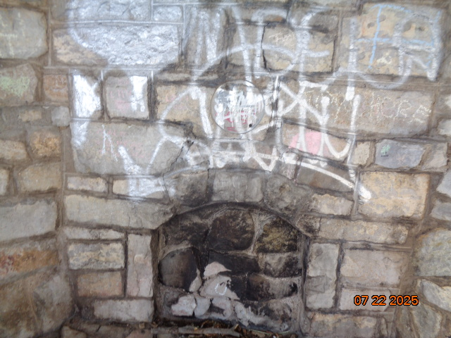

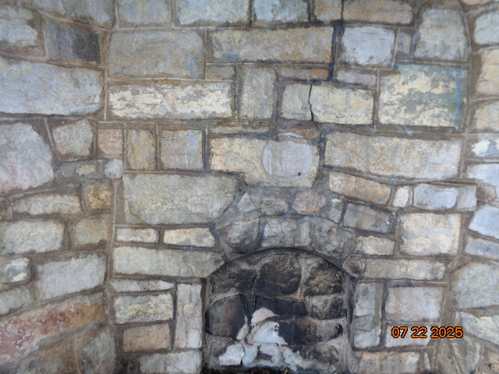

Before and after photos of silver graffiti on Kiwanis Cabin fire place.

All photos by Sam Beard unless noted otherwise

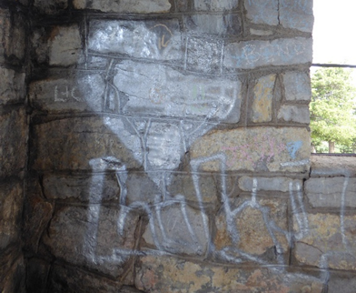

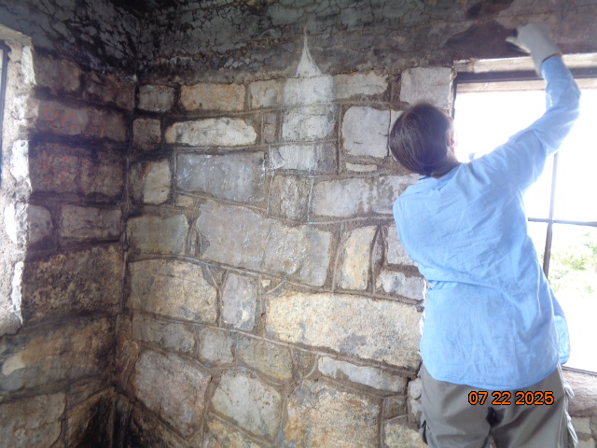

Before and after photos of silver tags on southwest corner of cabin.

Top - Photo by Pauline Ho

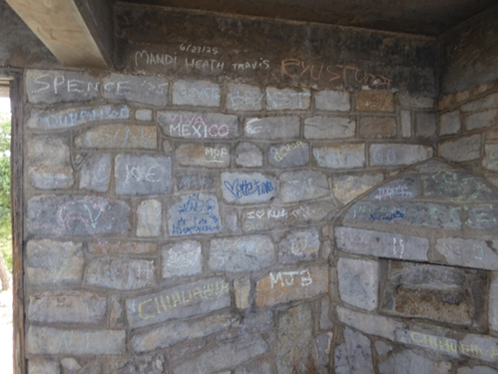

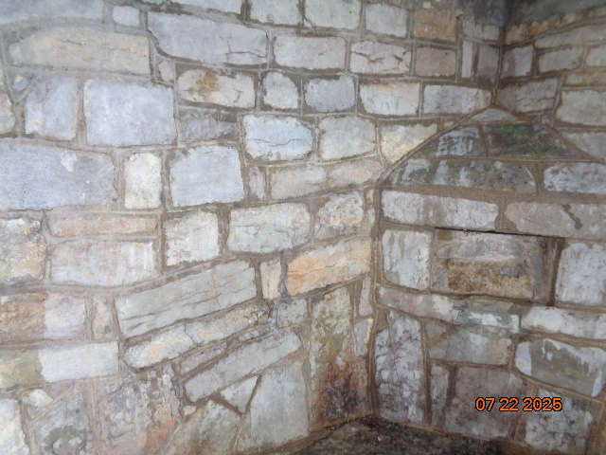

Before and after photos of northeast corner of cabin.

Top – Photo by Pauline Ho

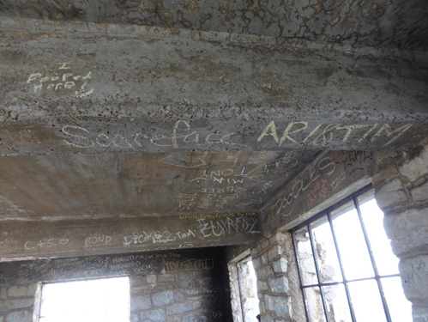

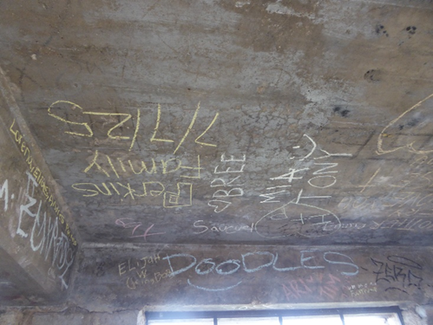

Photos of graffiti tags on concrete ceiling and beams. Photos by Pauline Ho

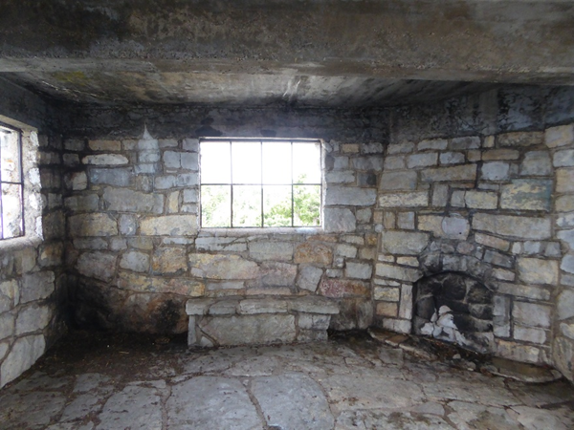

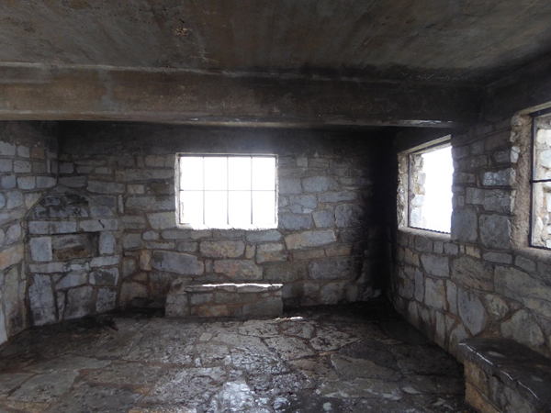

Top – West half of the cabin interior and fireplace. Bottom – East half of the cabin

interior with two benches. Photos by Pauline Ho

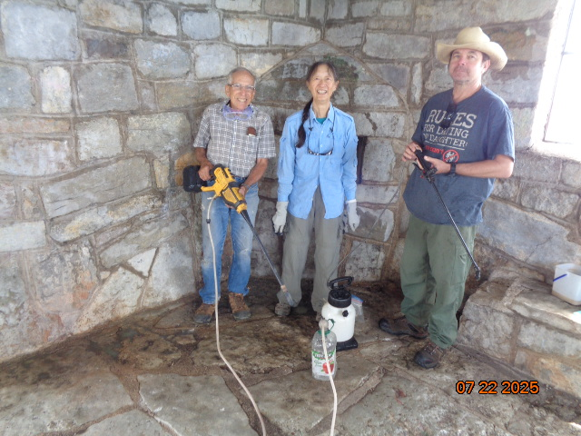

Graffiti removal crew. L to R: Rick Buss, Pauline Ho, and Michael Arndt. Rick is holding the FOSM

battery-powered low-pressure washer, and Michael is holding the sprayer used to apply chemical to the tags.

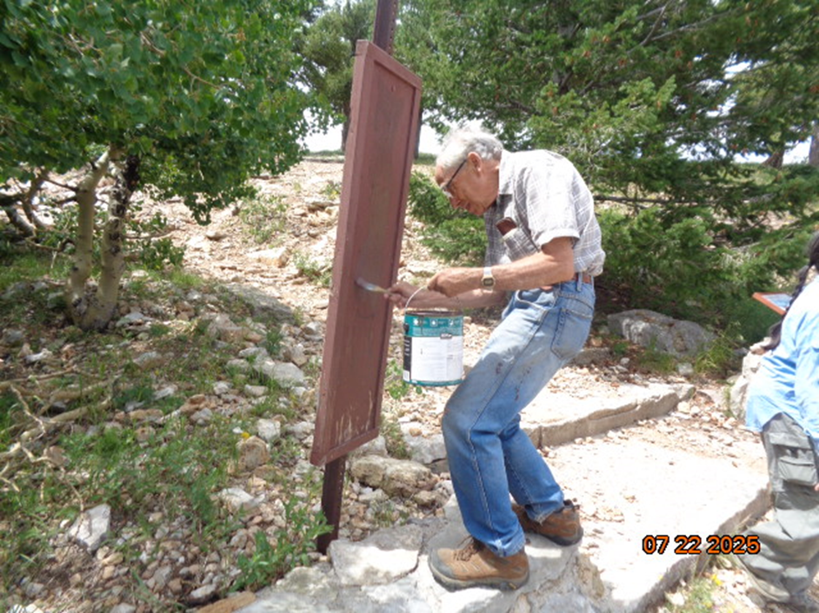

Rick is painting over a black tag on this small board at the cabin parking lot.

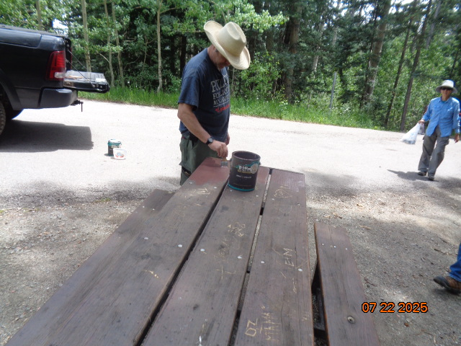

Michael is painting over carvings on the picnic table at the gate to Kiwanis Meadow Road.

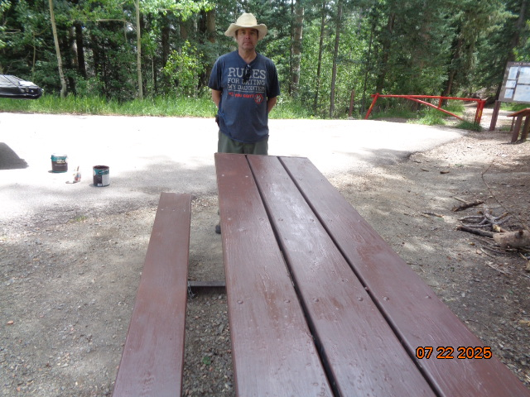

The table has been painted with USFS brown paint.

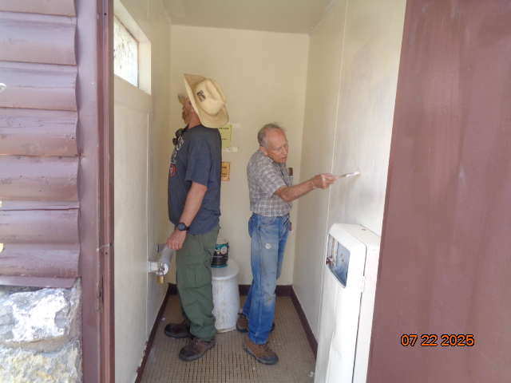

Michael and Rick painting over graffiti on the walls of one of the lower Crest restrooms.

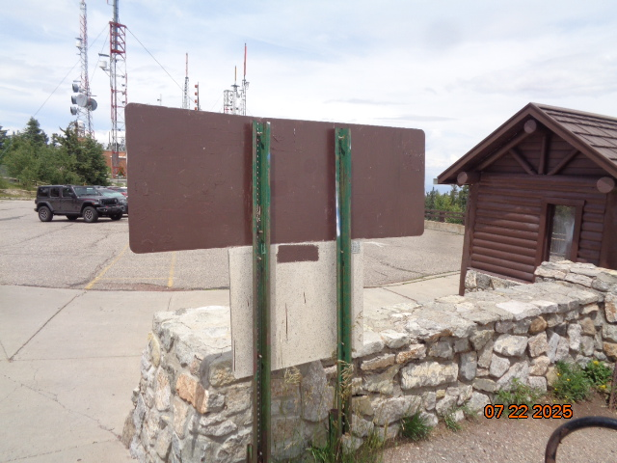

The graffiti tags on back of this sign at the Crest parking lot were painted 0ver with USFS brown paint.

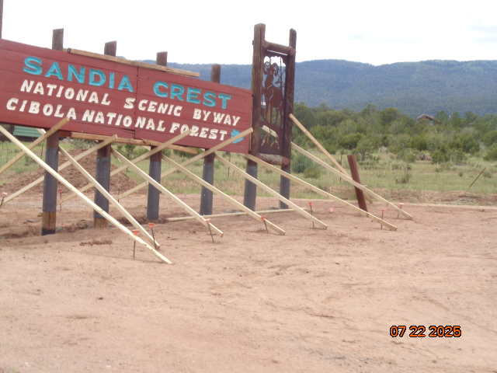

The Sandia Crest National Scenic Byway at the southwest corner of the new roundabout.

Ross Ward, the founder of Tinkertown, constructed this sign several decades ago.

The 2x4 supports were removed after the concrete around the posts had hardened.