**Report of** **FOSM Outing to Fell Hazard Trees along Gravel Pit Trail**

**on Wednesday, July 30, 2025**

Sam Beard

On Wednesday, July 30, eight FOSM volunteers felled hazard trees along Gravel Pit Trail near Ellis Trailhead. From Ellis Trailhead, the crew hiked segments of Switchback Trail, all of Kiwanis Meadow Trail, and a short segment of South Crest Trail to arrive at the upper Gravel Pit Trailhead.

Dan Benton’s crew members were Eric Russell, Cliff Giles, and Sam Beard. Dan’s crew felled and bucked approximately a dozen trees in the diameter range of 3 inches to 12 inches. Jerry Carroll’s crew members were Steve Roholt, Lorna Morrow, and Sim Cook. Jerry’s crew felled seven trees with maximum diameters of 20 inches and 28 inches.

Project photos are presented below.

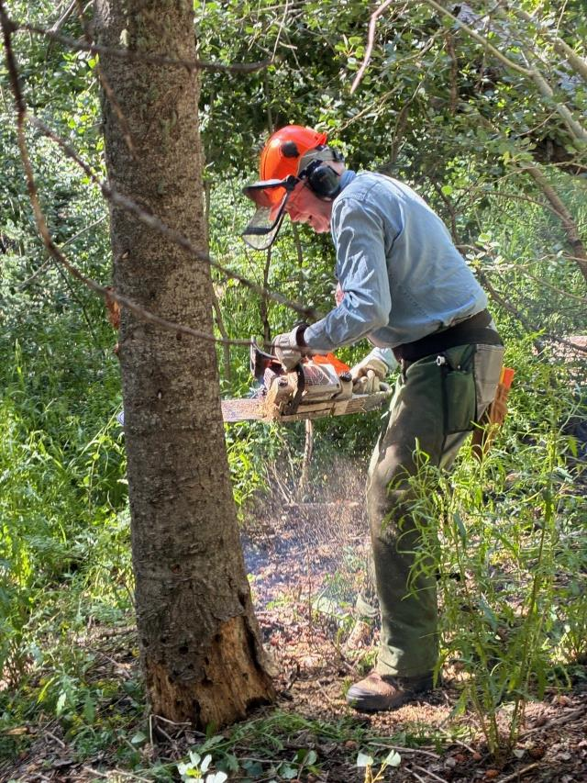

Eric Russell making the face cut in a hazard tree on Gravel Pit Trail.

All photos of Dan’s crew made by Cliff Giles.

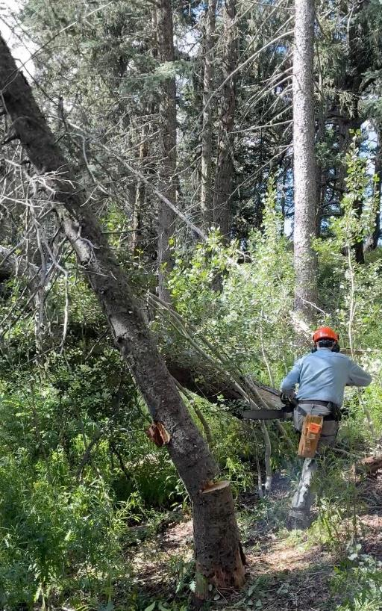

Eric running away from the falling tree.

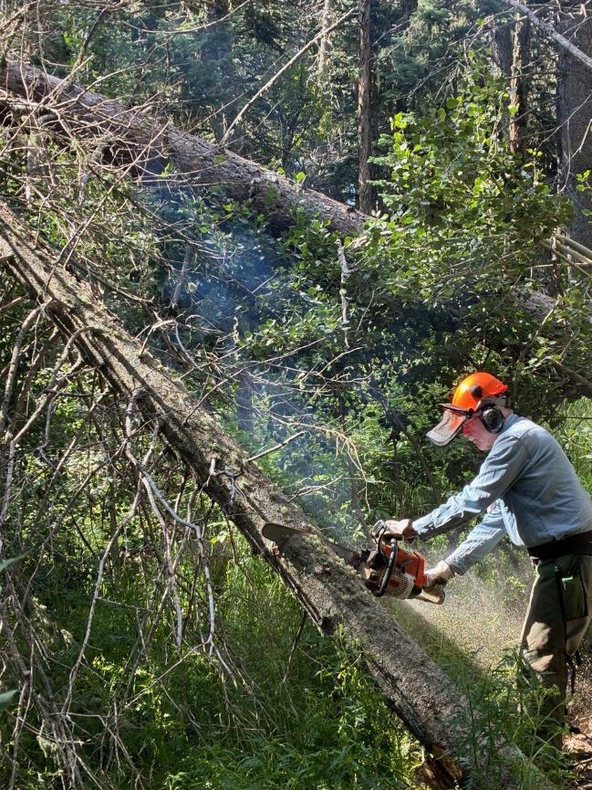

Eric bucking the hung-up tree so that it will fall to the ground. Felling hazard trees along this trail

was difficult, because most of the trees were in thick groves, and they were likely to hang

up on adjacent trees.

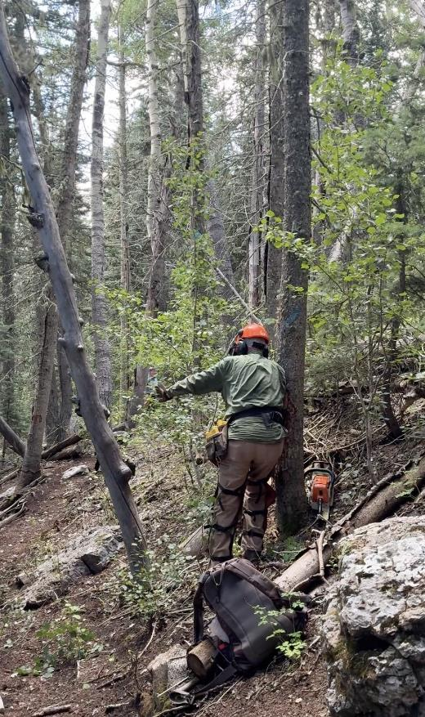

Dan has just pushed over a leaning tree.

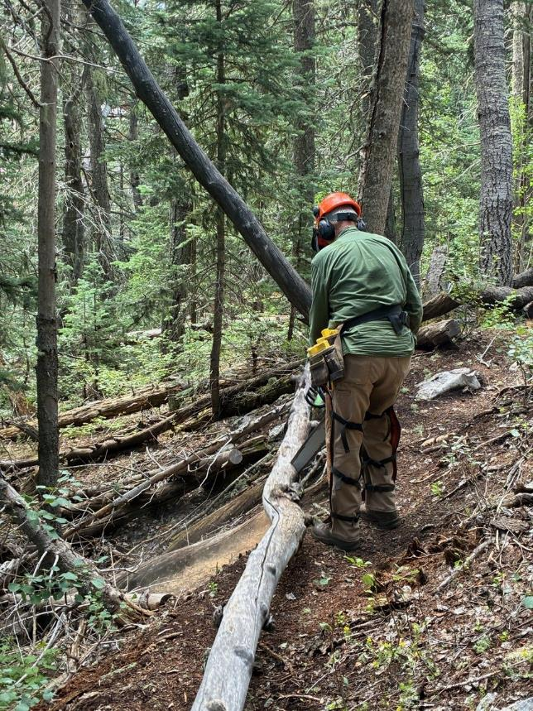

Dan bucking a felled tree.

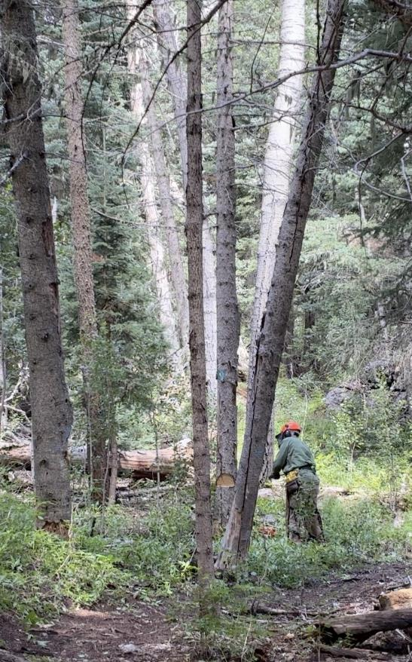

Dan making the back cut in a hazard tree.

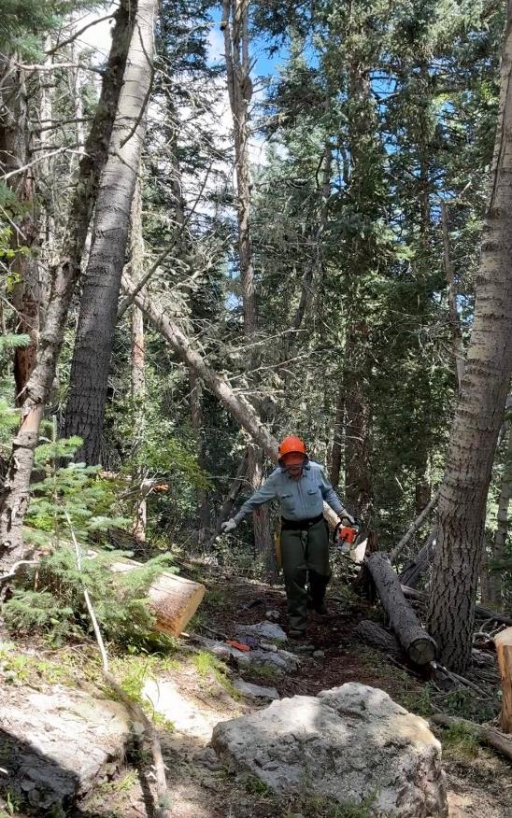

Eric running away from a falling tree.

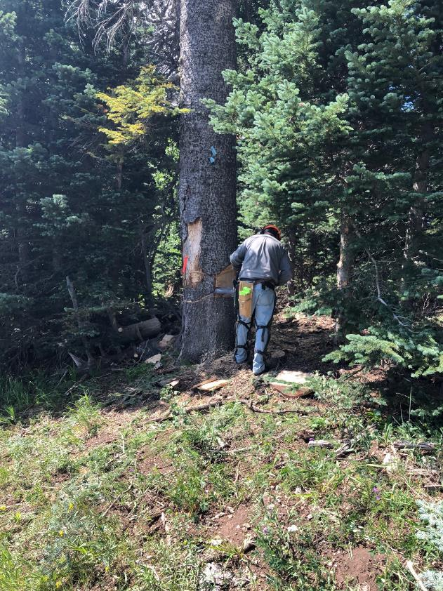

Jerry completing the face cut in a 28-inch fir tree.

All photos of Jerry’s crew made by Sim Cook

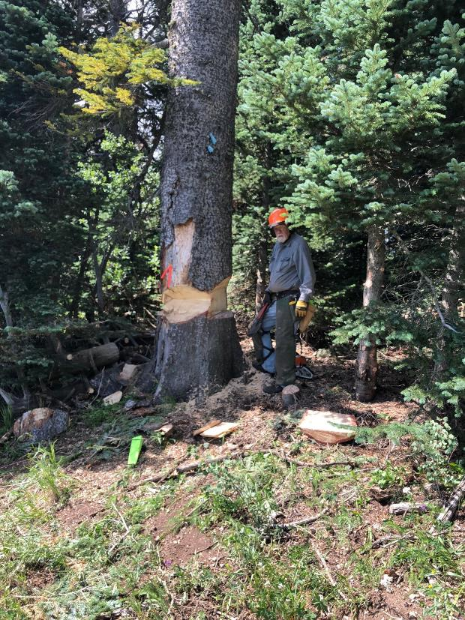

Jerry ready to make the back cut in this large tree. The cut on the side of the tree next to Jerry

was a deep slap cut to effectively reduce the thickness of the wood so that he could make

one back cut with his chain saw having a bar length less than the diameter of the tree.

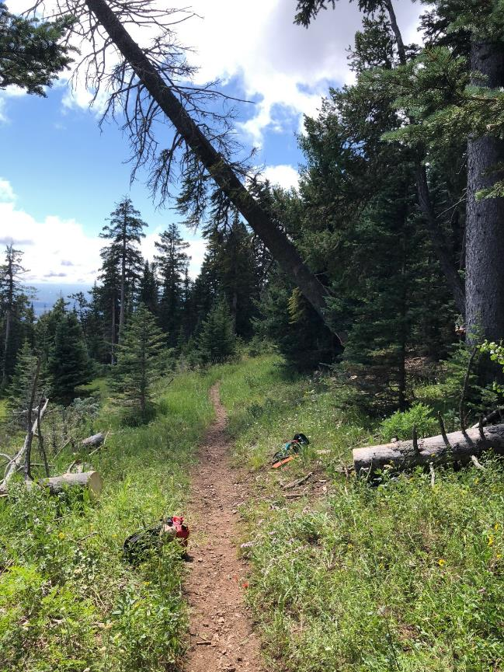

The large hazard tree falling across Gravel Pit Trail.

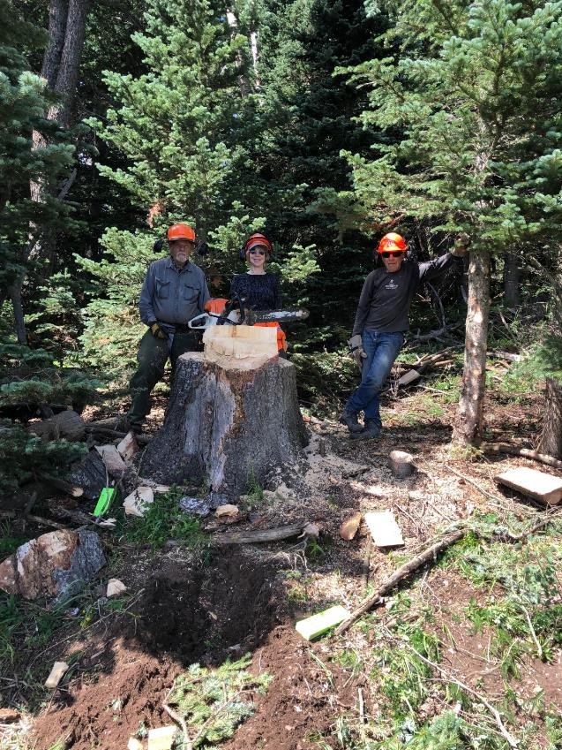

Jerry Carroll, Lorna Morrow, and Steve Roholt standing behind the stump of the large tree

felled by Jerry.

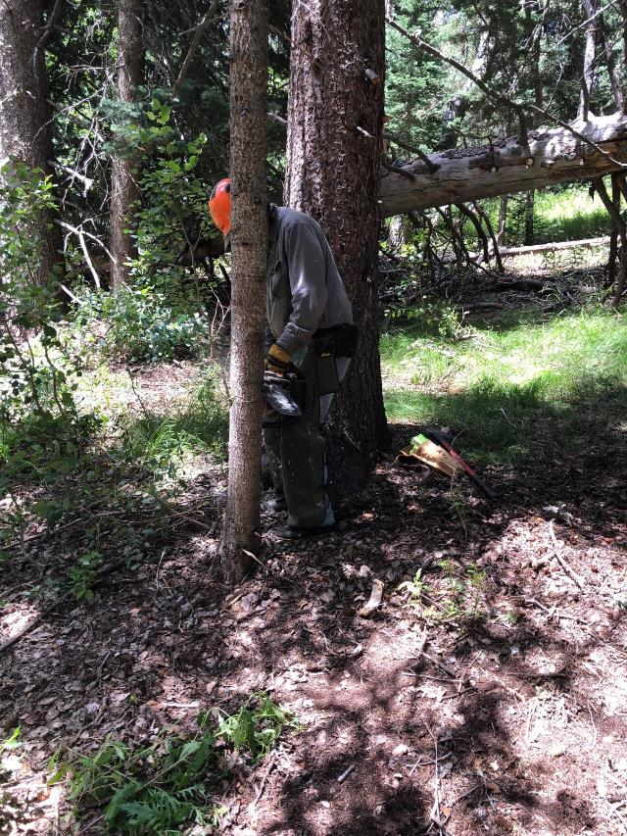

Jerry making a face cut in a small tree with branches intertwined with the large hazard

tree hazard tree behind him.

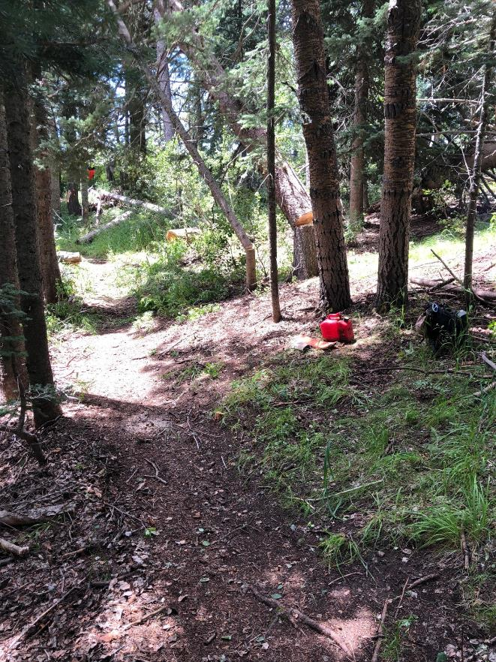

The hazard tree and the small tree falling together.

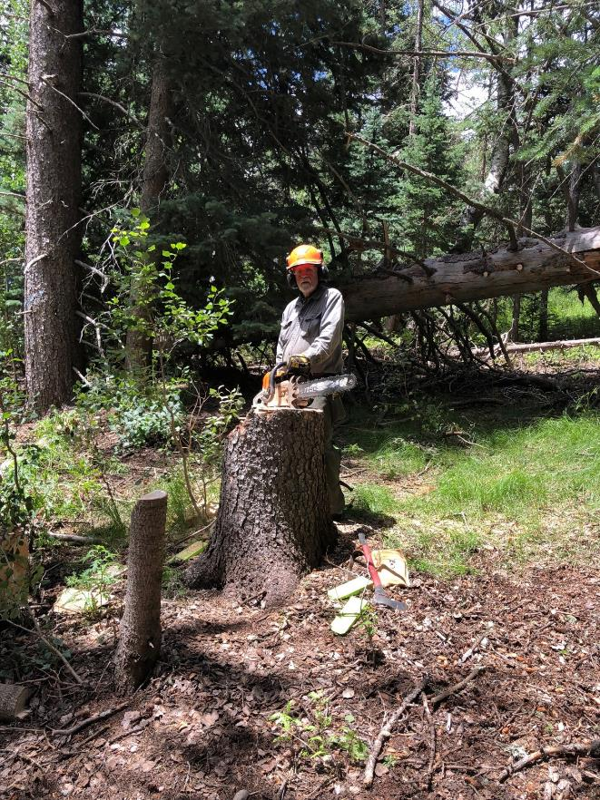

Jerry at the stump of the hazard tree and the small tree he has just felled.