**Replacement of Four Fence Rails**

**in Cienega Canyon Picnic Area, Saturday, August 2, 2025**

Sam Beard and Michael Arndt

On Saturday, August 2, Sam Beard and Michael Arndt replaced four missing or rotten rails in the fence leading to the gate to the group area. The new rails were picked up at Don Carnicom’s house where FOSM stores fence posts and rails.

This project required the removal of the rotten rails by cutting the rusty ½-inch threaded rod with the FOSM battery reciprocating saw, drilling holes in the new rails, countersinking with Forstner bits, and installing recycled washers, threaded rod and nuts.

Sections of the repaired fence are shown in the photo below.

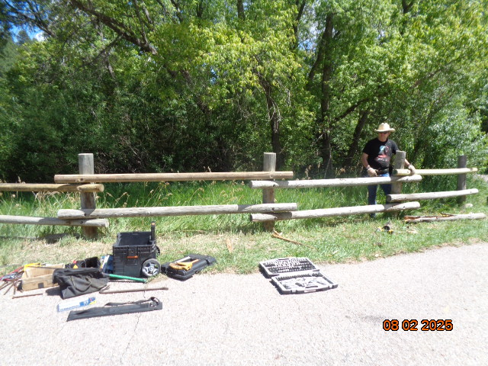

The following rails replaced rotten or missing rails: top rail on left, top rail on center section, and top rail at Michael’s hand. A rotten rail to the left of the picture closer to the gate to the group area was also replaced. Photo by Sam Beard