**Report of FOSM Project to Fell and Buck Hazard Trees**

**along Kiwanis Meadow Road, Wed., August 6, 2025**

Sam Beard

On Wednesday, August 6, FOSM sawyers Jerry Carroll, Dan Benton, and Lorna Morrow felled 12 hazard trees on the uphill side of Kiwanis Meadow Road at the Crest. The diameters ranged from 4 inches to 24 inches. On the downhill side of this road, the forest will be thinned and masticated in the future. These skillful sawyers felled all the trees in somewhat dense groves, and no trees hung up on other trees. Next Wednesday, these felled trees will be bucked to fireplace/stove lengths, split, and hauled to the Mountain Christian Church Wood Ministry woodlot, and during the winter the wood will be donated to East Mountain families who heat their homes with wood.

The other volunteers who worked on Wednesday were Sam Beard and Cliff Giles.

Project photos are presented below.

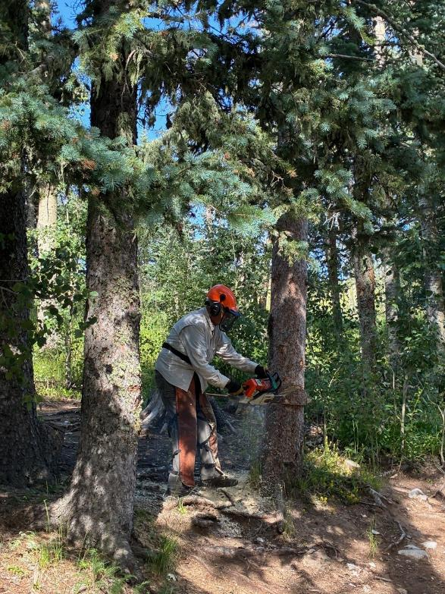

Dan Benton making the face cut on an Engelmann spruce near the gate to Kiwanis

Meadow Road, All photos by Cliff Giles

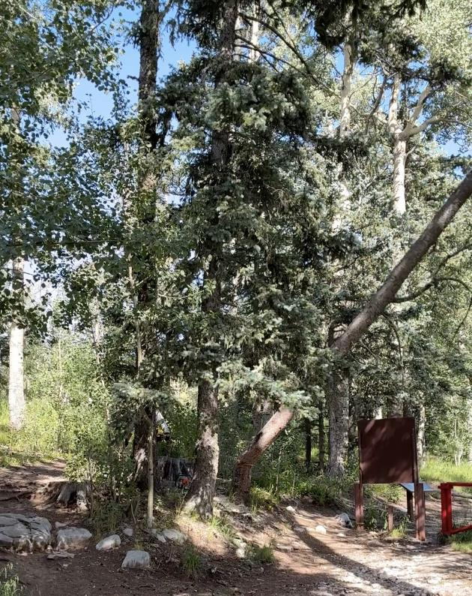

Dan’s spruce tree falling near the map board and gate to Kiwanis Meadow Road.

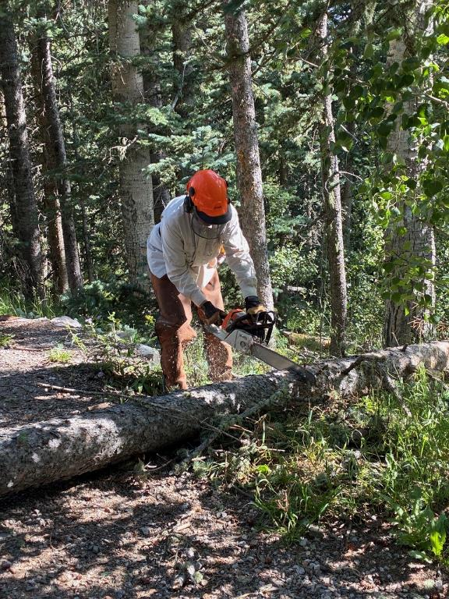

Dan bucking the tree that he has just felled.

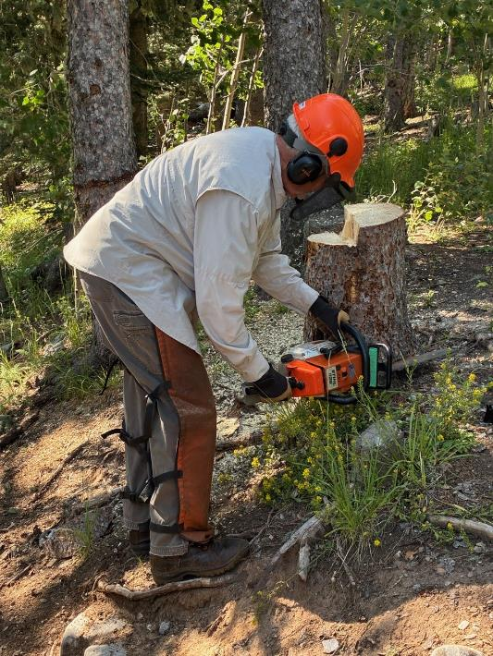

The last step in felling a tree – low cutting the stump to improve the

appearance of the forest.

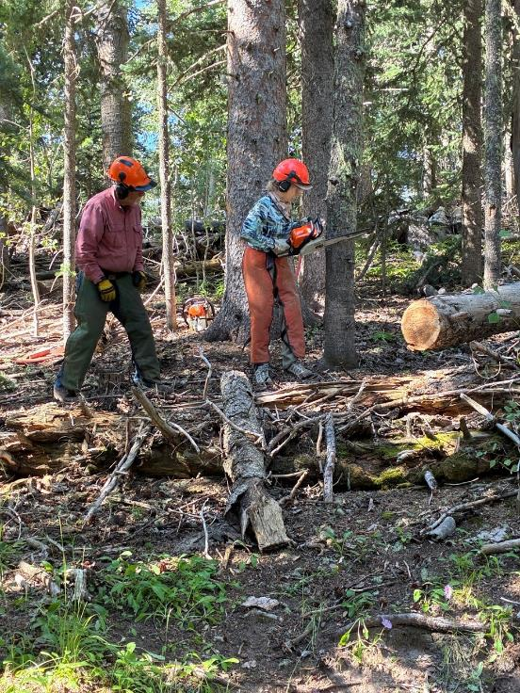

Lorna Morrow making the face cut in a hazard tree with Jerry Carroll observing.

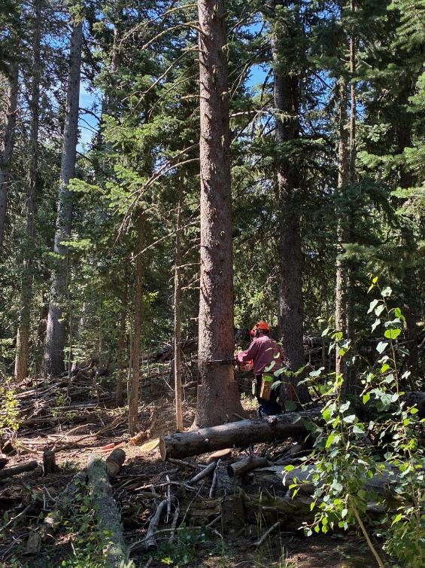

Jerry beginning the back cut on a 24-inch hazard tree. Note that he has make two

deep slab cuts on the sides of the tree so the diameter is less than the

length of the bar on the chain saw. He can make the back cut standing on just

one side of the tree.

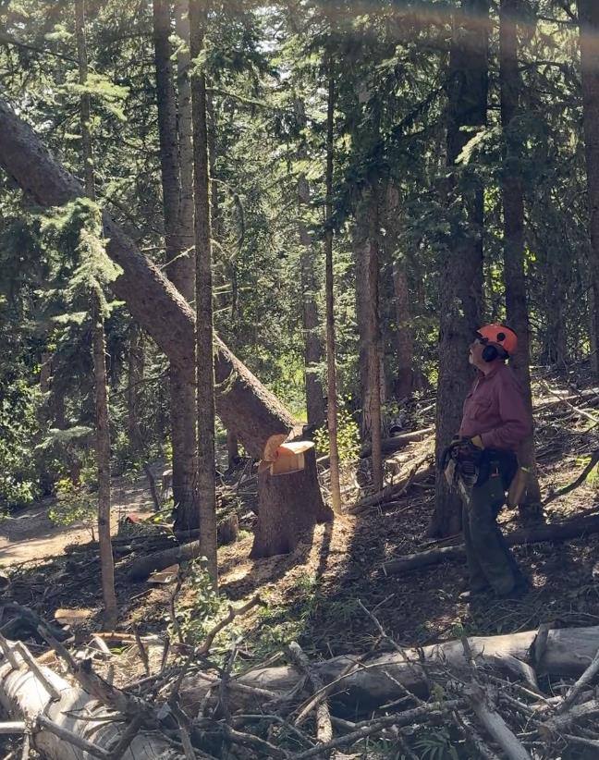

Jerry’s large tree is falling.

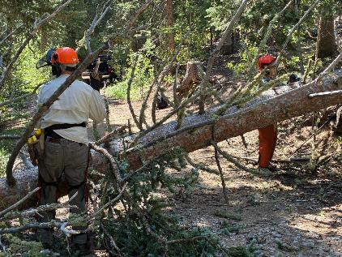

Dan and Lorna are limbing an Engelmann spruce that has been felled.

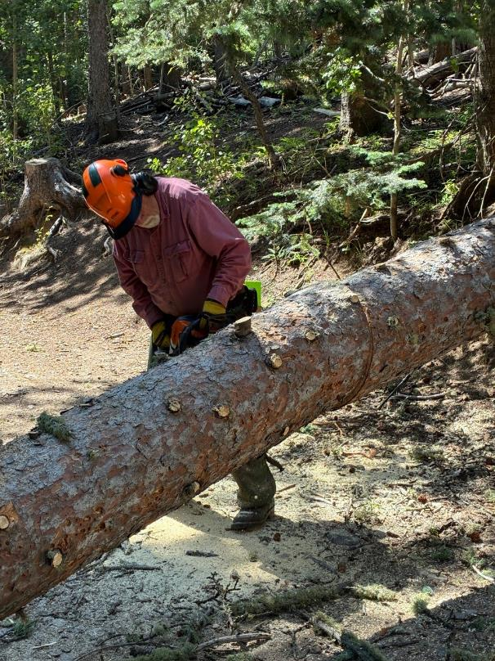

Jerry is bucking the spruce after it has been limbed.

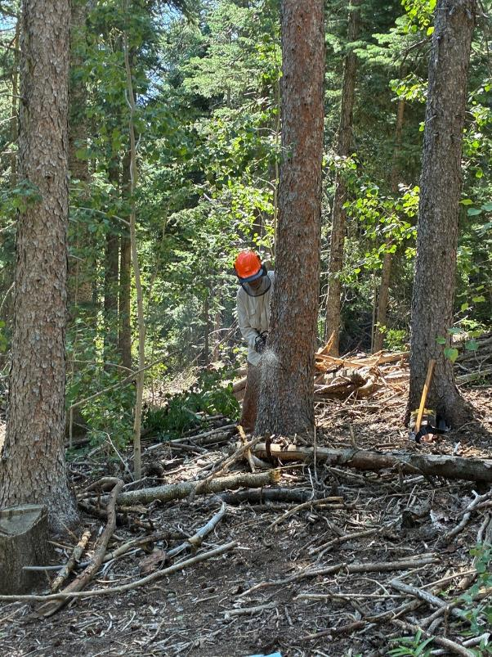

Dan is making the face cut in this hazard tree

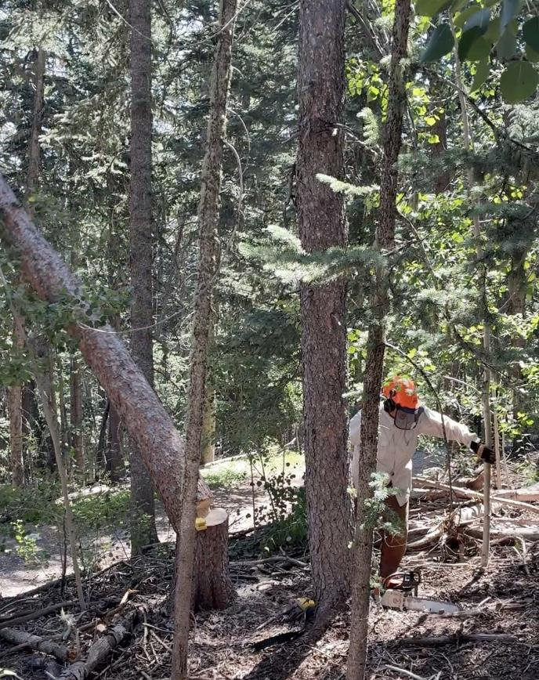

Dan is running away from the falling tree.

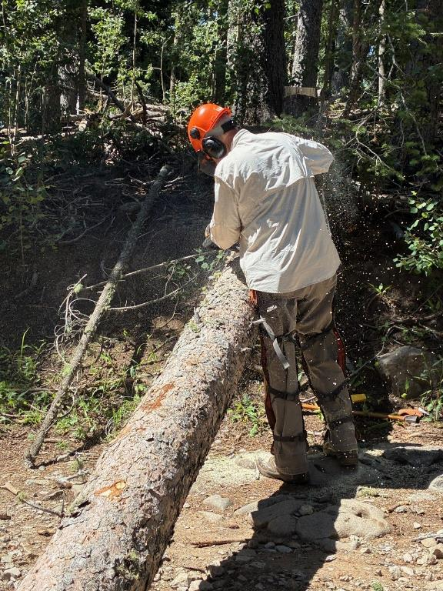

Dan is bucking the spruce tree that has been felled.

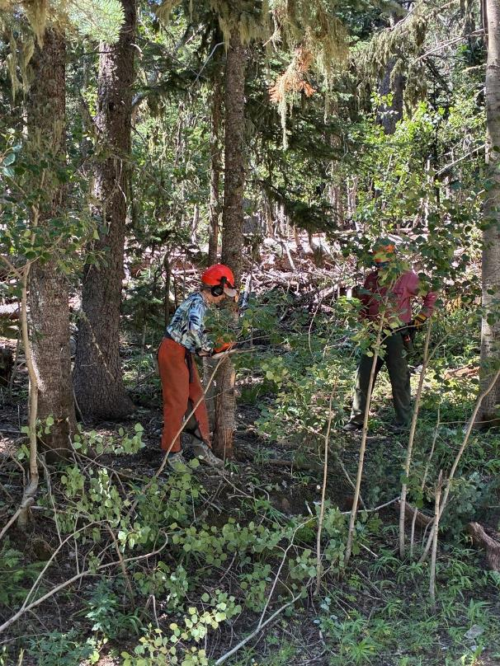

Lorna is making the face cut in a small tree.

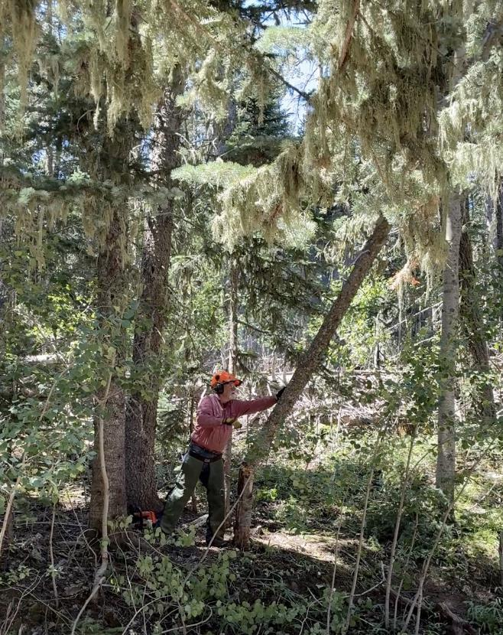

Jerry is pushing a small dead tree over after the back cut was completed.

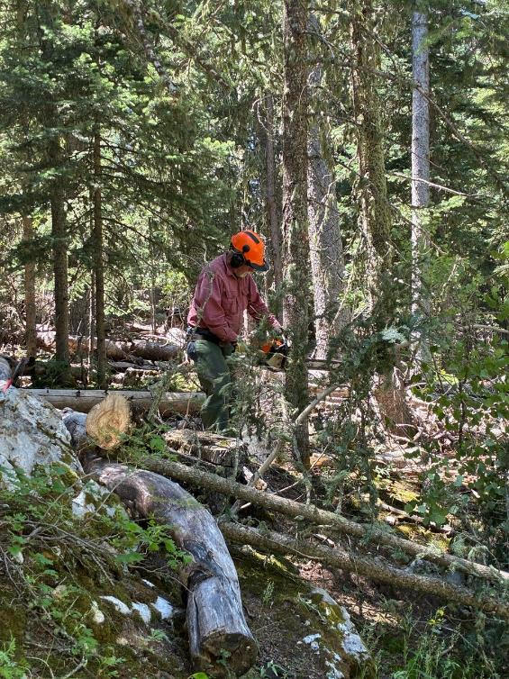

Jerry is making a face cut in a small tree.

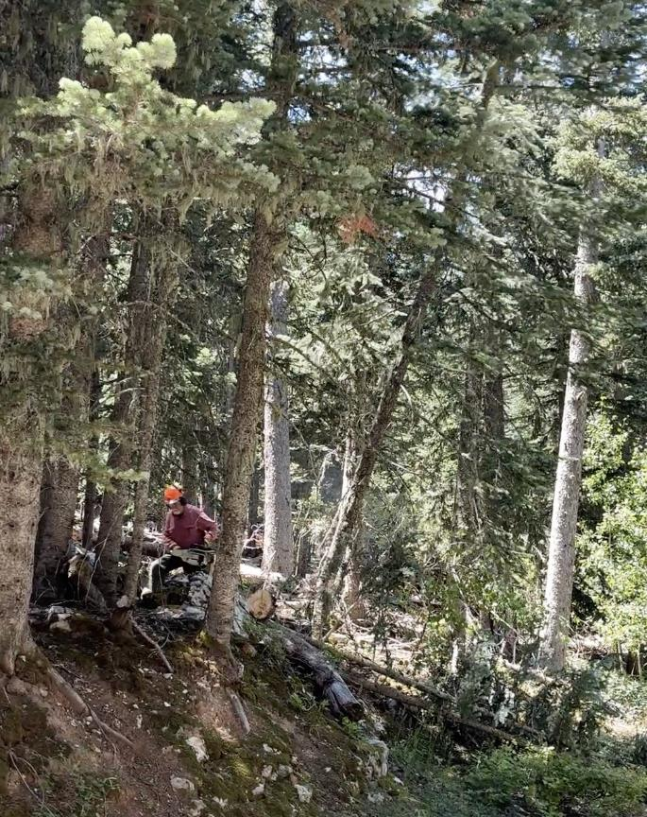

Jerry is running away from the falling hazard tree.

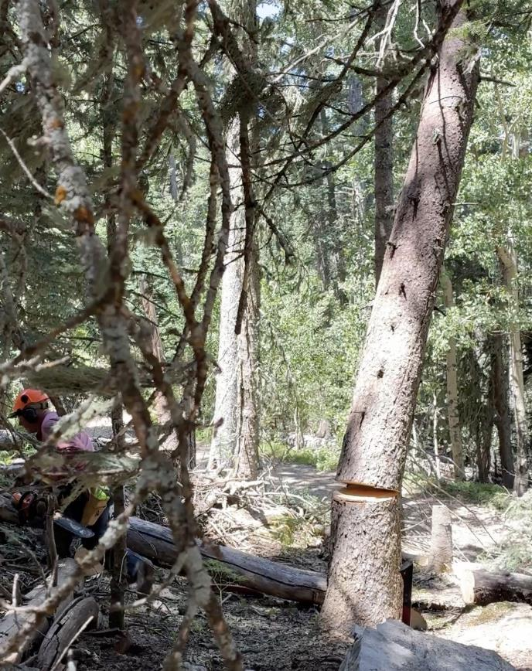

Jerry is running away from this falling 12-inch hazard tree.

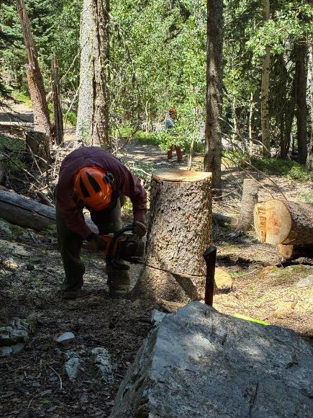

Jerry is low stumping the tree he has felled.

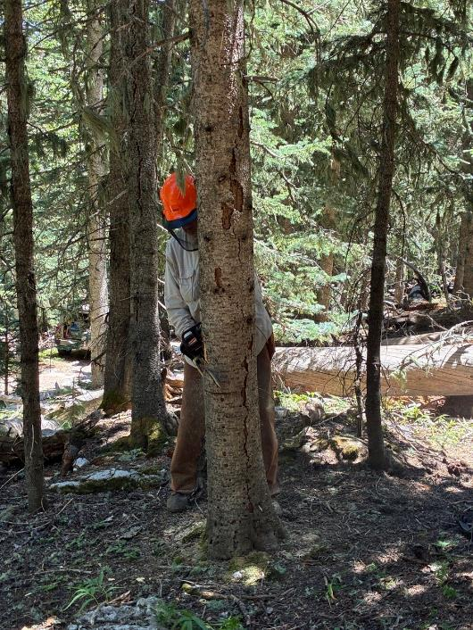

Dan is making a face cut in a dead cork bark fir.

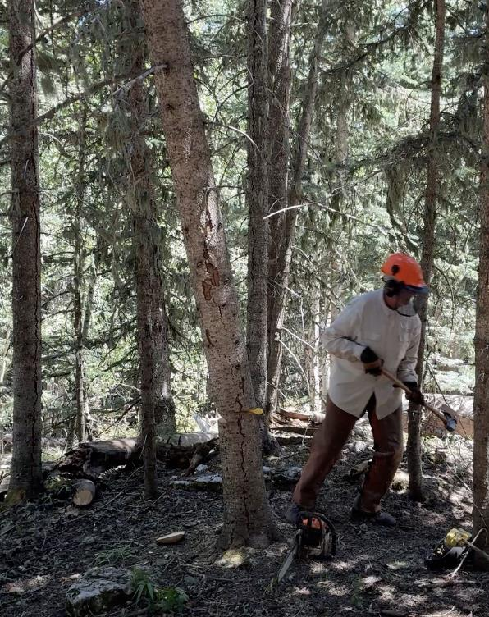

After felling the dead tree with a wedge, Dan is running away.

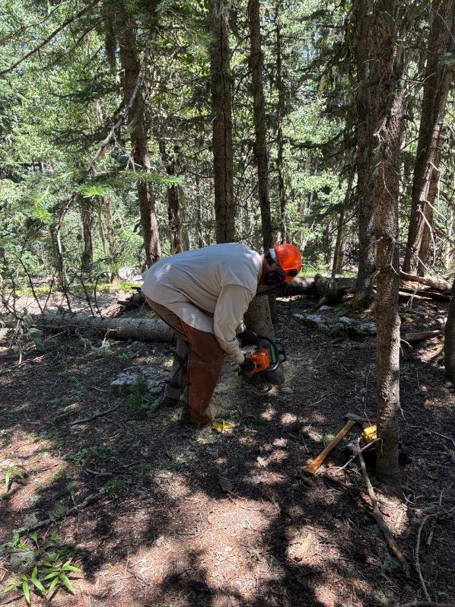

Dan is low stumping the fir tree he felled.