**Report of FOSM Project to Process Donation Wood near the Kiwanis Meadow Road Gate at the Crest, Wednesday, August 13, 2025**

Sam Beard

On Wednesday, August 13, seven FOSM volunteers processed wood from a few hazard trees felled last week near the Kiwanis Meadow Road gate at Sandia Crest. All the trees were spruce with diameters ranging from 8 inches to 24 inches. The split firewood was loaded onto Mike Oliver’s large trailer to be hauled to his woodlot. Next winter Mountain Christian Church Wood Ministry members will donate the wood to East Mountain families who heat their homes with firewood.

Project photos are presented below.

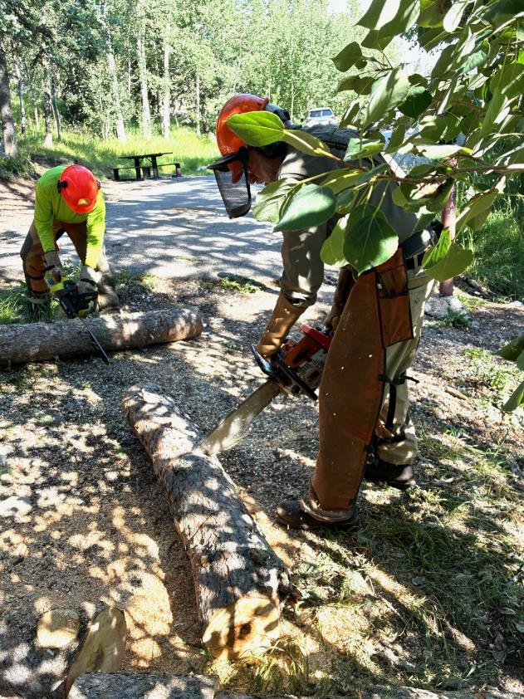

L to R: Steve Roholt and Sam Beard bucking Engelmann spruce logs at the Kiwanis Meadow Road gate.

All photos by Cliff Giles

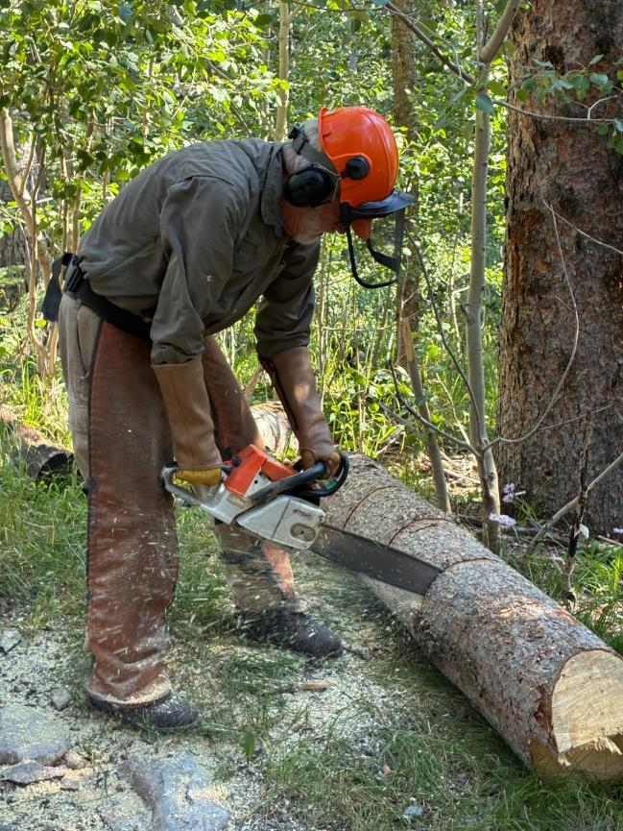

Sam bucking a spruce that Dan Benton had felled earlier.

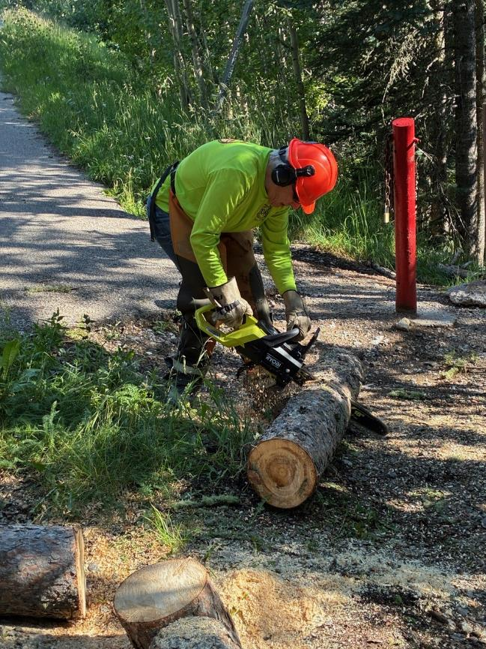

Steve bucking a log with his new battery-powered chain saw.

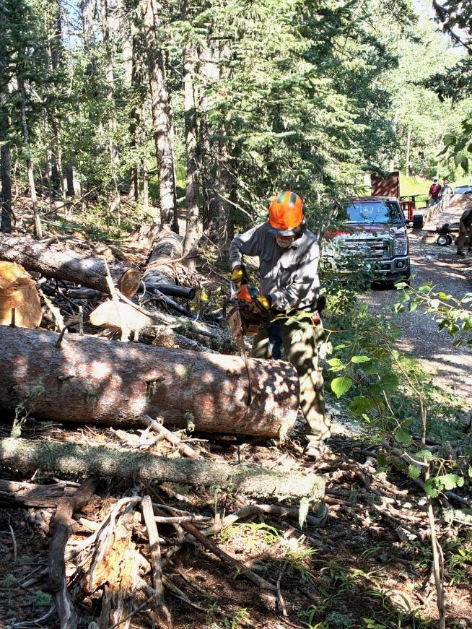

Jerry Carroll bucking a large spruce he felled last week

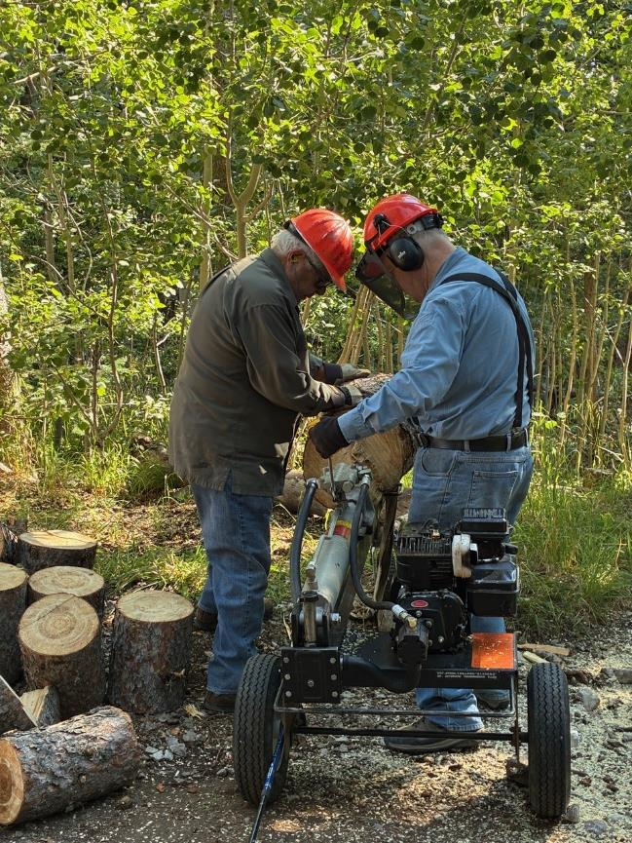

Lou Romero and Dennis Crowther using Lou’s power splitter to split the larger rounds.

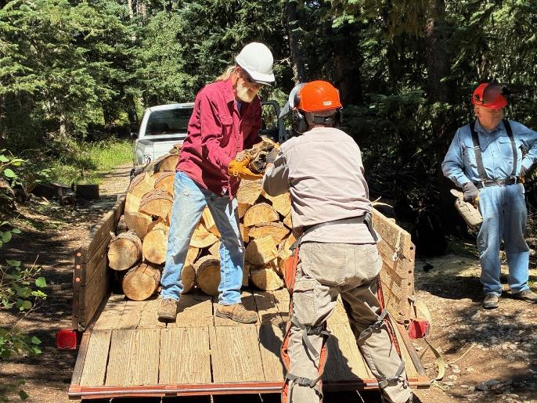

Dan Benton handing Mike Oliver a piece of wood.

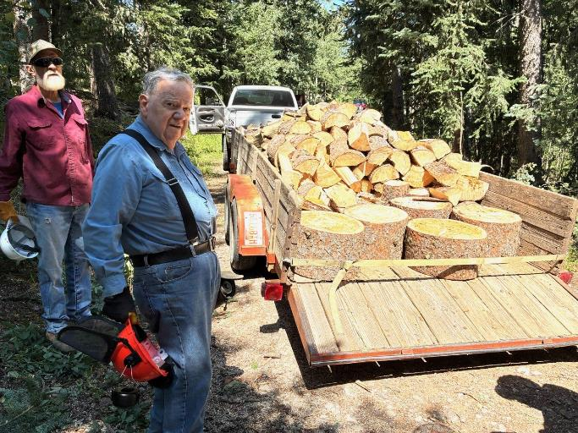

Mike Oliver and Dennis Crowther at the Mike’s loaded trailer.