Thursday, 08/14/25- North Faulty: Six volunteers joined Jen on North Faulty again this week. We continued work on reroute #2, widening some areas where work had been started and firming up areas of the trail where the downslope is very steep. There was a lot of moving rocks around and the soil was very dry and difficult to work with. On the up side, it wasn’t as hot as last week since there were some clouds around. We still have some areas to revisit and some new areas to work through- a couple of more weeks to go.

Volunteers: Byron Garner, Bill Perkins, Eric Messerschmidt, Laura Leon,
Luis Cuadros and Claudia Bergsohn

Pictures: Laura Leon and Claudia Bergsohn

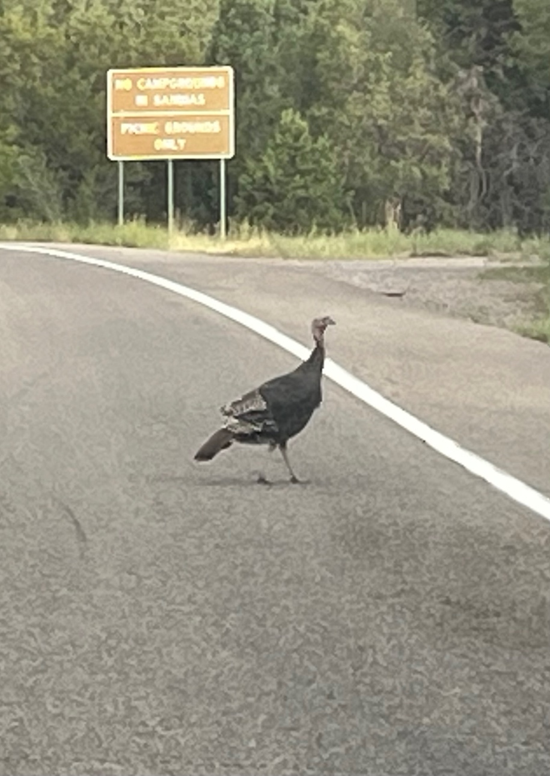 An early morning greeter.

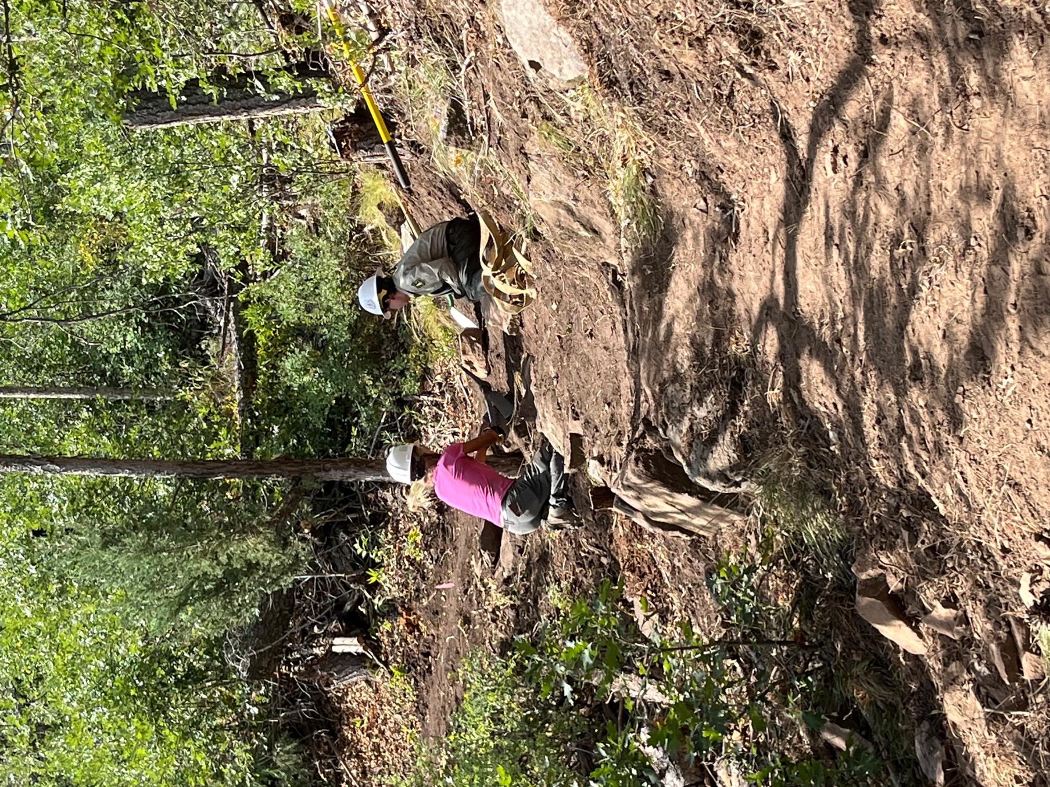

Claudia And Jen work on a rock wall strategy.

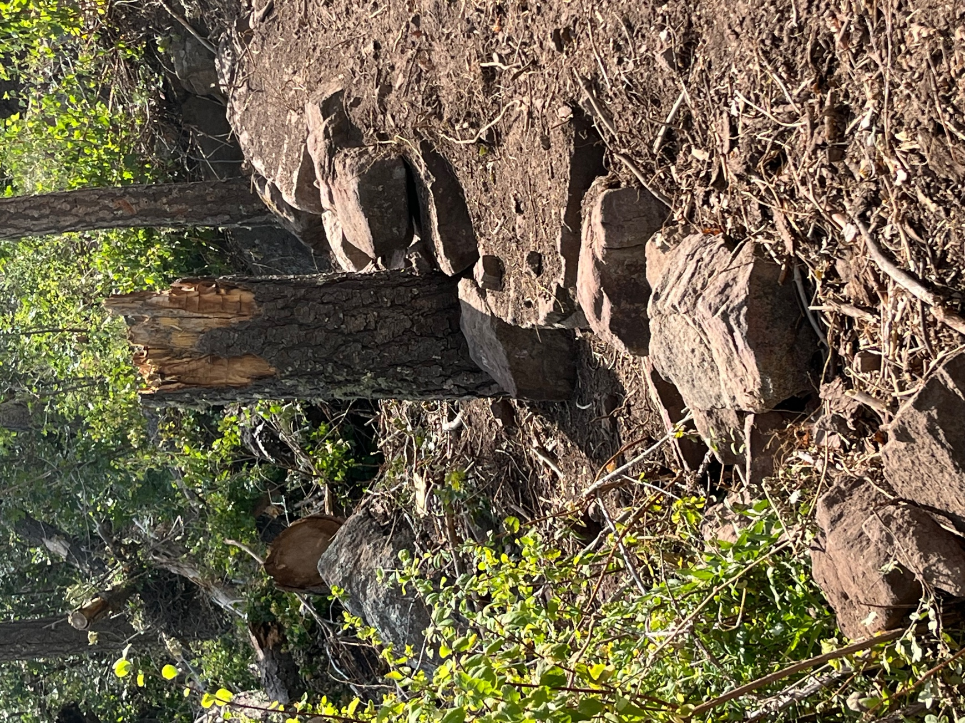

Still amazed at the rock work Bruce and Chris pulled off last week.

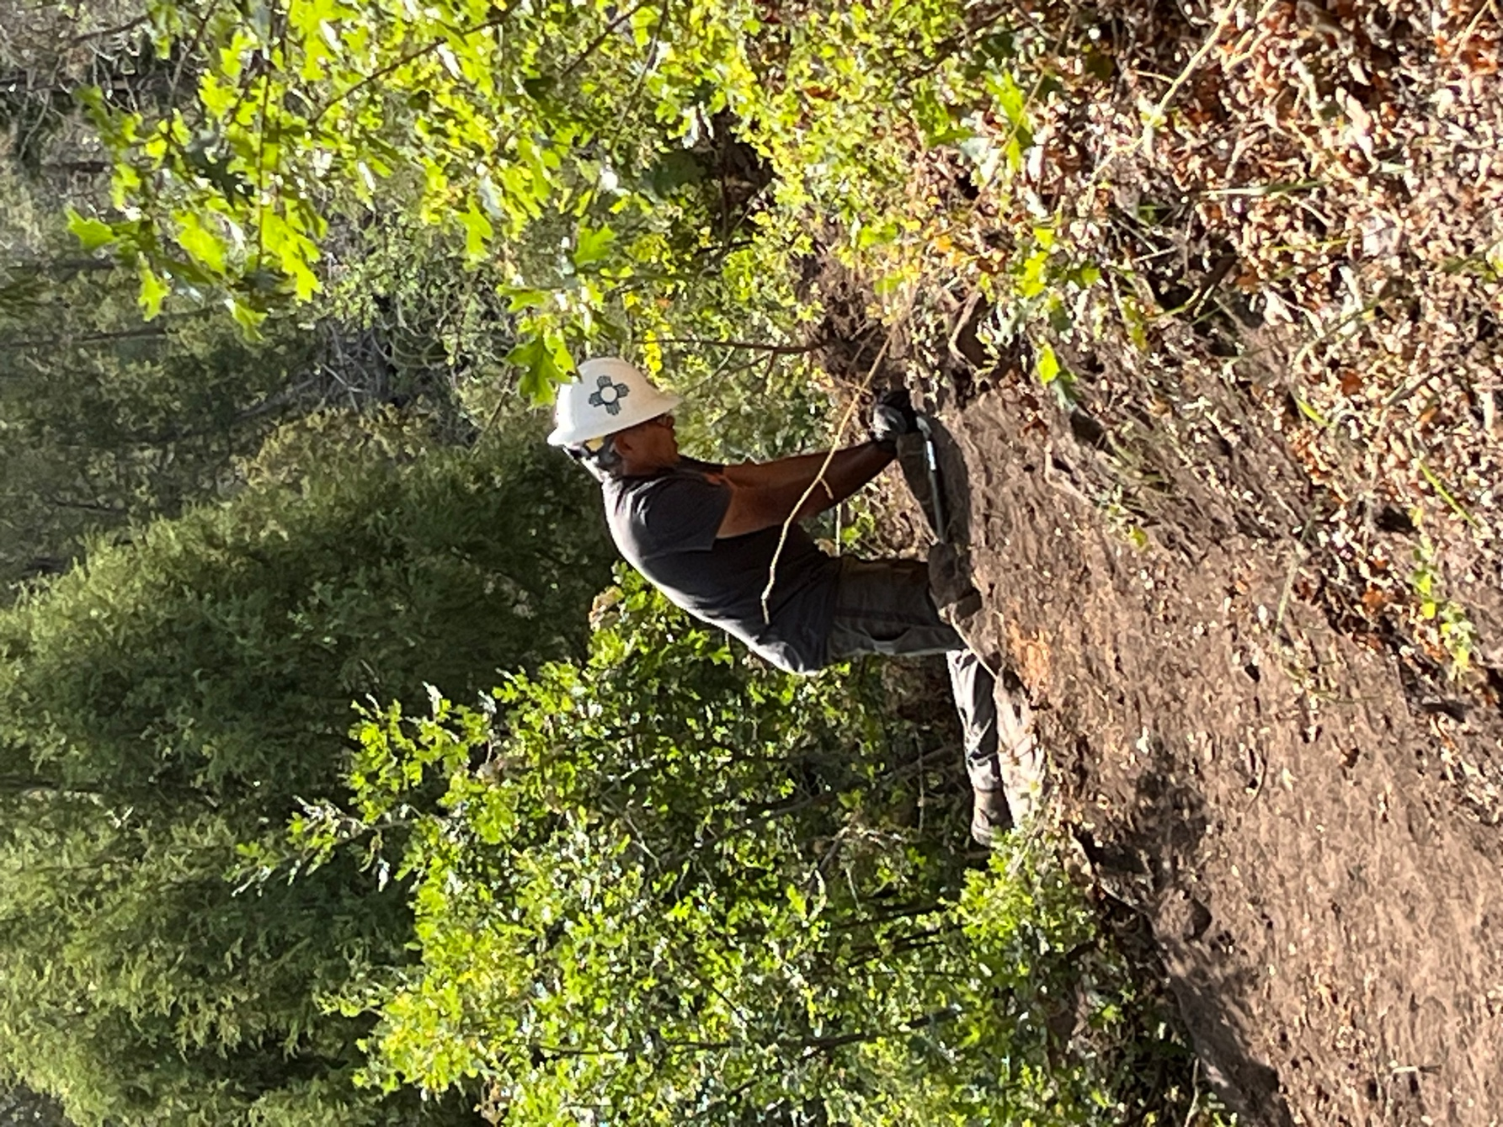

Luis shores up a trail edge.

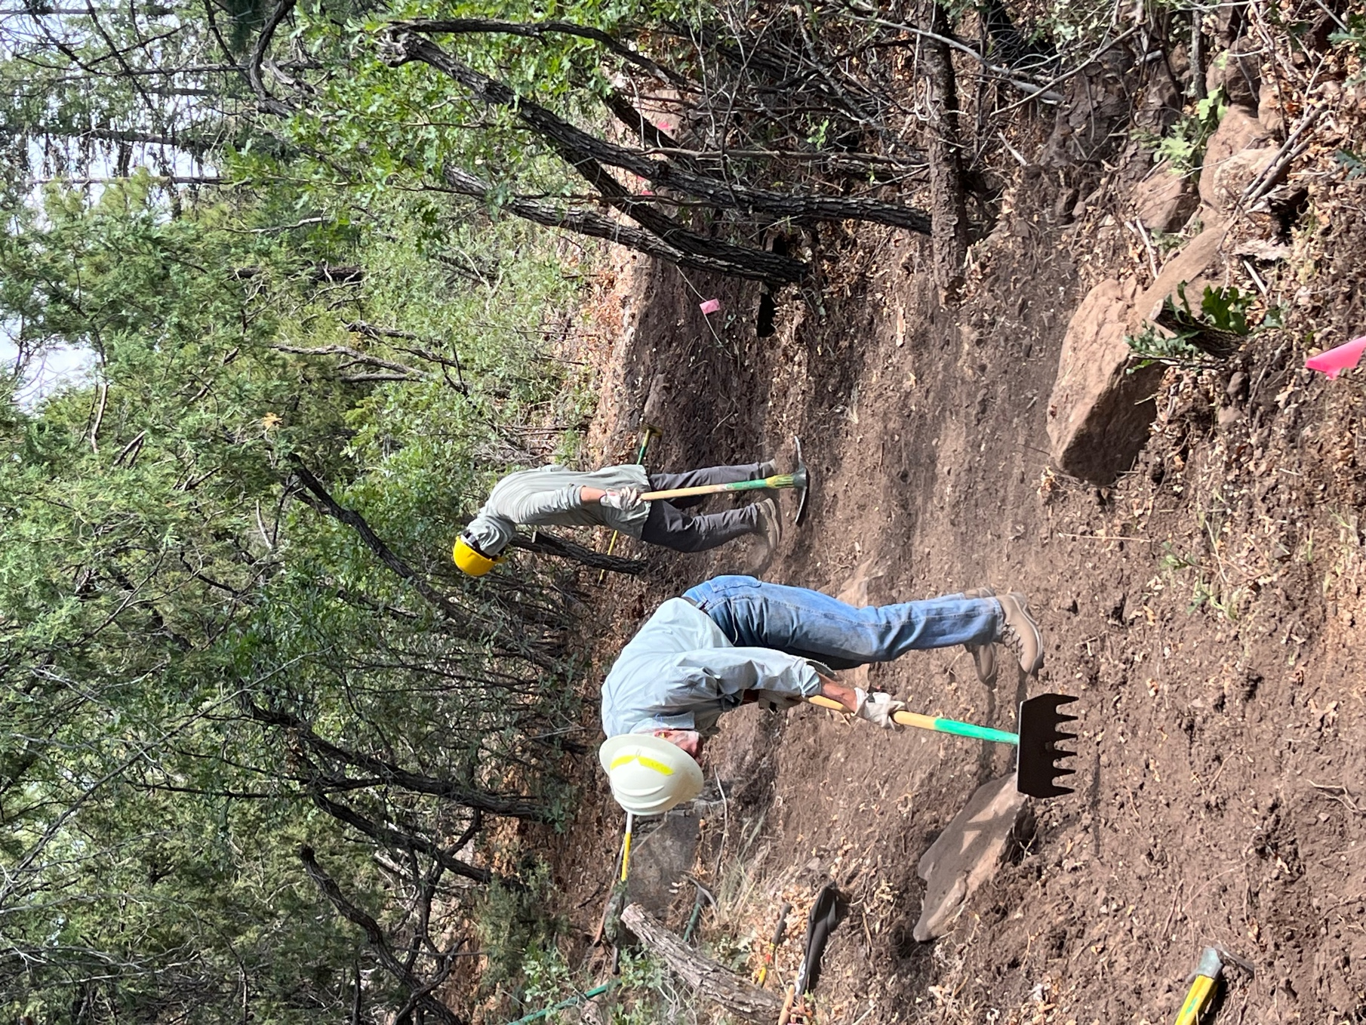

Byron and Eric work on a very dusty stretch.

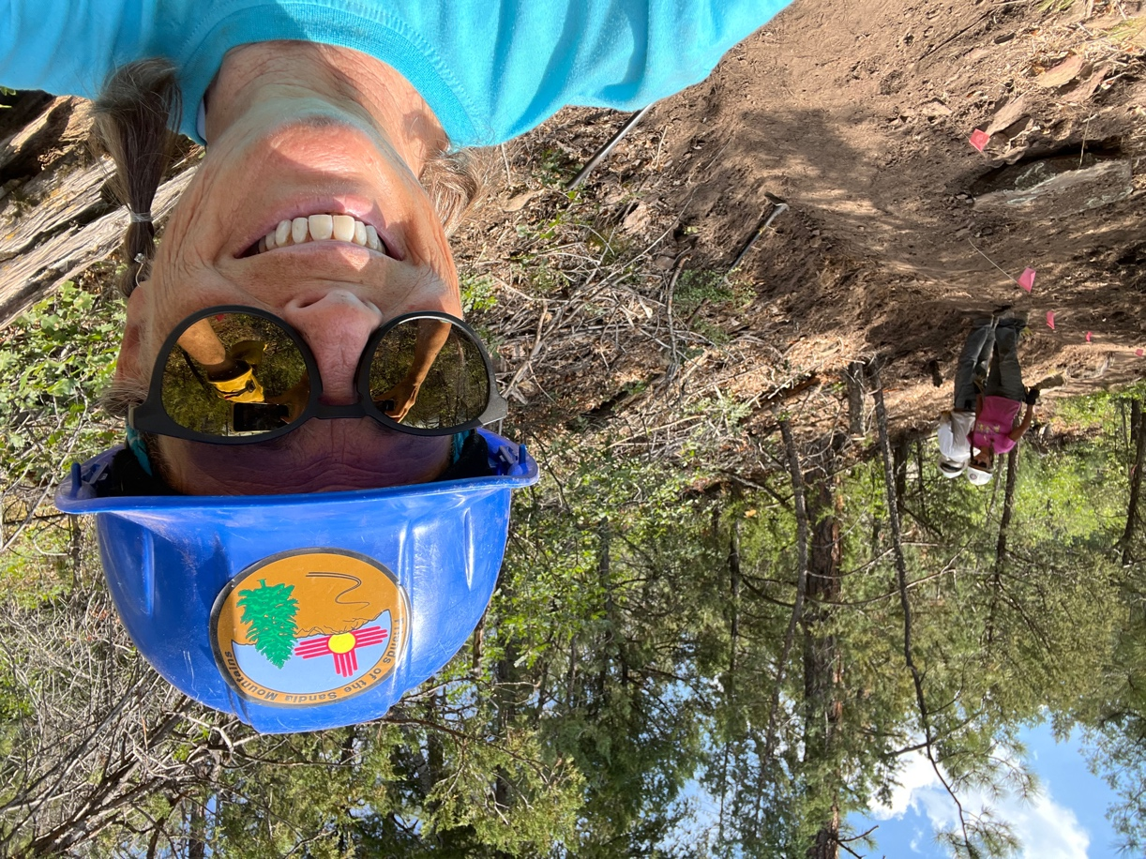

Good looking trail! We had to finally tell Bill it was pretty enough to quit.
A lunch time visitor.
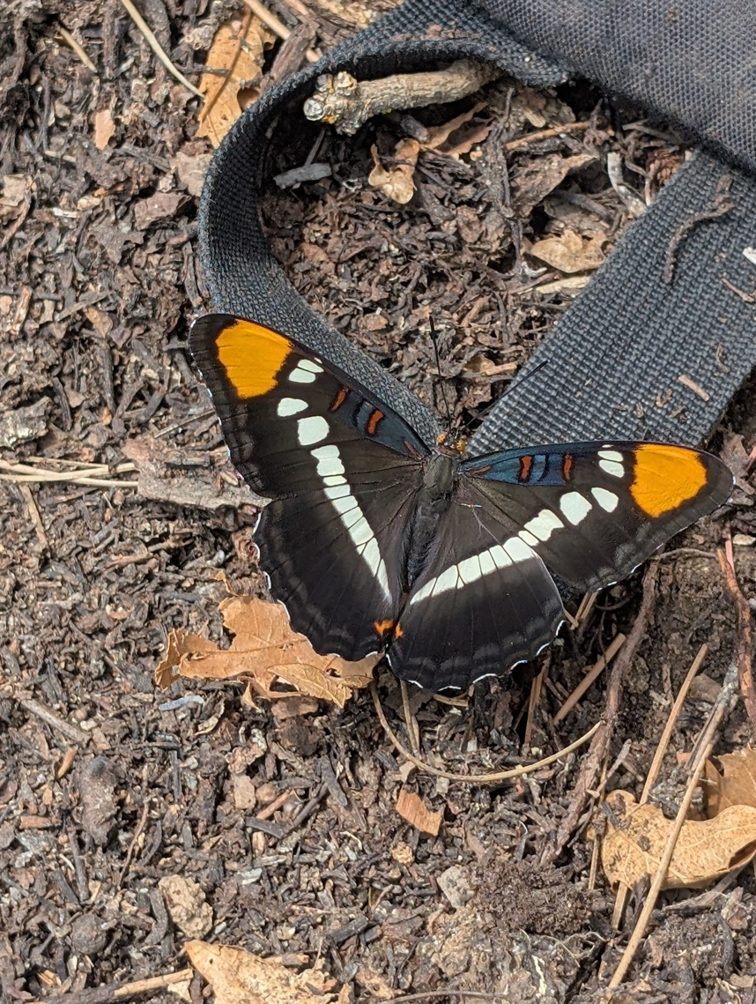
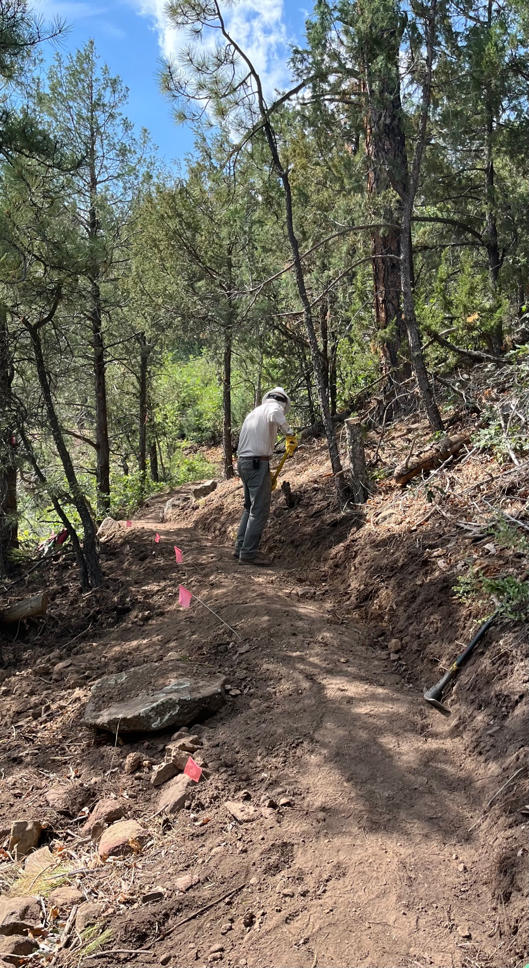

Bill finishes his work of art. He added some obliteration to the down slope to try and hold the dusty soil in place until it rains.

