Thursday, 08/21/25- North Faulty: A cool meet up in the parking lot led to another hot day on North Faulty. Nuthatches (White-breasted and Red-breasted) chattered and the temps warmed as we hiked back up to the reroute #2 site Eight volunteers and Chris and Jen (SRD) continued work on the reroute, removing and shifting endless rock and chopping around roots. Progress made! Some previously worked on areas were widened and some new sections started.

Volunteers: Eric Russell, Mackenzie Gibbs, Bruce Hansche, Jim Houle,
Claudia Bersgohn, Rich Fagioli, Luis Cuadros and Laura Leon

Pictures: Laura Leon

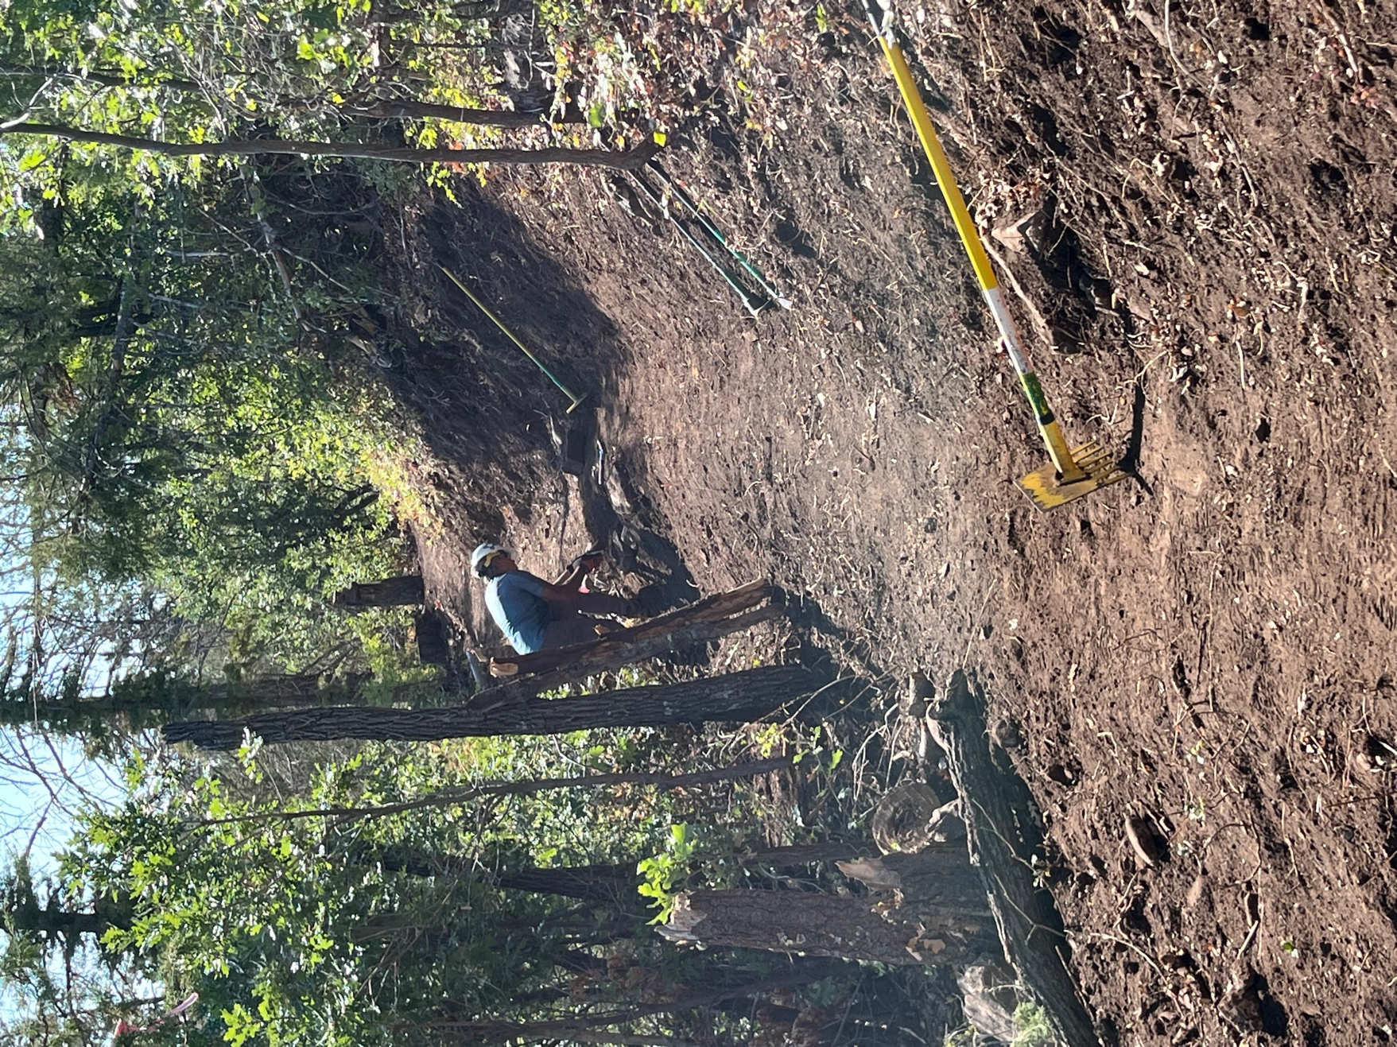

Luis continued work on widening a section. The steep slope and debris below were causing problems.

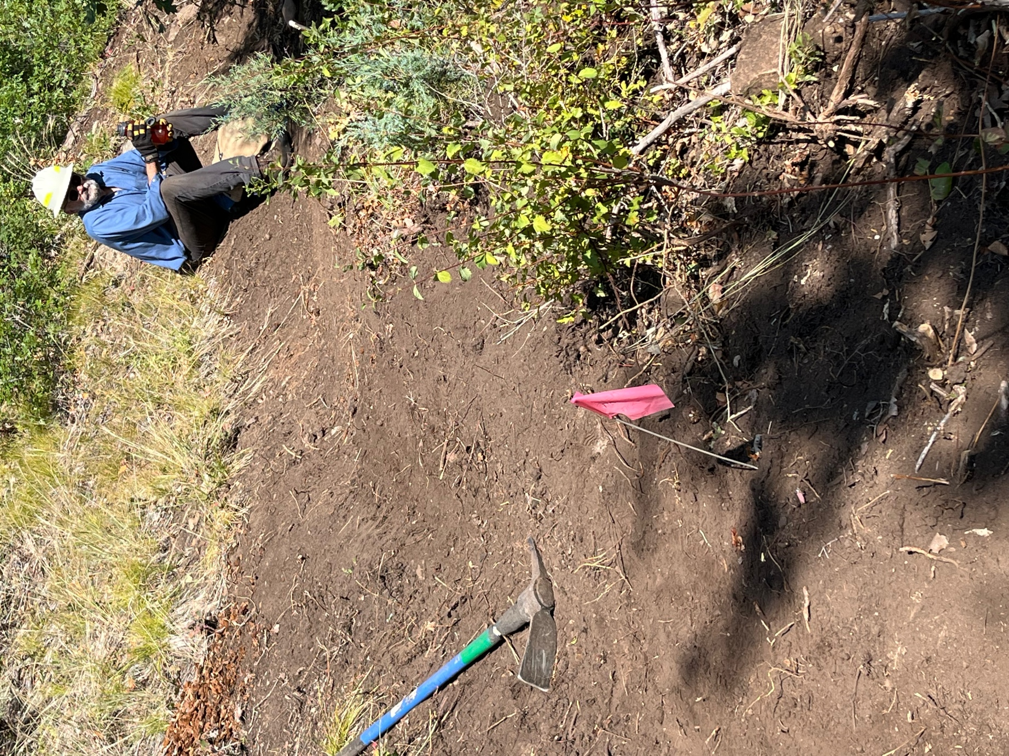

Jim finished reworking a section and took a much-needed water break.

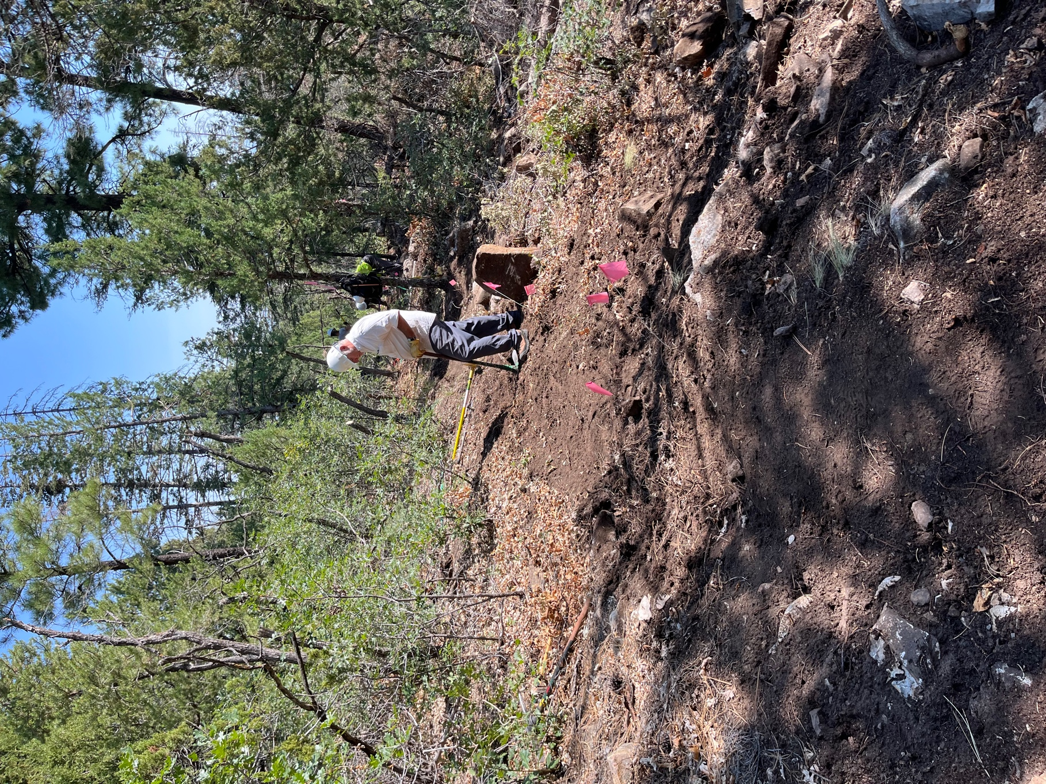

Rich picked a spot with lots of sun.
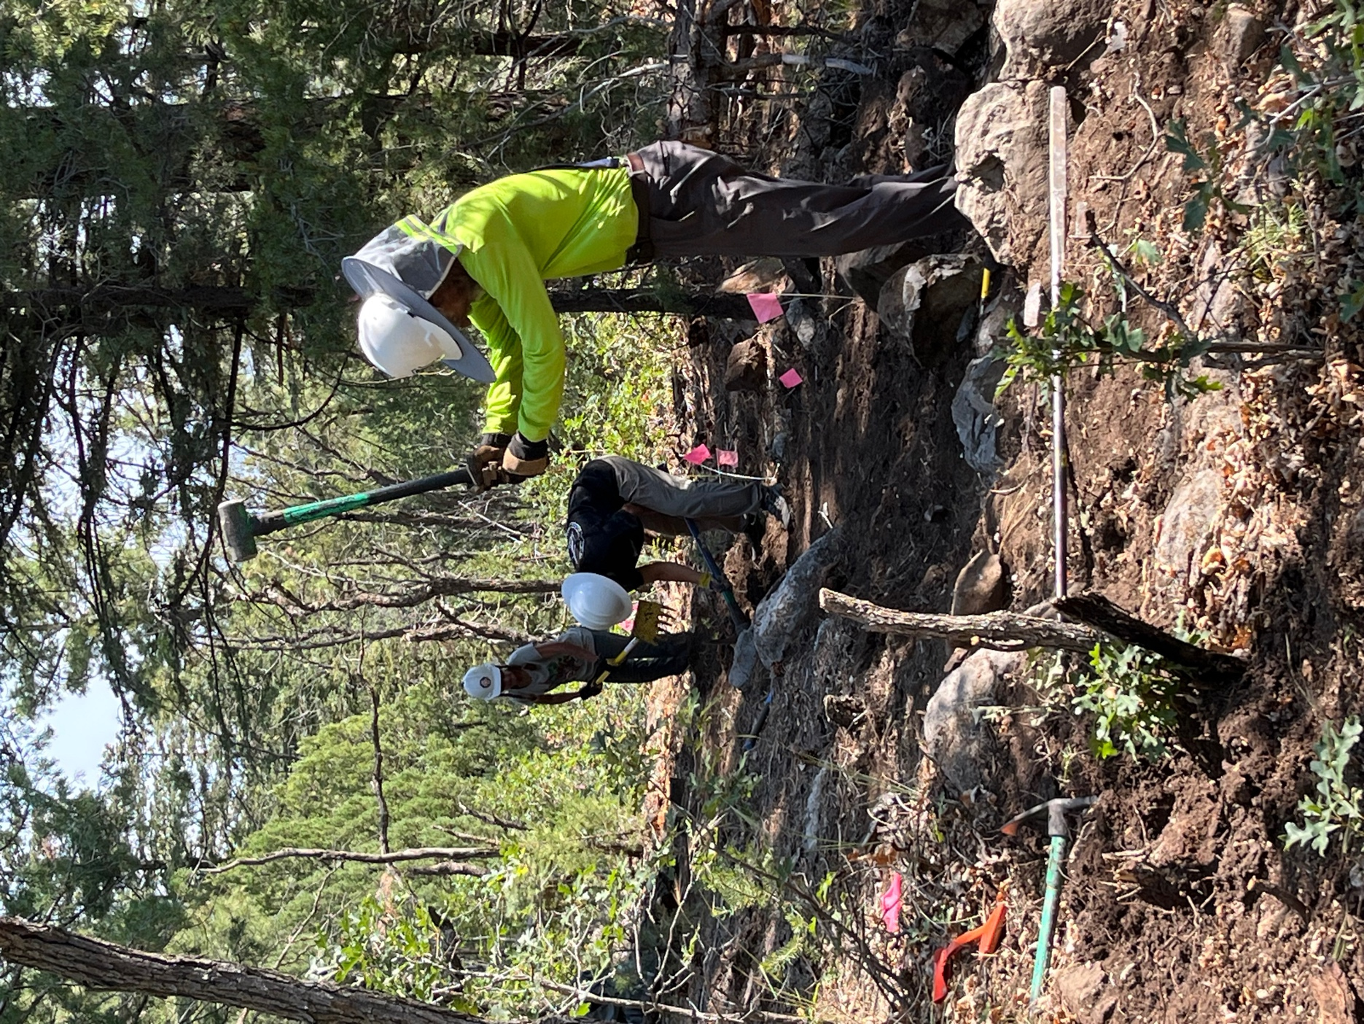

Bruce, Mackenzie ad Claudia found a patch of shade and lots of rocks.
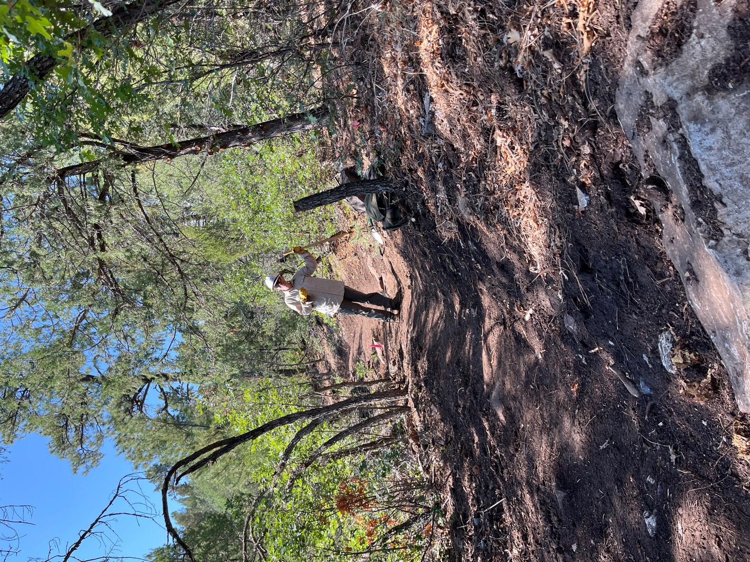

Chris being his happy self.
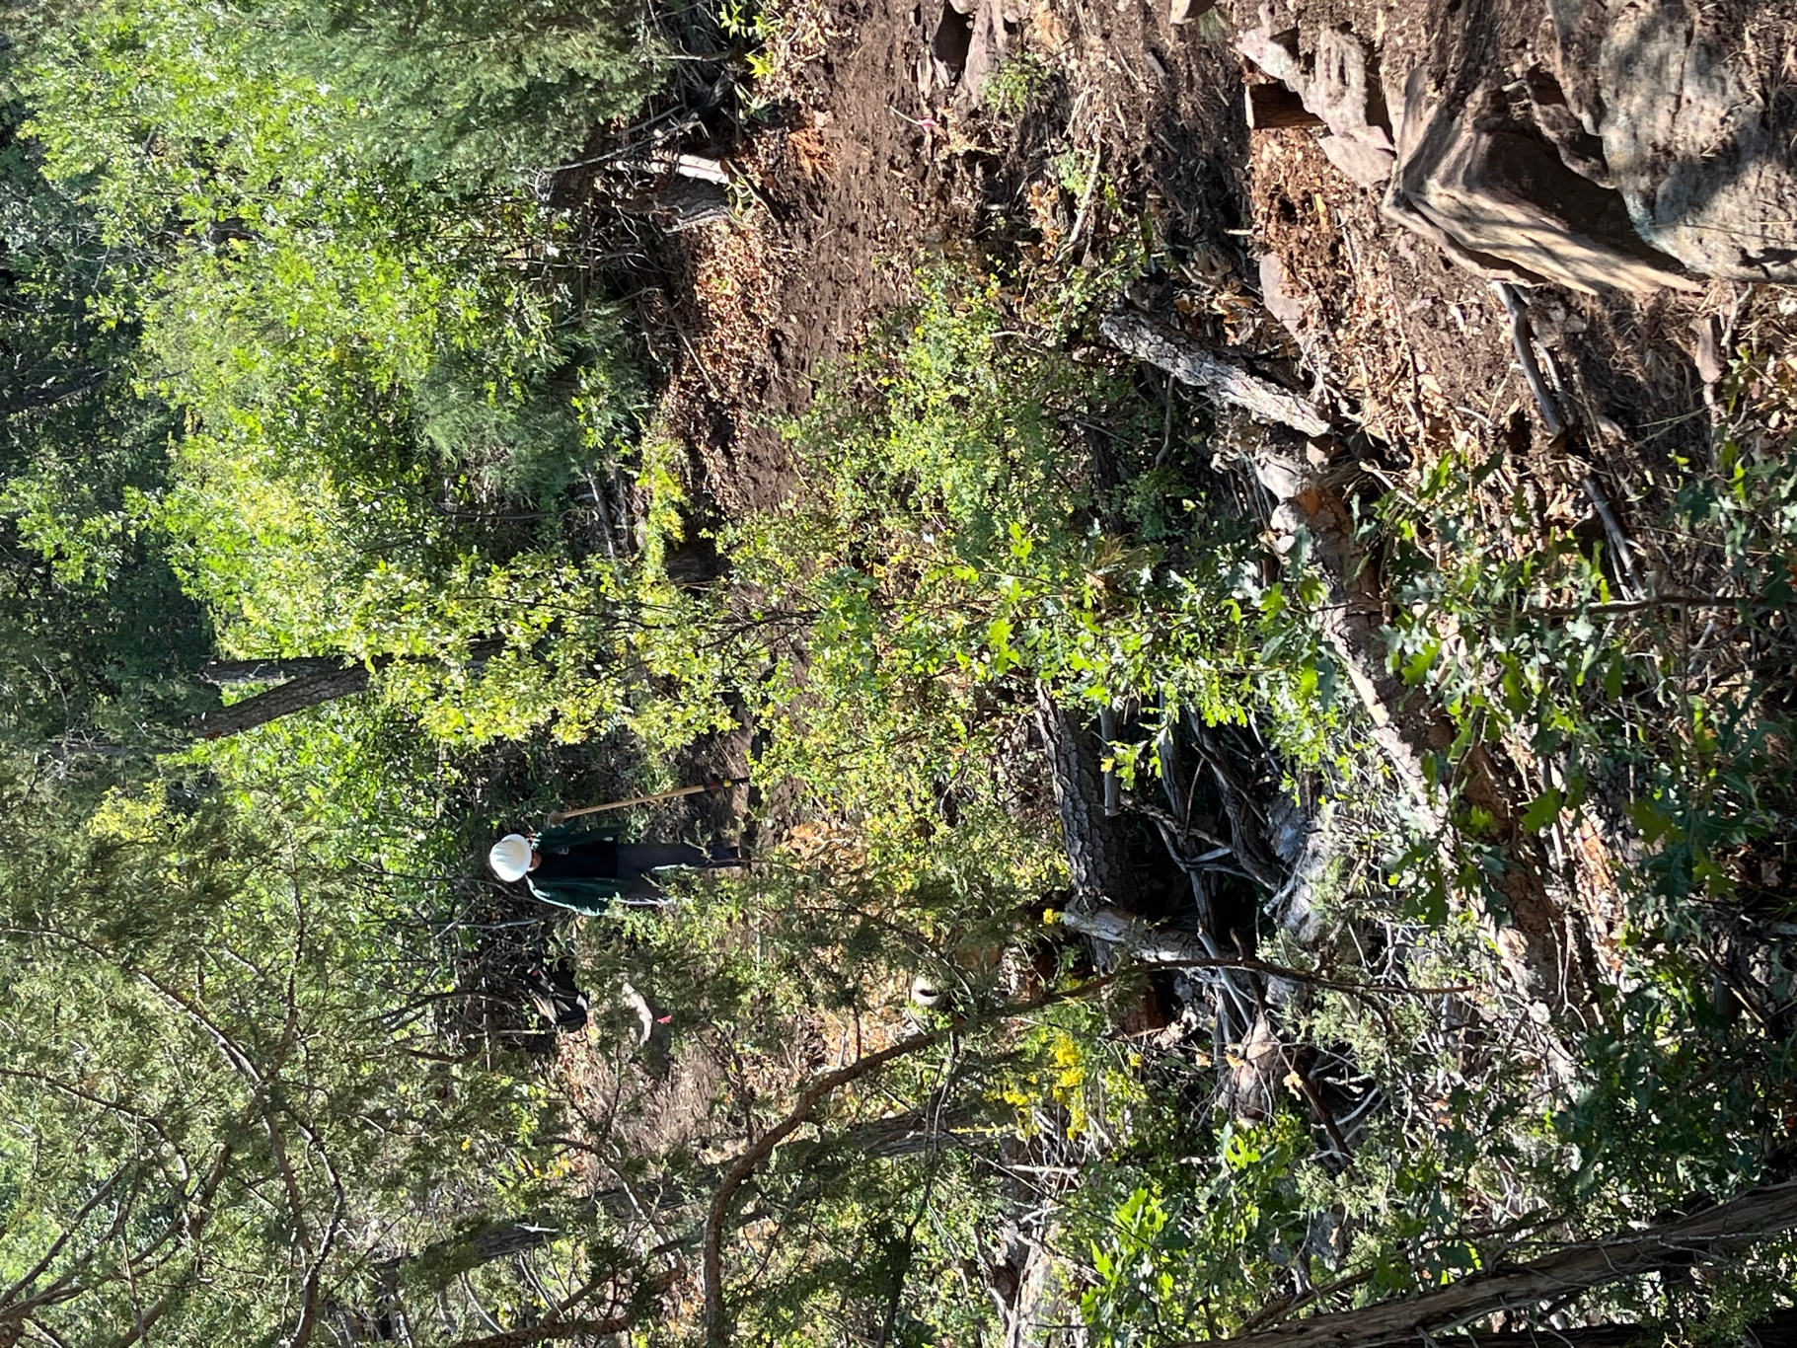

Jen removed a few more rocks at the “big curve”.

