Felling Hazard Trees near the Kiwanis Meadow Road Gate
at the Crest on Wednesday, August 20, 2025

Sam Beard
On Wednesday, August 20, seven FOSM volunteers felled hazard trees near the picnic table at the Kiwanis Meadow Road gate at the Crest. A total of eight dead trees with diameters ranging from 10 inches to 12 inches were felled, limbed, and bucked to lengths of approximately 8 feet. After lunch, the crew moved past the gate to the intersection of Kiwanis Meadow Gate and Switchback Trail where they bucked several logs on the ground to lengths of about 6 feet. Later, all the trees processed on Wednesday will be bucked to 12 inches, split, and hauled to the Mountain Christian Church woodlot. The church Wood Ministry will donate the wood to East Mountain families who heat their homes with wood.
The volunteers working on Wednesday were Chuck Logan, Sam Beard, Dennis Crowther, Cliff Giles, Sim Cook, Jerry Carroll, and Lorna Morrow.
Project photographs are presented below.

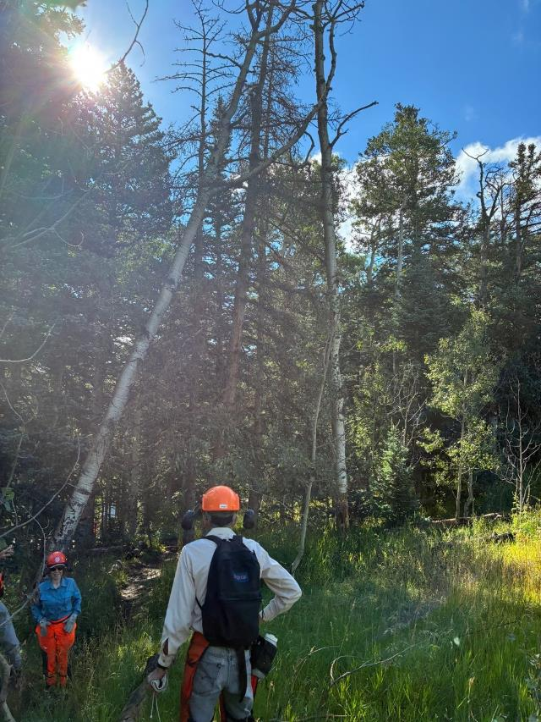
Three trees tangled together at their tops uphill from picnic table at Kiwanis Meadow Road Gate.
L to R: Lorna Morrow and Sim Cook. All photos by Cliff Giles unless noted otherwise.
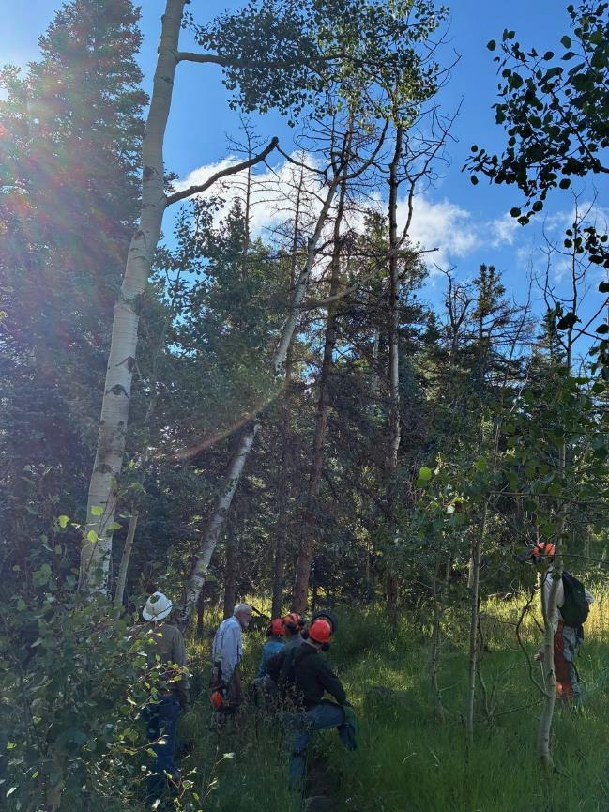
Crew discusses how to remove the “teepee” of trees.
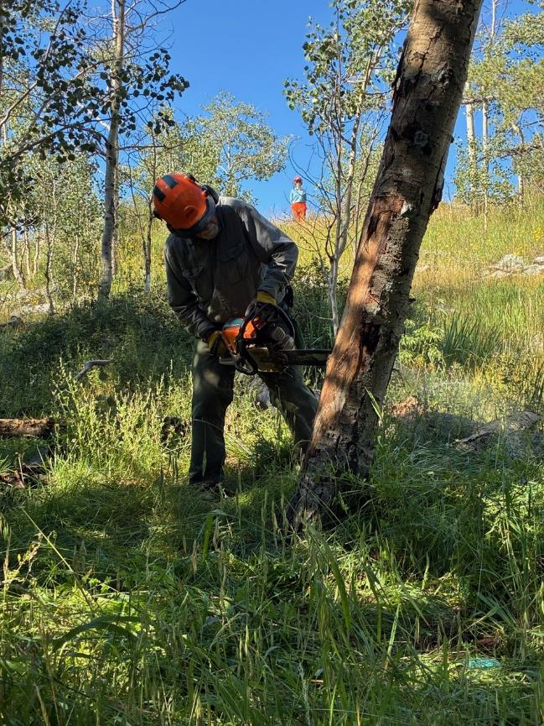
Jerry Carroll making the face cut on the left tree (looking up from below the three trees).
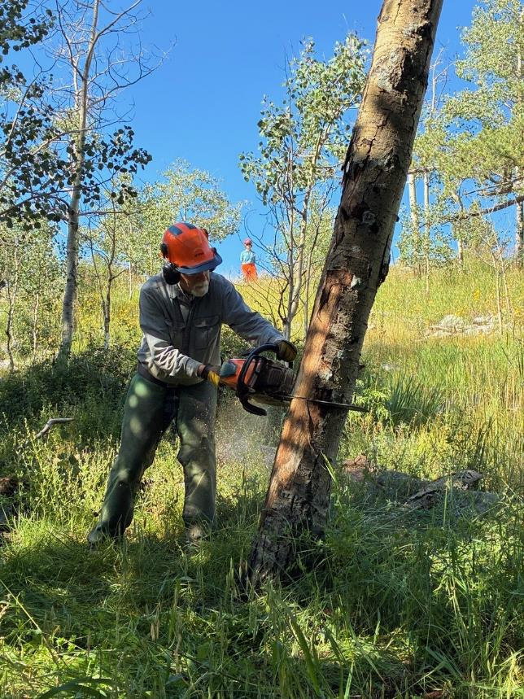
Jerry making the back cut in the first tree.
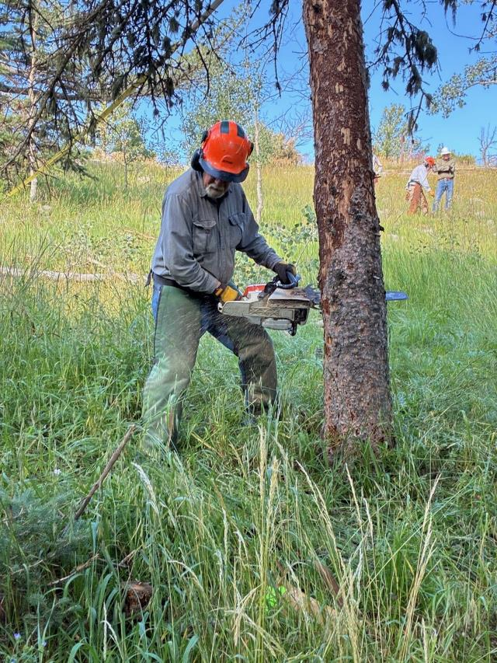
Jerry making the face cut in the middle tree.

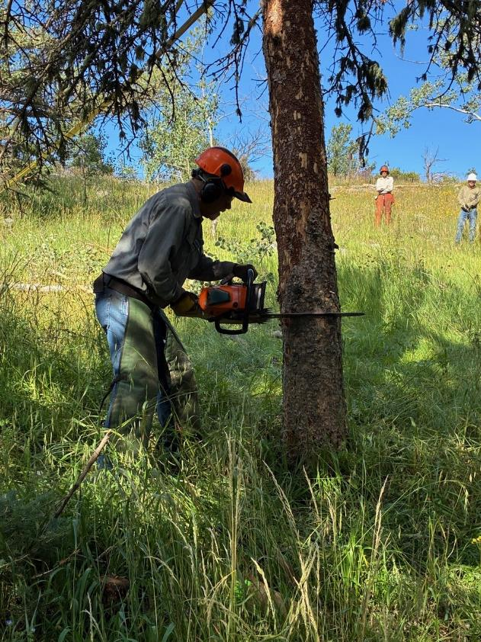
Jerry making the back cut in the middle tree. After Jerry made the back cut in this tree,
the three trees fell together.
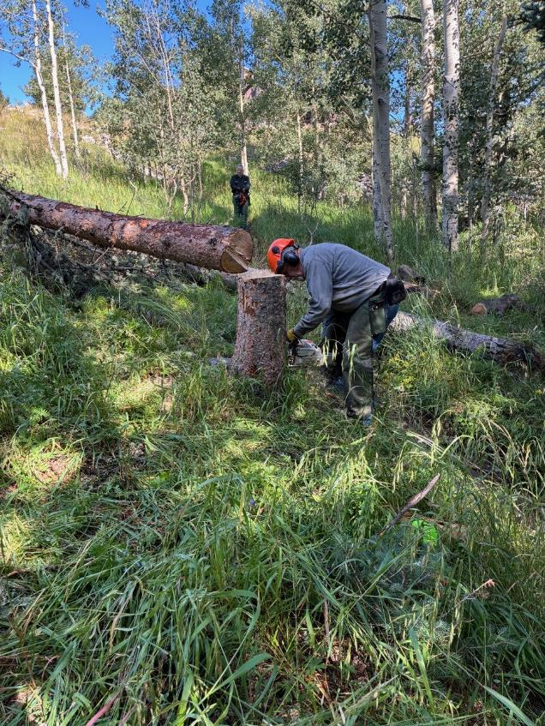
Jerry low cutting the stump of the middle tree.

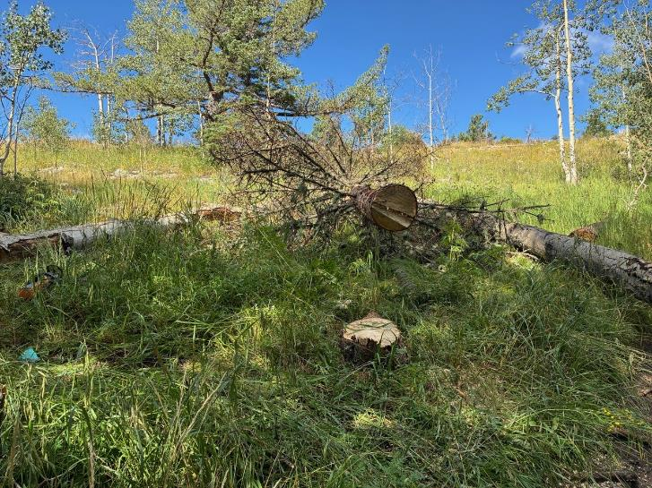
The three trees on the ground. The tree on the right broke at ground-level and was not cut.

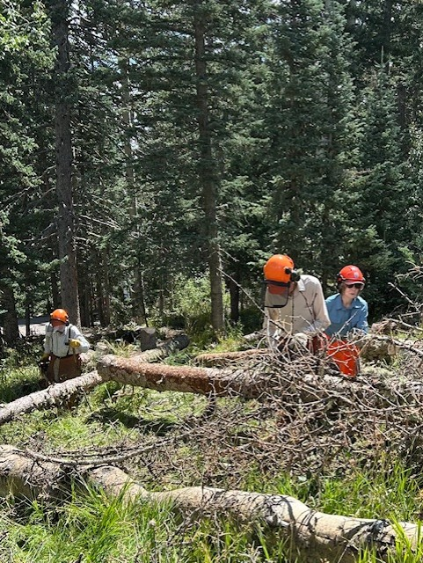
Limbing felled trees. L to R: Sam Beard, Sim Cook, and Lorna Morrow.
Photo by Jerry Carroll
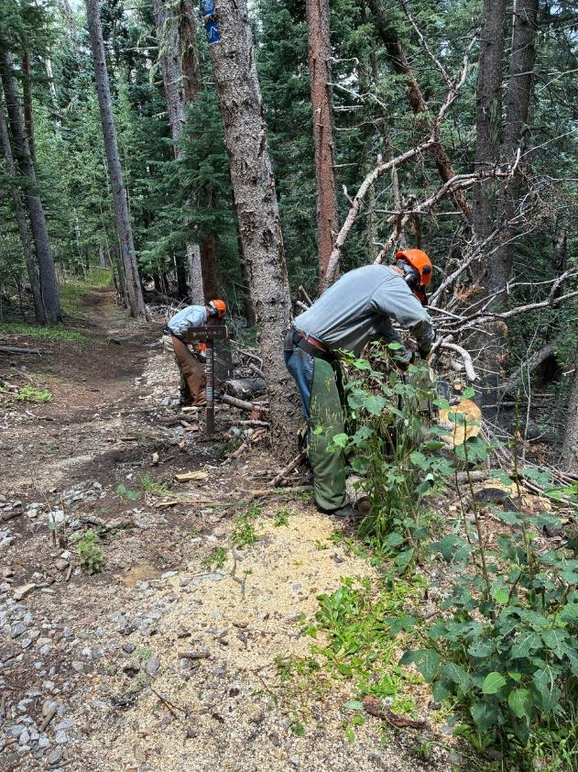
After lunch, the crew moved down to the intersection of the Kiwanis Meadow Road and
Switchback Trail and began clearing debris off of logs on the ground.
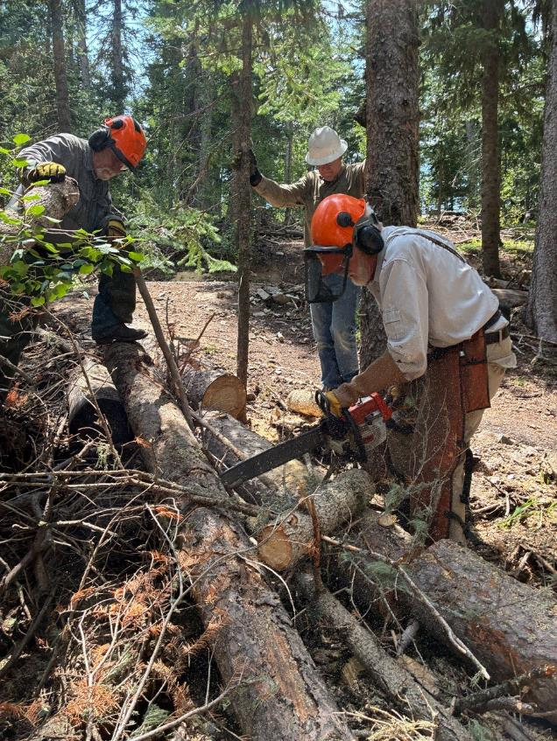
Sam Beard bucking a log with Jerry Carroll and Cliff Giles observing. Later these logs will be bucked
to shorter lengths, moved up to the road, split, and loaded on Mike Oliver’s trailer.

