Report of Painting Four Large Beams and Other Parts of Two Picnic Shelters
in Doc Long Picnic Area on Tuesday, August 26, 2025

Sam Beard
On Tuesday, August 26, Pauline Ho, Rick Buss, and Sam Beard painted parts of four large overhead beams in the modern picnic shelters in Doc Long Picnic Area. Other shelter parts such as low beams and large columns were also touched up with USFS brown paint.
Photographs are presented below.

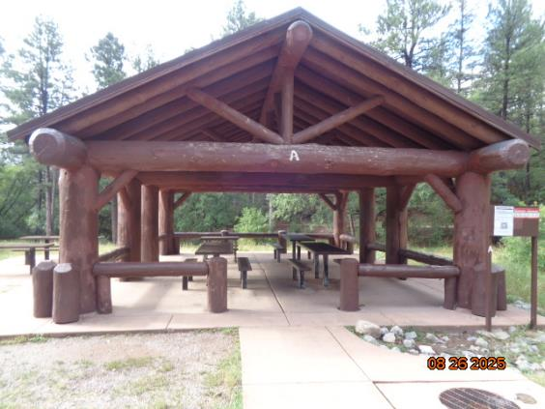
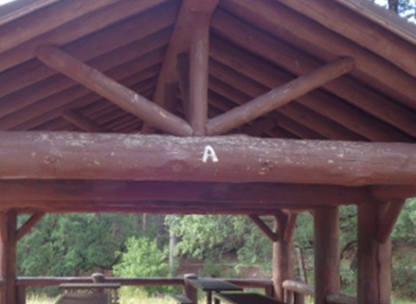
Top – Gable end of Shelter A near the road in Doc Long Picnic Area.
Bottom – Enlarged center part of the large horizontal beam showing the gray areas where
paint has been removed by weathering.
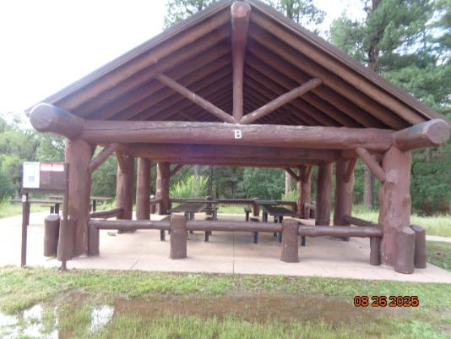
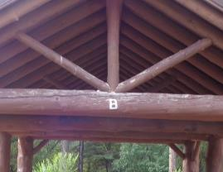
Top – Gable end of Shelter B in Doc Long Picnic Area.
Bottom – Enlarged center part of the large horizontal beam showing the gray areas where
paint has been removed by weathering.

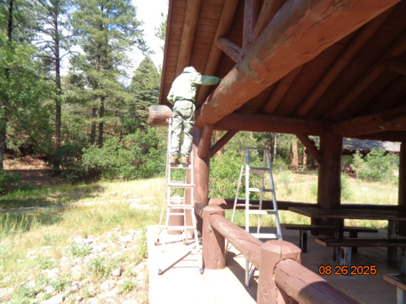
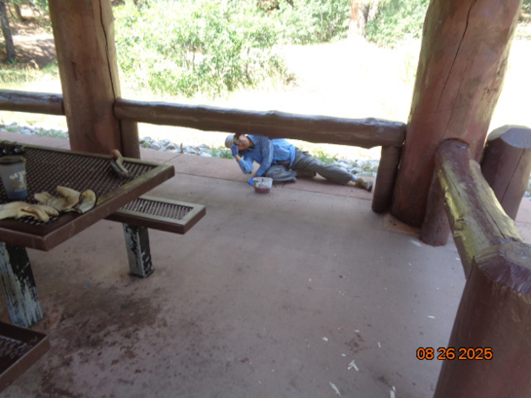
Top – Rick Buss is painting the top of the large beam on one gable end of Shelter A.
Bottom – Pauline Ho is painting a low beam on Shelter B.

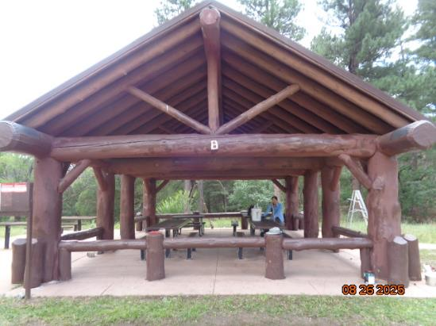
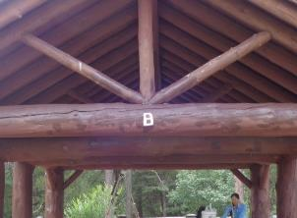
Top – Gable end of Shelter B showing where paint has been applied to the bare areas of the horizontal beam. Bottom – Enlarged center part of the large horizontal beam where the weathered parts were painted. The lower parts of the smaller beams were also painted.
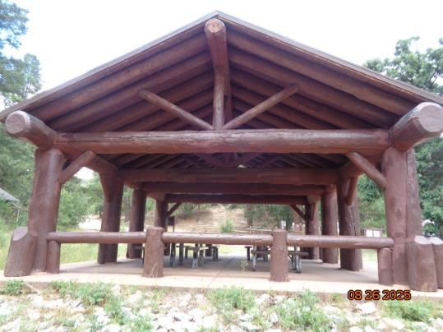
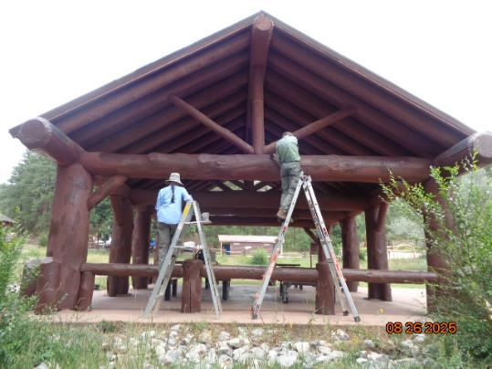
Top - Upper parts of the gable end of Shelter A have been painted. Bottom – Pauline and Rick are painting the beams in the gable end of Shelter B. The shelters have been painted with at least three different shades of brown paint since they were constructed about 30 years ago.

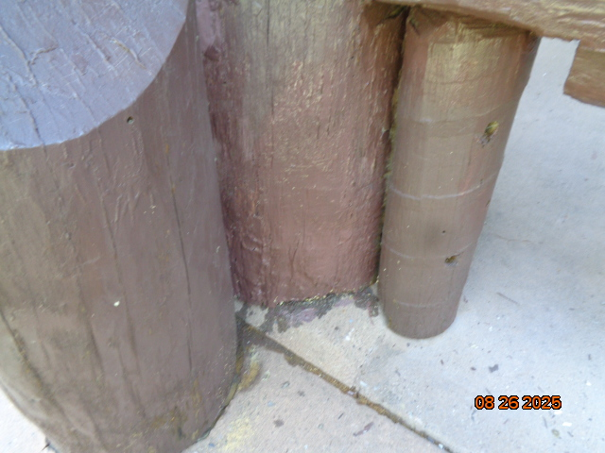
The lower 8 inches of the center post at one corner of Shelter A had decayed and epoxy paste was
put in the decayed area. The epoxy-filled area was painted with USFS brown paint on Tuesday.

