Thursday, 08/28/25- North Faulty: We were back to North Faulty to continue work on reroute #2 this week. The weather was a refreshing change from the blazing sun and heat we have been dealing with. The soil was even moist and stayed that way all through the work day. Nine volunteer and Jen (SRD) split into 2 groups to work on both ends of this reroute. The far end was able to pull off some magic and complete the work there. The other group was smaller and got lost in the oak but was able to make some progress. With a chain saw coming out next week to take care of some of the big logs we should complete our work on North Faulty- not making any promises!

Volunteers: Mackenzie Gibbs, Bruce Hansche, Claudia Bergsohn, Luis Cuadros,
Mike Madden, Laura Leon, Rich Fagioli, Jim Houle, and John McNett

Pictures: Laura Leon and Luis Cuadros

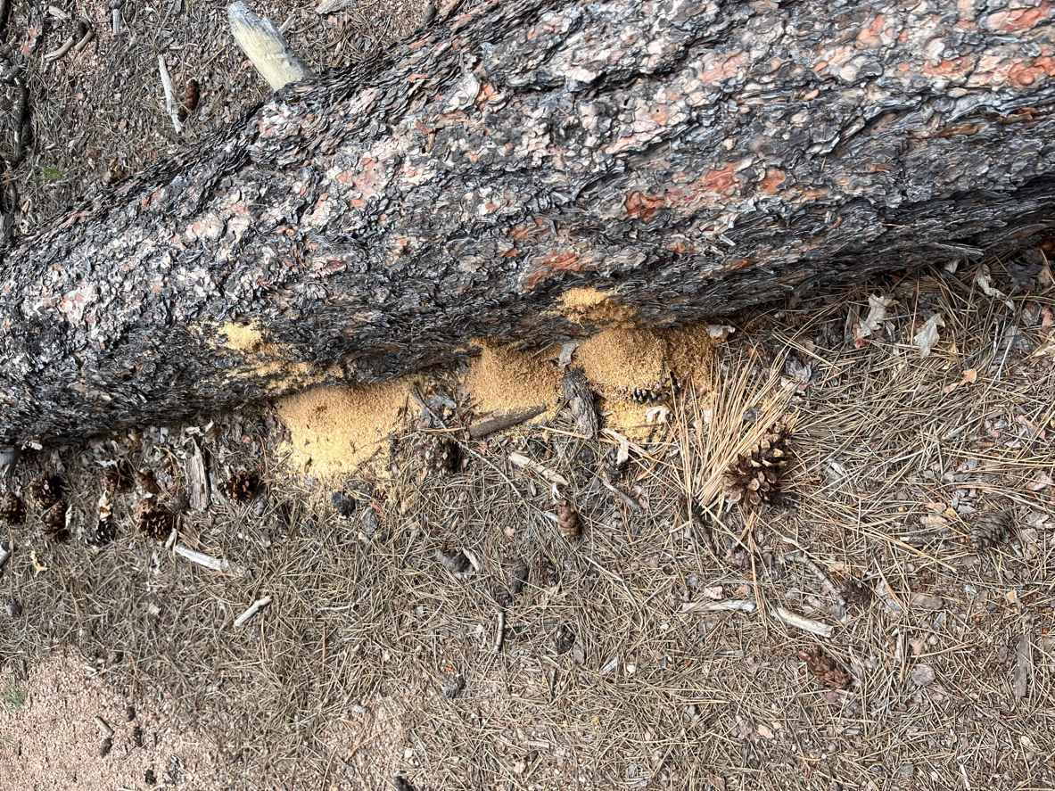 Ants as busy as we were!
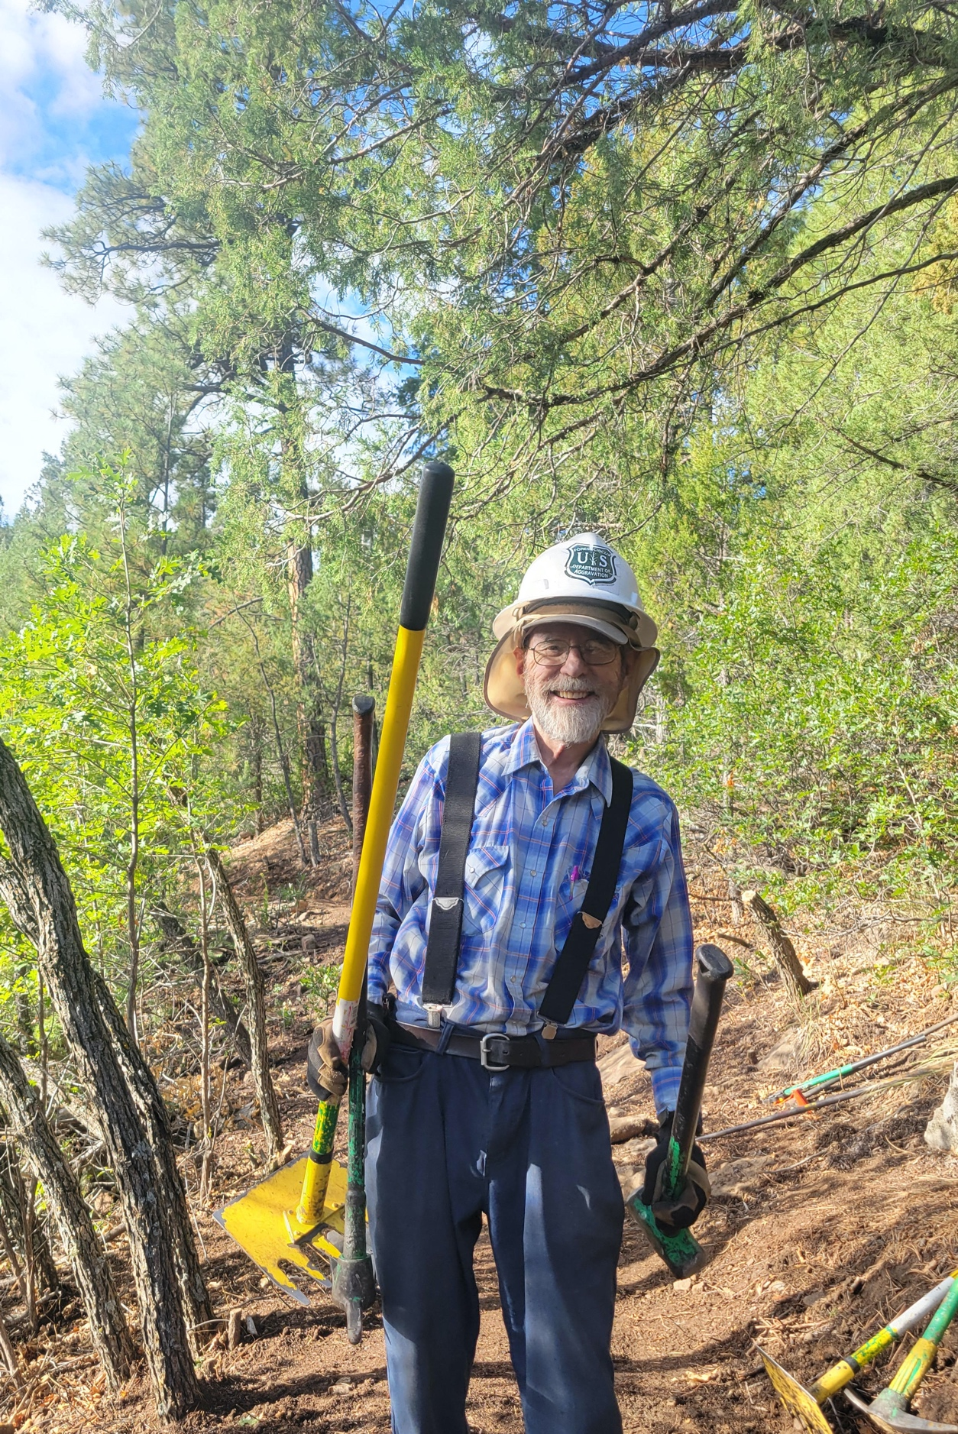

Bruce prepares for battle with rocks.
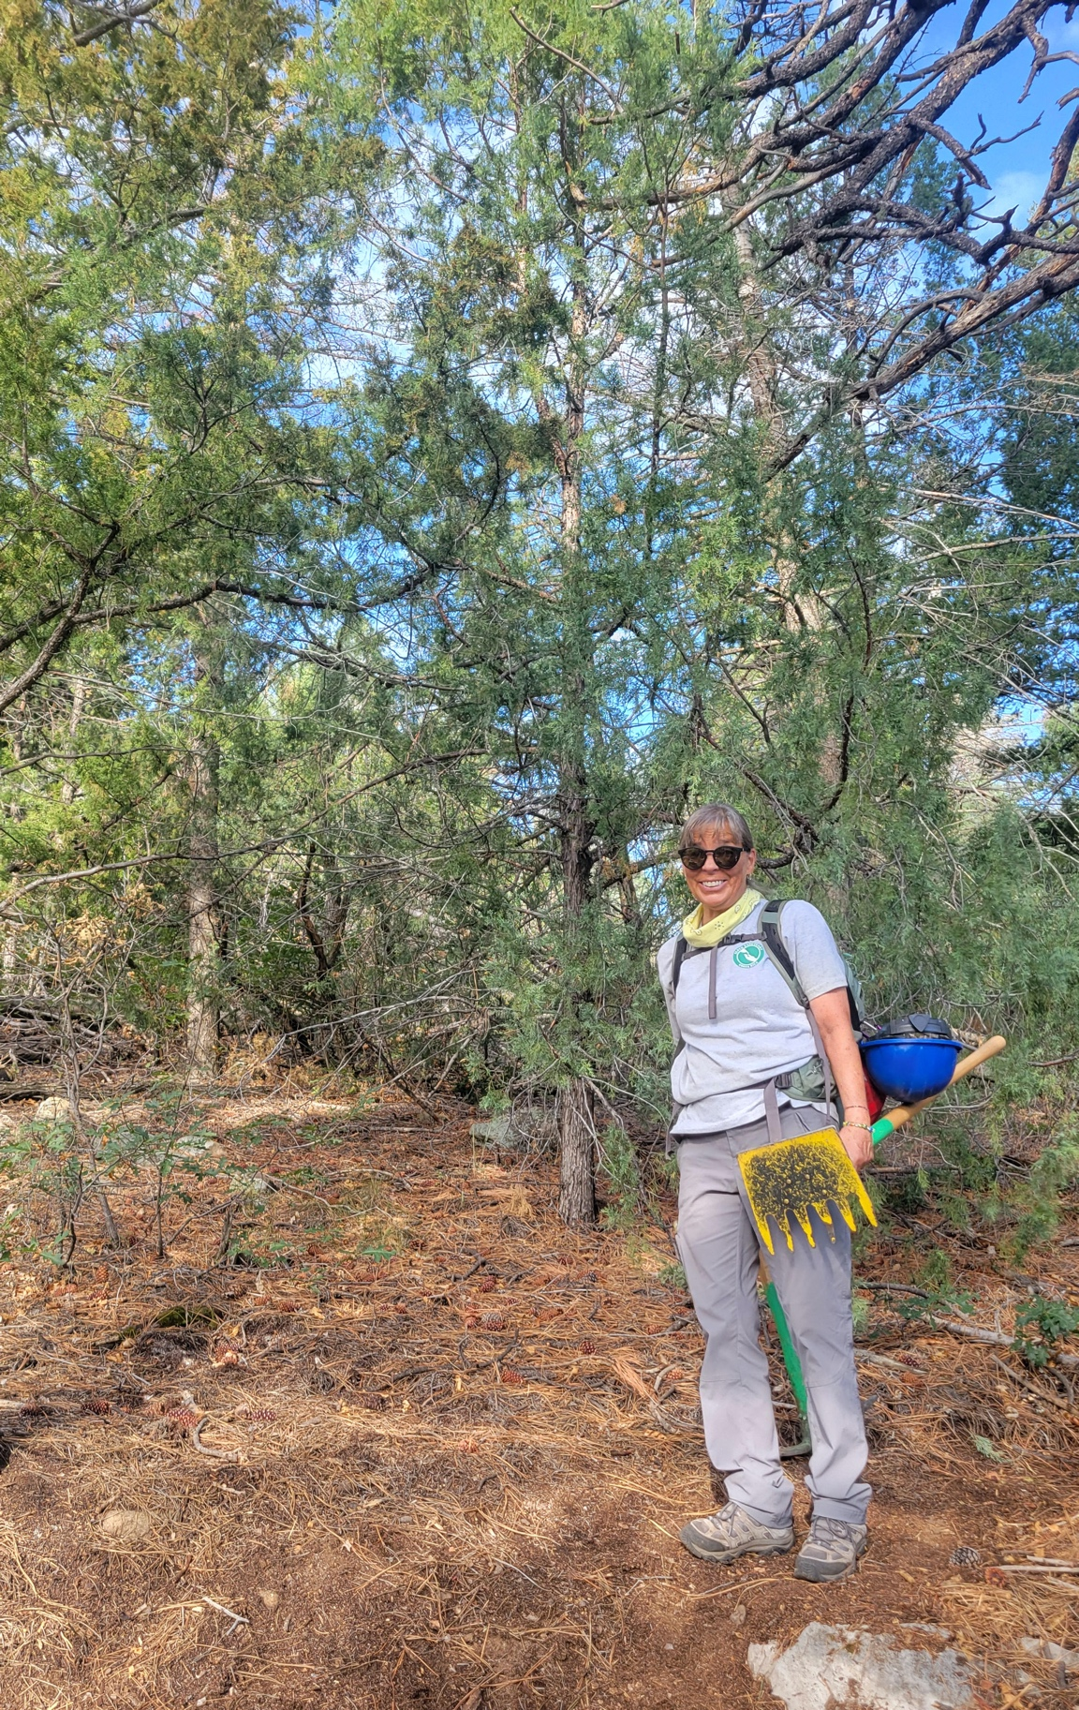

Laura leaves our favorite tool stash/lunch spot to start work on the end closest to the parking area.

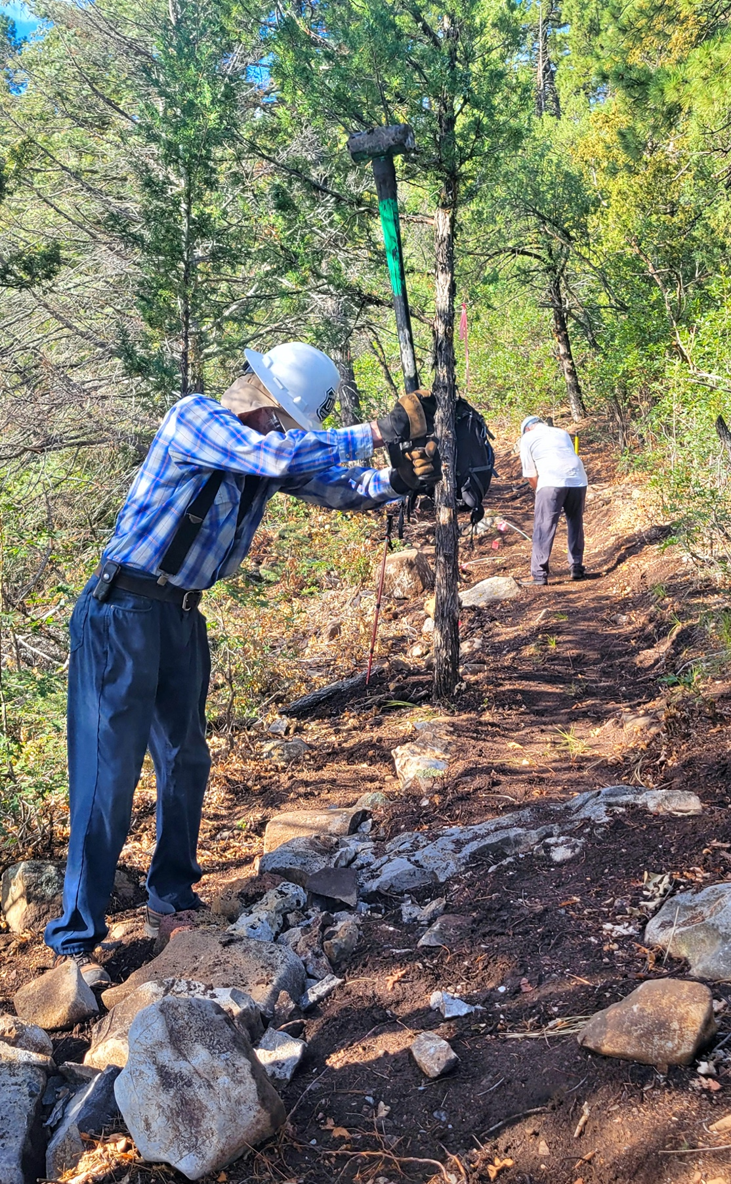

Bruce works his rock magic while Rich does detail work on the trail.

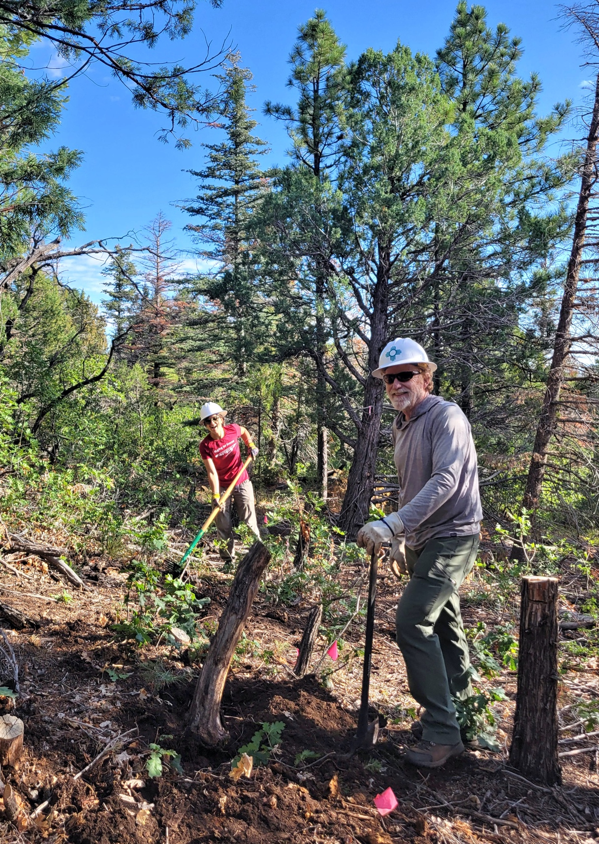

John with one of his beloved stumps. Mackenzie is laughing with you, not at you.

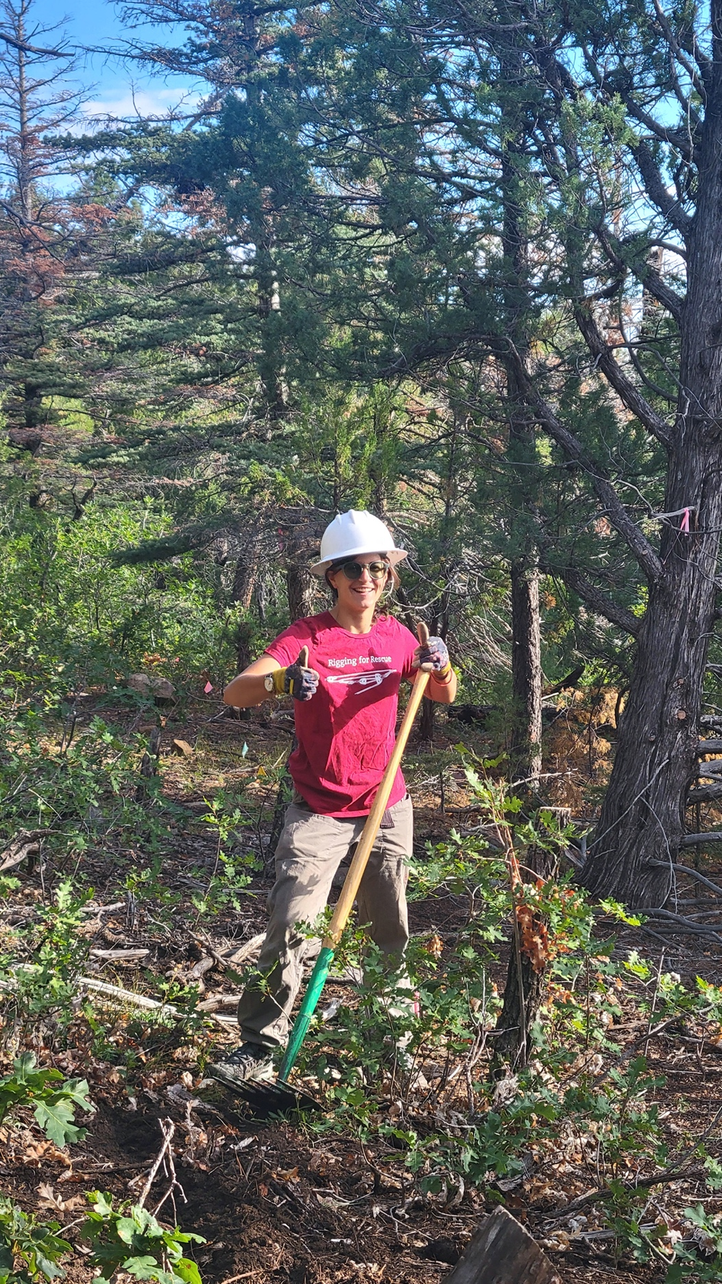

Mackenzie is all in.
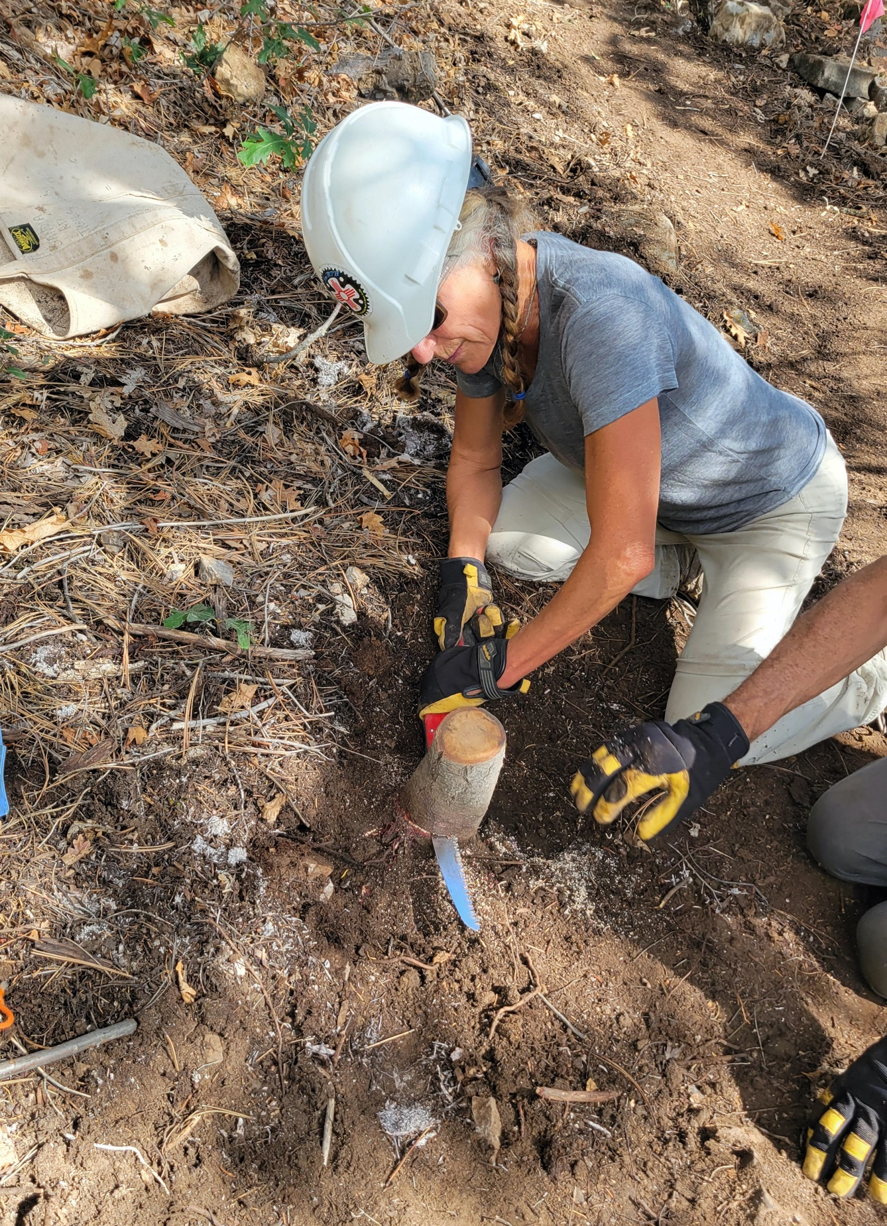

Claudia goes for a low, low stump.
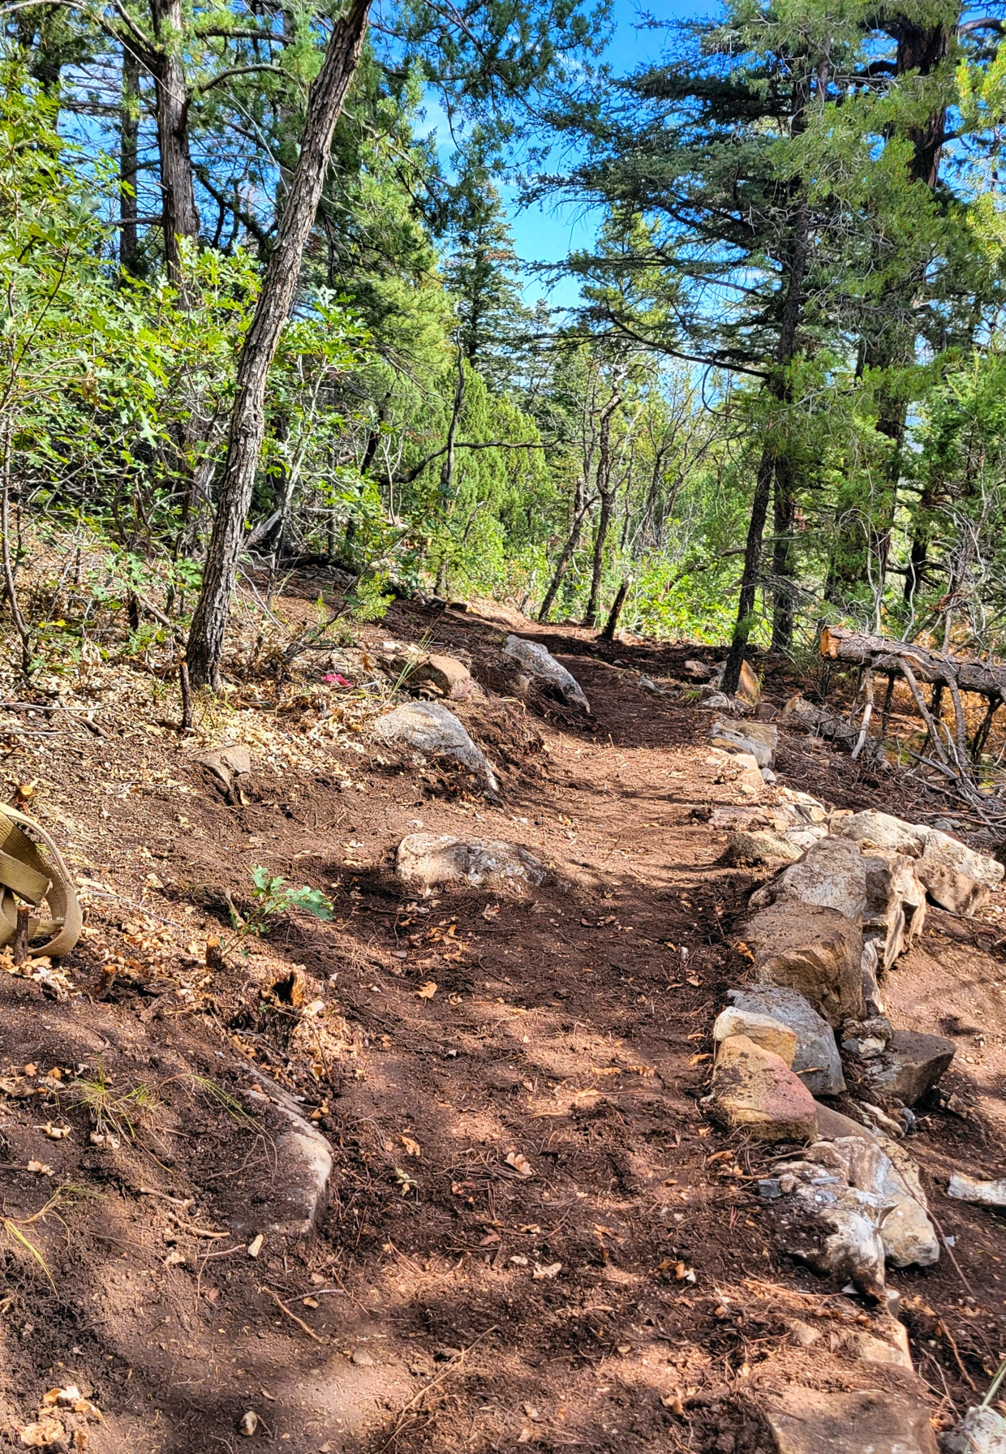

A beauty of a trail at the far end.

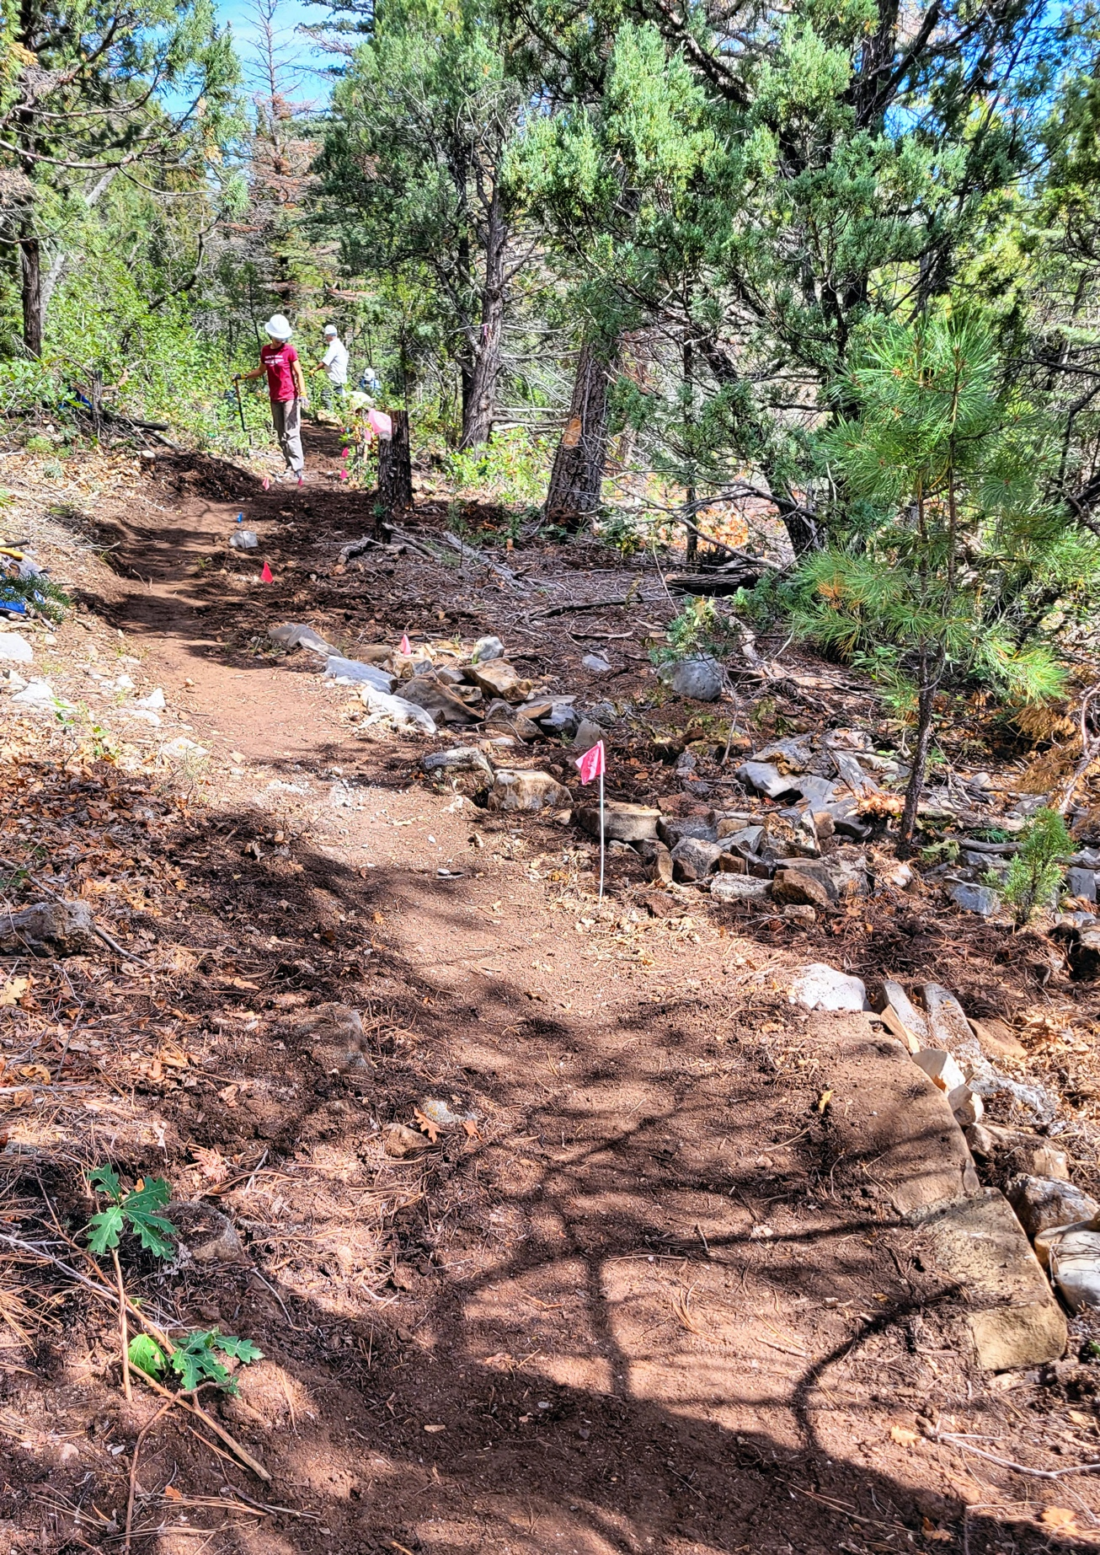

Adding the finishing touches.
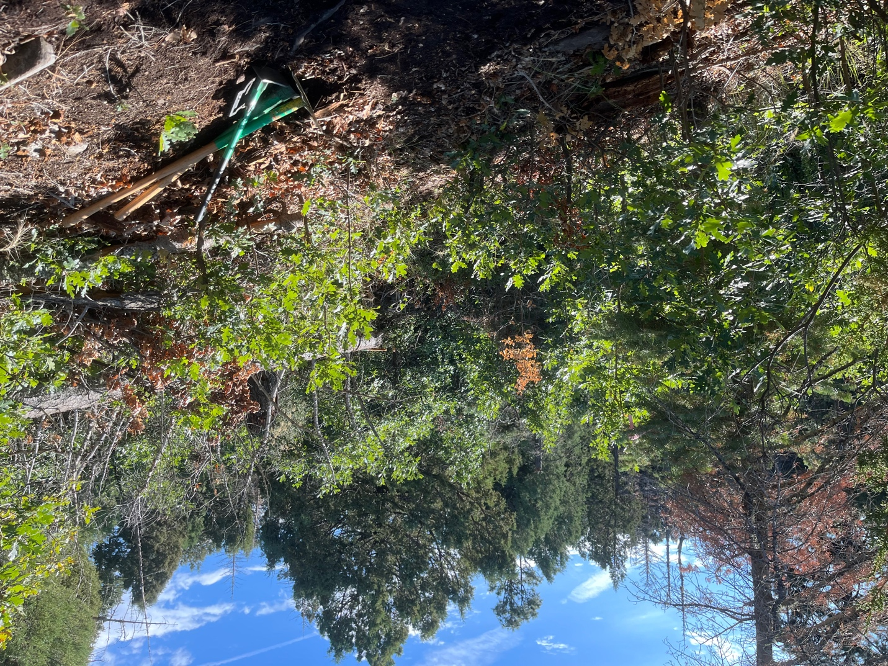

Meanwhile on the other end of the reroute, there appears to be some vegetation in the way….

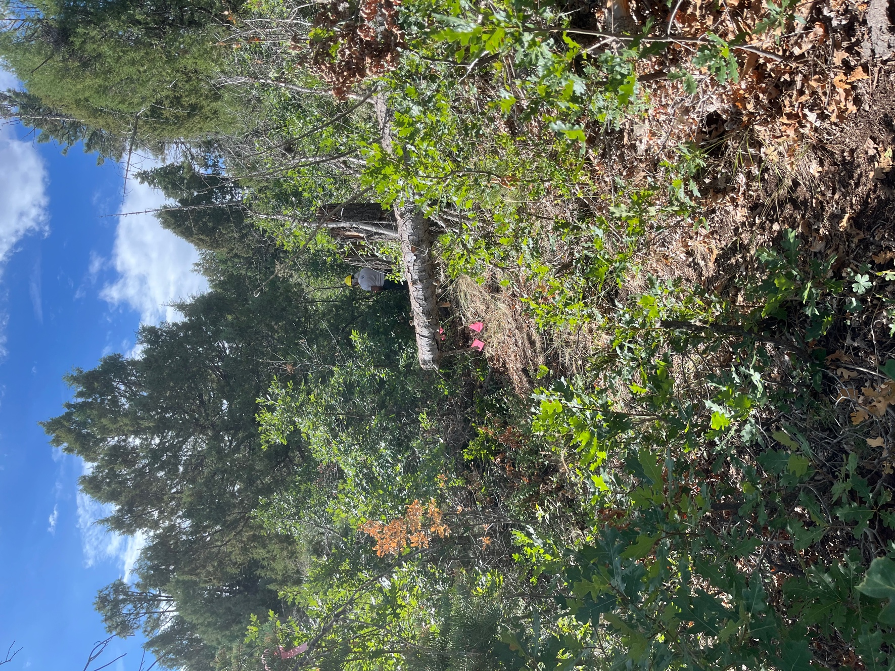

Can you spot Mike carving his way through? Laura was working on the other side heading towards Mike.

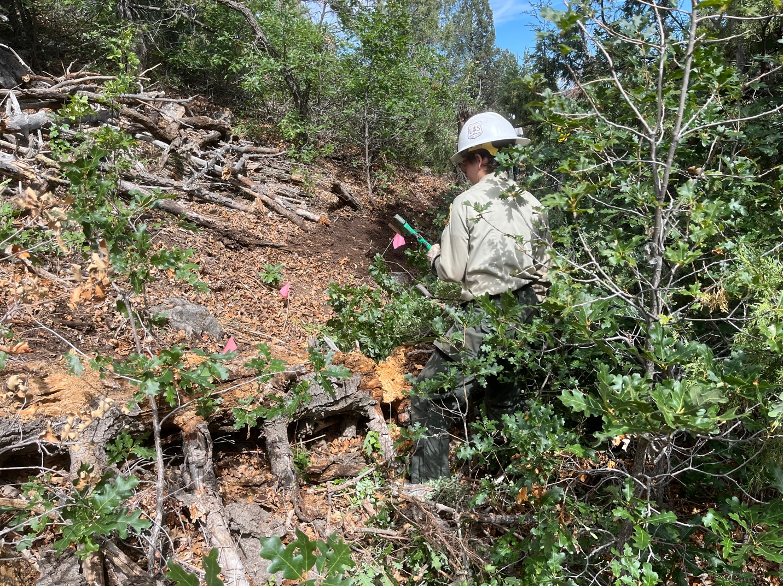

Jen came along to help with her trusty ax skills.
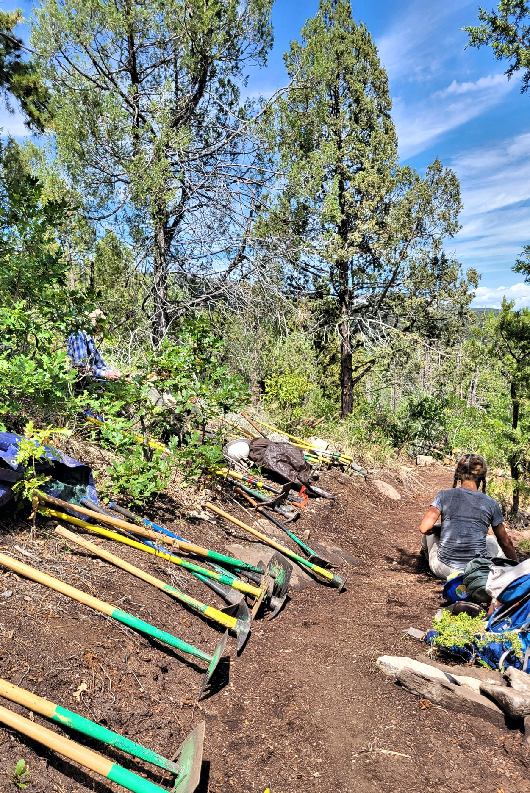

And then everyone found a spot of shade for lunch.

