Report of Removal of Graffiti Tags on the Interior
of the La Cueva CCC Stone Shelter, Tuesday, September 2, 2025

Sam Beard
On Tuesday, September 2, Pauline Ho, Rick Buss, and Sam Beard removed several graffiti tags from the interior of the CCC Stone Shelter in La Cueva Picnic Area. They used the World’s Best Graffiti Removal System chemical for stone and brick. The chemical and paint mixture was removed from the floor and walls with the FOSM low pressure water washer.
Project photographs are presented below.

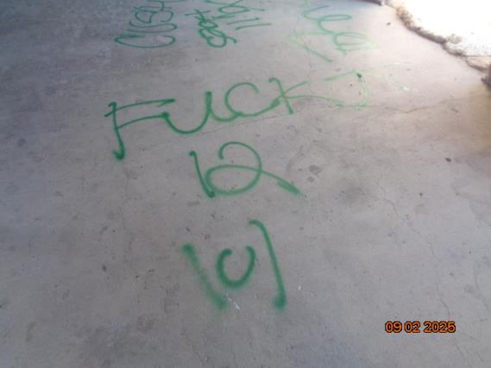
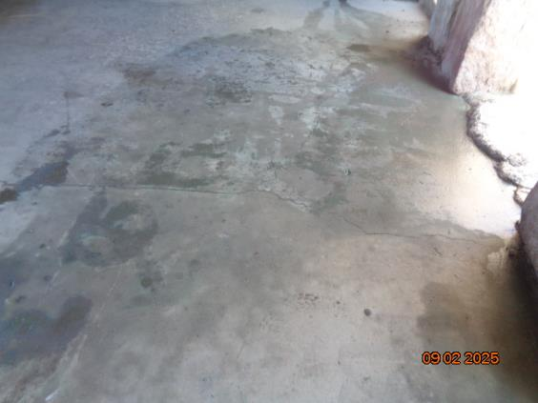
Top – Green tags on the floor of the La Cueva CCC stone shelter.
Bottom – All the tags on the floor were removed.
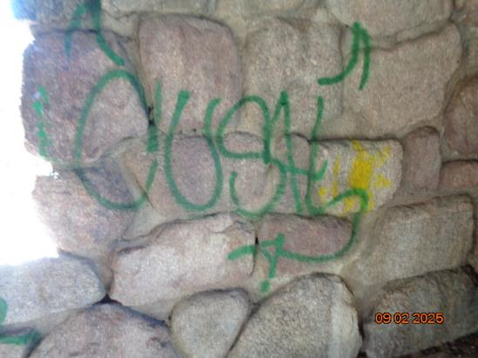
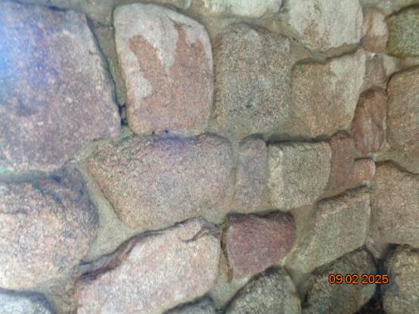
Top – Tags on the south wall.
Bottom – All the tags on this wall were removed.

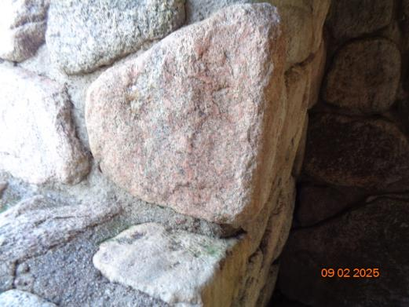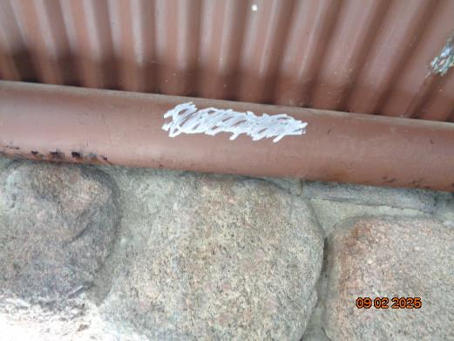
Top – The large green tag on this boulder at the northwest window was removed.
Bottom – Several tags on the roof beams and the corrugated steel roof were painted
over with USFS brown paint.

