Thursday, 09/04/25- North Faulty: We did it!! On Thursday, 10 volunteers joined Jen and Chris (SRD) and their chainsaw and hiked in on North Faulty to finish work on the North faulty reroutes. We had clouds in the morning which helped keep it cool and allowed us make progress and we were pretty much done by lunch time. I don’t have any really concrete numbers but I know we have spent 21 weeks between 02/27 and 09/04 working on this project. We had a few weeks away on Wagon and Kiwanis Meadow. We had about 19 different FOSM volunteers spend time working on these reroutes, with about 10 volunteers per week which comes out to about 1300 hours of grinding work. I’m so proud of everyone who was able to hike the distances (with and without tools), brave the sloping terrain and muster through the heat. It’s really been a group effort and of course Jen and Chris have been there to keep us on track and keep the work quality what it should be. Go get out there and hike it!

Volunteers: Eric Russell, Bart Vander Plas, Luis Cuadros, Bruce Hansche,
John McNett, Jim Houle, Claudia Bergsohn, Mackenzie Gibbs, Dan Burwinkle and Laura Leon
Pictures: Laura Leon
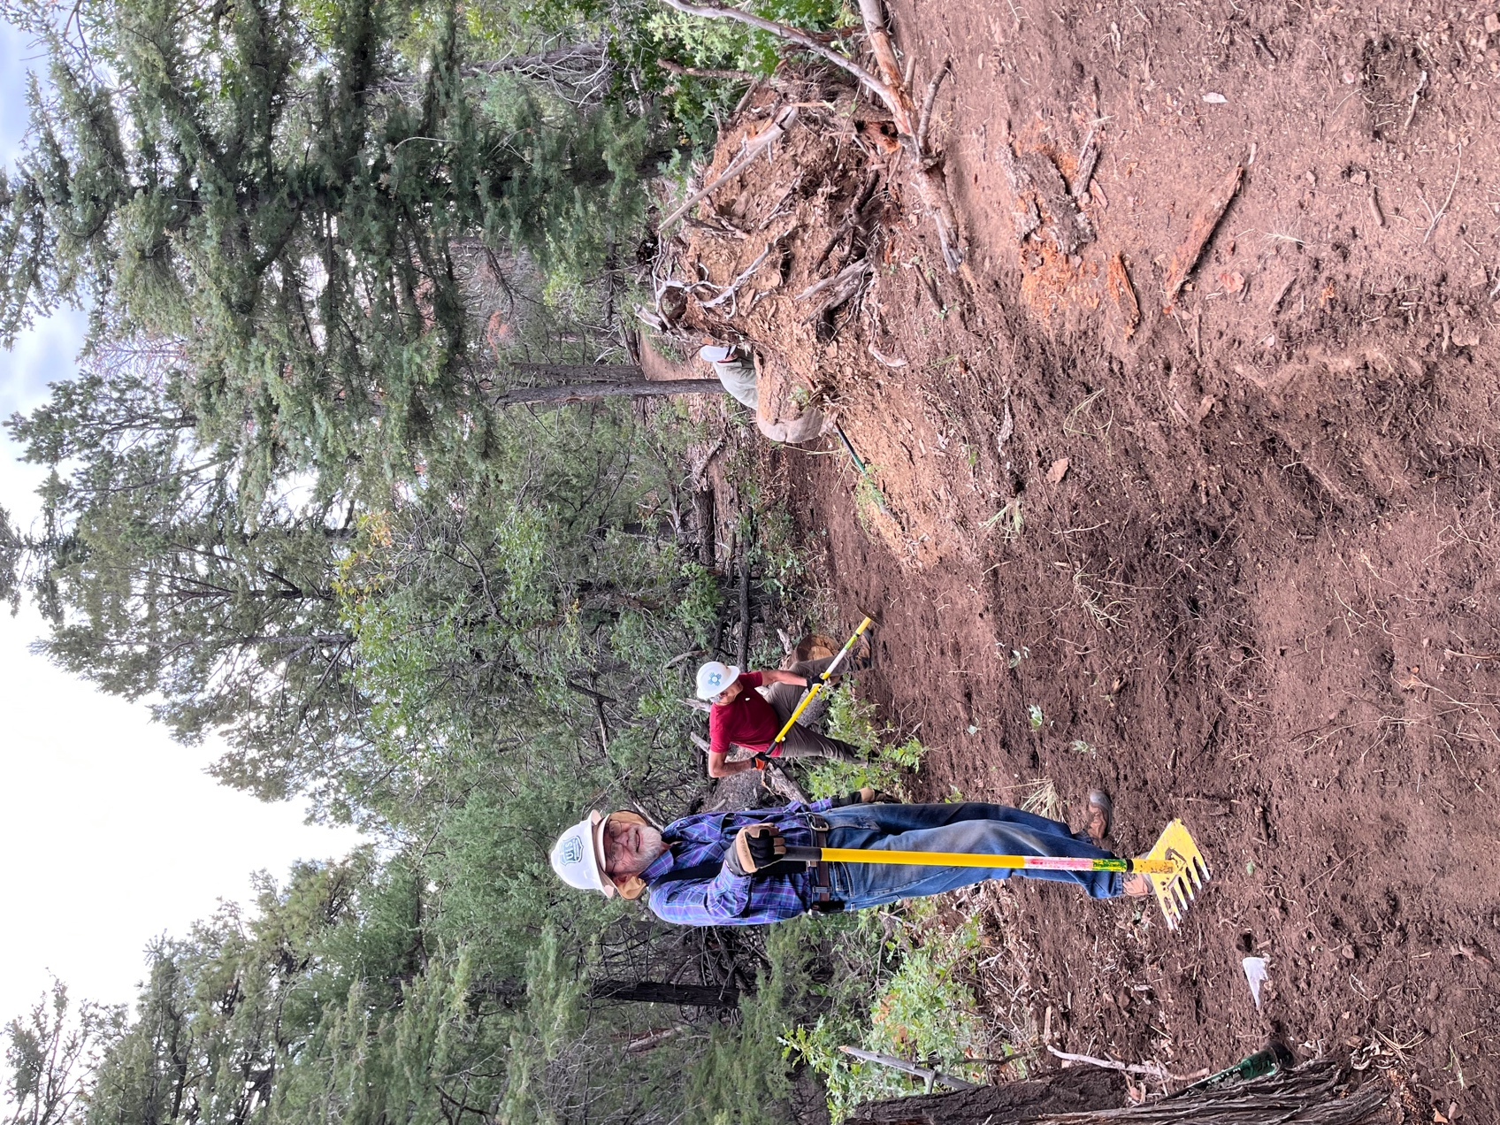

Bruce, Luis and Chris worked around a fallen tree to restore trail after Jen cut the tree with the chainsaw.

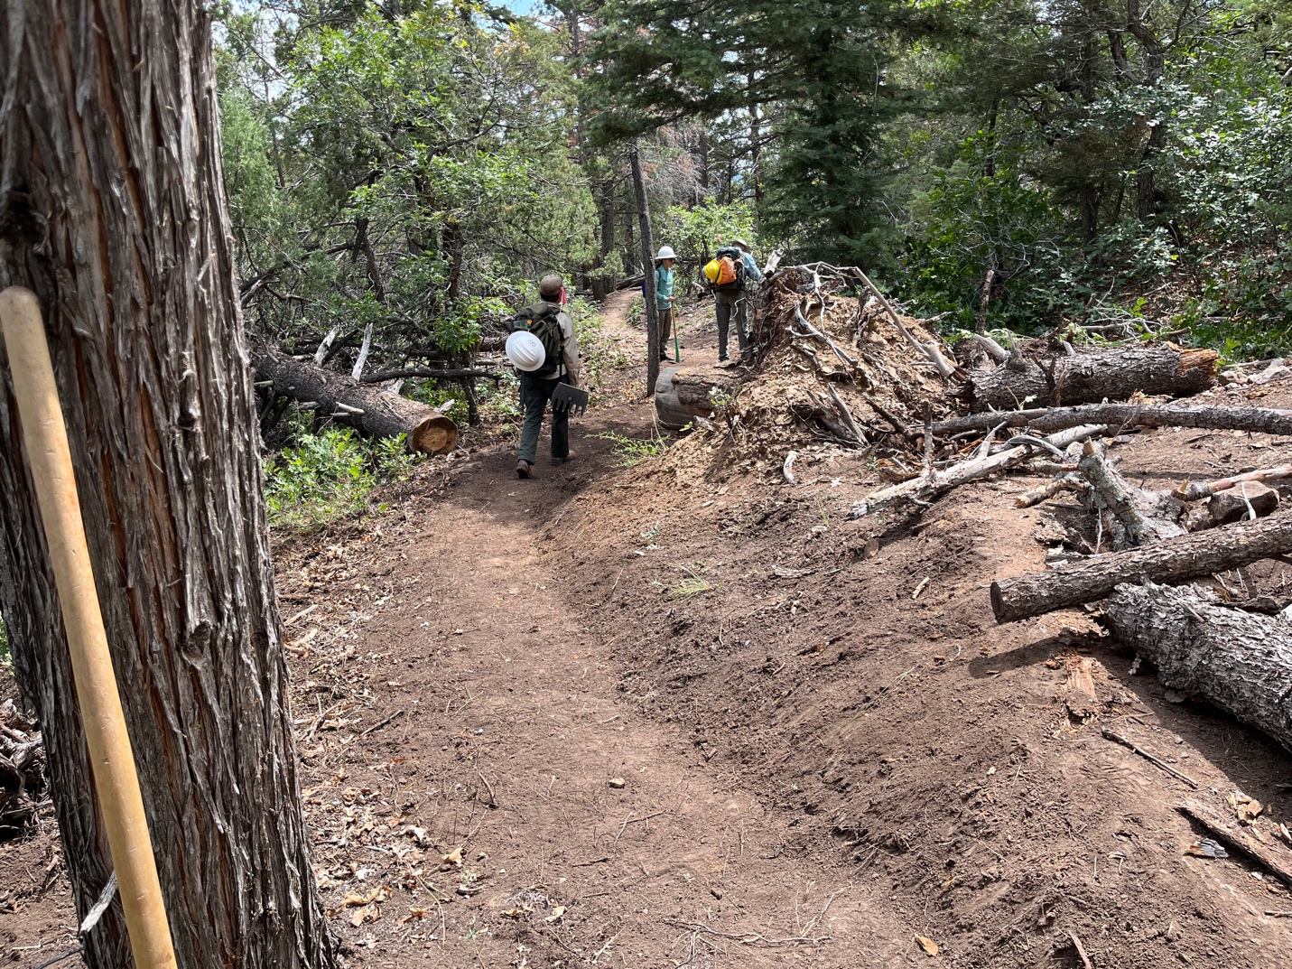

The finished product.

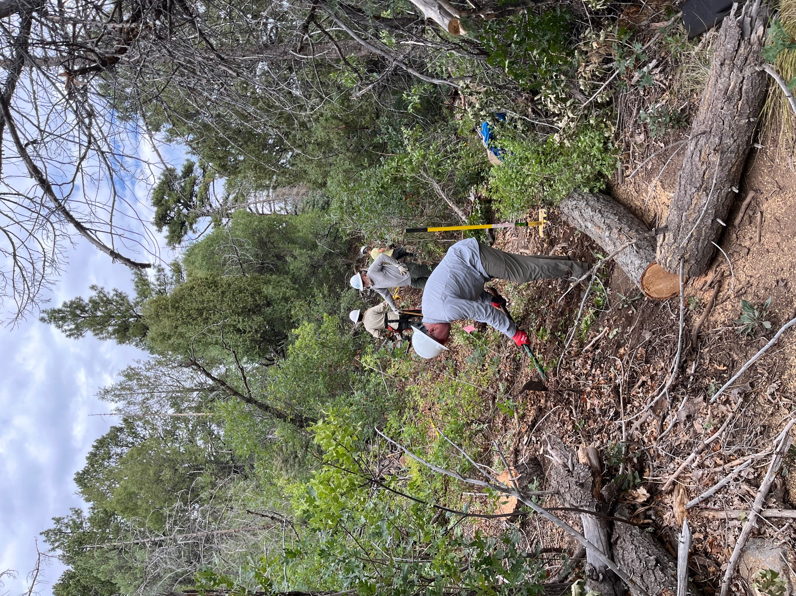

Jen has cut up a fallen tree and Dan and John clear debris.

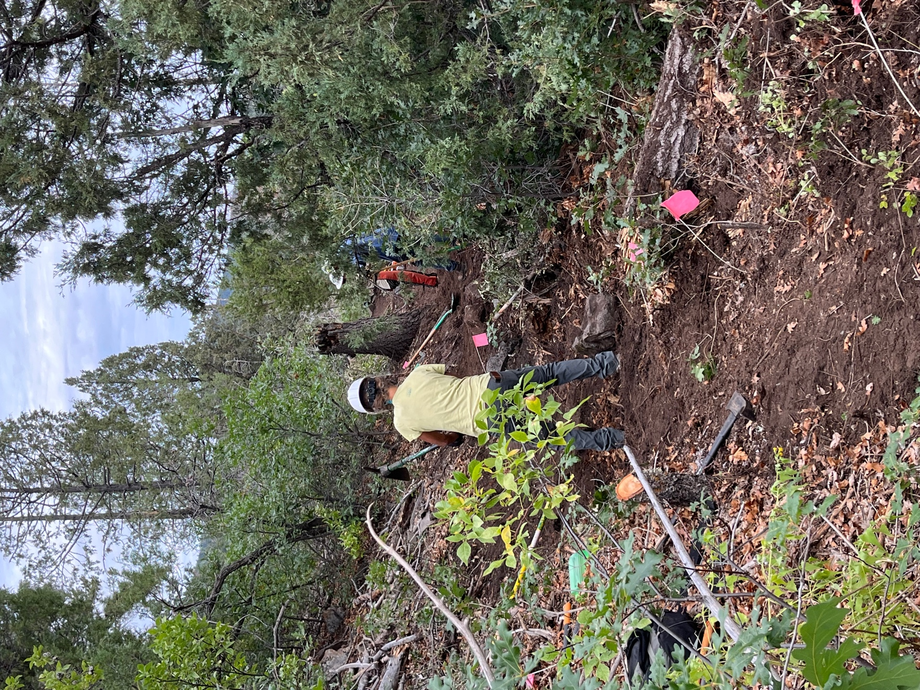

Claudia did battle with a giant root ball and Jim and Jen debate what to do with all the duff and rocks.
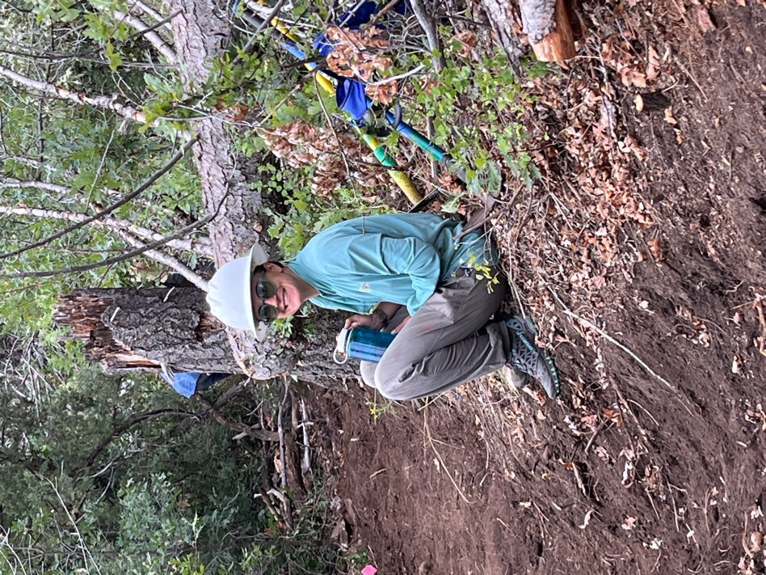 Mackenzie and Bart take a break.
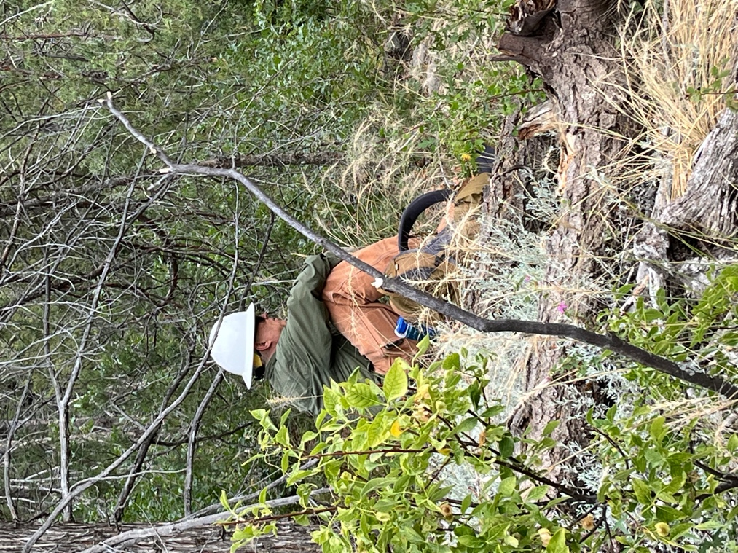
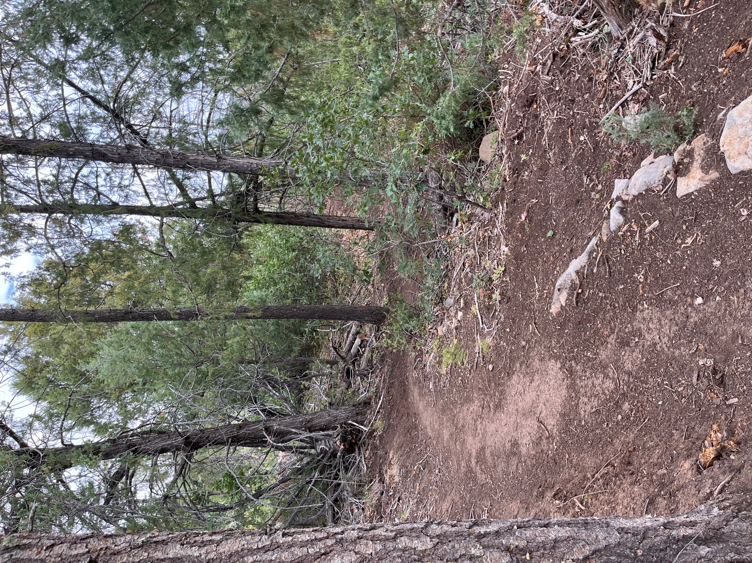

Beautiful new trail!!
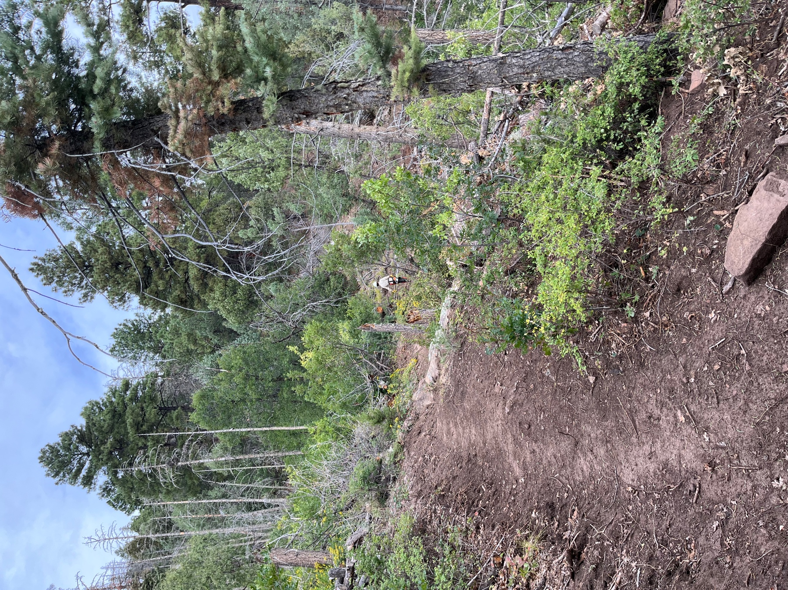

Jen used the chainsaw to take care of odds and ends.

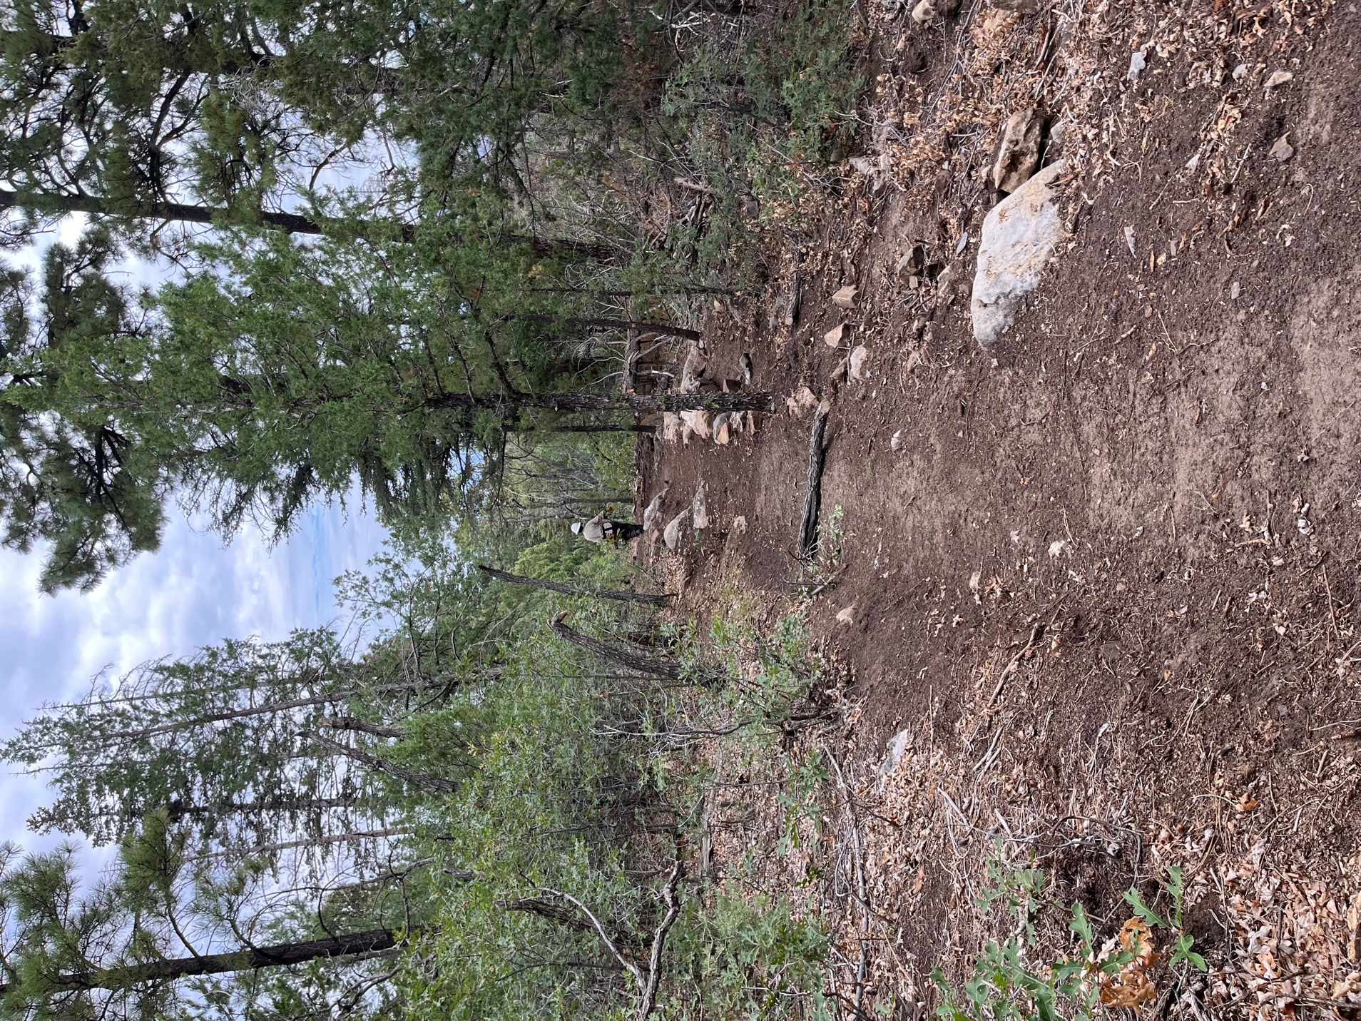

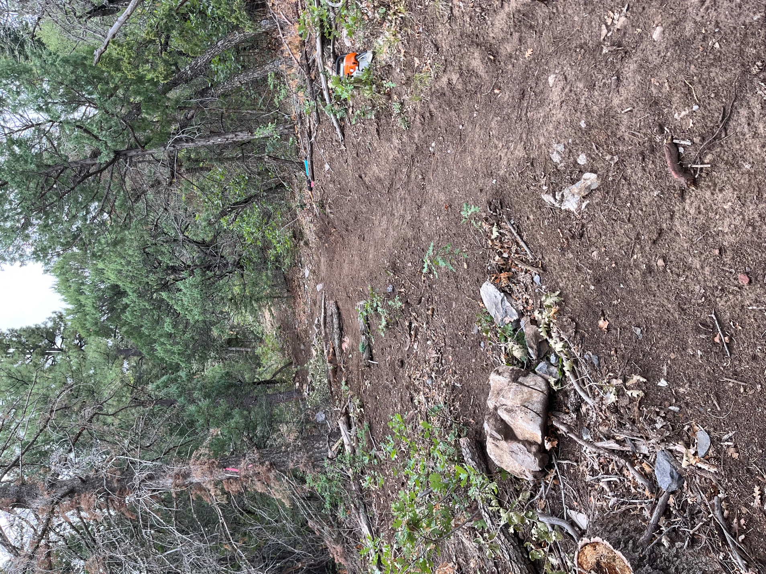

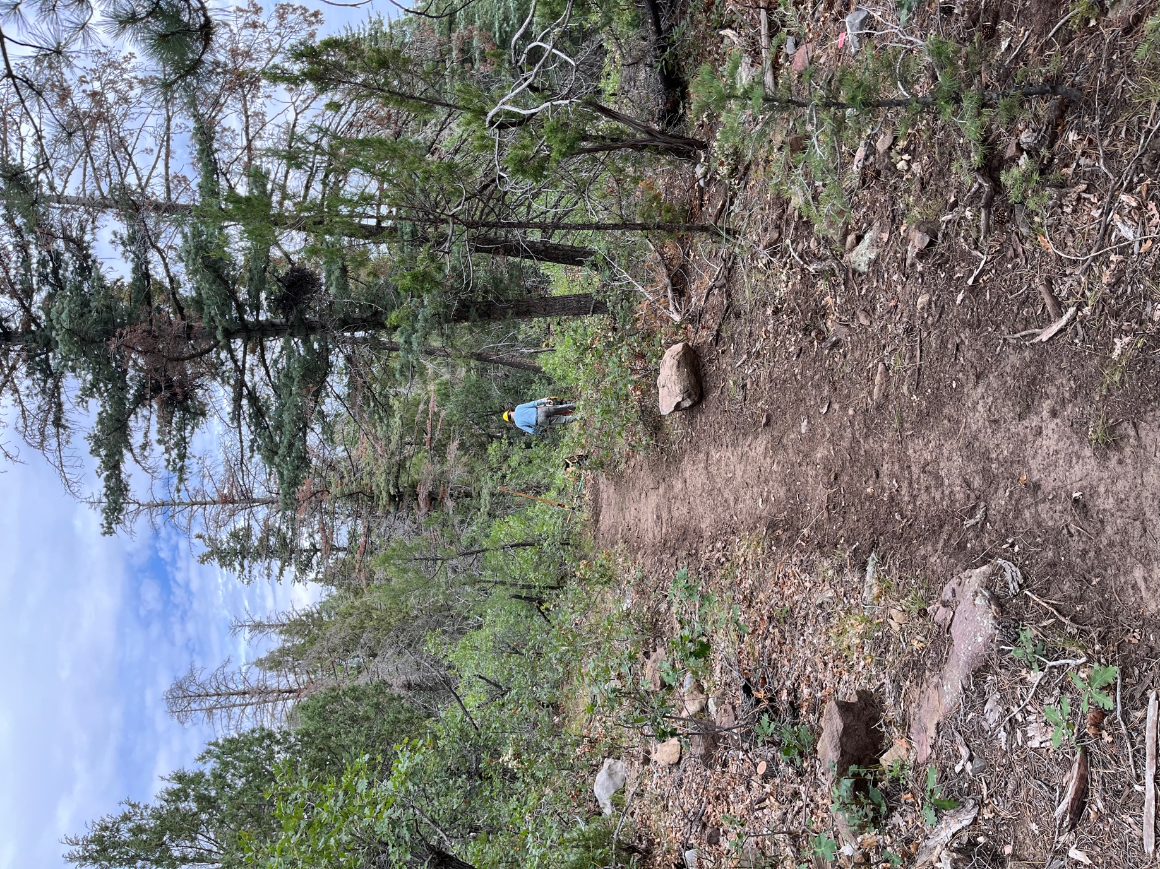

Eric hand sawed some tree stumps and obliterated the far end.
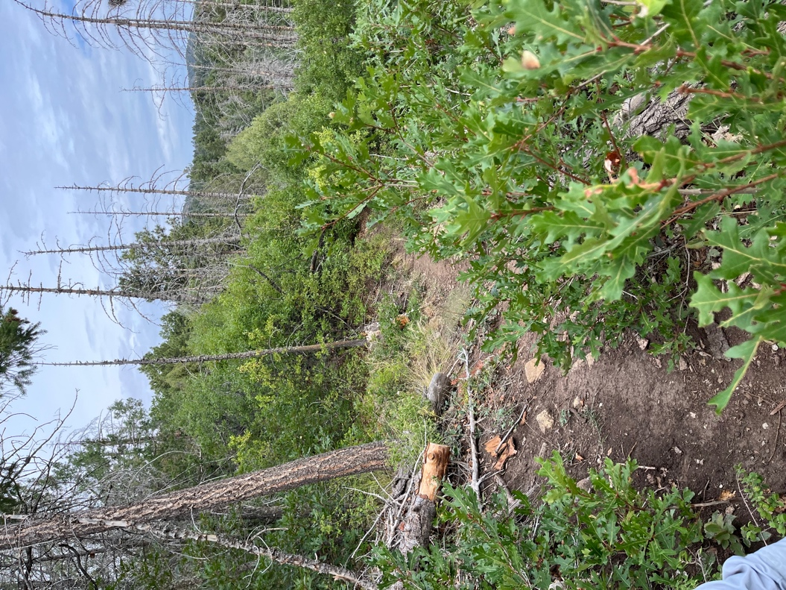
Old trail disappearing into the oak and grass.
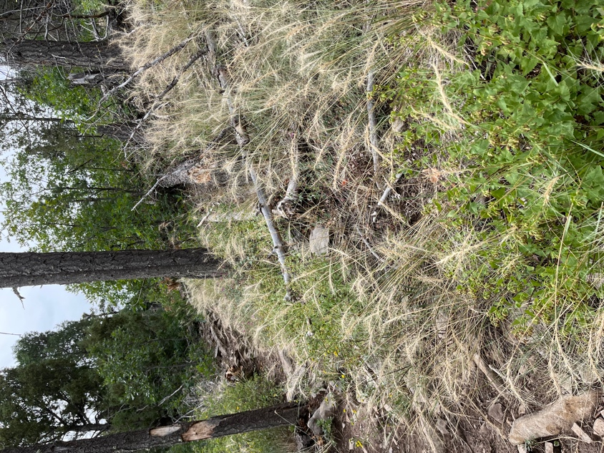
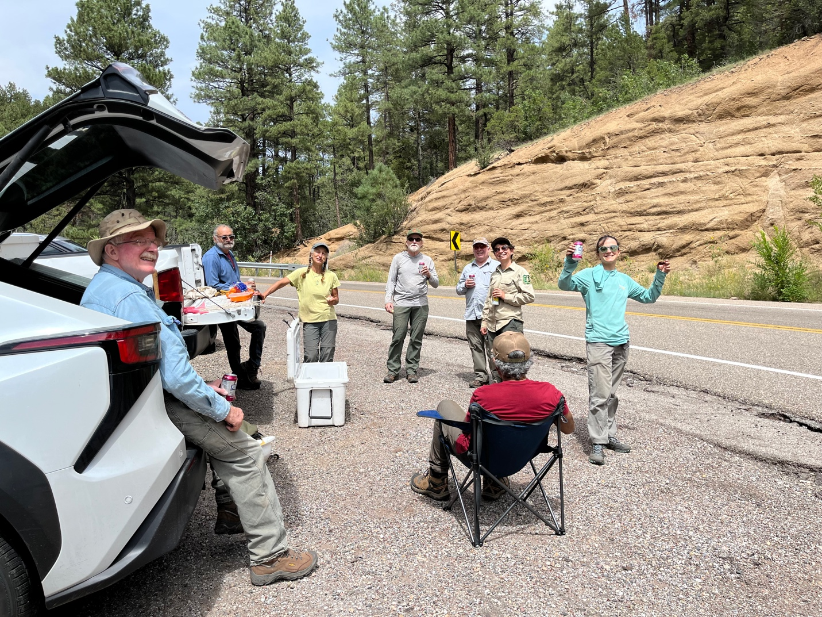

Victory is ours!!

