Report of Processing Donation Wood at Kiwanis Meadow Road Gate
at Sandia Crest, Wednesday, September 3
Sam Beard
On Wednesday, September 3, ten FOSM volunteers and two Mountain Christian Church Wood Ministry members processed approximately eight hazard trees that were felled earlier near the picnic table at the Kiwanis Meadow Road gate at Sandia Crest. Sawyers buck the tree trunks, the rounds were moved down to the splitter at the picnic table, the rounds were split, and loaded on Mike Oliver’s trailer. After the wood at the table was split, volunteers moved down the road about 200 feet past the gate where sawyers bucked a few logs where trees were felled sometime in the past. These rounds were loaded on Jerry Carroll’s pickup, hauled to Mike’s trailer, and loaded on the trailer to complete the project.
The volunteers working on this project were Lou Romero, Dennis Crowther, Sam Beard, Sim Cook, Eric Russell, Rene Archer, Chuck Logan, Steve Roholt, Dan Benton, Jerry Carroll, Mike Oliver, and Allen Gregory.
Project photos are presented below.

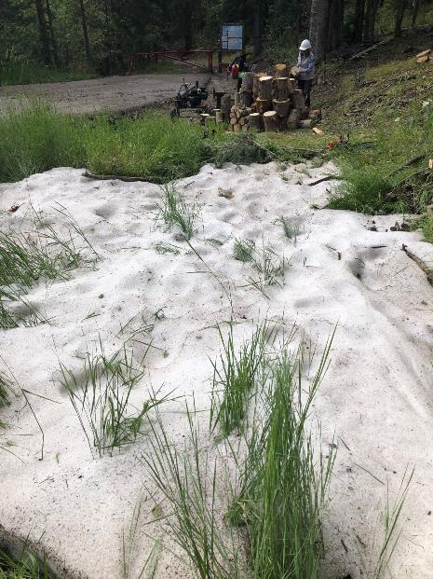
Rene Archer stacking rounds that will be split later. The white
material in the foreground is hail that fell earlier. All photos by Dan Benton
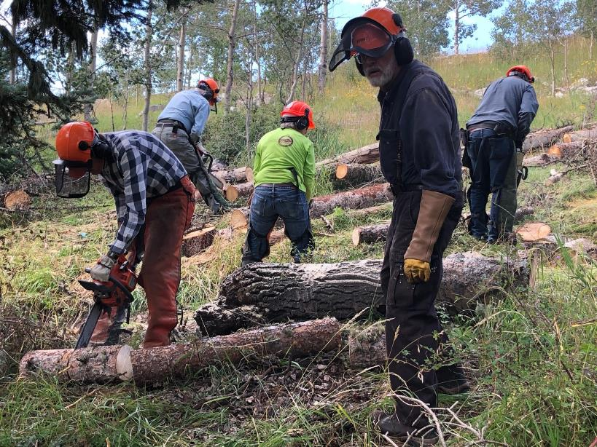
L to R: Sim Cook, Eric Russell, Steve Roholt, Sam Beard, and Jerry Carroll. The sawyers are bucking trees
that were felled earlier up the hill from the picnic table near the gate.
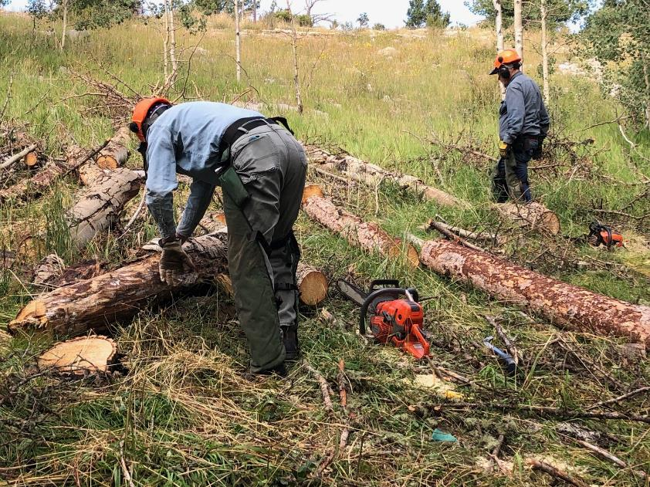
Eric Russell and Jerry Carroll bucking trees in a meadow between the South Crest Trail on the horizon and the picnic table.
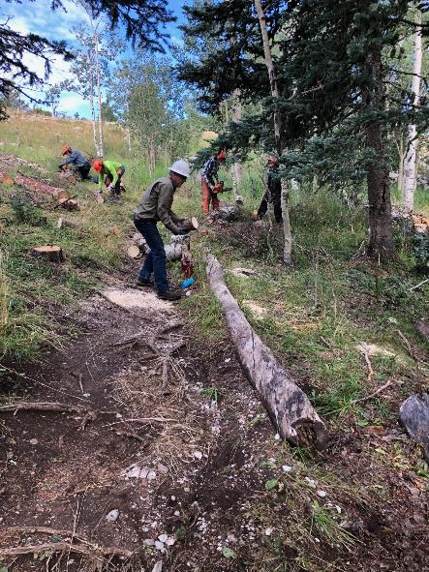
Chuck Logan preparing to move a round down to the splitter
while others continue to buck tree trunks. He is standing in an unofficial
trail from the gate below to the restroom and South Crest Trail above.
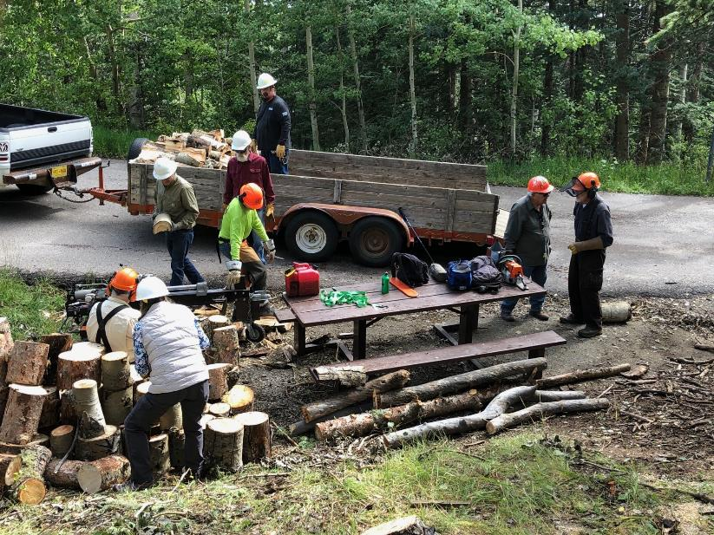
Splitting rounds and loading the split wood on Mike Oliver’s trailer. L to R: Dennis Crowther, Rene Archer, Chuck Logan,
Steve Roholt, Mike Oliver, Allen Gregory, Lou Romero, and Sam Beard.
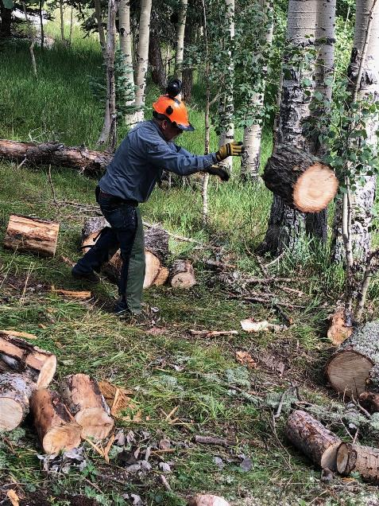
Jerry Carroll throwing a round down to the splitter.
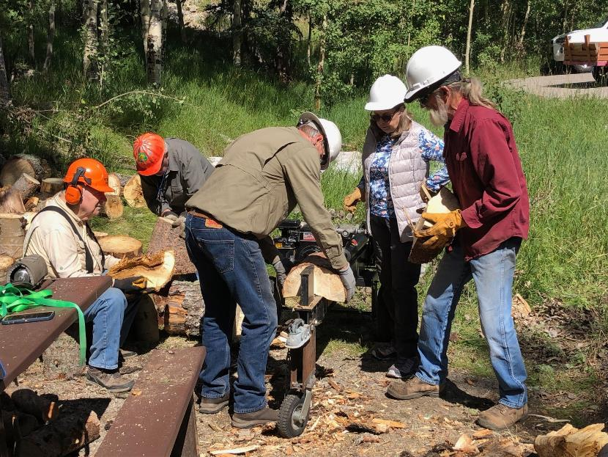
Splitting rounds with Lou Romero’s power splitter. L to R: Dennis Crowther, Lou Romero, Chuck Logan, Rene Archer and Mike Oliver.
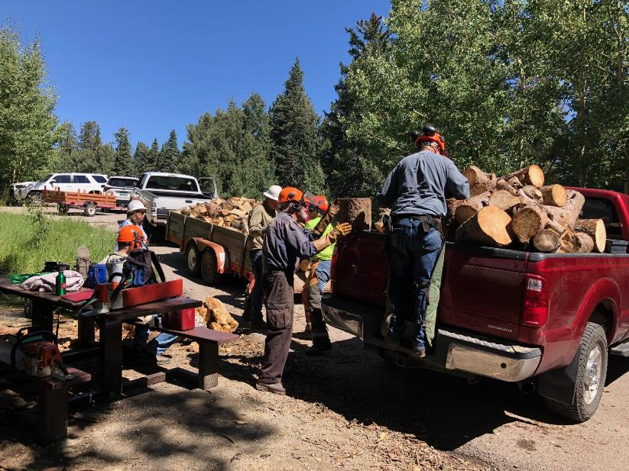
After the rounds from the hillside were split and loaded on Mike’s trailer, Jerry Carroll hauled a load of rounds
from past the gate at the intersection of Switchback Trail and Kiwanis Meadow Road.
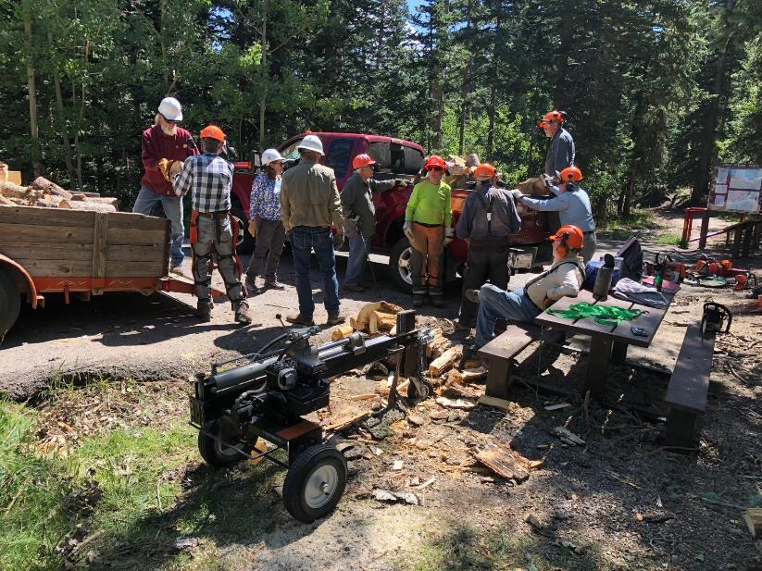
Rounds are being moved from Jerry’s pickup to Mike’s trailer. These rounds will be split later by Mountain Christian Church
wood ministry members and donated to East Mountain residents who heat their homes with wood.
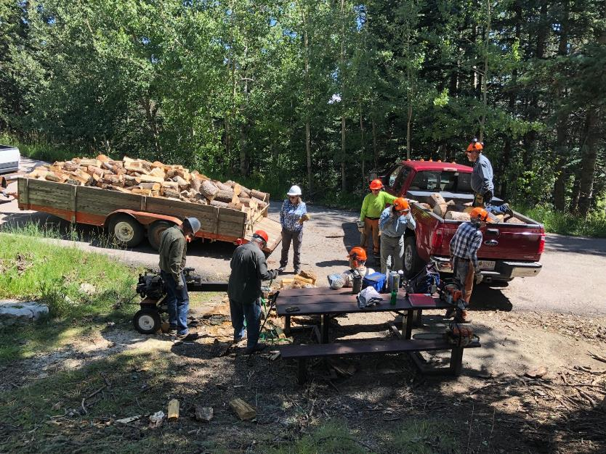
Mike’s trailer has been loaded with donation wood, and the FOSM project to process wood at this site has been finished.

