Report of FOSM Project to Paint Large Cibola National Sign on Forest Service Road 55
in the Mountainair Ranger District, Tuesday, September 9, 2025

Sam Beard
On Tuesday, September 9, at the request of the Mountainair Ranger District, the FOSM paint crew of Pauline Ho, Rick Buss, and Sam Beard painted the large Cibola National Forest sign located on Forest Road 55 a few miles west of Tajique. This village is about 30 miles south of the Sandia Ranger Station.
Project photographs are presented below.

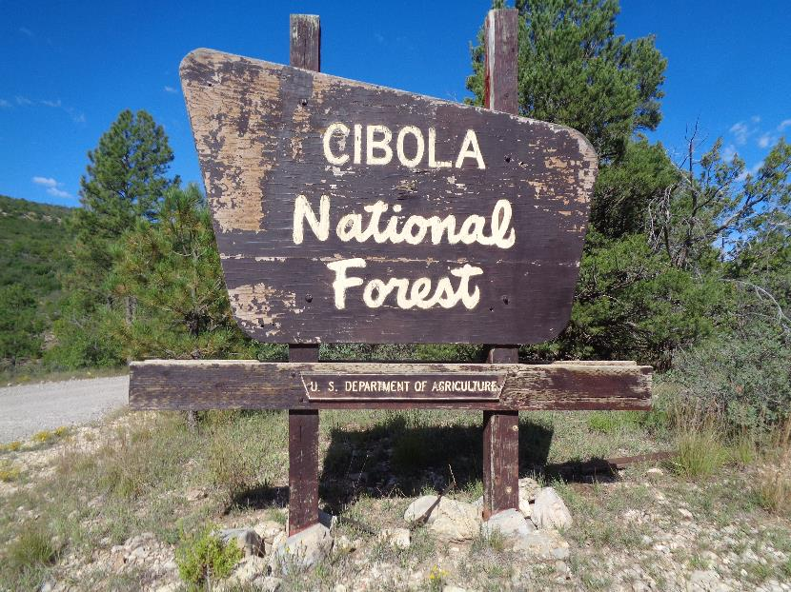
Cibola National Forest sign on Forest Road 55 in the Mountainair Ranger District a few miles west of Tajique.
Apparently, the sign had been painted many years ago with a very dark brown paint.
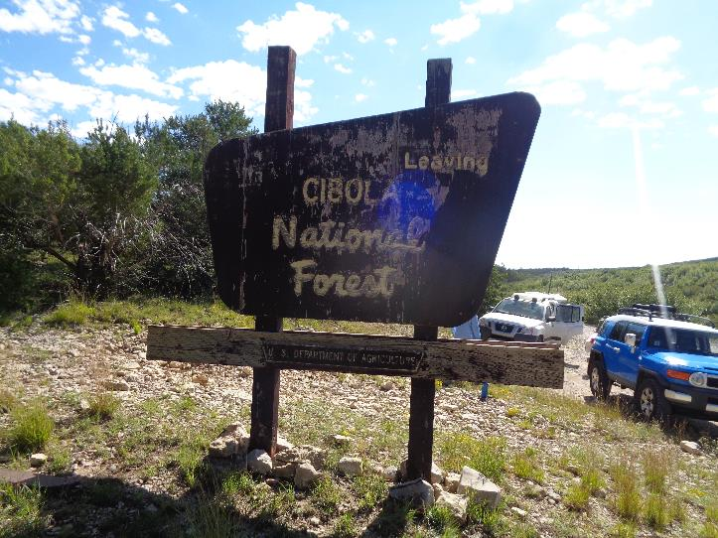
The “Leaving Cibola National Forest” side of the sign.

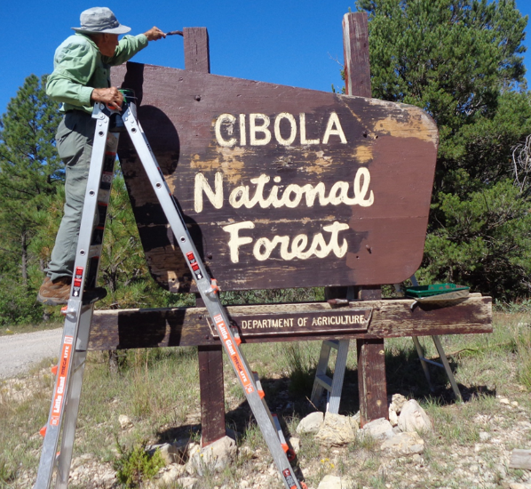
Rick painting the east side of the sign with the official USFS brown paint color.
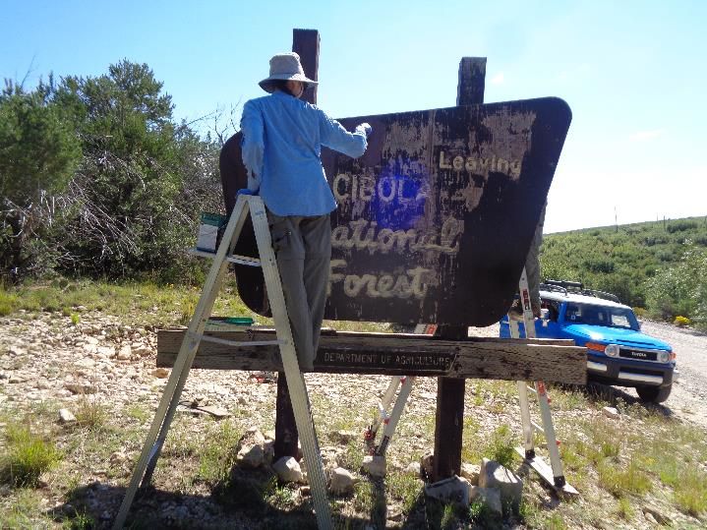
Pauline painting the other side of the sign after loose paint chips had been scraped off.
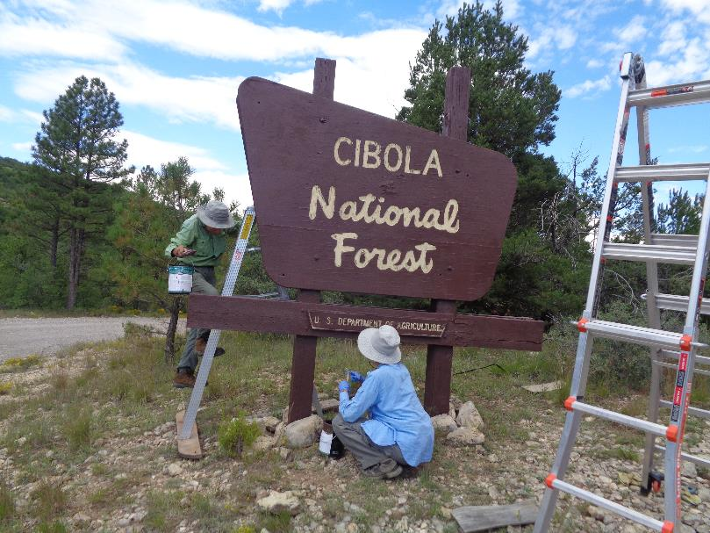
Pauline is painting the “U. S. Department of Agriculture” part of the sign with brown paint. All the white letters
on the sign and the line around the USDA panel were painted with small artist’s brushes.

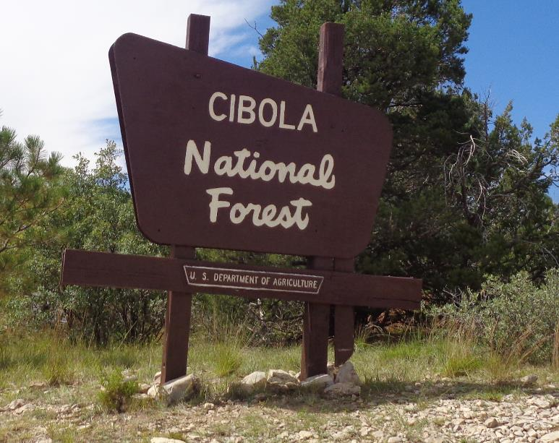
The east side of the painted sign.
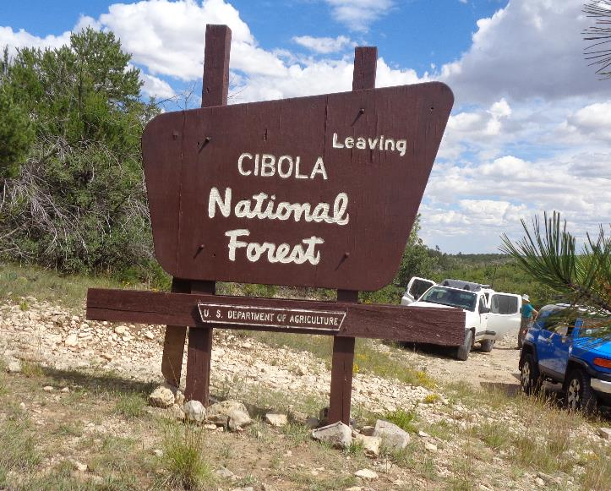
The west side of the painted sign.

