Report of the Replacement of Two Rotten Fence Posts in Doc Long Picnic Area
near the Middle Restroom, Wednesday, September 10, 2025

Sam Beard
On Wednesday, September 10, a FOSM crew of Chuck Logan, Jerry Carroll, Cliff Giles, and Sam Beard replaced two rotten fence posts in Doc Long Picnic Area near the middle restroom. The replacement of the first post proceeded smoothly, because the most of old wood in the hole had been removed earlier.
After the four rails on the first post had been bolted to the new post, they moved to the second six-inch post that was loose in the hole or broken below the ground level. After digging down several inches, it was found that the center core of the post was very firm wood with a diameter of 2 or 3 inches. After repeated efforts to pull us the post, Jerry Carroll cut the core with his chain saw several inches below the ground level. The chain saw was used to cut grooves in the core and a steel dirt bar was used to break up the core at a depth of about 24 inches. Due to the extensive effort and long time required to remove the sound core, it was decided that if we find a solid core in the future, we would stabilize the post with rocks below the surface and not remove the post.
Project photos are presented below.

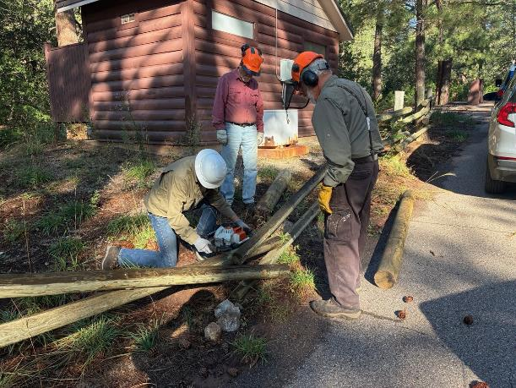
Chuck Logan is using the FOSM power auger to break up the remaining wood where this first
rotten post was located between the Doc Long Picnic Area second gate and middle restroom.
All photos by Cliff Giles

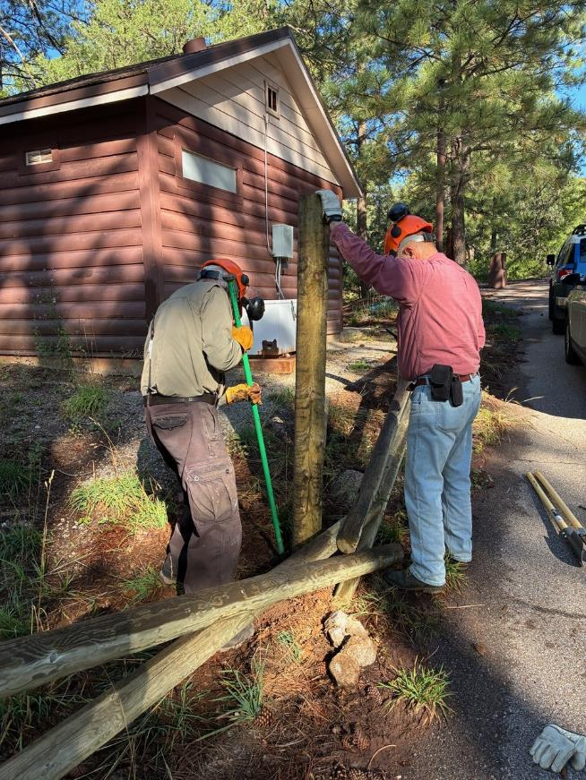
Tamping the dirt around the new post at this first location.
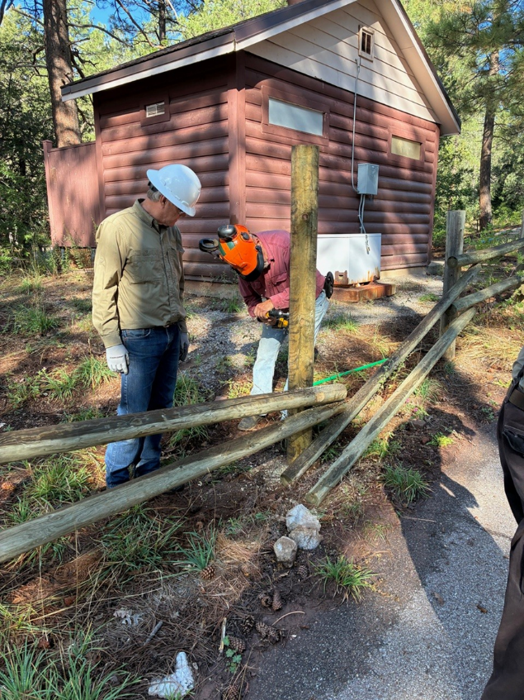
Jerry is using a battery-powered drill and Forstner bit to make a countersink
for the bolt and nut on the back of the post.

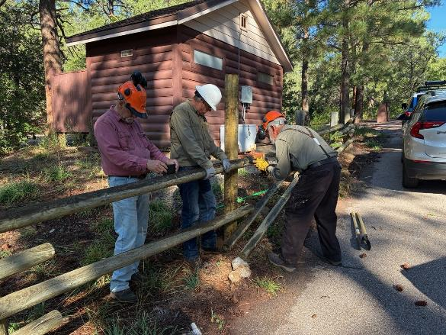
Sam is drilling a hole in the rail and post for the bolt in the top rail. Jerry is checking the
level of the rail.

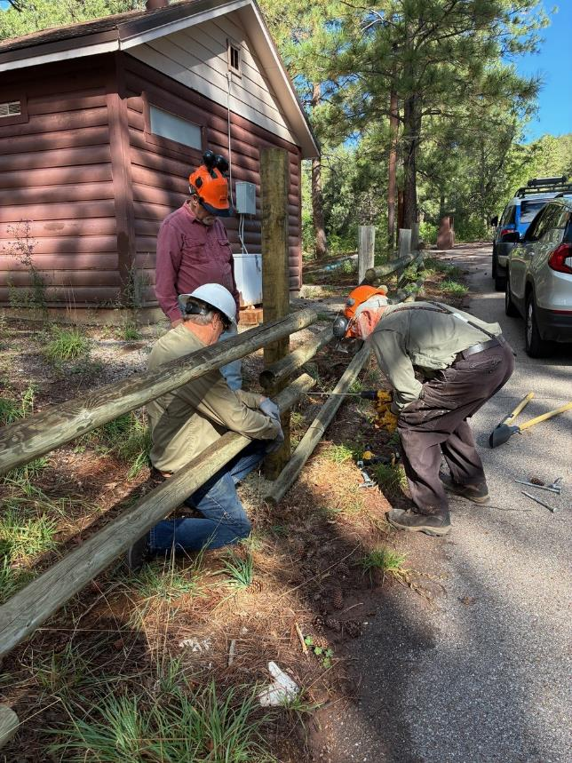
Sam is drilling a hole for the third bolt.
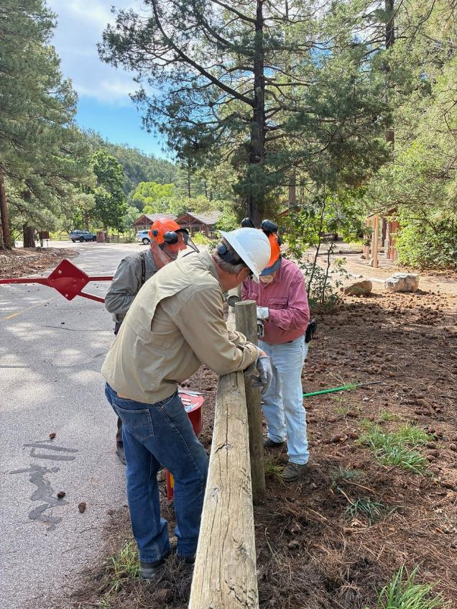
Jerry is using a battery-powered reciprocating saw to cut off a bolt and nut so that the rail can be removed
from the second post nearer the gate.
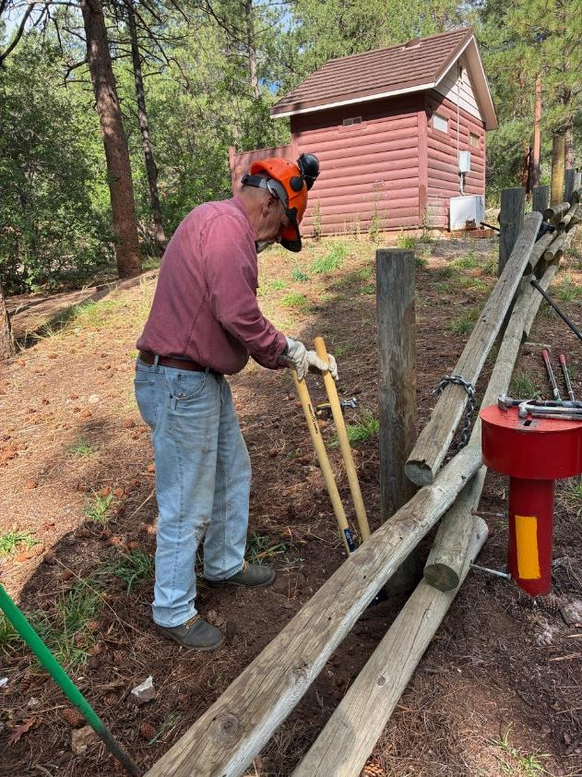
Jerry is using the FOSM small post hole digger to remove dirt from around the post.

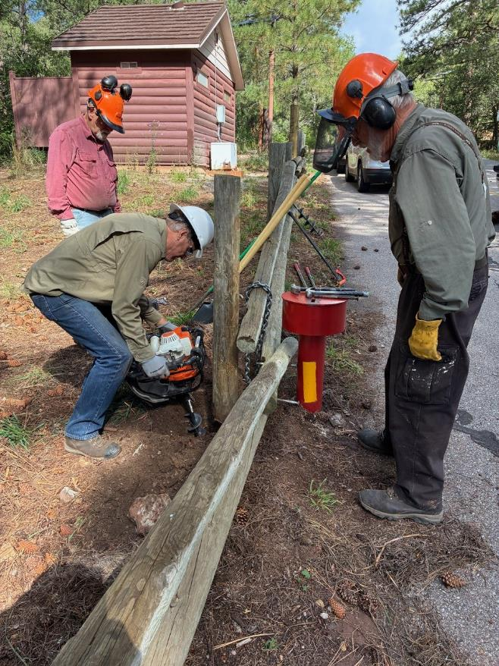
Chuck is using the FOSM power auger to loosen dirt around the post.
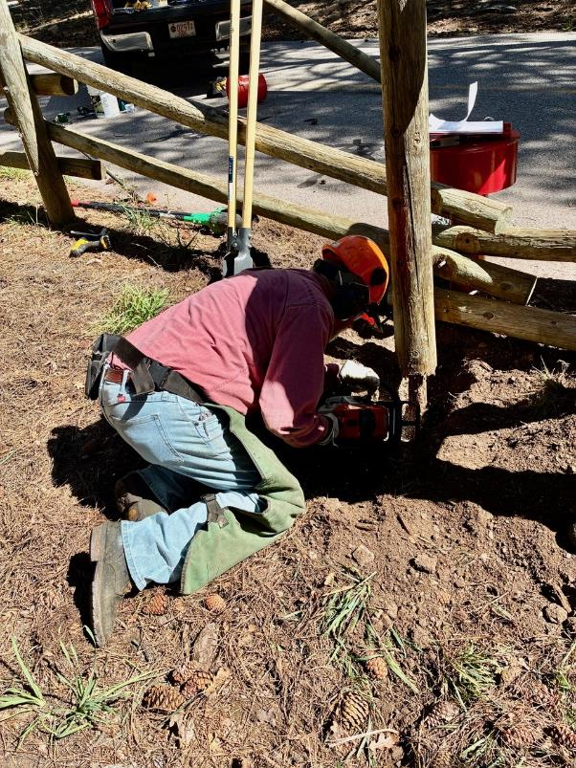
After digging dirt from around the post which seemed loose in the hole, we found that the 6-inch post
was supported by a very small core of very sound wood. Jerry is using his chain saw to cut the
solid core. Note the small diameter of the solid wood below the ground surface compared
with the diameter of the post above the ground.
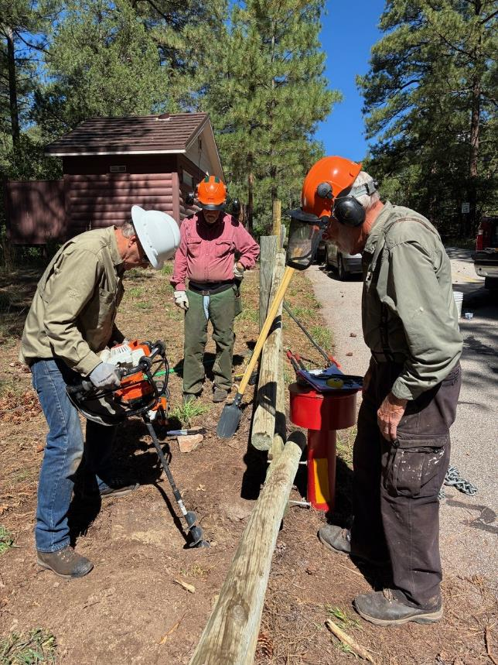
Chuck is using the power auger to loosen dirt around the solid core.
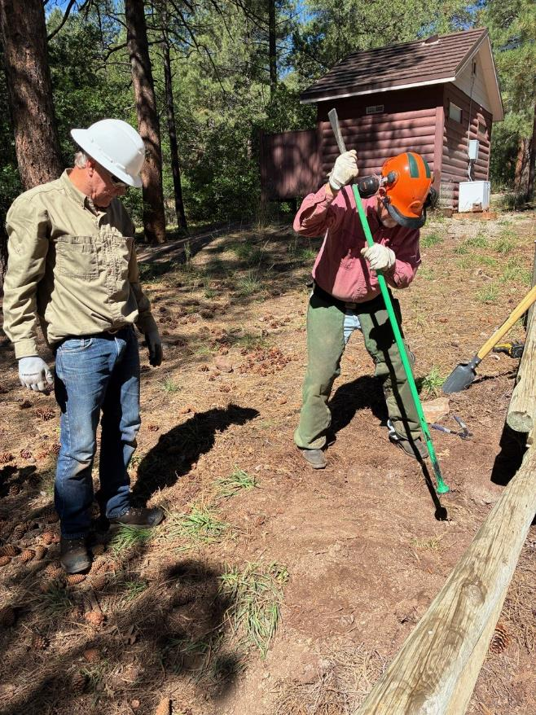
Jerry is using the dirt bar in an attempt to break apart the remaining wood core.
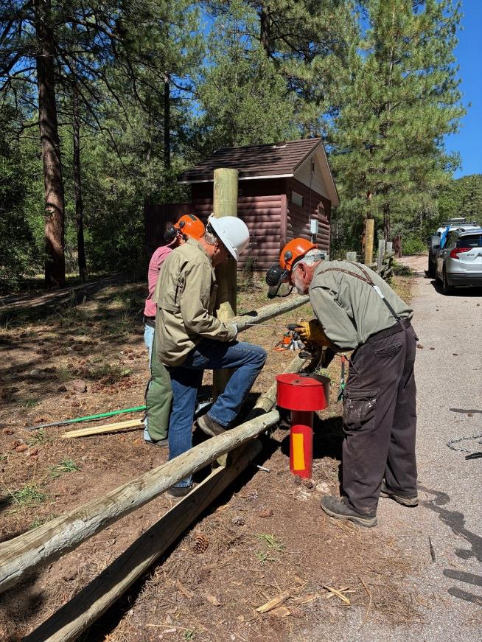
Sam is drilling the hole for a bolt to secure the top rail.
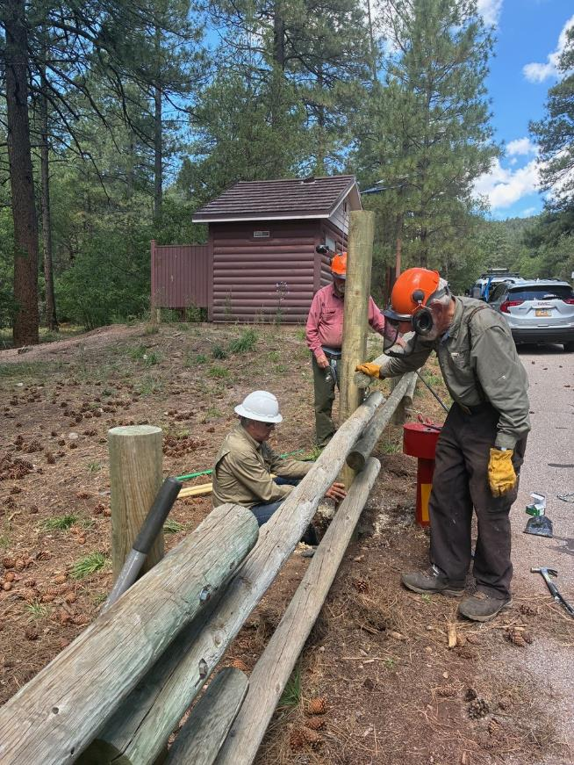
Chuck is tightening the nut on the bolt on the back of the post.
/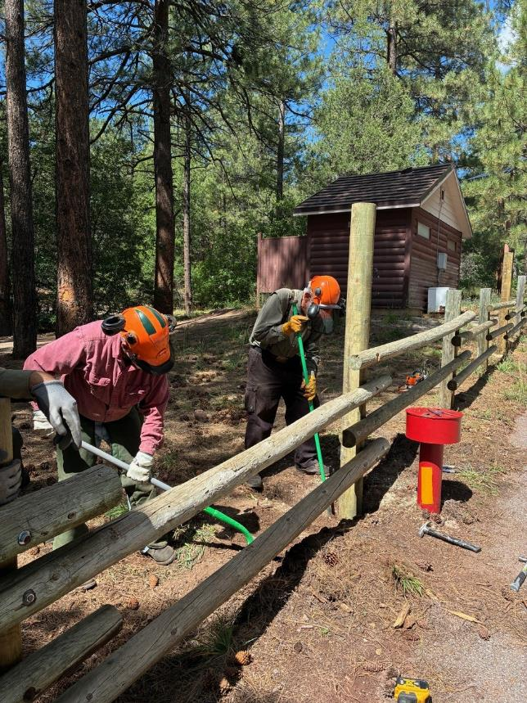
Jerry is throwing dirt in the hole around the post, and Sam is tamping the dirt with the dirt bar.
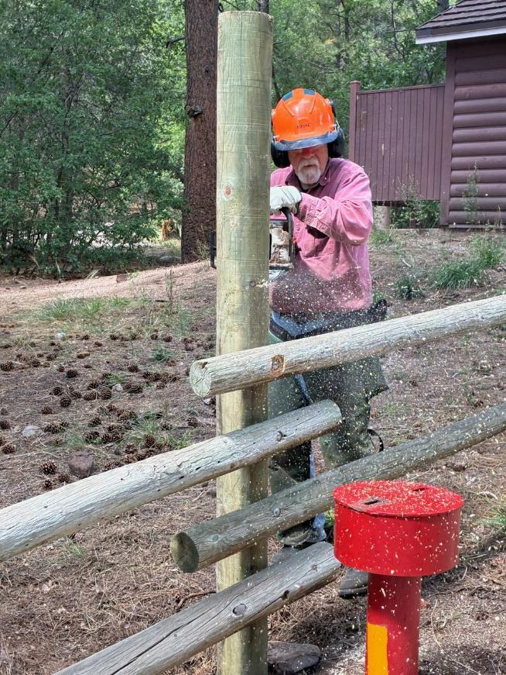
Jerry is using his chain saw to cut the post down to a height of 4 feet.

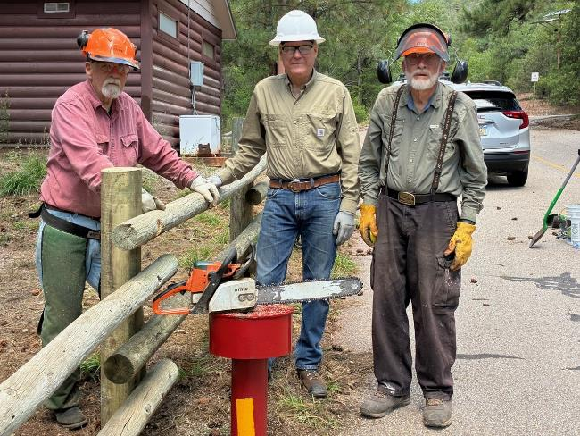
L to R: Jerry Carroll, Chuck Logan, and Sam Beard replaced two rotten posts near the middle restroom.

