Thursday, 09/11/25- Old Faulty: We took a break from the long hikes and worked on a couple of reroutes to Old Faulty this week. Nine volunteers met Chris (SRD) at Sulphur Springs parking area to make the hike to the 1st area of work. As we were meeting up, 2 deer walked down Wagon Trail just above us- glad everyone is out there enjoying it! We hiked about a mile up Sulphur Canyon and work 2 areas: one, a reroute of the existing trail and one, reestablishing trail where a tree had fallen across the trail. We moved onto the next reroute which again brought the trail up out of the low areas and we almost finished work there. We will need to do a bit more finishing work next week. Three more reroutes to go and then we’ll work on the existing trail.

Volunteers: Eric Russell, Bill Perkins, Mackenzie Gibbs, Jay Wulf, John McNett,
Claudia Bergsohn, Bruce Hansche, Roland Stumpf and Laura Leon

Pictures: Laura Leon and Roland Stumpf

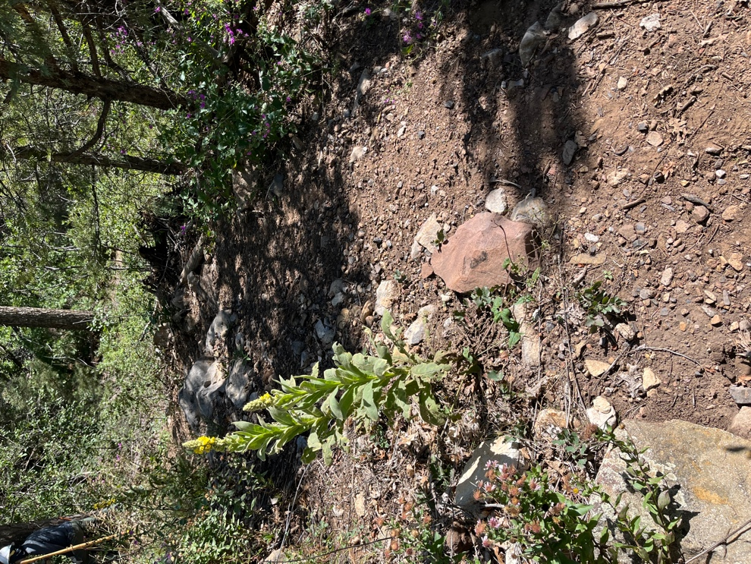

The existing trail is narrow, overgrown and uneven.
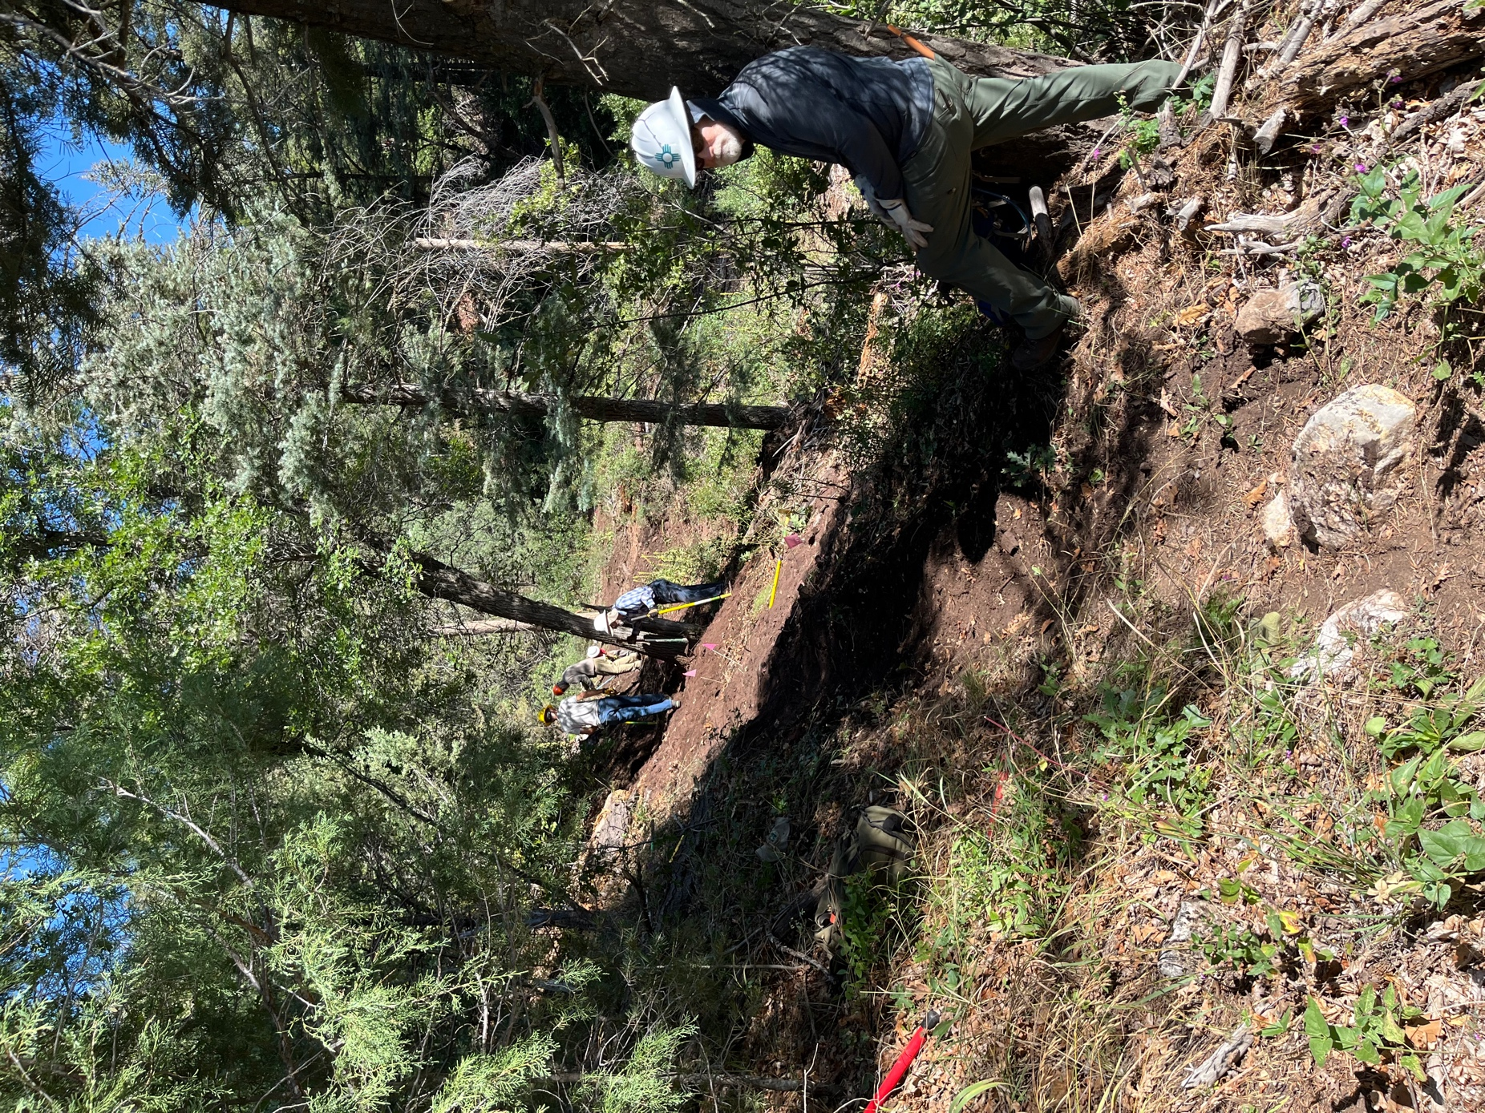

The existing trail runs below where John, Bruce, Roland and Jay are working.
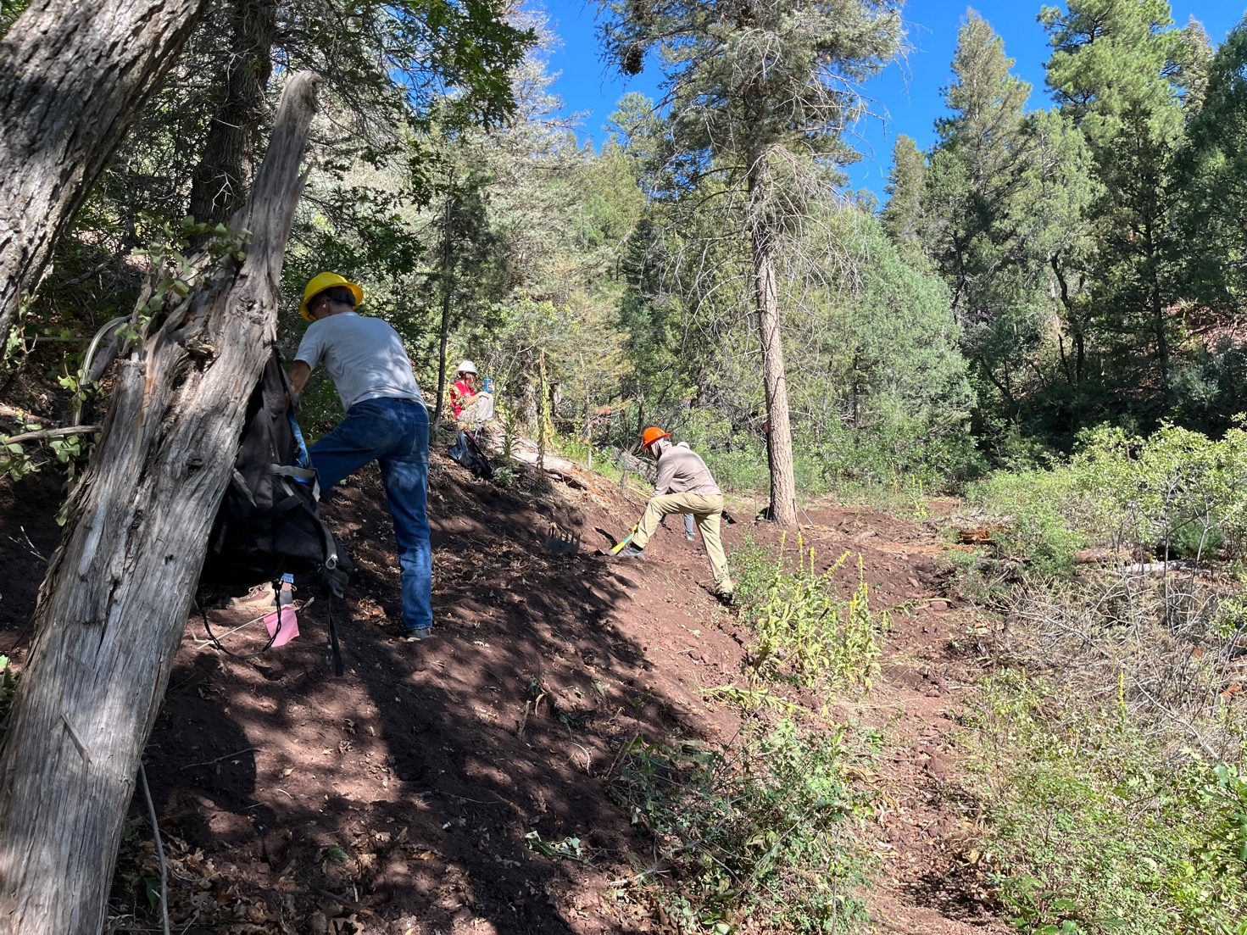

Roland, Jay and Mackenzie are working on the new trail with the old trail below.
Lots of duff!!

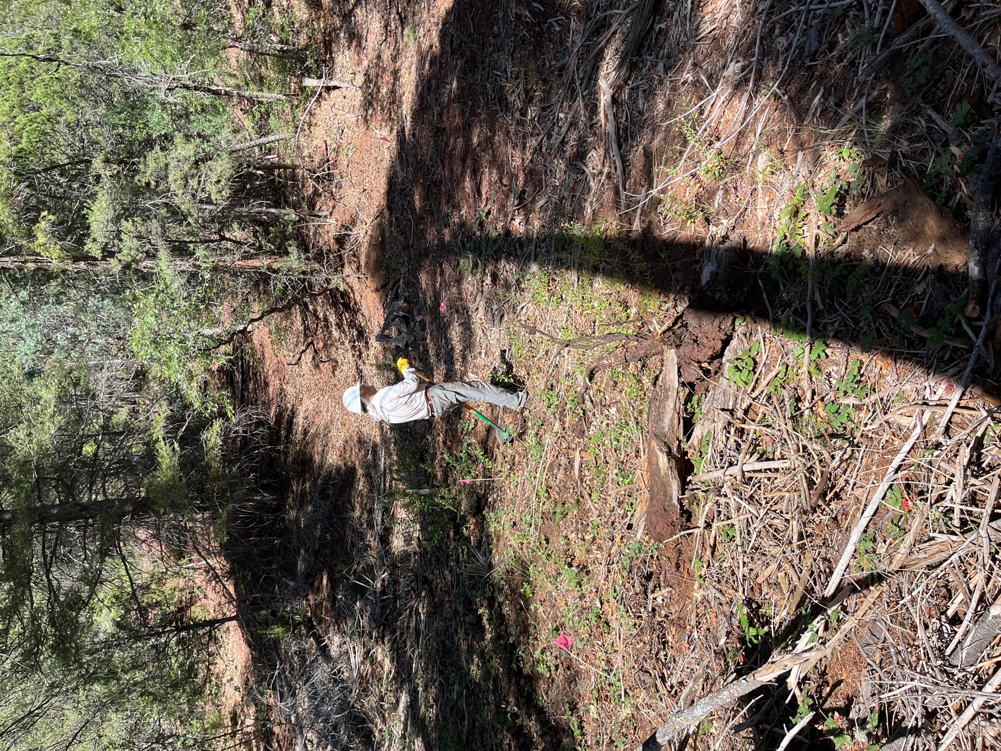

Bill, Laura and Eric went on to the next reroute and started clearing dead wood.

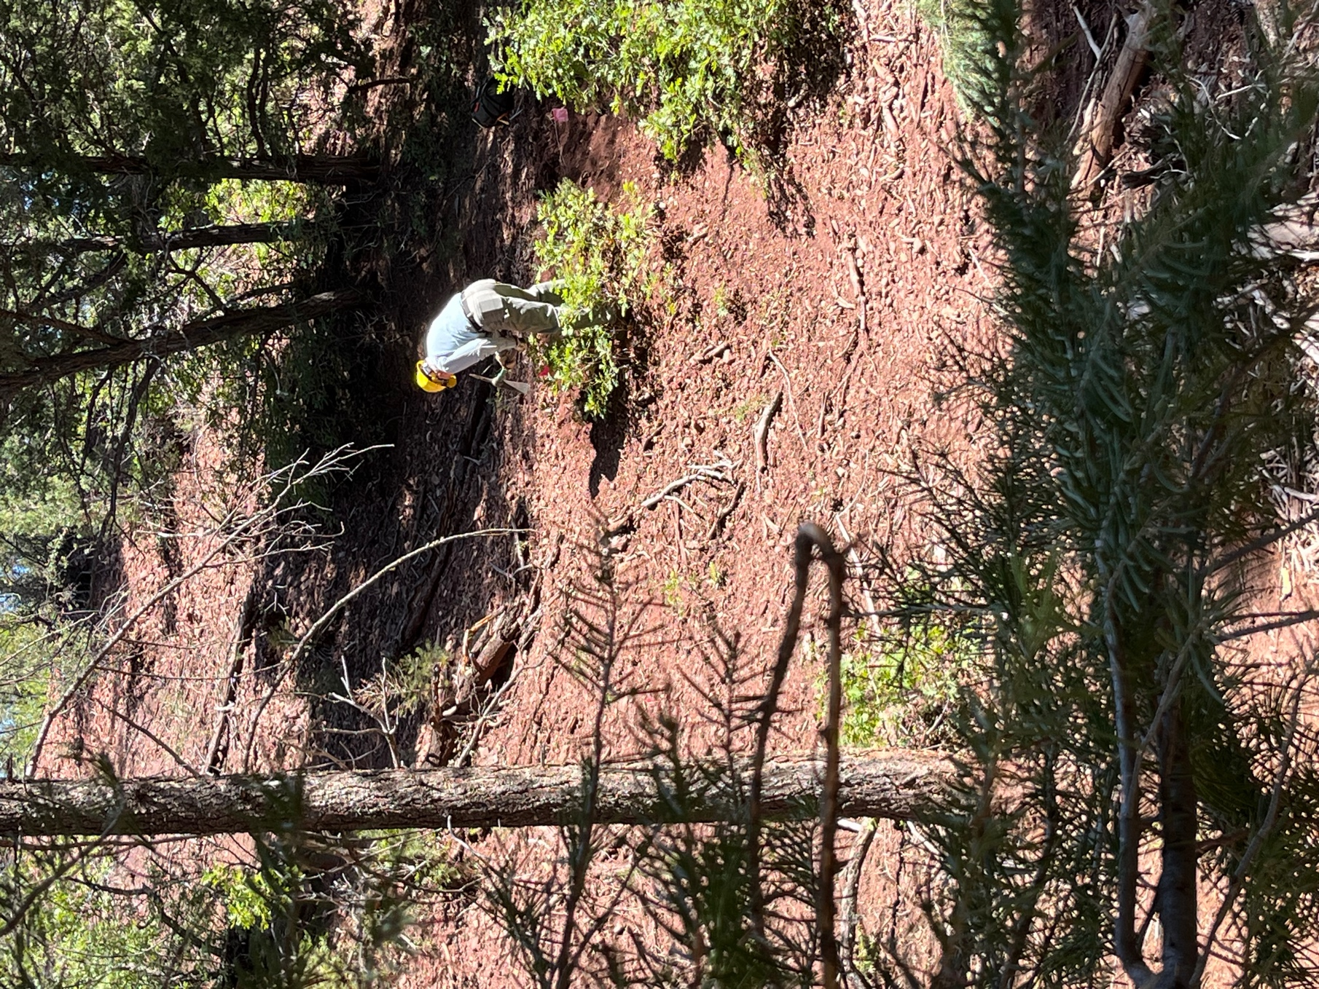

Eric starts digging trail. The old trail runs below the oak where Eric stands.

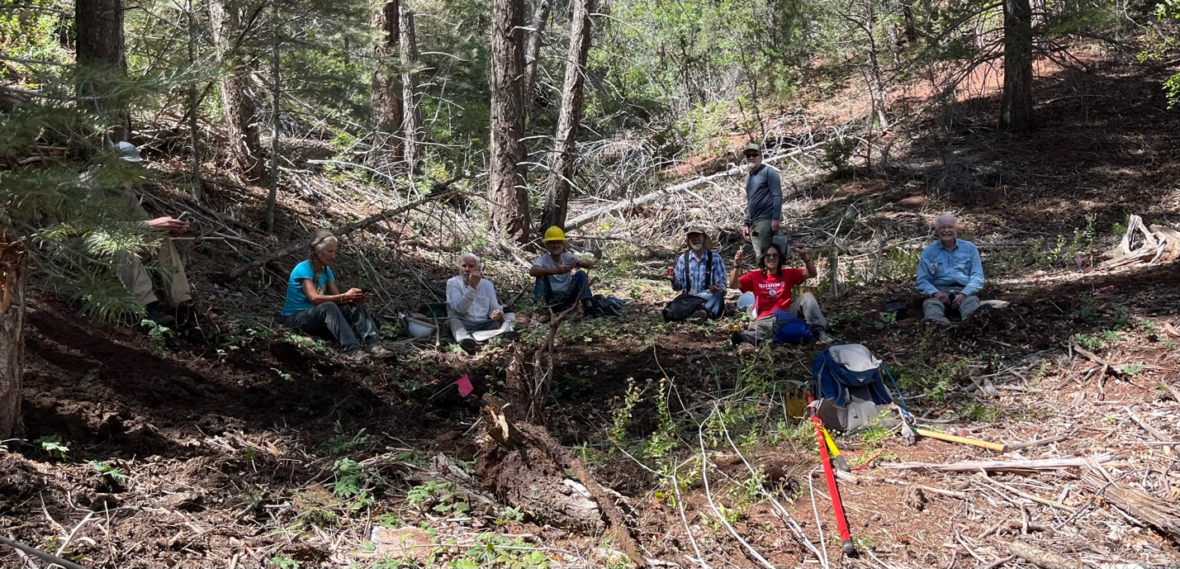

Best part of the day is lunch time!!

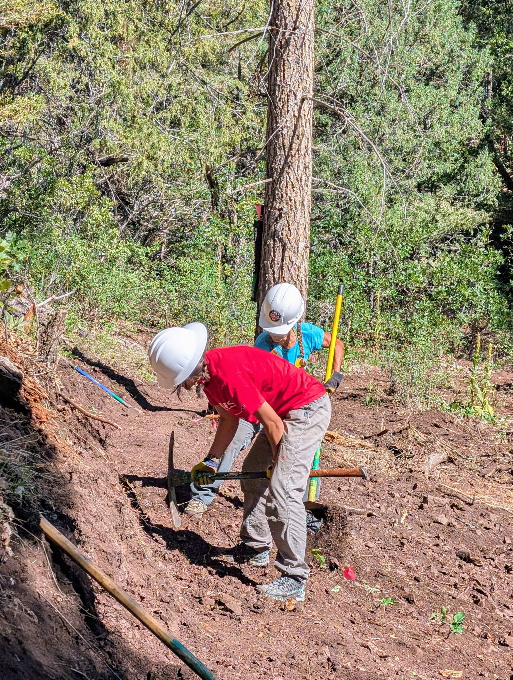

Back to work. Mackenzie and Claudia cut trail into the clay. The slope is rather steep where they are working.

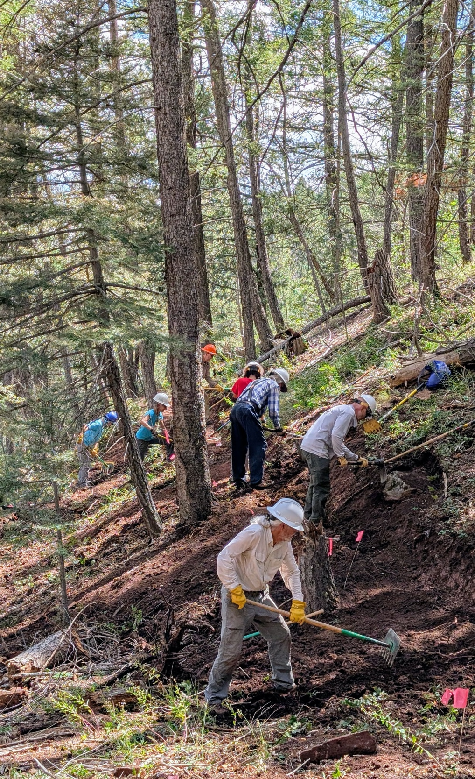

Everyone hard at work- Bill, Chris, Bruce, Mackenzie, Claudia, Jay and Laura.
The old trail runs down where Claudia and Laura are working. Lots of dirt to move!

