Report of the FOSM Project to Fabricate a New Door for the CCC Men’s Restroom in the Lower Part of Juan Tabo Picnic Area, Saturday, September 13, 2025

Sam Beard and Joelle Hertel
Last spring FOSM volunteers fabricated a new door to replace the decayed door for the CCC men’s restroom in the lower part of Juan Tabo Picnic Area. Late in the summer, the door was installed and painted. Recently, a sliding bolt fixture was attached to the inside of the door for security when the restroom is being used.
The volunteers working on this project were Dan Benton, Betsy Galloway, Joelle Hertel, and Sam Beard.
Photos of the installed door are presented below.

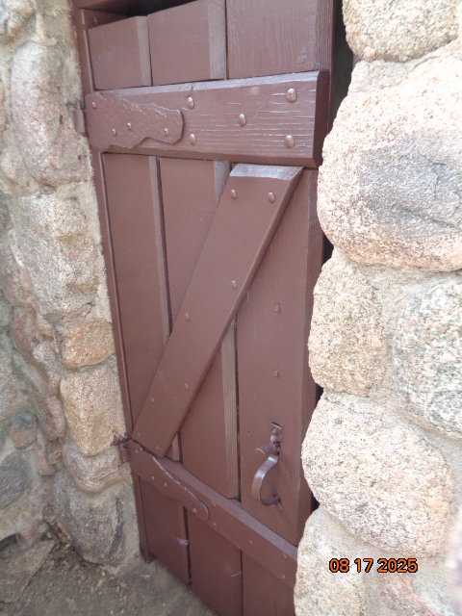
New door on CCC men’s restroom in the lower part of Juan Tabo Picnic Area. All photos by Sam Beard
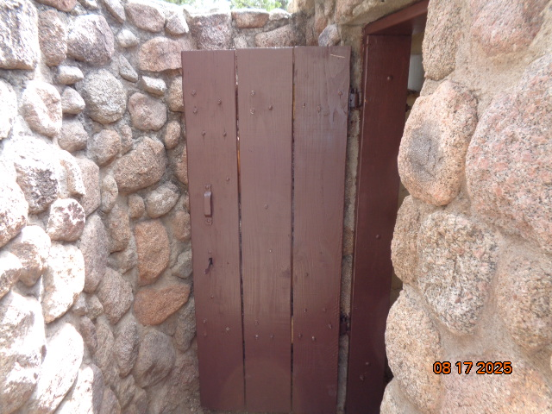
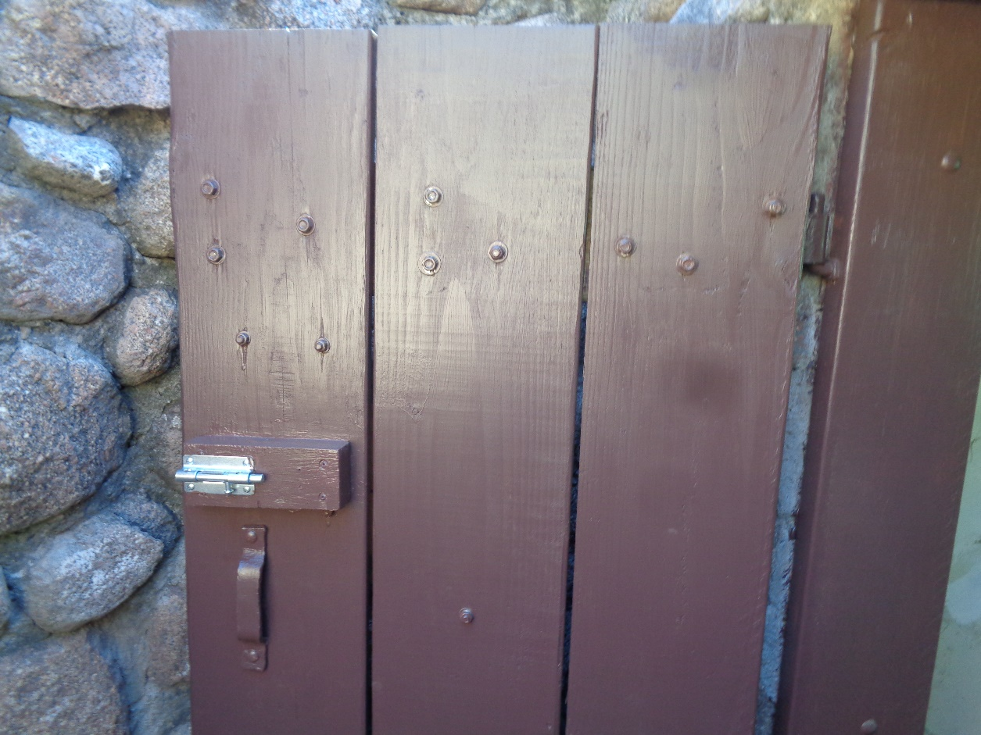
Sliding bolt fixture was installed on the door to provide security when the restroom
is being used.

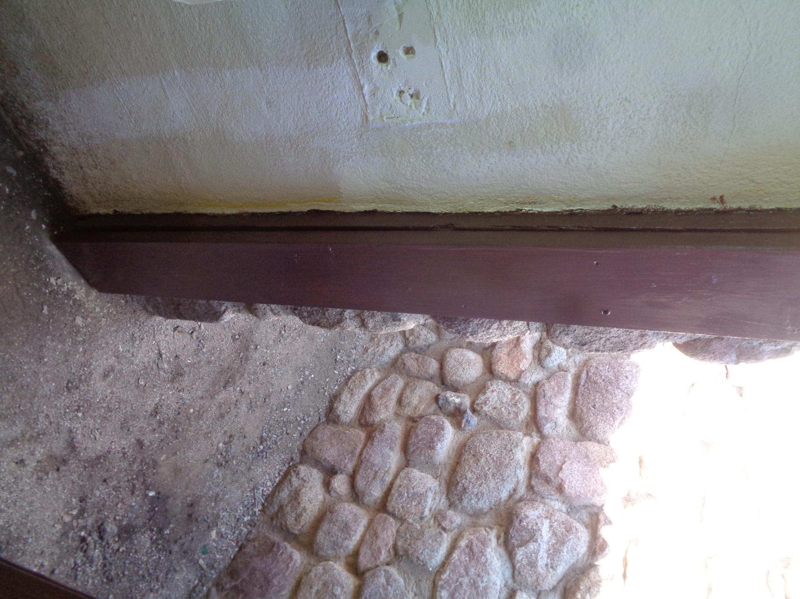
New 2x8 was screwed over the old door frame to fill gap between the door frame and the new door.

