Report of FOSM Project to Repair the Fence in the Parking Lot
at the Lowest Restroom in Cienega Canyon Picnic Aea,
Wednesday, September 17, 2025

Sam Beard
On Wednesday, September 17, eight FOSM volunteers replaced four rotten posts and two rotten rails in the fence in the parking lot of the lowest restroom in Cienega Canyon Picnic Area. One loose post was stabilized with rocks and dirt.
The pressure-treated posts were installed approximately 30 years ago, and they frequently decay a few inches below the surface of the ground. It is usually very difficult to dig out all the wood remaining in the hole after the upper part of the post is removed. Occasionally, only the outer part of the wood around the post decays, leaving a small cylinder of good wood attached to more wood deeper in the hole. These parts of the decayed post are especially difficult to remove. Chuck Logan just donated his high-lift jack to FOSM; therefore, it may be easier to remove the wood from the holes.
The volunteers working on Wednesday were Cliff Giles, Sim Cook, Sam Beard, Dan Benton, Eric Russell, Jerry Carroll, Chuck Logan, and Lorna Morrow.
The photos below illustrate the process of removing the old post and installing a new post in the fence.

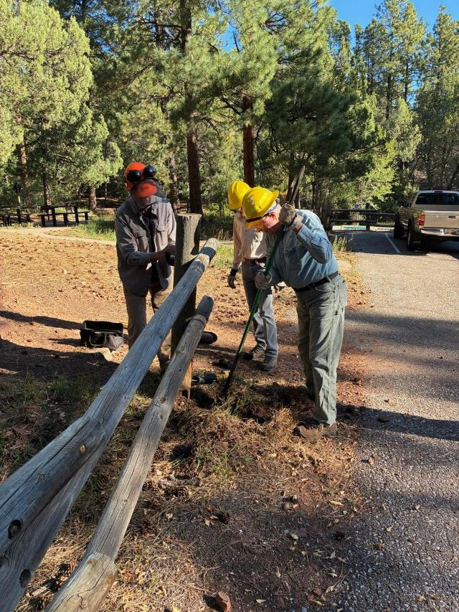
Dan Benton, Sim Cook, and Eric Russell are digging out a rotten post in the parking lot
at the lowest restroom in Cienega Canyon Picnic Area. All photos by Cliff Giles

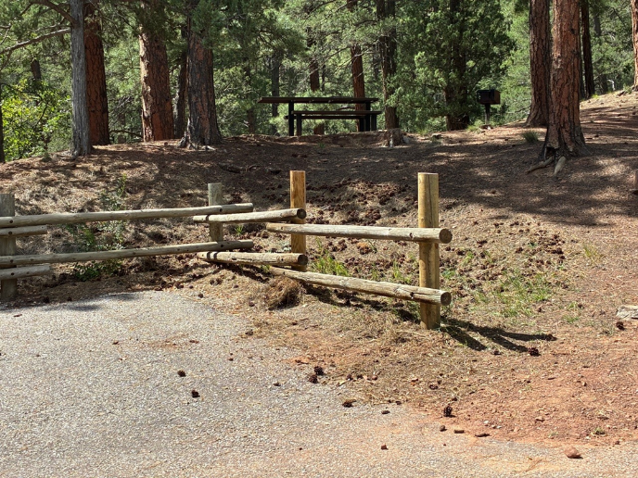
The end post has been replaced, and the rails have been bolted to it.

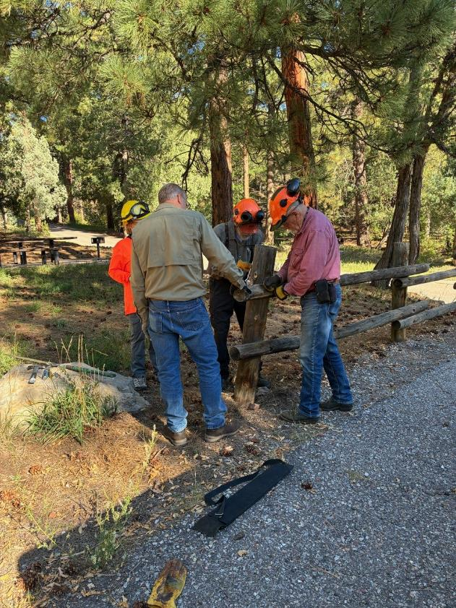
Lorna Morrow, Chuck Logan, Sam Beard, and Jerry Carroll are removing rails from the rotten post.

+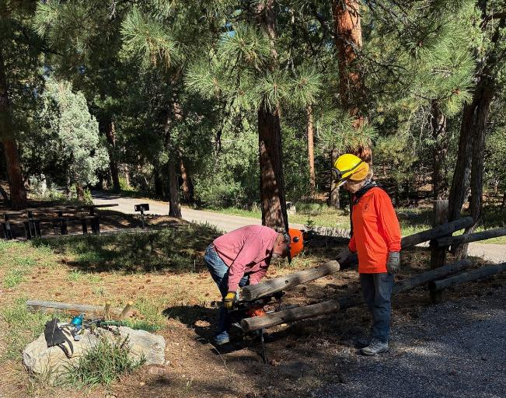
Lorna is observing Jerry using the FOSM power auger to dig out parts
of the rotten post still in the ground. Removing the parts of the rotten post still in the ground
is usually the difficult part of replacing a fence post.

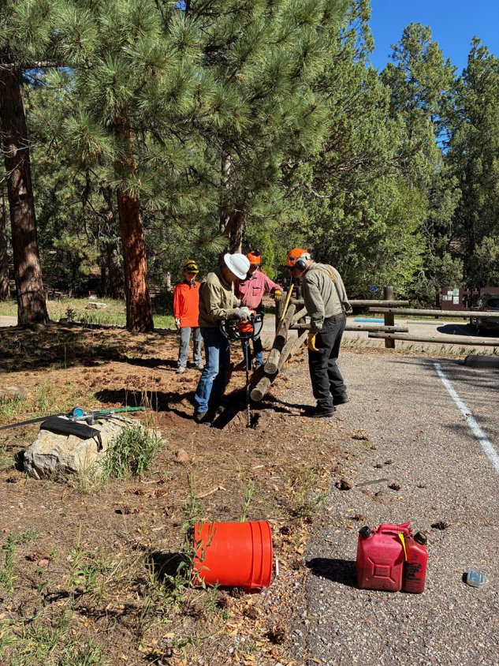
Chuck is also using the FOSM Stihl power auger in an attempt to remove of the
post still in the ground.
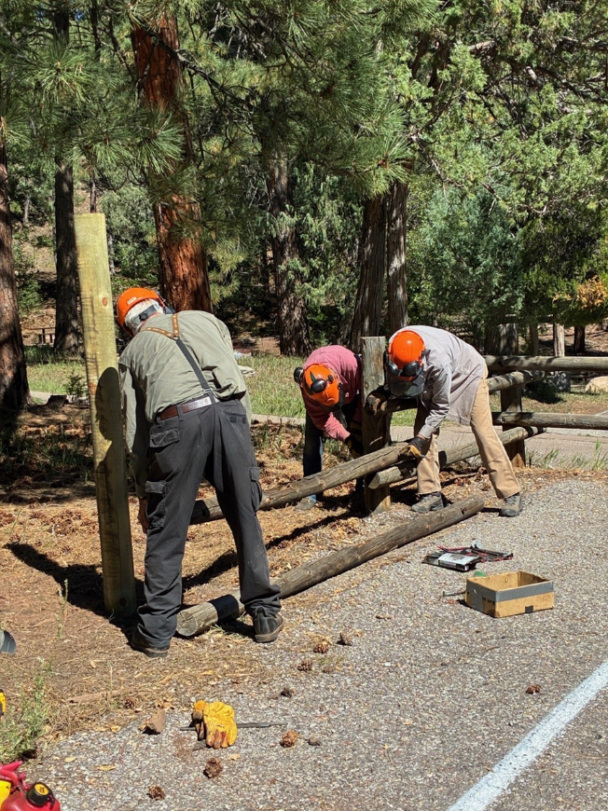
Removing two rotten rails from the section of the fence.

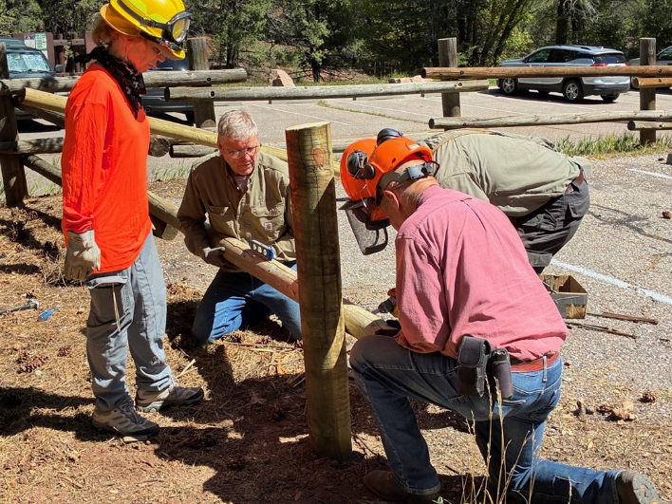
Lorna is observing Chuck and Jerry holding a rail while Sam drills a hole for the ½-inch threaded
steel rod that will secure the new rail to the post.

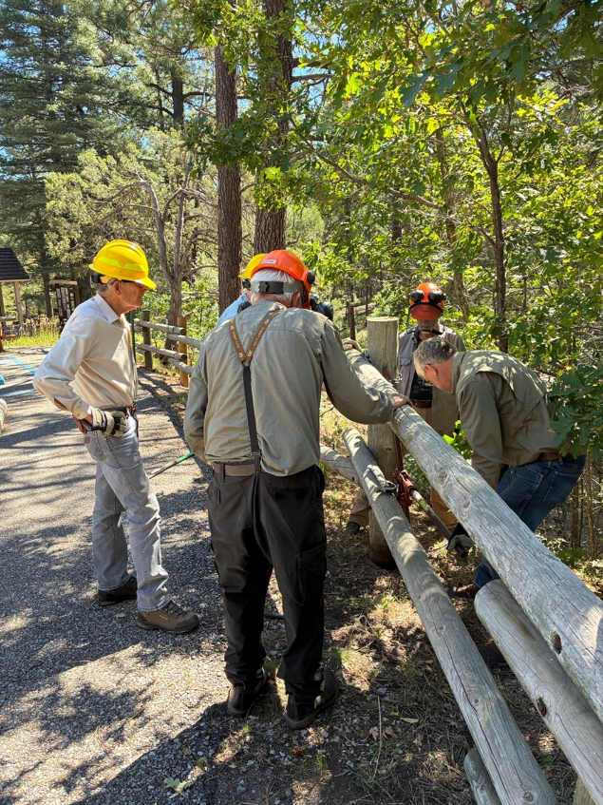
Chuck is demonstrating the use of a large steel high-lift jack to pull a post out the ground.
He donated the jack to FOSM to use in fence repairs.
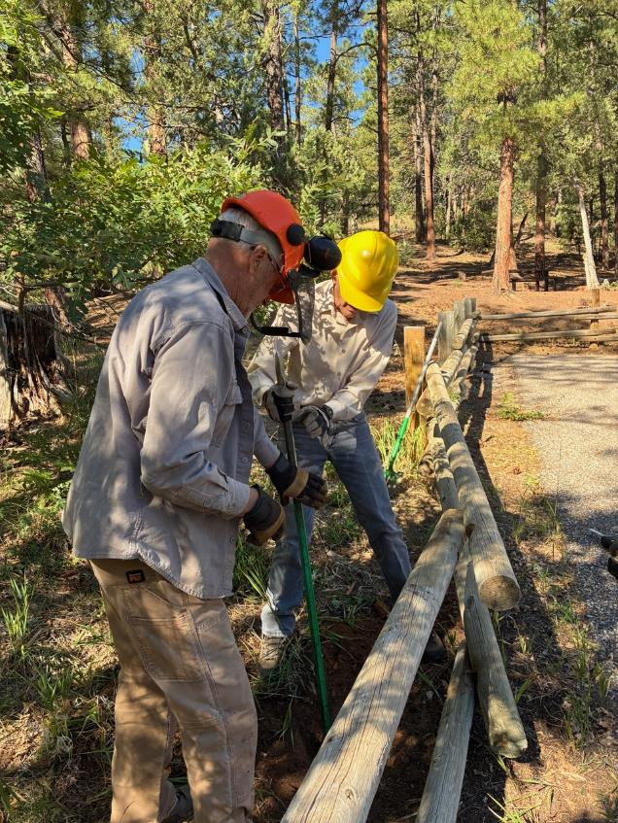
Dan Benton and Sim Cook are using a steel rock bar in an attempt to remove
wood from the old post hole.
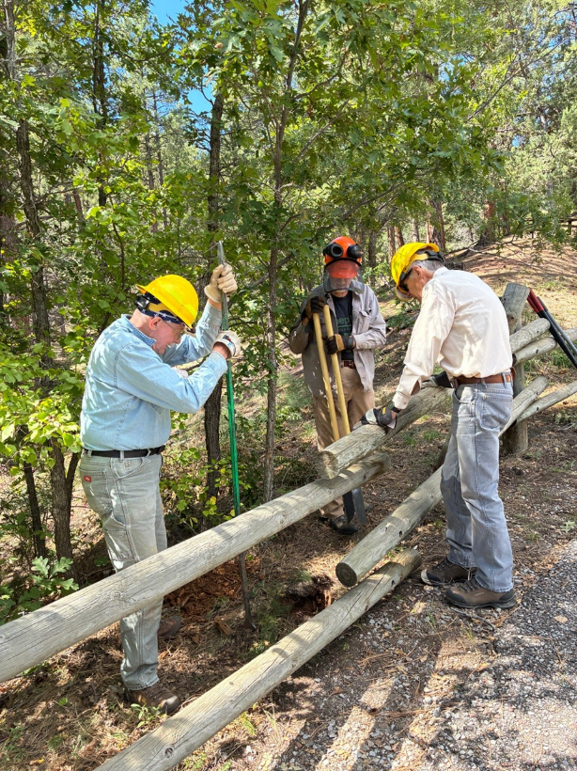
Eric, Dan, and Sim continue to remove parts of the rotten post from the ground
using a rock bar and post hole digger.

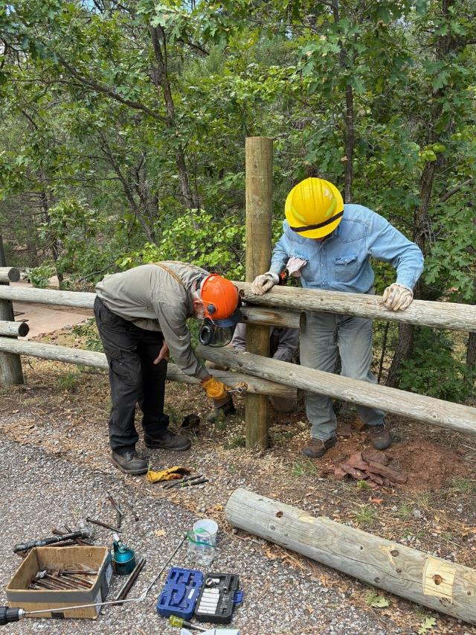
Dan is holding the rail while Sam is using a socket wrench drive to tighten the nut
on the threaded rod securing the rail to the post.
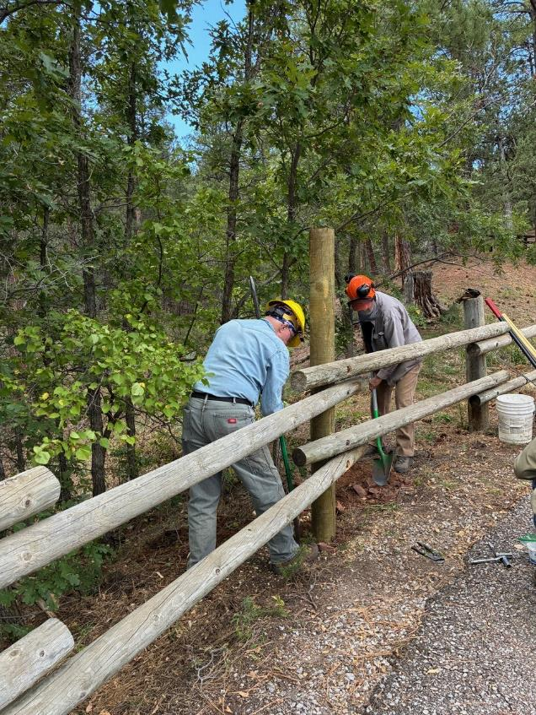
Dan is throwing dirt in the hole around the post while Eric is packing the dirt with a rock bar.
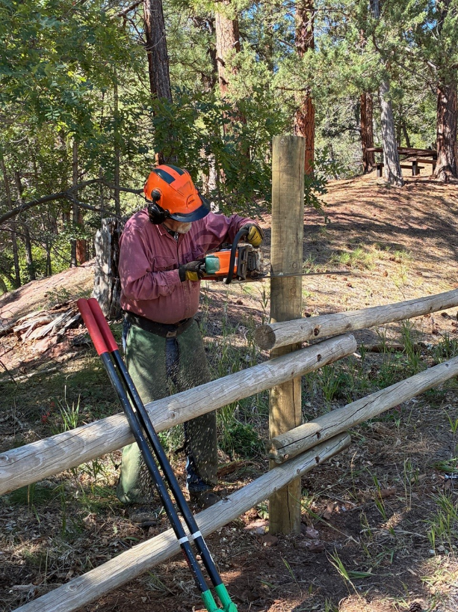
Jerry is using his chain saw to cut two feet off of the post.
The original pressure-treated post was 8 feet long, and the post is in the ground
two feet. The height of the post above the ground is 4 feet.

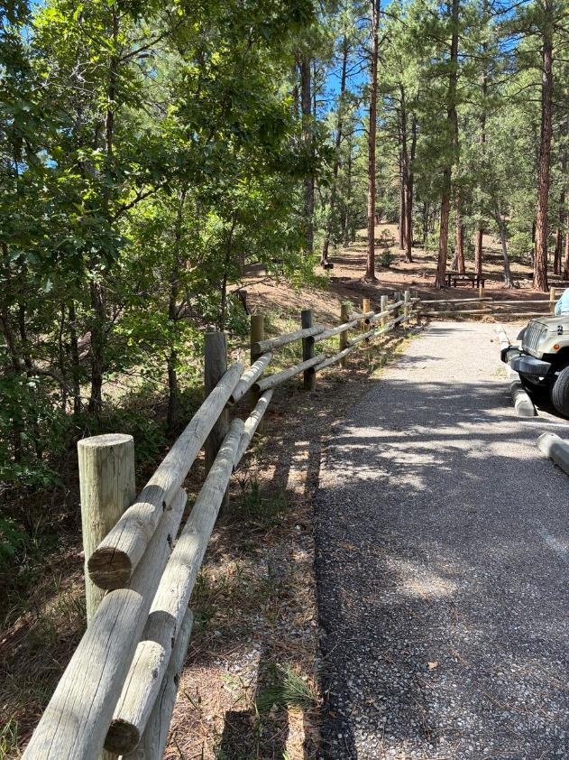
This section of the fence has been repaired. The third post in the fore ground was replaced.

