Thursday, 09/18/25- Old Faulty: What a fabulous day! The morning was cool when 8 volunteers met up with Jen, Chris and Naomi (SRD and FS) for work on Old Faulty. The group spit into 3 with Chris completing some work on the farthest reroute, Jen, Naomi, Eric and Bruce continuing work on the next reroute and Claudia, Cai, Dan, Mike and Laura starting work on the middle reroute. Luis did some mapping and photographing while he deals with a hand injury. By lunch time we were all working on the middle reroute on a picture-perfect day.

Volunteers: Luis Cuadros, Eric Russell, Mike Madden, Bruce Hansche, Cai Reil,
Claudia Bergsohn, Dan Burwinkle and Laura Leon

Pictures: Luis Cuadros and Laura Leon

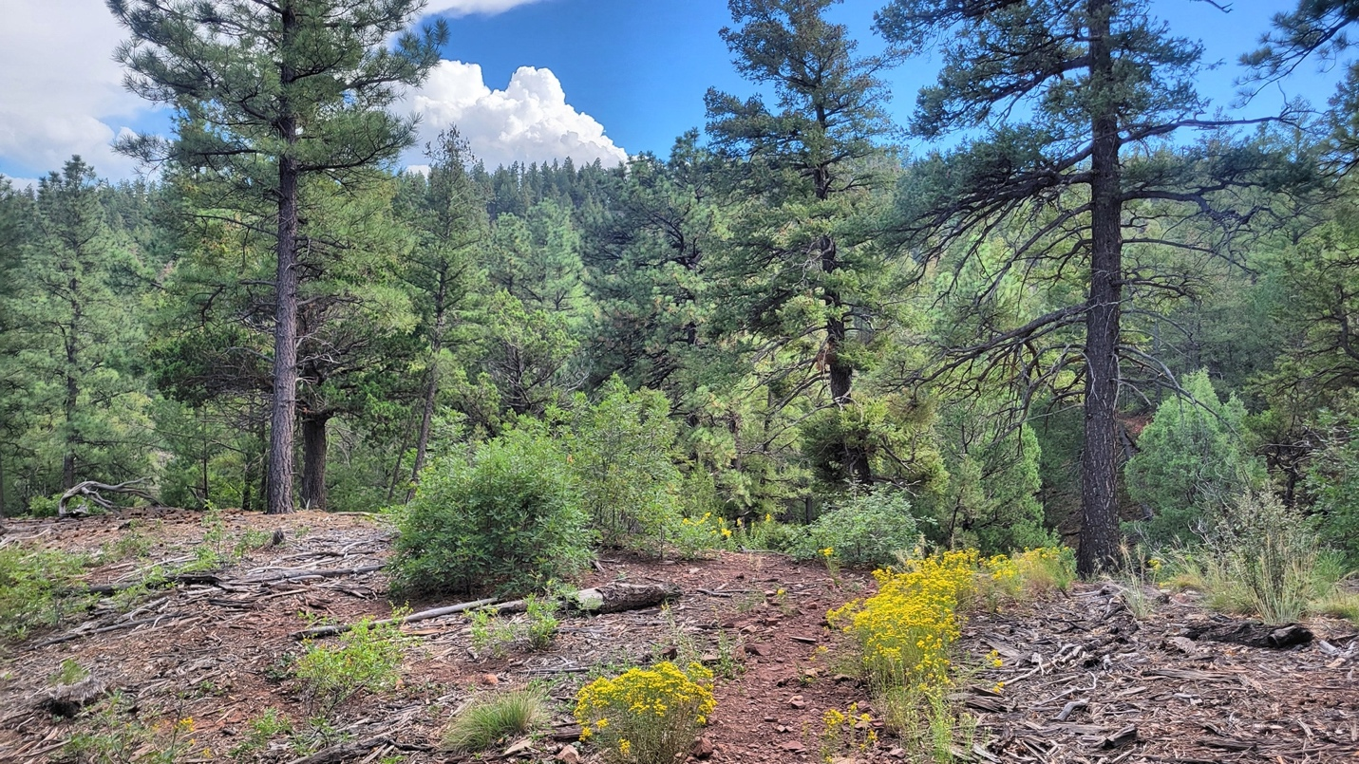

The view from our tool stash/meet up spot.

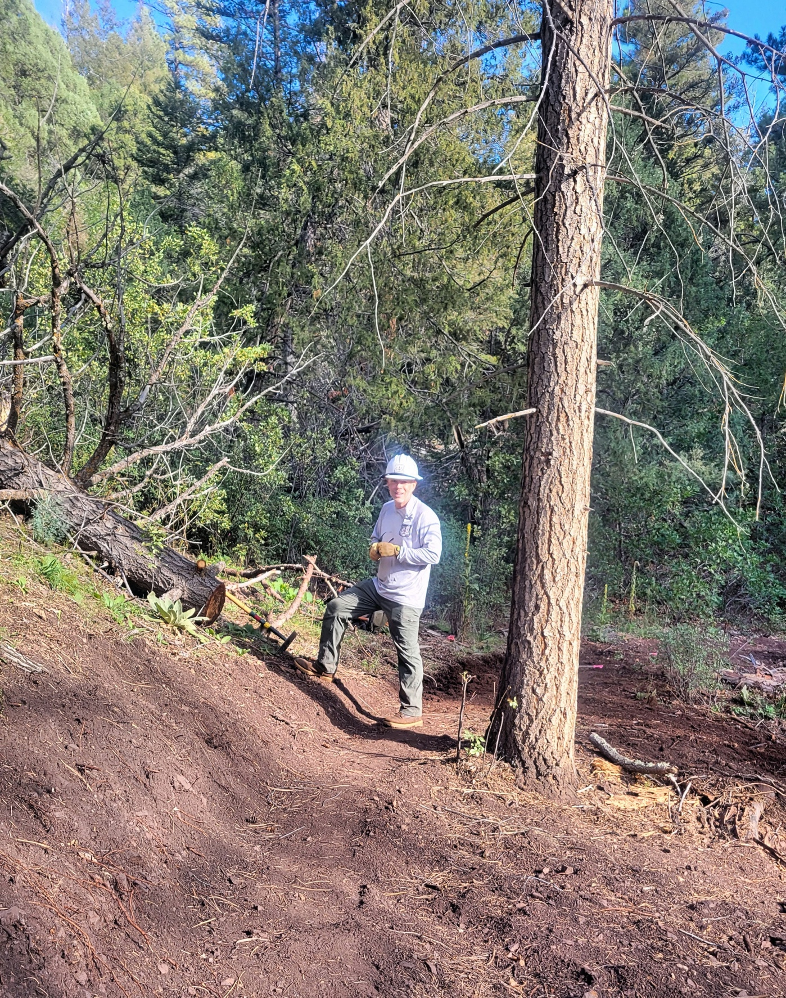

Chris finished up work on the farthest reroute. He’s glowing in the sunshine!

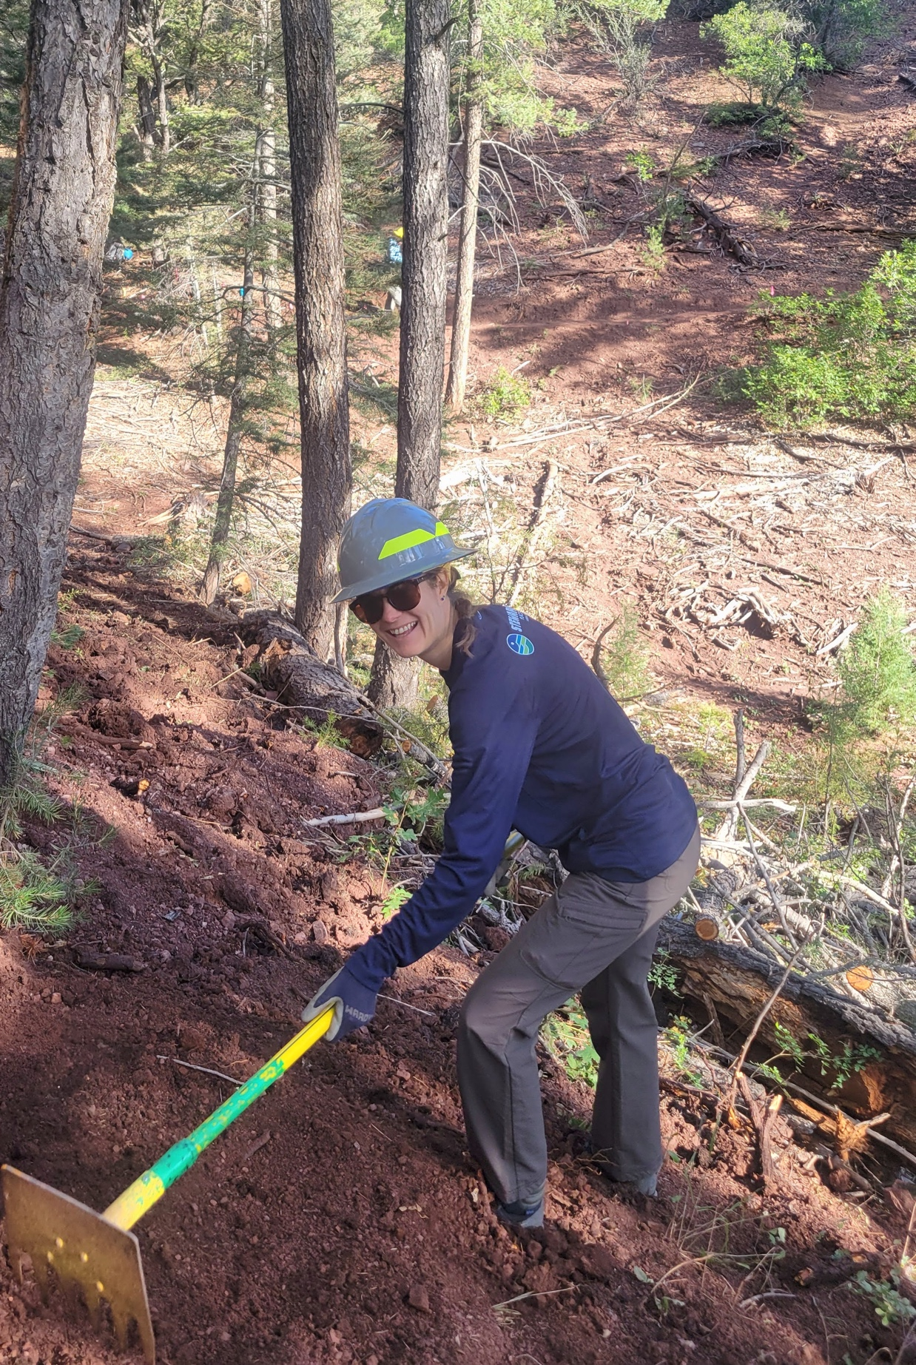

Naomi from the FS joined us for the day- she’s very excited to be a digger!
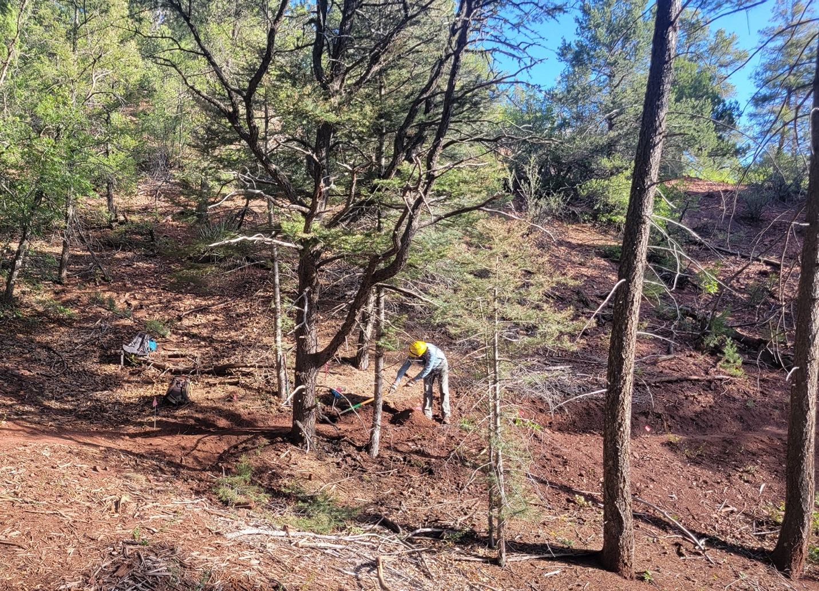

Eric and Bruce ended up where they left off last week- the curve is harder than it looks. And of course, there is a big rock.

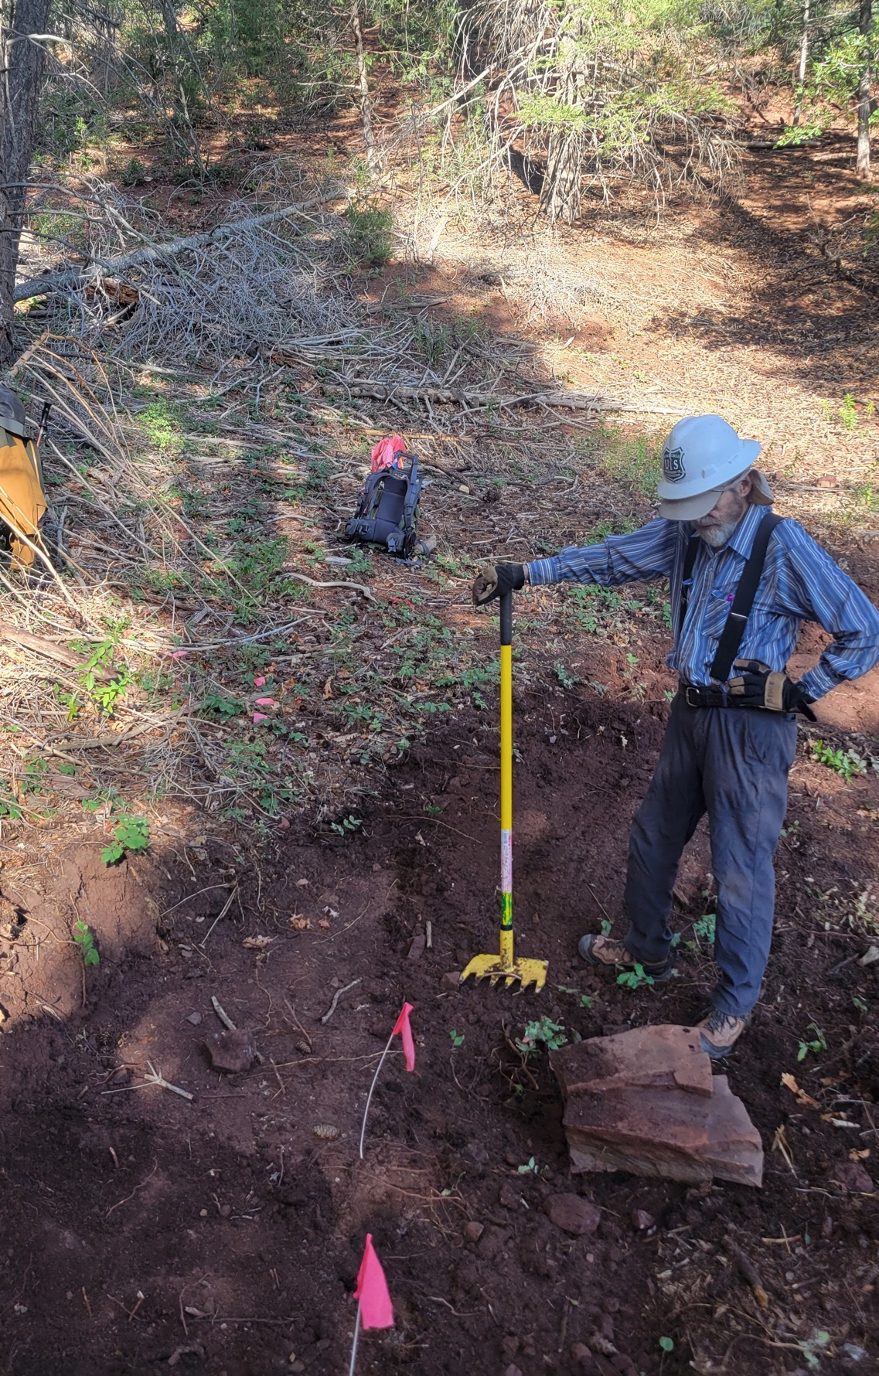

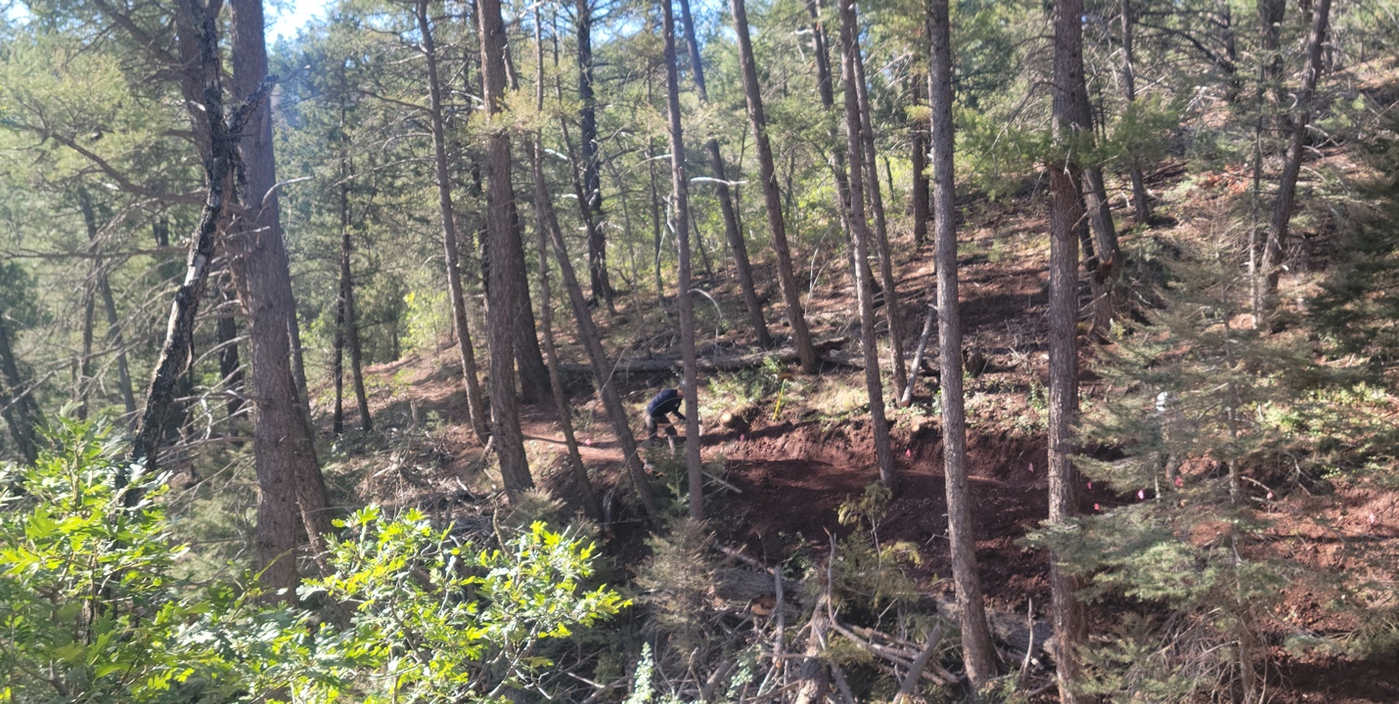Jen and Naomi do some clean-up work along the second reroute.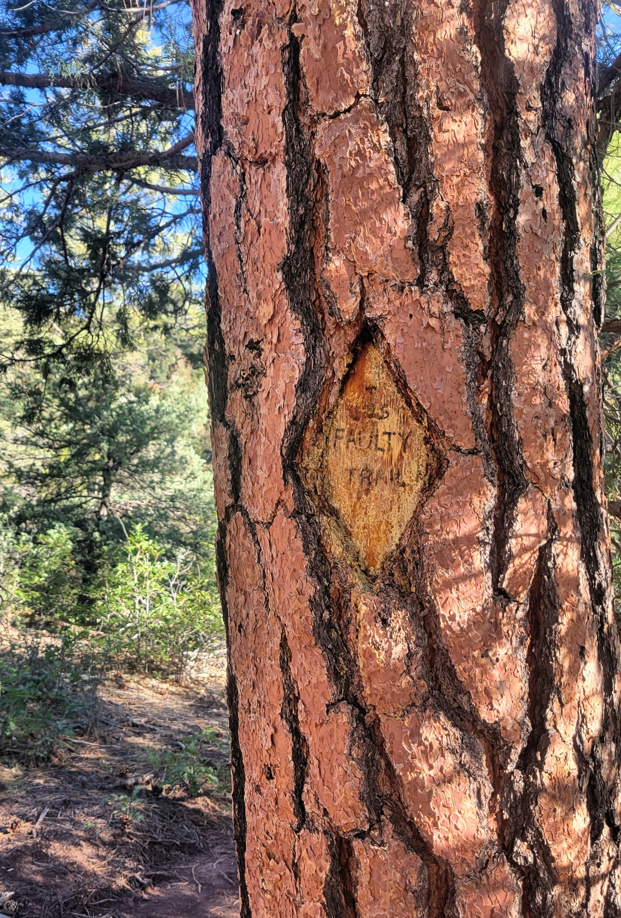
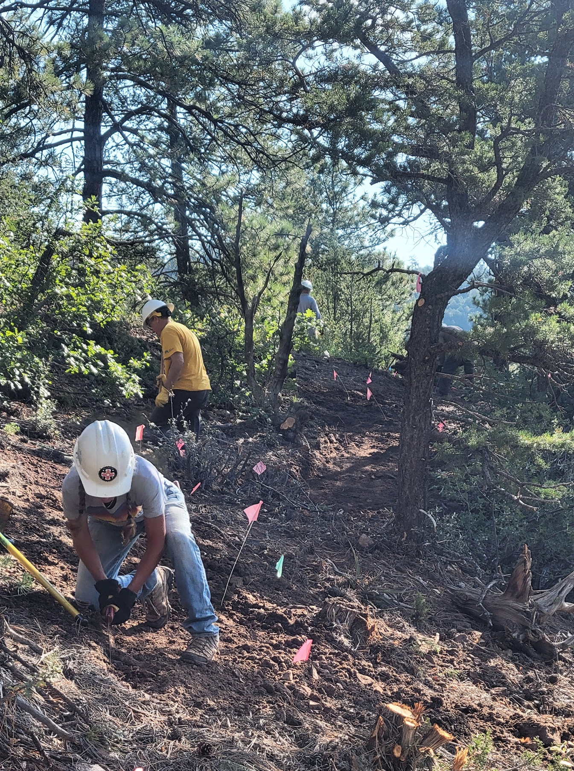

Meanwhile, Claudia, Cai and Dan start on the middle reroute.

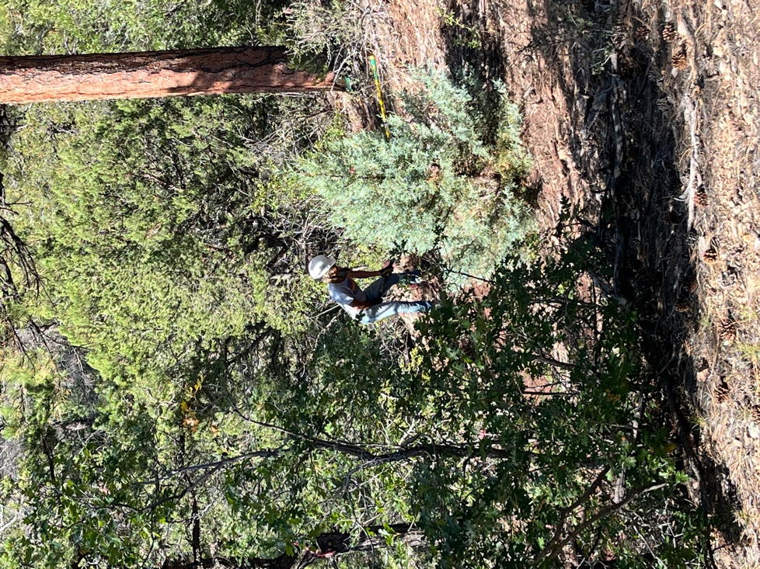

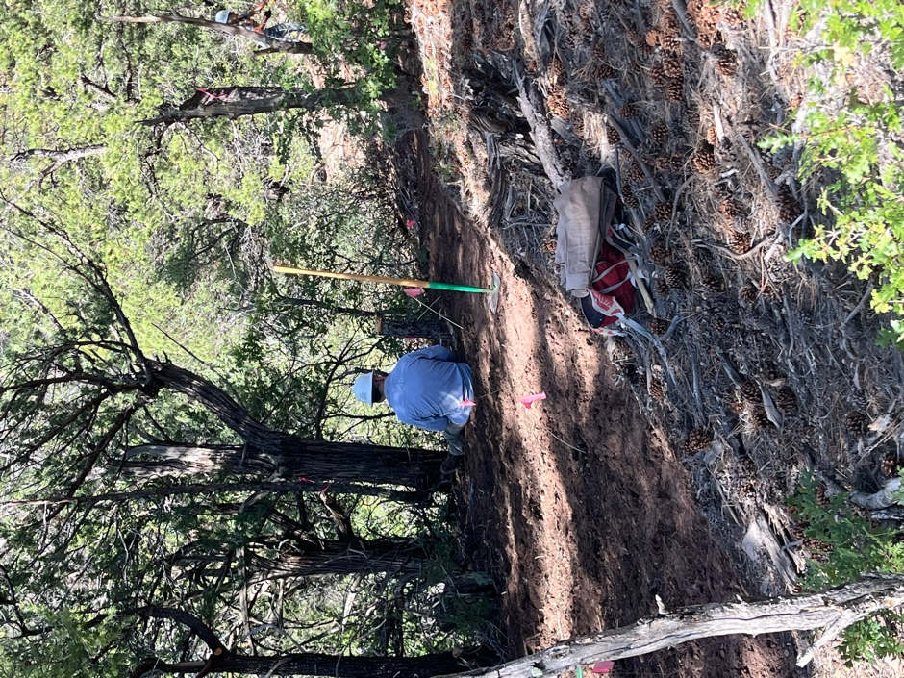 Take a break!
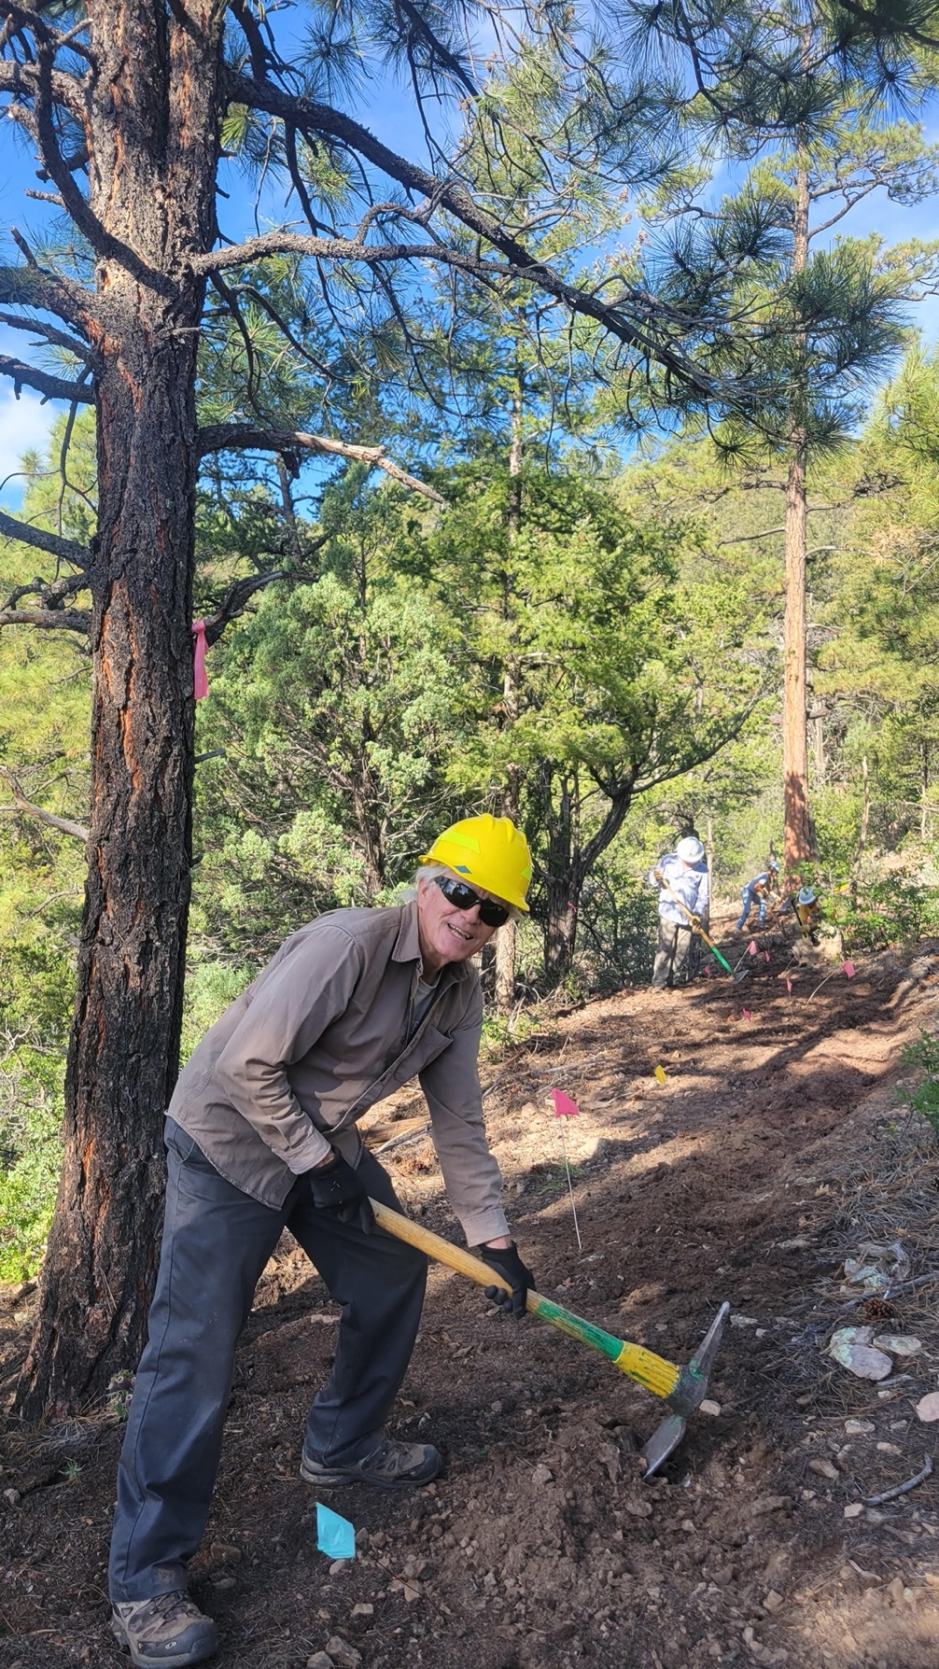

Mike is super excited to dig.

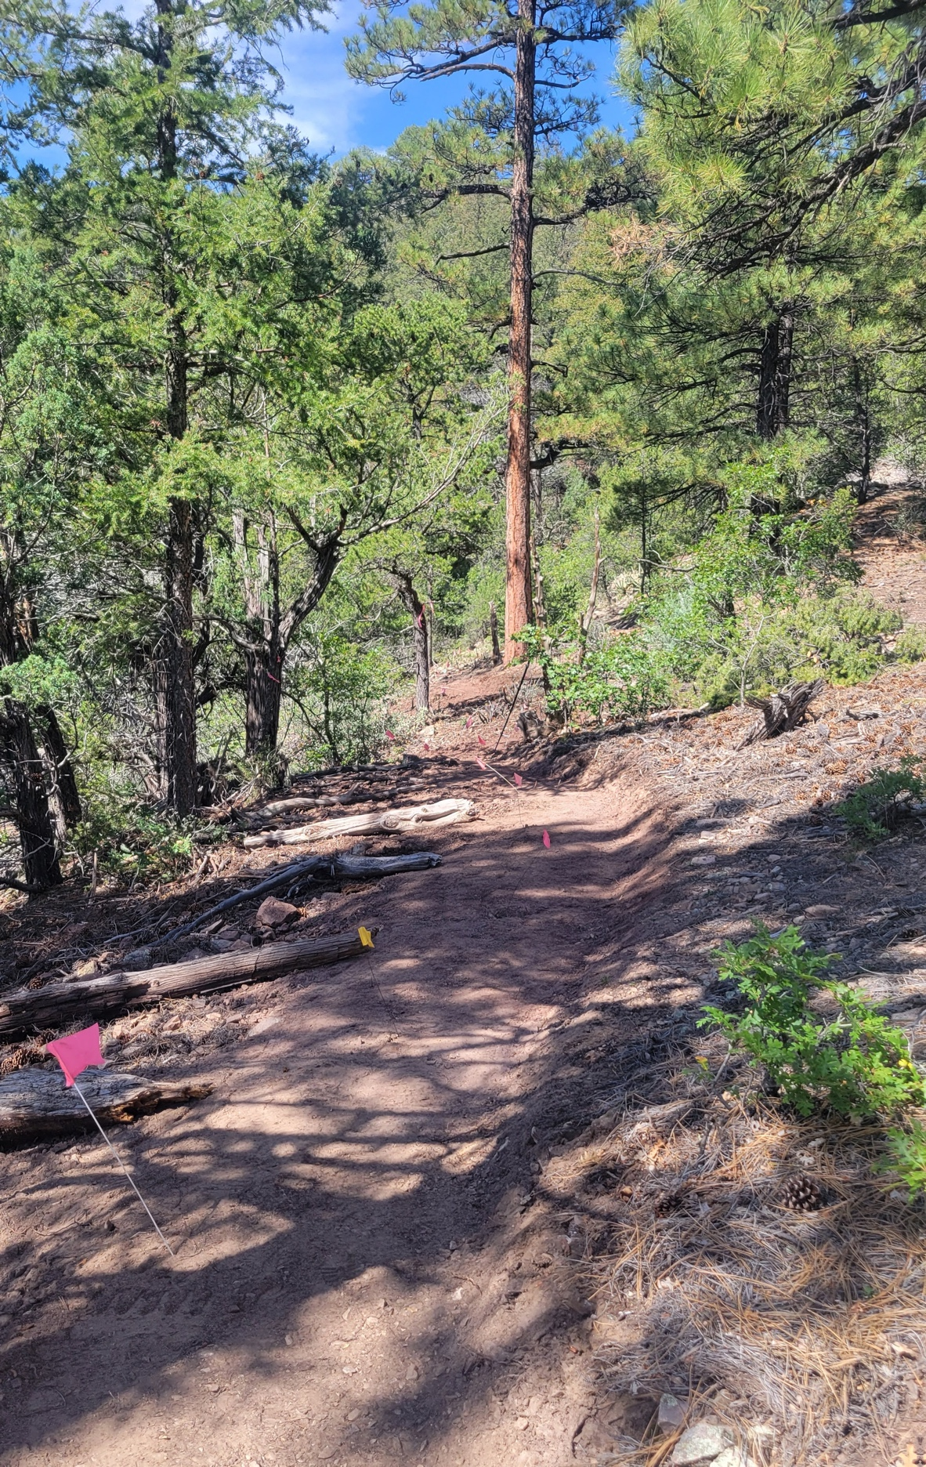
A finished section of the middle reroute.
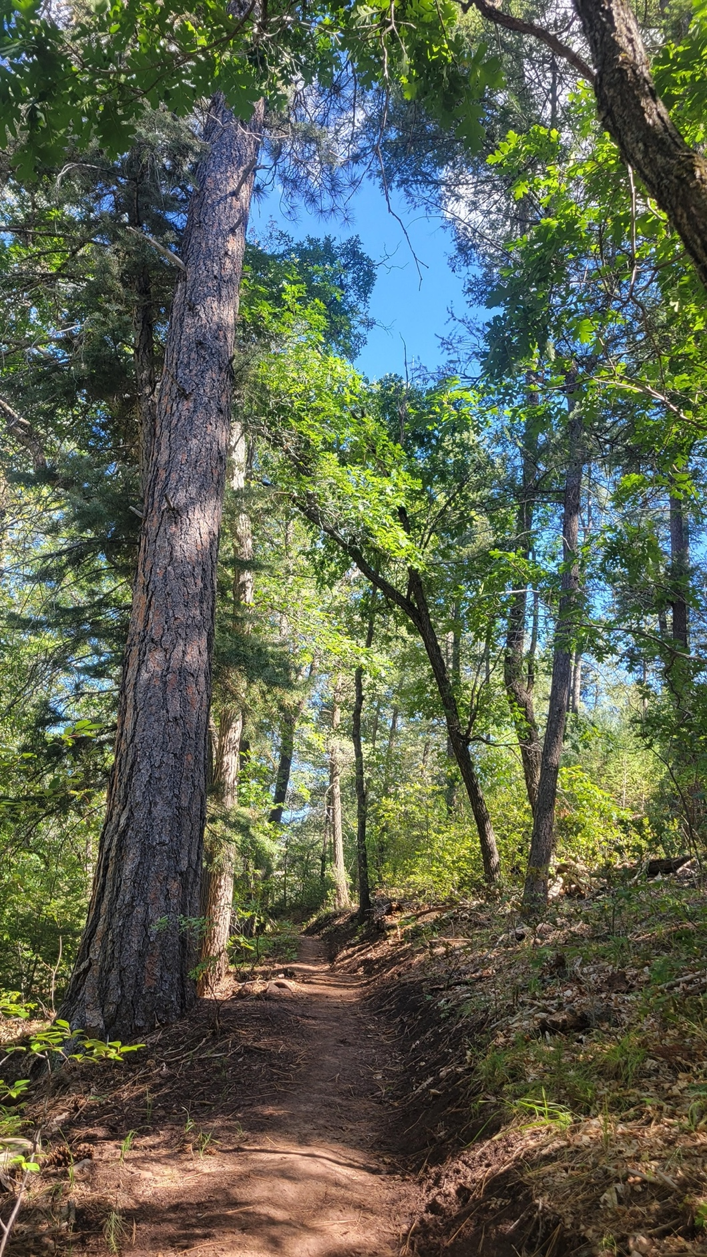
The finished second reroute.

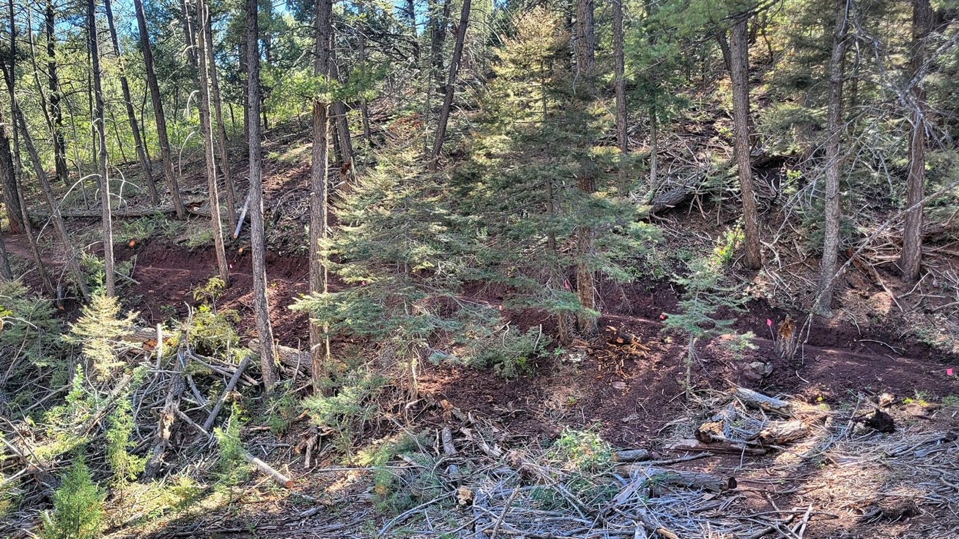

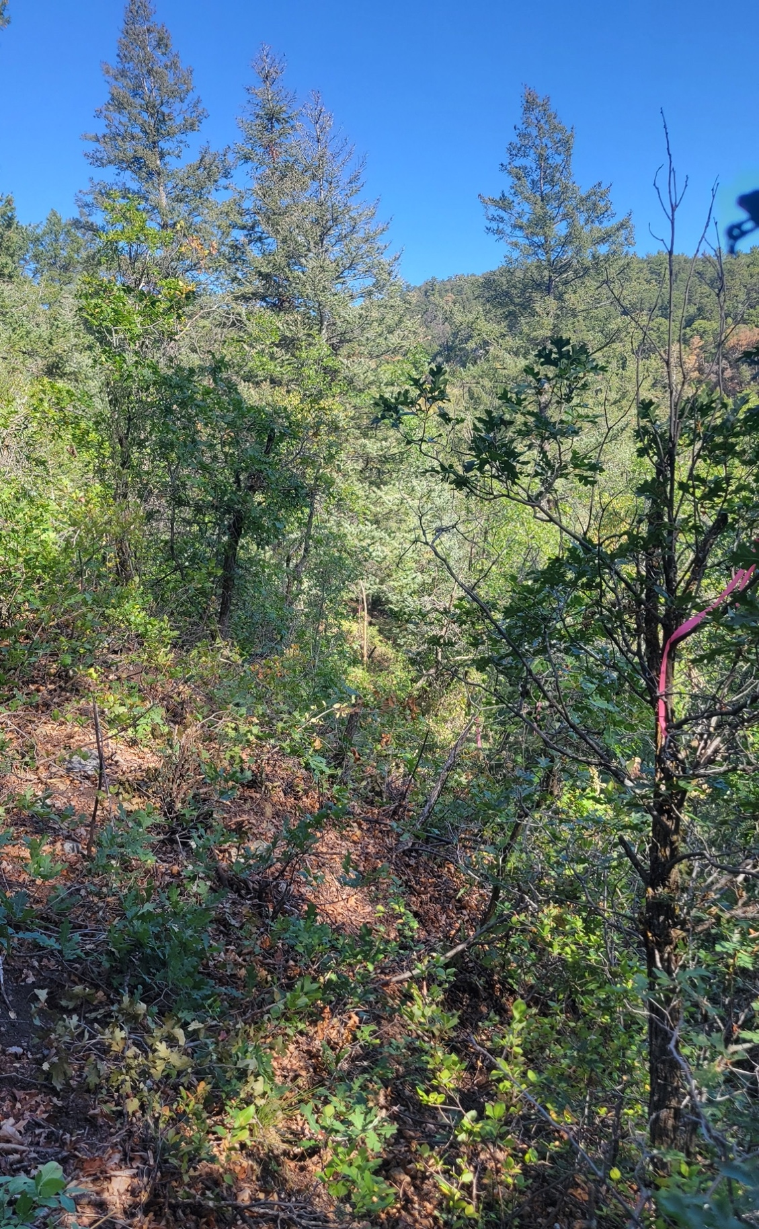

The upcoming challenge. And it gets really steep too.

