Report of FOSM Project to Fell Hazard Trees along Upper South Crest Trail
and Trail to Kiwanis Cabin, Wednesday, September 24, 2025

Sam Beard

On Wednesday, eight FOSM volunteers felled 28 hazard trees on the loop route composed of the upper Crest Trail above Kiwanis Meadow Road, the trail to Kiwanis Cabin, and the road leading down to where the three 4WD vehicles were parked at the entrance to the meadow. The hazard tree diameters ranged from about 3 inches to 24 inches. These trees were identified by a couple of volunteers who hiked the route and cut small blazes in the trunks after Canyon Young, SRD Trails and Wilderness Program Manager, gave FOSM permission to fell hazard trees along Sandia Crest area trails.
The volunteers working today were Cliff Giles, Sim Cook, John Quinley (new volunteer), Sam Beard,
Chuck Logan, Jerry Carroll, Dan Benton, and Eric Russell.

Project photographs are presented below.
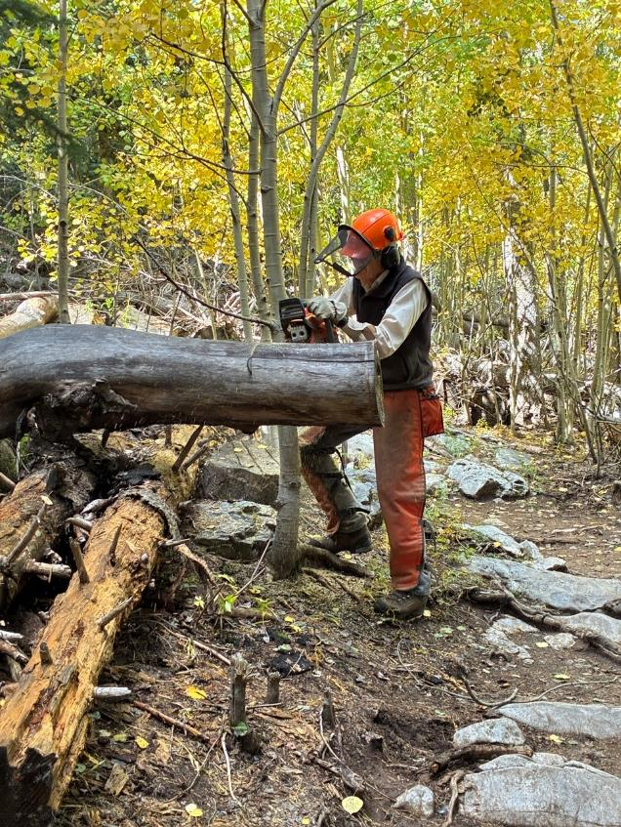
Sim Cook cutting off the end of a log extending into the trail corridor.
All photos by Cliff Giles unless noted otherwise
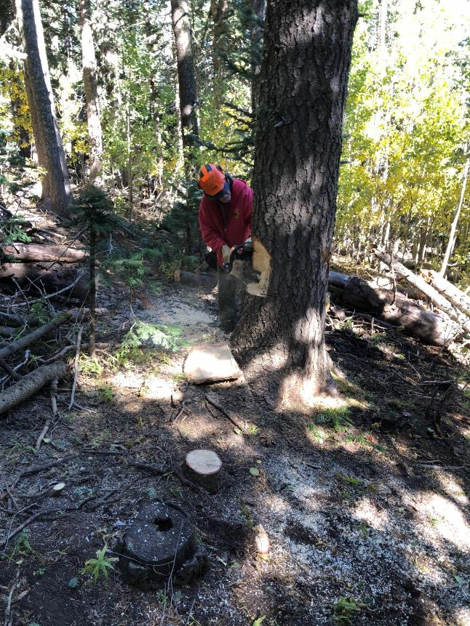
Jerry Carroll cutting a slab off of one side of this 24-inch tree so that the tree thickness is
less than the length of the chain saw bar. Photo by Sim Cook
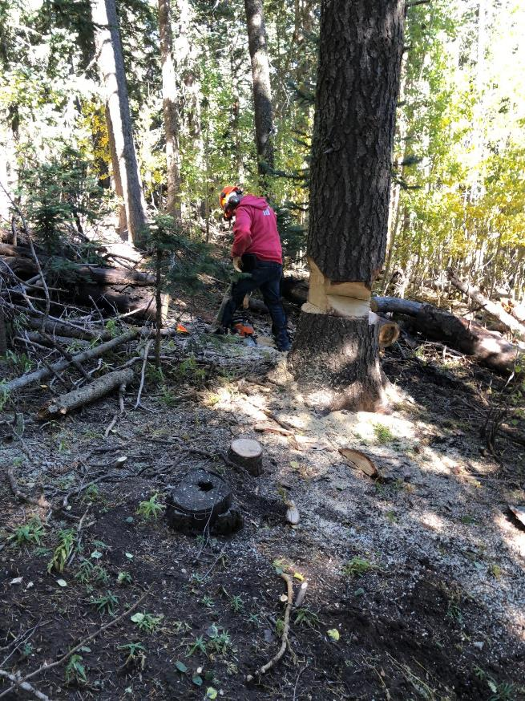
Jerry running away from the falling tree. Photo by Sim Cook
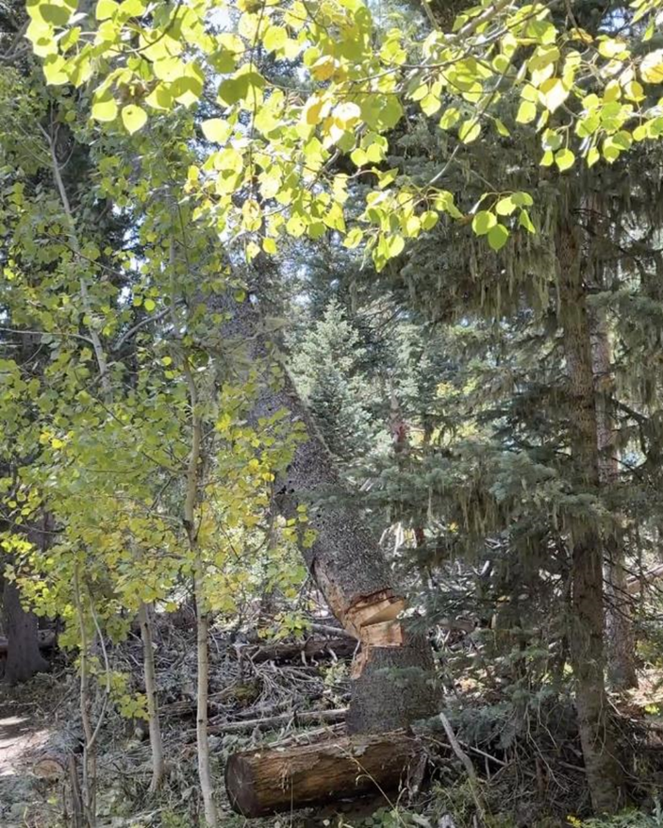
The 24-inch diameter hazard tree is falling.
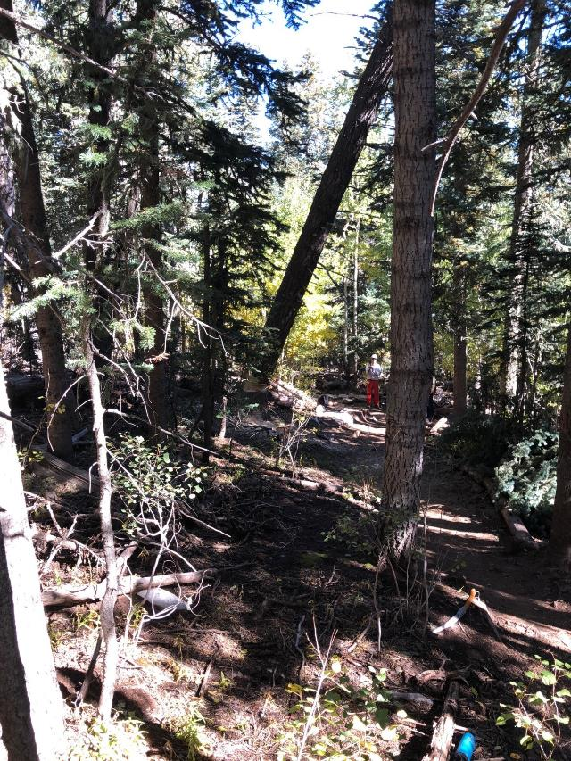
The large hazard tree falling across the South Crest Trail between Kiwanis Meadow Road
and the mountain ridge line. Photo by Sim Cook
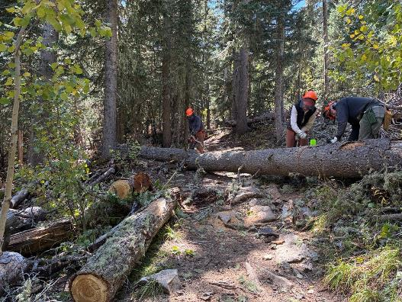
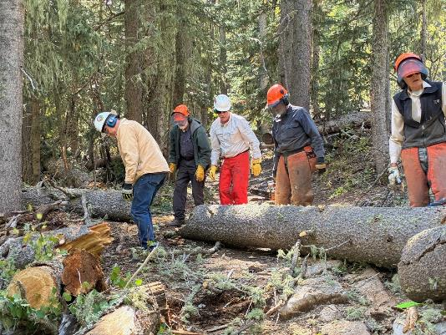
Top – Dan Benton and Eric Russell bucking the large tree felled by Jerry Carroll.
Sim Cook is driving a wedge so that Eric’s saw will not bind. Bottom – Volunteers are preparing
to roll the log off the trail. L to R: Chuck Logan, Sam Beard, John Quinley, Dan Benton, and Sim Cook.
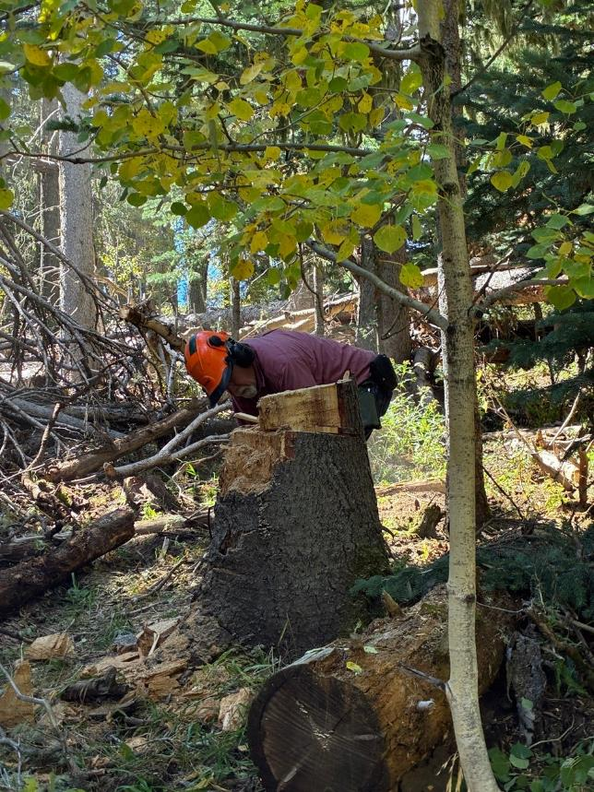
Jerry low stumping a large tree.
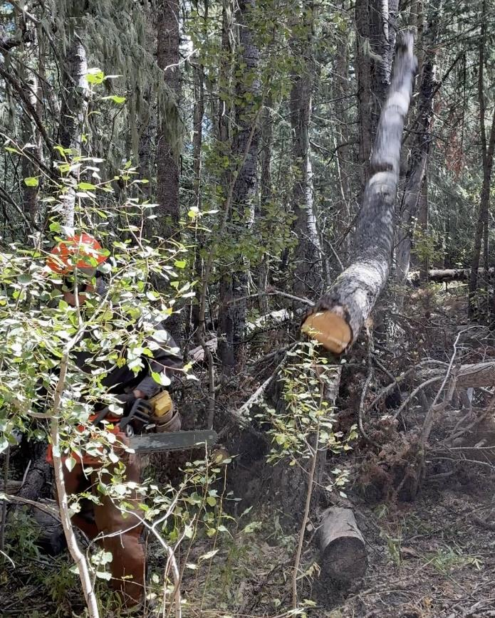
Dan running away as a hazard tree falls.
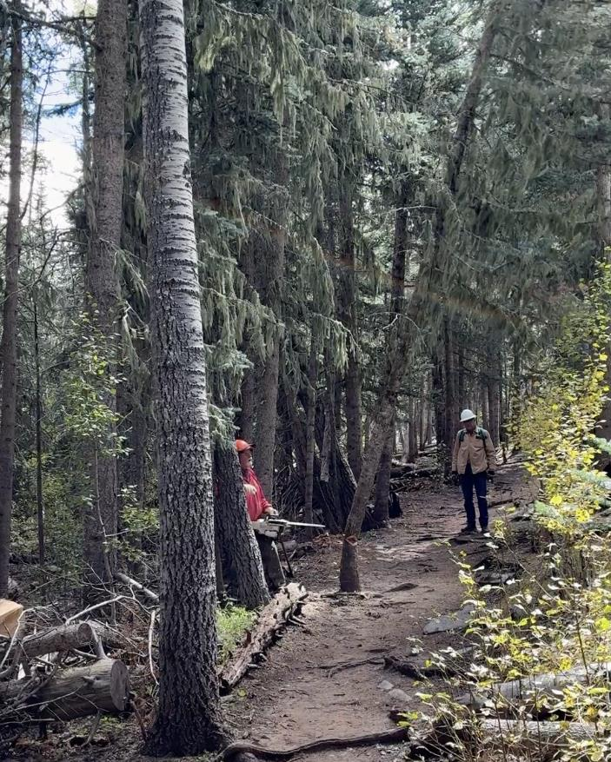
Jerry felling a small hazard tree as Chuck Logan observes.
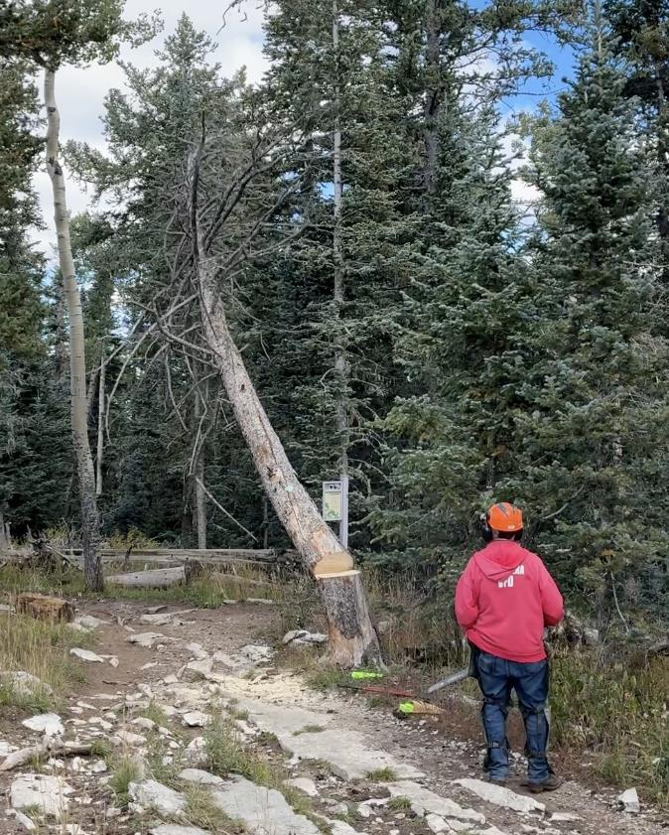
Jerry watches the hazard tree fall near the intersection of the South Crest Trail
and the trail to Kiwanis Cabin. Note that the falling tree will miss the Crest Nature Trail sign.
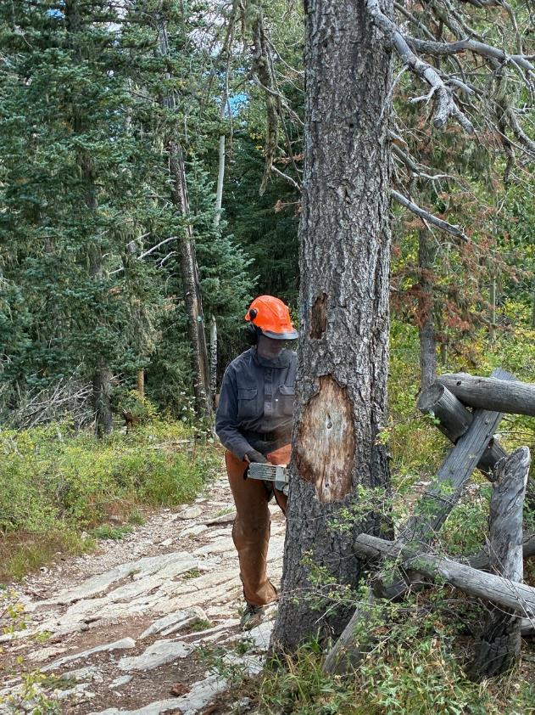
Dan making the face cut on a large hazard tree near the maintain ridge line at an old
buck and pole barrier installed to discourage hiking to Kiwanis Cabin along the ridgeline.

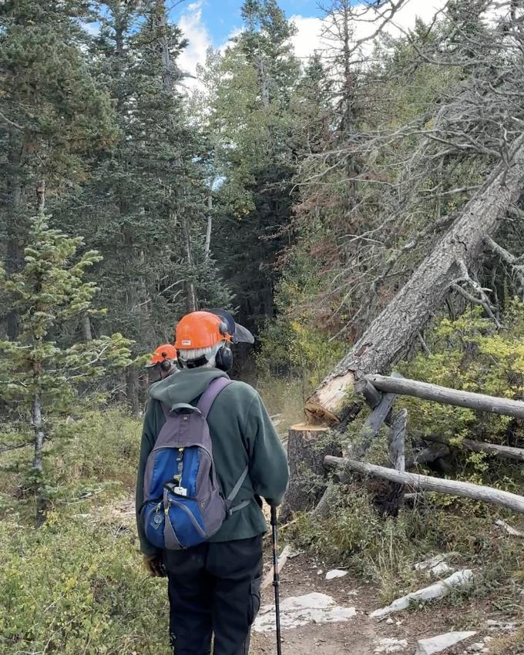
Dan running away from the falling tree while Sam observes. Note that most of the tree
was rotten where Dan cut it.
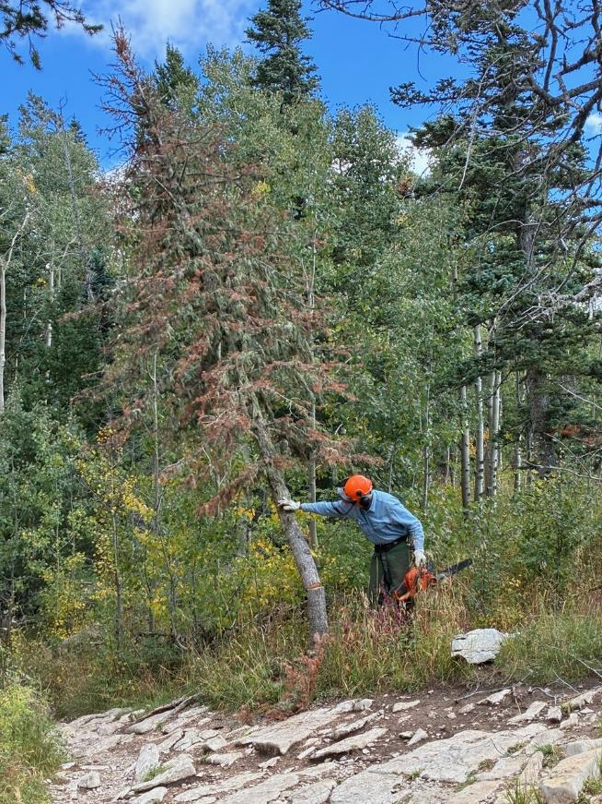
Eric pushing over a small hazard tree on the trail to Kiwanis Cabin.
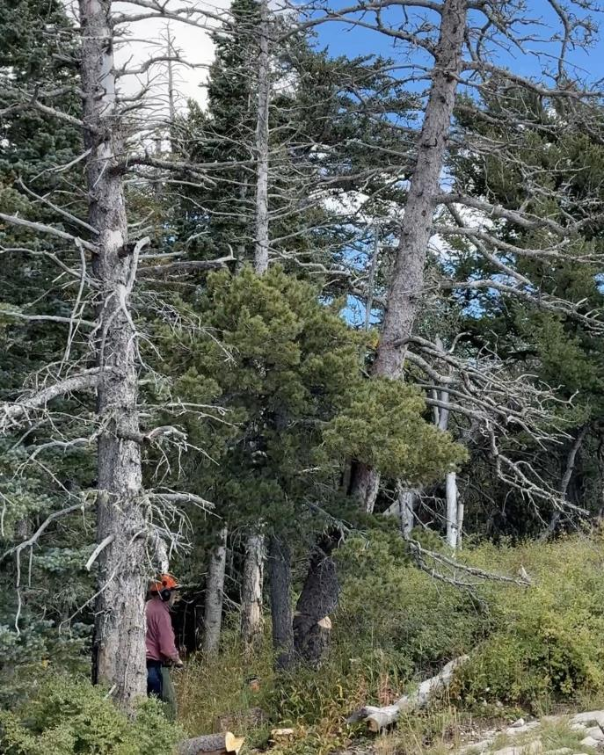
Jerry has just completed making a face cut and back cut in this hazard tree
and is watching it fall.

