Trail Maintenance Project: Monday, September 29, 2025
Byron Garner

On September 29, the Monday trail crew was ready and eager to trek out Ellis trail on a beautiful classic fall morning with peak aspen in full glow from the early morning sun. Though we had an agenda, this began as a leisurely "smell the roses hike" enjoyed by all on a great day. Our main target was the double trunk tree blocking 10k halfway between the Survey junction and Del Agua Overlook reported by Ken Smith. With some initial assessment, selected limbing and coordinated Katana work, the job was done. After taking a short break at the overlook, we began our return on Survey doing some brushing of light aspen overgrowth and some minor intrusions along the way with a sunny and restful lunch at the War of the Roses tree. Ellis and Survey are reported clear with good trail conditions in spite of the heavy rains. The crew included Rene Archer, Ken Wilson, Phil Cromer, Silke Bletzer, John Cooper, Dave McCreery and Byron Garner. Photo credits: Rene Archer and Silke Bletzer

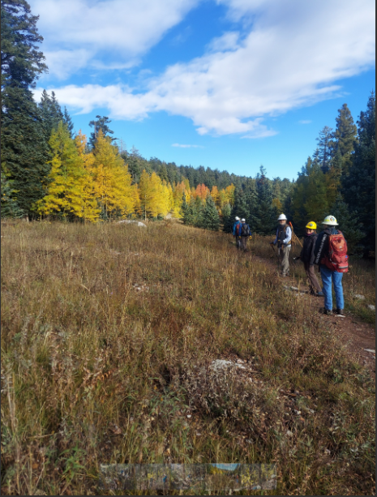RA
Ellis aspen

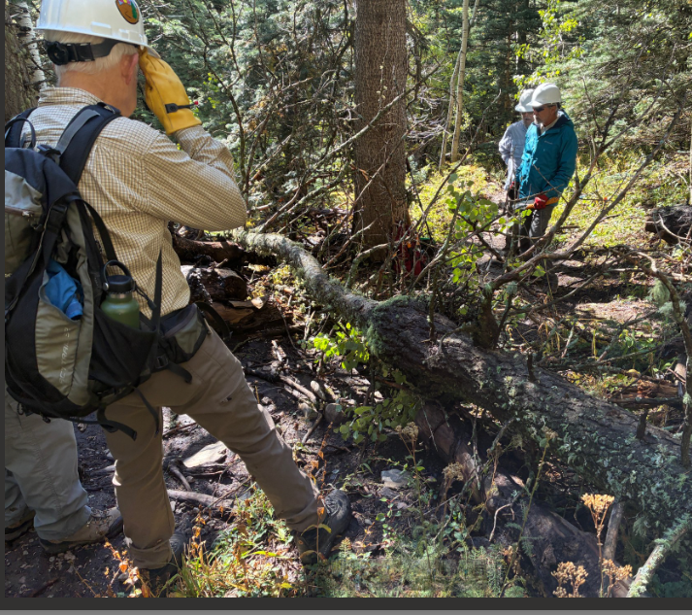SB
John plans the strategy

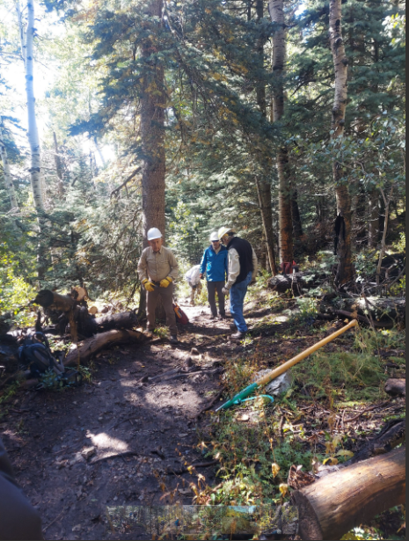RA
Clear and good to go

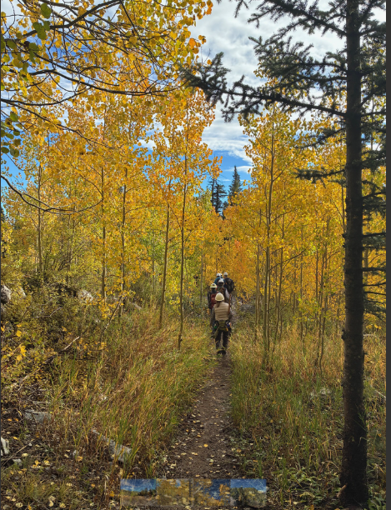SB
As good as it gets

