Report of FOSM Project to Remove Forest Debris from Cienega Canyon Picnic Area Trails That Was Washed onto the Trails by Very Heavy Rain on Monday Evening, Tuesday, September 30, 2025
Sam Beard and Chuck Logan
On Tuesday, September 30, Chuck Logan and Sam Beard had planned to work on restoring large picnic shelters in Doc Long and Balsam Glade Picnic Areas, but they found that the recent heavy rain had washed large quantities of hail, rocks, soil, and forest duff onto Cienega Canyon Picnic Area trails.
After a volunteer had earlier reported the debris on these trails, Chuck and Sam took a flat bottom shovel and outdoor push broom with them Tuesday morning. When they found several inches of debris on various trails, they began shoveling and sweeping off the heavy debris.
Shortly after we completed cleaning the Nature Trail, a group of about a dozen visitors with children in wheel chairs walked on the Nature Trail. We were especially happy that we had cleaned this trail.
The following photos show the removal of the heavy debris from the trails.

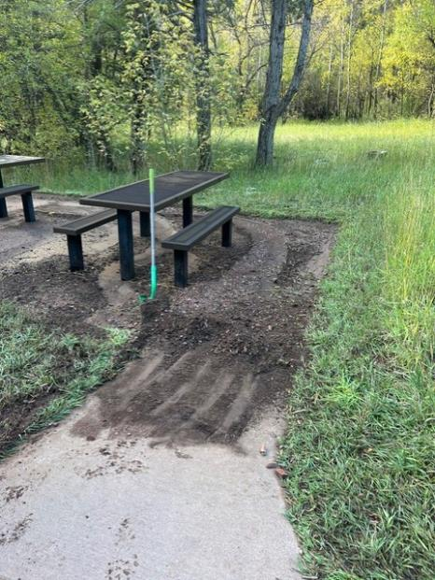
Before and after debris was removed at this picnic table.
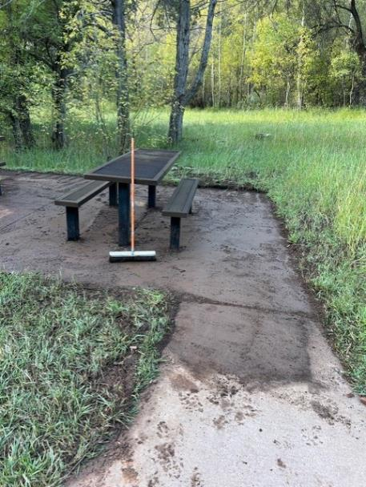
All photos by Chuck Logan

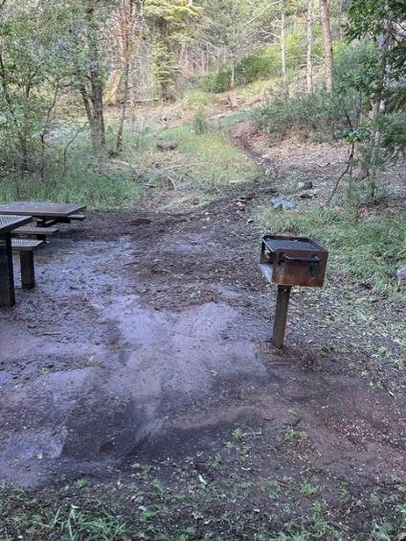
Too much debris at this upper table for us to remove.
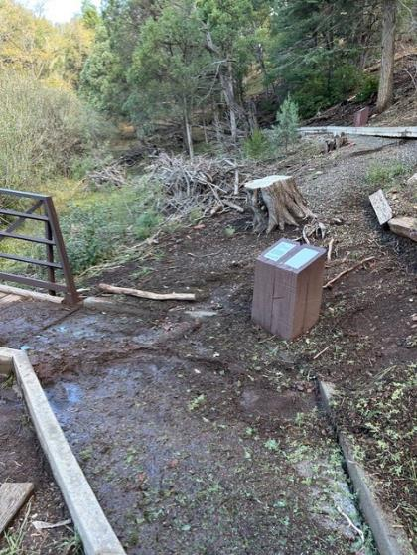
Debris at the lower bridge on the Cienega Nature Trail.

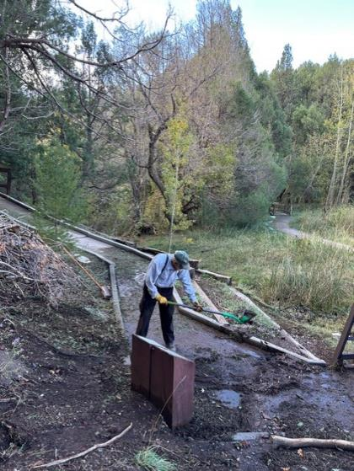
Sam removing mud from trail near the lower bridge.

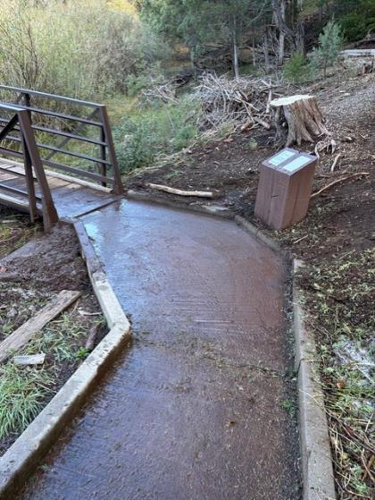
The cleaned trail.

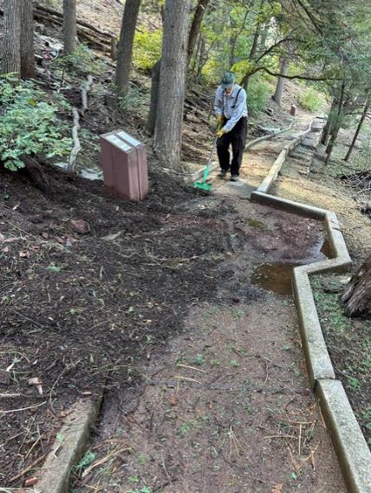
Before and after debris removed from this part of the trail.

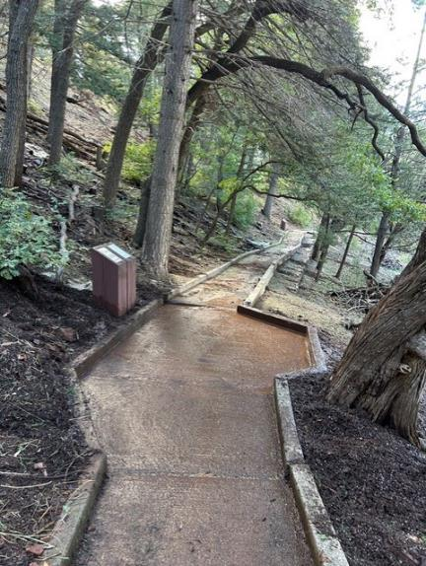

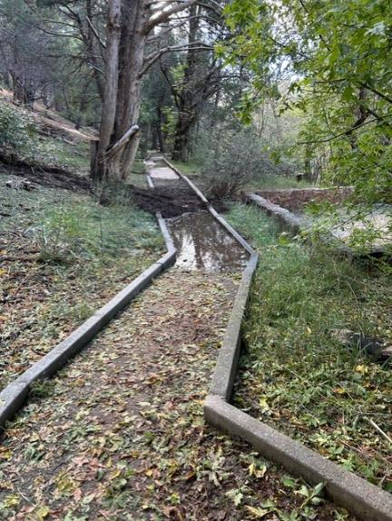
Before and after debris removed at this location on the trail.

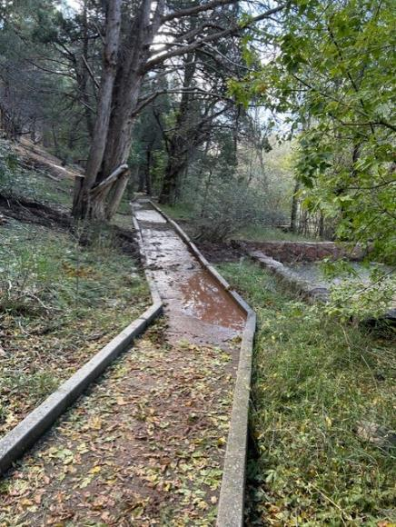

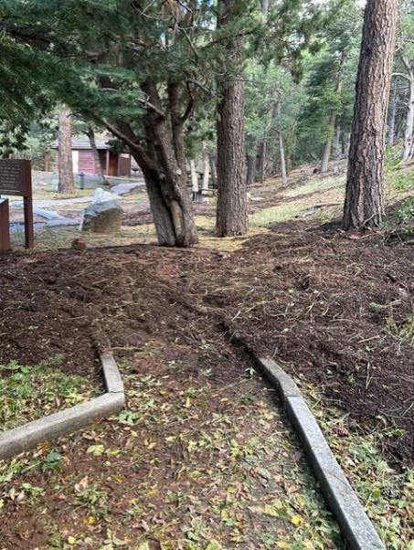
Thick debris near the group reservation site.
The debris here was about 10 inches deep.
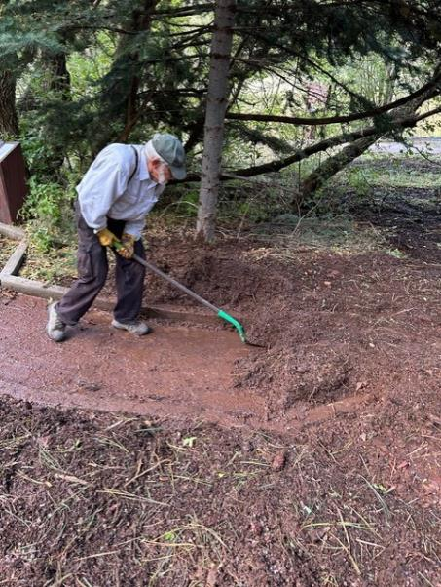
Sam removing the wet debris.

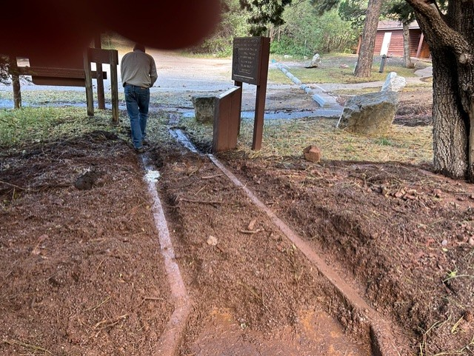
Chuck has uncovered the curbs along the trail.

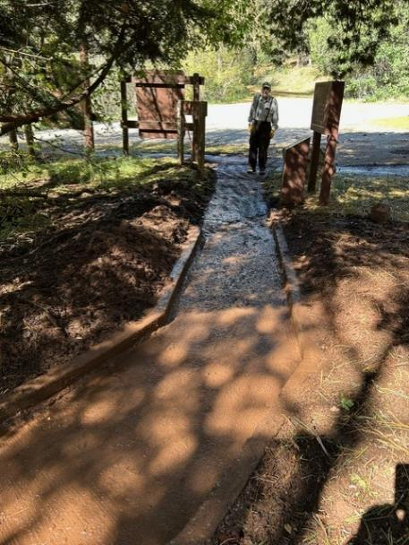
The debris has been removed.

