Report of FOSM Project to Buck Logs on the Ground
between the Electronic Site Fence and the Upper Crest Highway and Load Them on the Church Wood Ministry Trailer for Distribution to East Mountain Families next Winter, Wednesday, October 1, 2025

Sam Beard
On Wednesday, October 1, a FOSM crew bucked a few dozen logs on the ground between the new Electronic Site fence and the upper Crest Highway to produce fire wood that the Mountain Christian Church Wood Ministry will donate to East Mountain families who heat their homes with wood. The trees had been felled earlier by Hot Shot Crew members under the direction of SRD employees to thin this forest and reduce the number of hazard trees that could fall on the new fence.
The diameters of the logs ranged from a few inches to over a foot. The largest and heaviest rounds were from an Engelmann spruce near the North Crest Trail. The rounds were rolled down to Mike Oliver’s trailer so that he could haul them to the wood lot at his home. This wood will be split by wood ministry volunteers.
The FOSM volunteers working on this project were Jerry Carroll, Sam Beard, Sim Cook, John Quinley, Steve Roholt, Dan Benton, Cliff Giles, Chuck Logan, and Lou Romero.

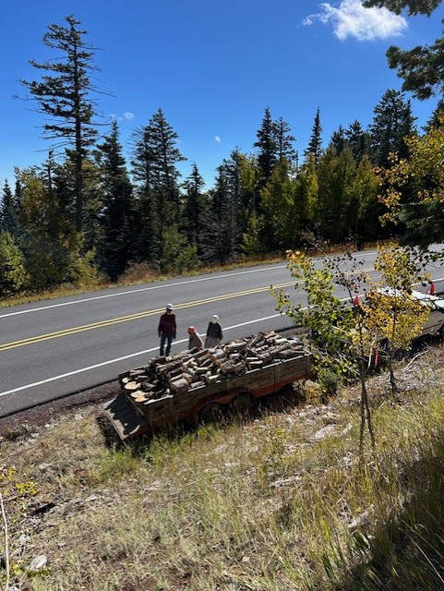
View of Mike’s trailer from the top of the highway cut bank. Rounds were rolled
from here down to the trailer for loading. Photo by Chuck Logan

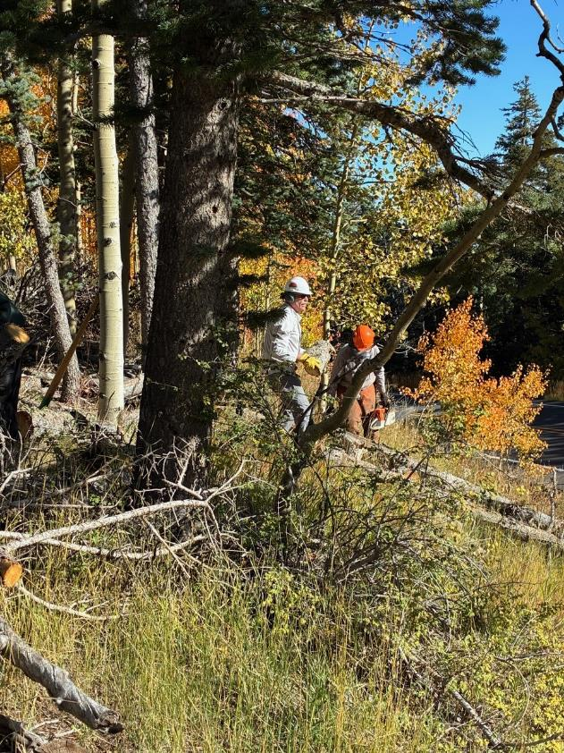
John Quinley ready to roll a round down to the trailer. Dan Benton is preparing to buck
a log on the hillside. All photos by Cliff Giles unless stated otherwise
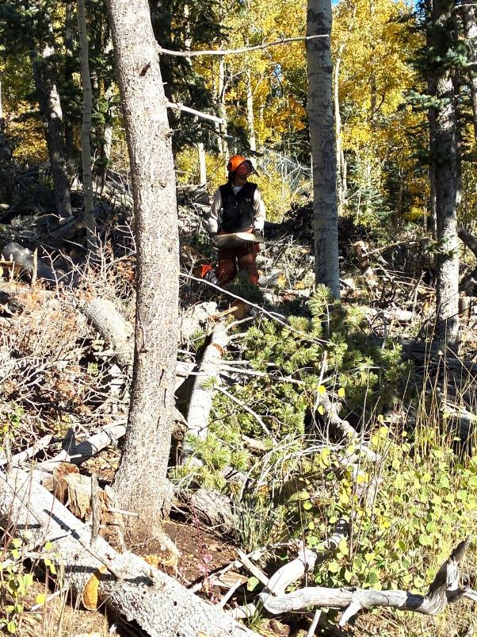
Sim Cook moving a piece of wood that he just bucked.

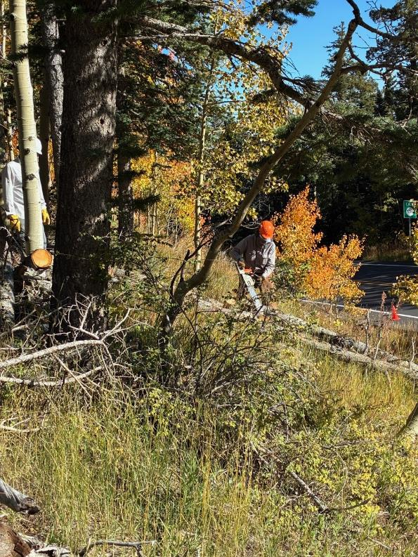
Dan Benton bucking two logs on the slope.
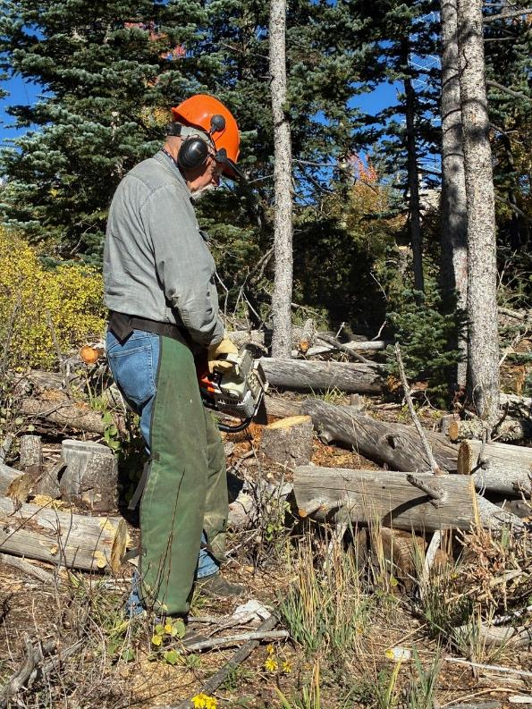
Jerry Carroll bucking a log.

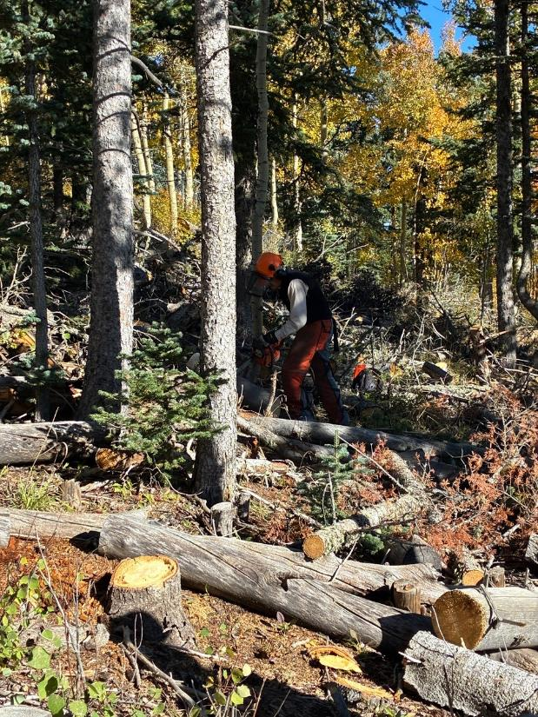
Sim bucking a log.

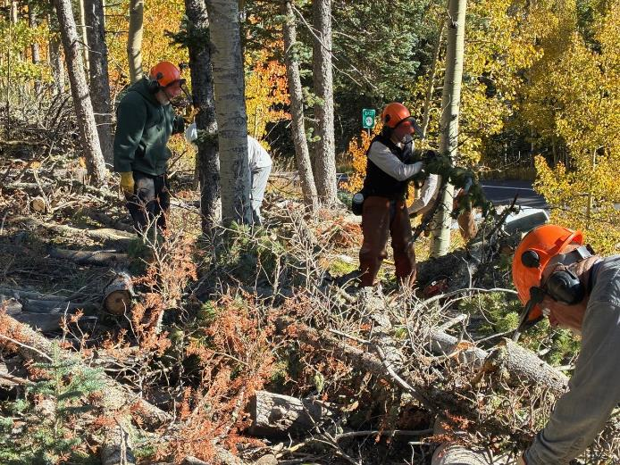
Sam, John, Dan, and Jerry bucking logs and moving them down to the highway.

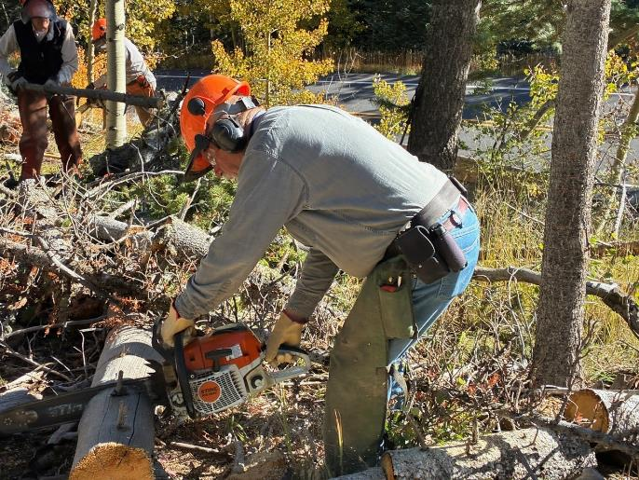
Jerry bucking a 10-inch log.

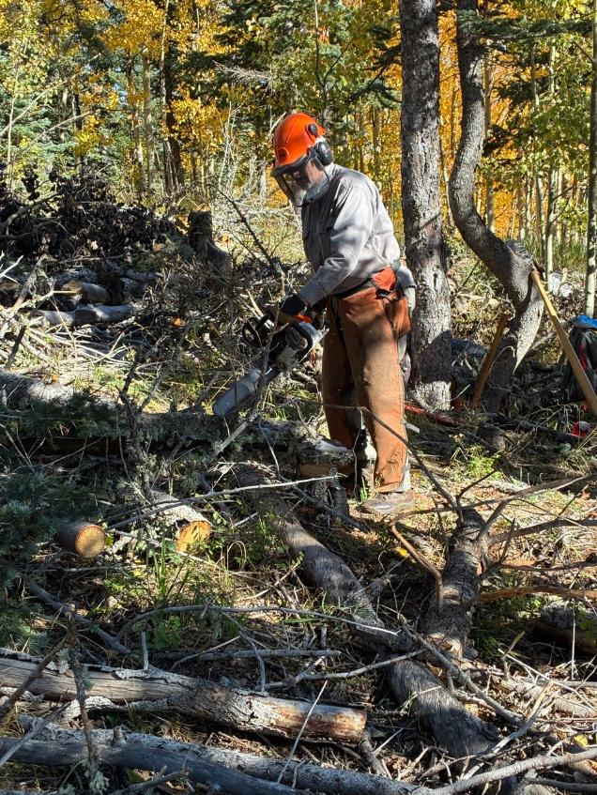
Dan bucking a log.

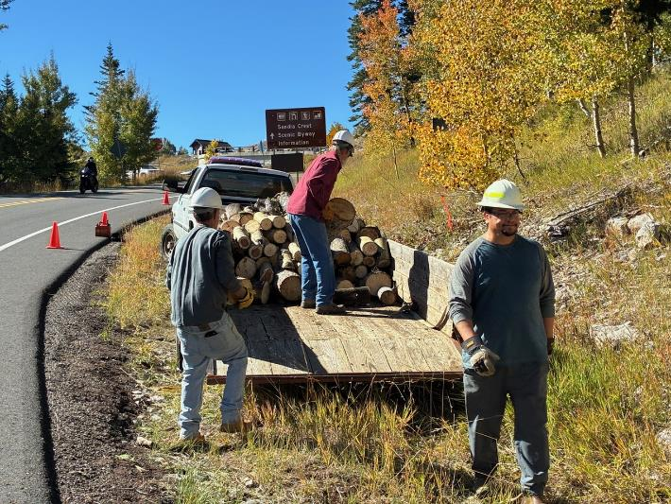
Joe, Mike Oliver, and Cruz loading rounds on Mike’s trailer.

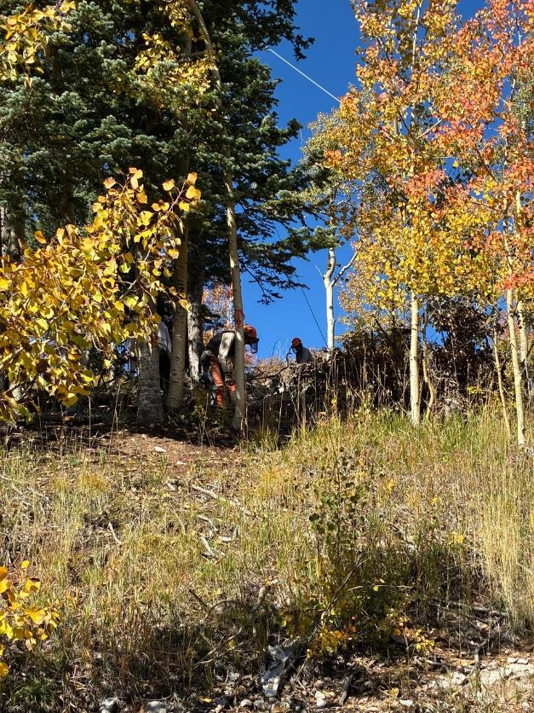
Sim and Dan bucking logs in the forest. Rounds were rolled down to the trailer here.
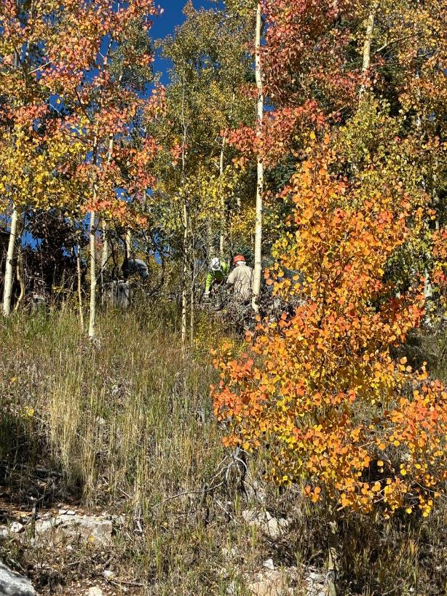
Steve Roholt bucking a log and Lou Romero swamping.

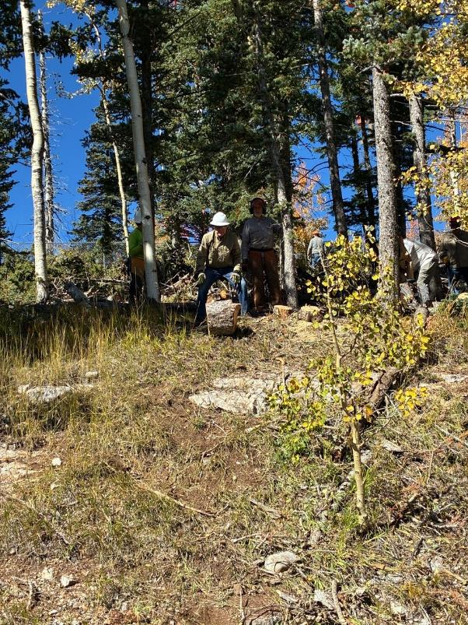
Chuck Logan rolling a large heavy Engelmann spruce round down the hill.
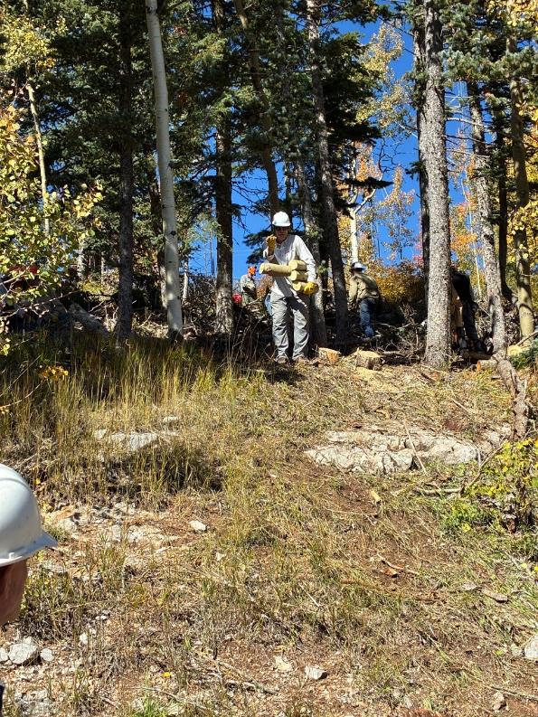
John rolling four small pieces of aspen wood down the hill.

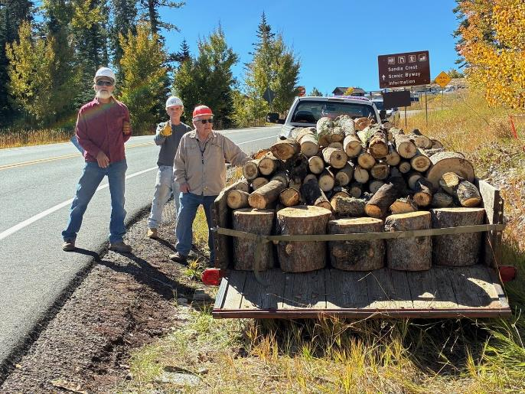
Mike, Joe, and Lou at the fully loaded trailer of donation wood that the church Wood Ministry
will donate to East Mountain families who heat their homes with wood.

