Trail Maintenance Report: Monday, October 6, 2025
Byron Garner
On October 6, the Monday trail crew headed out on Bill Spring trail to the Challenge junction and a short distance up that trail to clear a reported debris slide covering about eight feet of trail. This was mostly McLeod work and small rock removal on the tread and back slope.
With no other reports for this trail, we moved on up to 130N and did some clean up and tread work along the new fence line to remove some down slope berms, slash and trees left from the fence building in a effort to restore the trail to its more natural state.
With lunch time approaching, we then dropped back down to Nine Mile picnic area to enjoy lunch on a beautiful fall day with no crowds.
The crew included Rene Archer, Ken Wilson, John Cooper, Phil Cromer and Byron Garner. Photos: Rene Archer

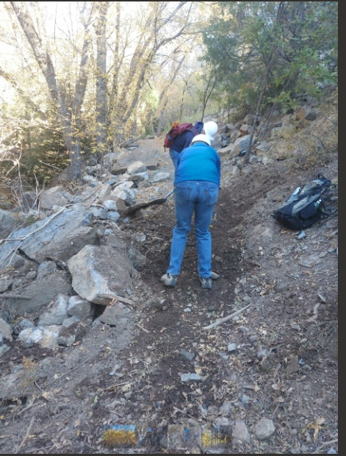

The tread almost restored

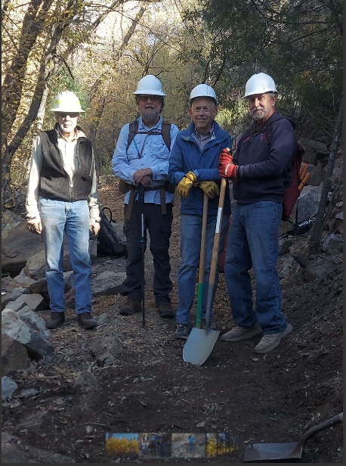

Byron, Phil, John and Ken

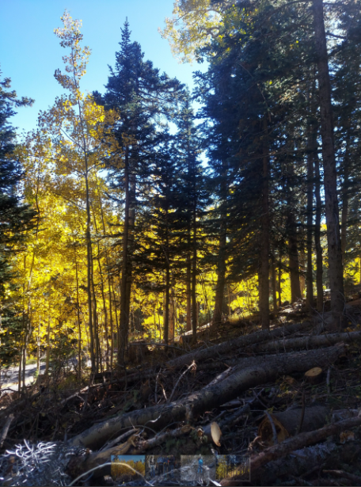

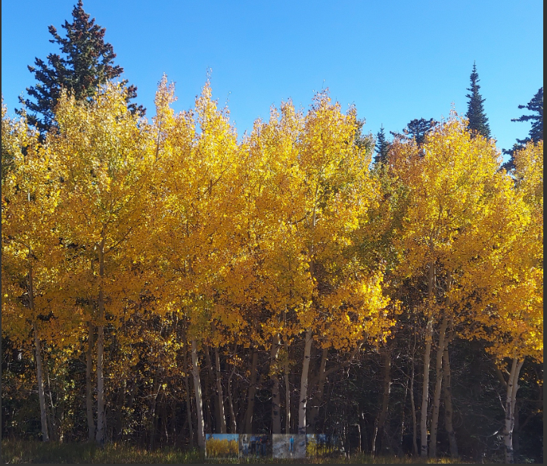
The aspen made it all the more worthwhile

