Report of FOSM Project to Remove Graffiti Tags on the Juan Tabo Picnic Area CCC Shelter
and on the Large Boulder at the Upper Restroom on Tuesday, October 7, 2025.

Sam Beard and Fred Hagstrom
On Tuesday, October 7, we used the World’s Best Graffiti Removal System (WBGRS) chemical to remove paint from stone and brick to remove several tags in the Juan Tabo CCC Stone Picnic Shelter and on a very large boulder at the upper restroom in this picnic area. Sam returned on Thursday, October 9, to paint over tags on posts in the shelter and on two trash receptacles and a guard rail section in the parking lot.
Project photos are presented below.

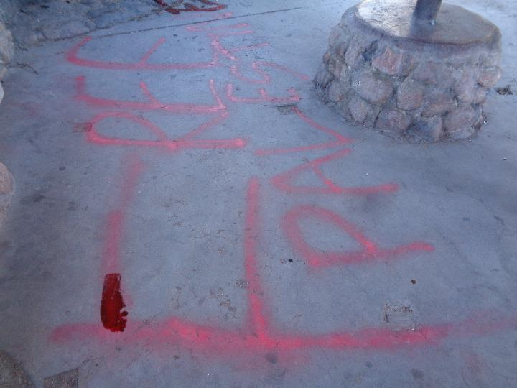
Large red “Free” tag on floor of Juan Tabo CCC Picnic Shelter that we later removed
with the WBGRS chemical for stone and brick. All photos by Sam Beard
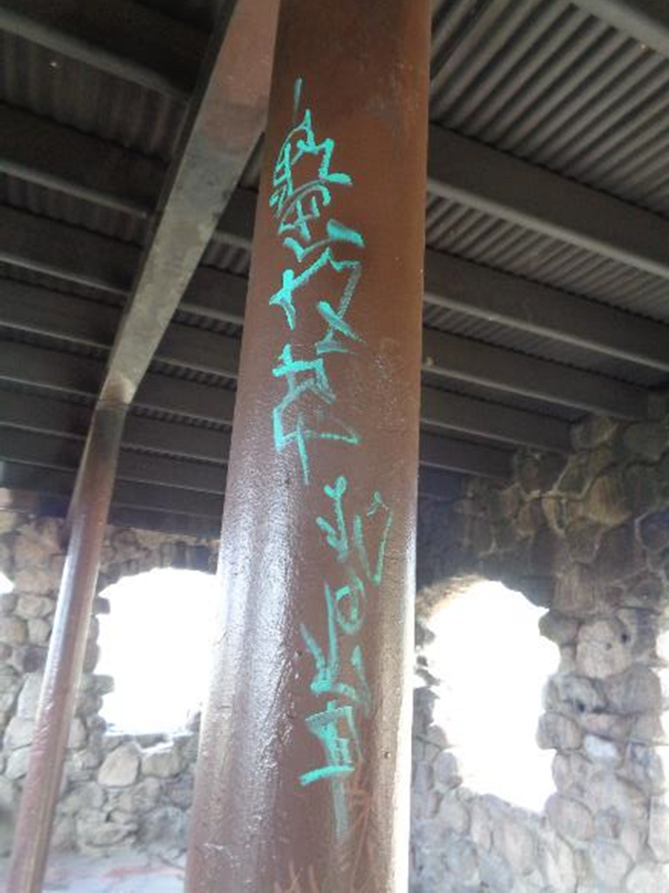
Tag on one of the brown posts in the picnic shelter.

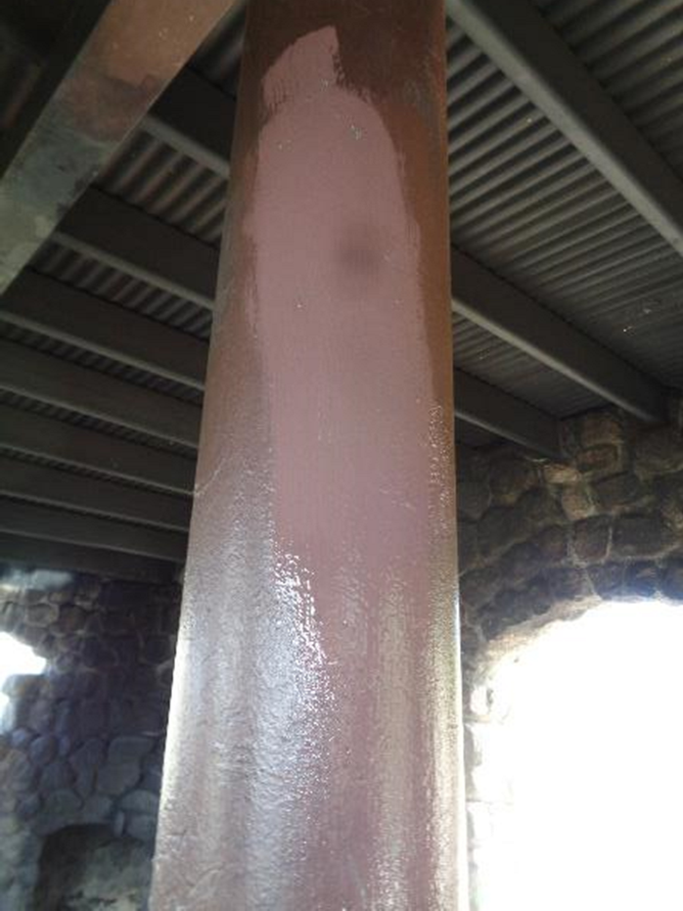
The tag has been covered with USFS brown paint.
We only paint over tags that are on surfaces that have been painted in the past.

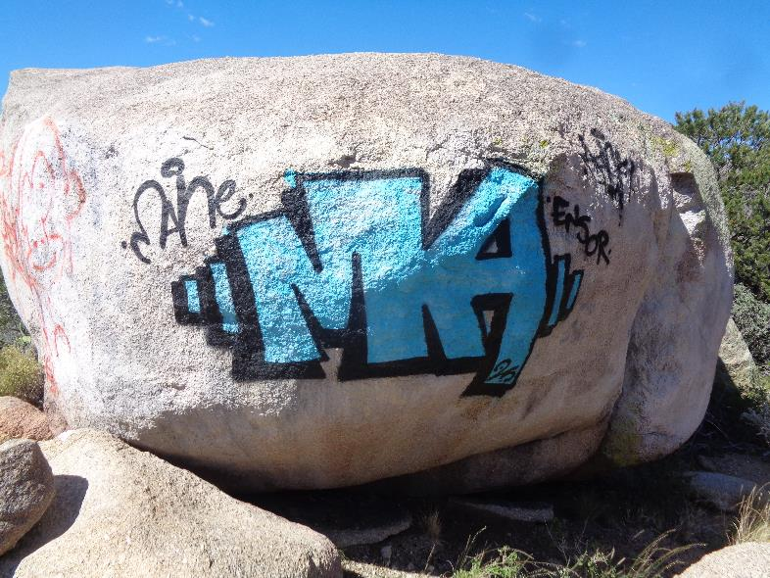
Large blue and black “MA” tag on east end of boulder at the upper Juan Tabo PA restroom.
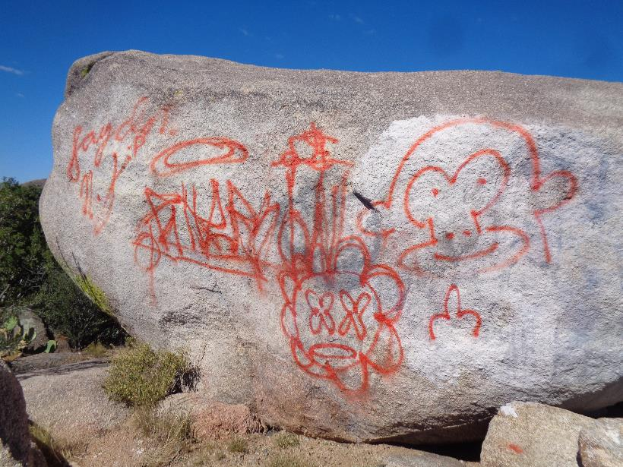
Large red “Monkey” tag on south side of boulder.
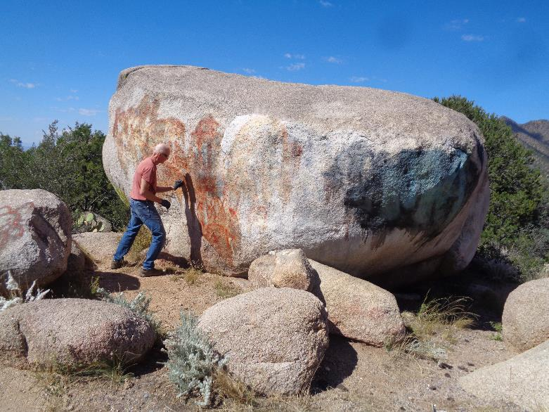
Fred Hagstrom working on removal of the large red tag.
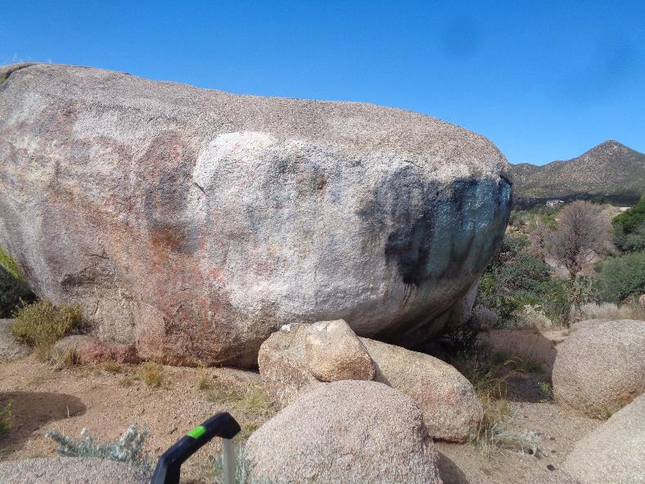
Three applications of the chemical have been applied to the two large tags, and we were ready
to rinse off the paint and chemical residue with water and small paint brushes.
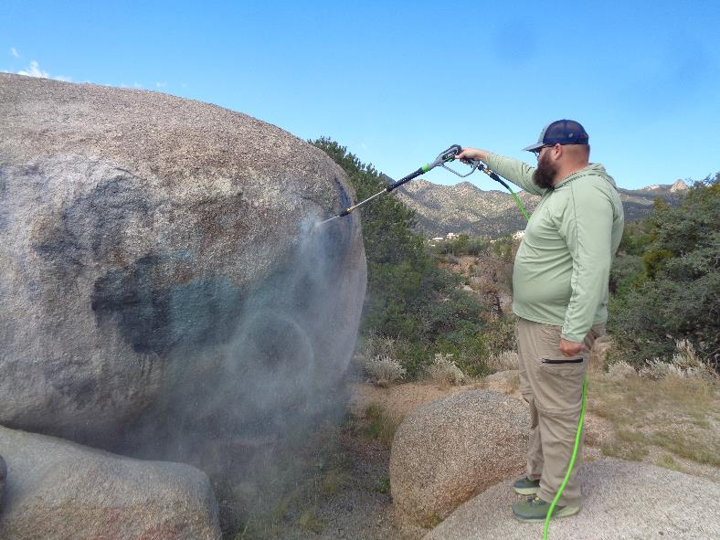
Fortunately, two employees of the Cibola National Forest Supervisor’s Office arrived with a large water tank and pressure washer.
He was able to rinse off the residue in about 10 minutes. Note the bare granite just left of the nozzle
where all the residue has been completely removed. They were doing picnic area maintenance and using
the washer to clean restroom floors during the government closure.
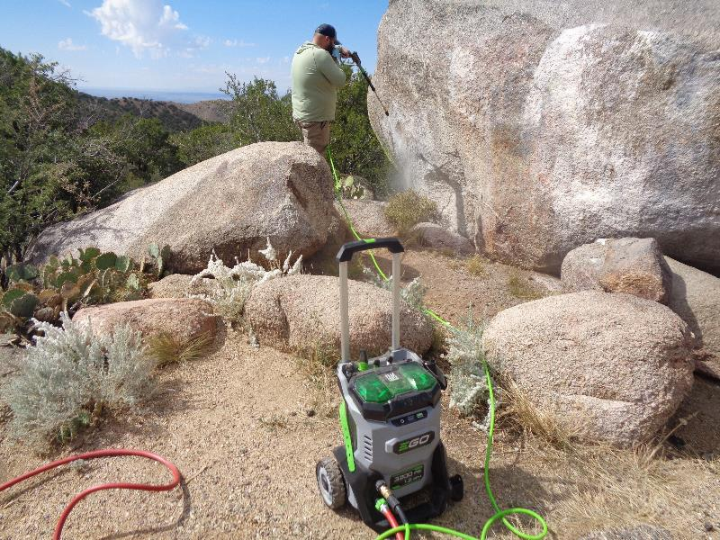
He has removed almost all the “Monkey” tag with the EGO power washer that used water from a tank on the USFS truck.
The washer was powered by the two large green batteries in the top of the unit.
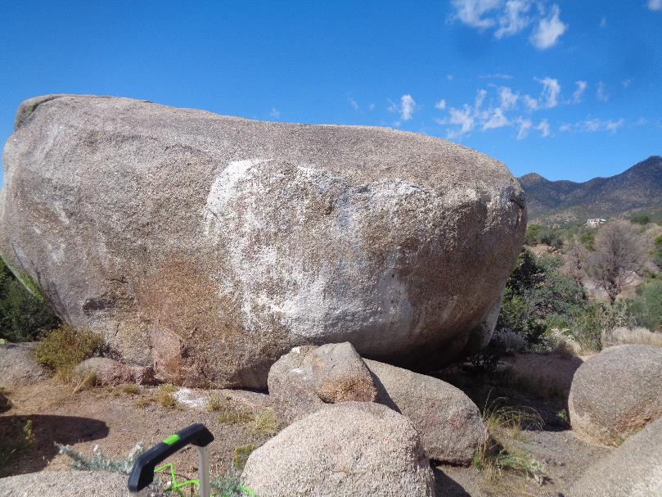
The two large tags were completely removed.
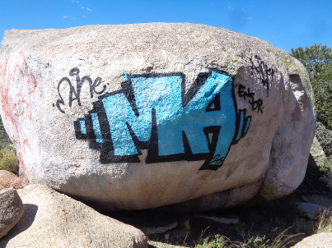
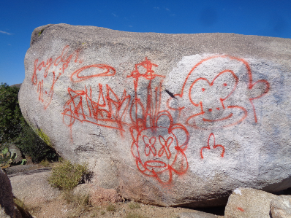
Compare these original photos of the tags with the clean boulder in the photo above.

