Report of FOM Project to Cut Brush in Snow Play Area Traffic Island and at Capulin Picnic Area Entrance, Wednesday, October 8, 2025

Sam Beard
On Wednesday, October 8, FOSM volunteers cut brush in the traffic island in the Capulin Snow Play Area Parking Lot so that the USFS would have a place to push snow when the parking lot is being plowed. Brush was also cut at the Capulin Picnic Area entrance for a better sight distance for drivers leaving the picnic area and driving onto the Crest Highway. Volunteers cut brush with two FOSM Stihl power brush cutters, small chain saws, and hand loppers.
The volunteers working on this project were Jerry Carroll, John Quinley, Dan Benton, Cliff Giles, Sim Cook, Lorna Morrow, Kerry Jones, and Sam Beard.
Project photos are presented below.

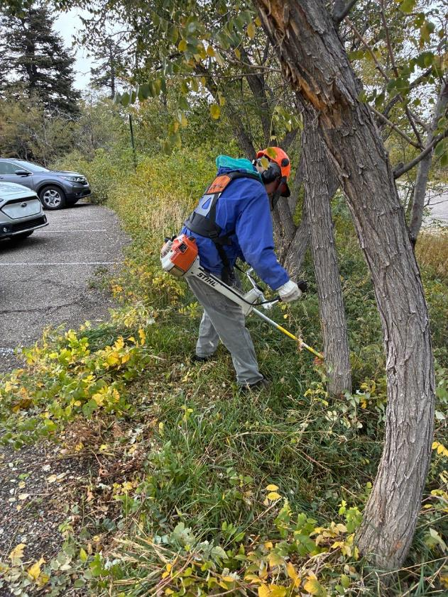
Eric Russell cutting brush in the Snow Play Area traffic island with a FOSM brush cutter.
All photos by Cliff Giles

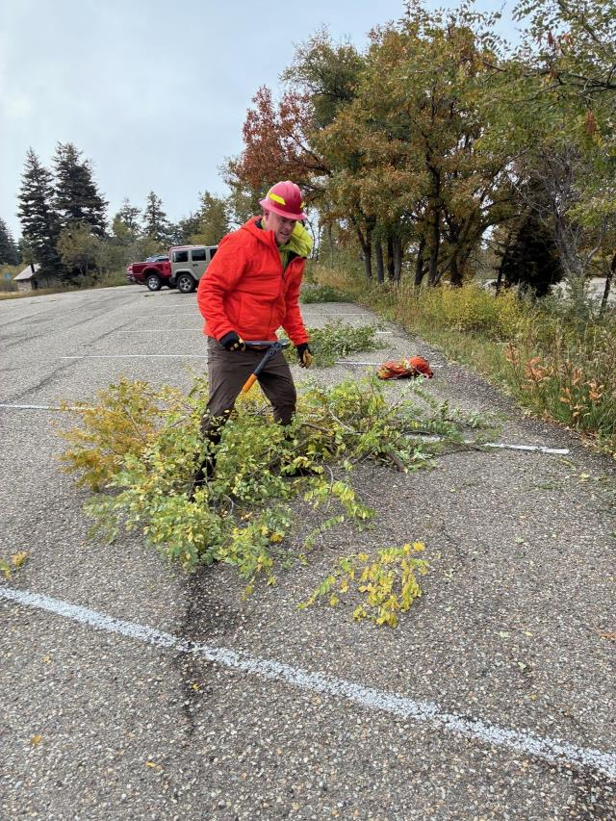
Kerry Jones swamping for a brush cutter and cutting brush with his short loppers.

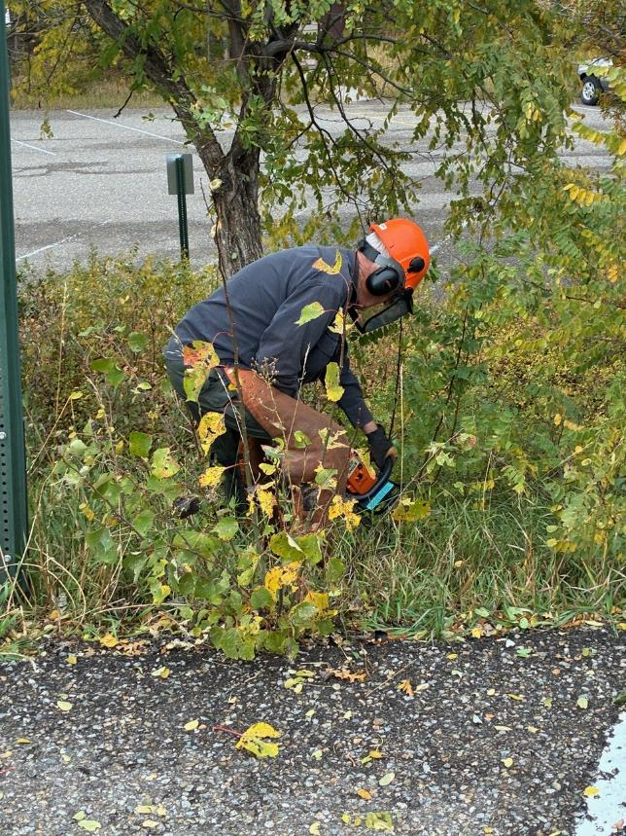
Dan Benton cutting brush with a FOSM chain saw.
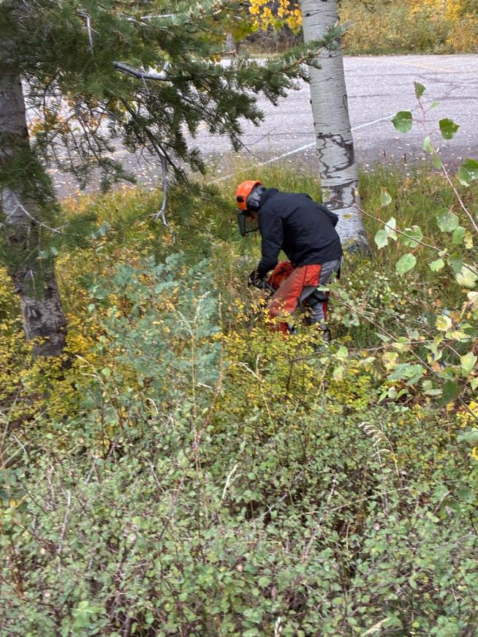
Sim Cook cutting brush with a chain saw.
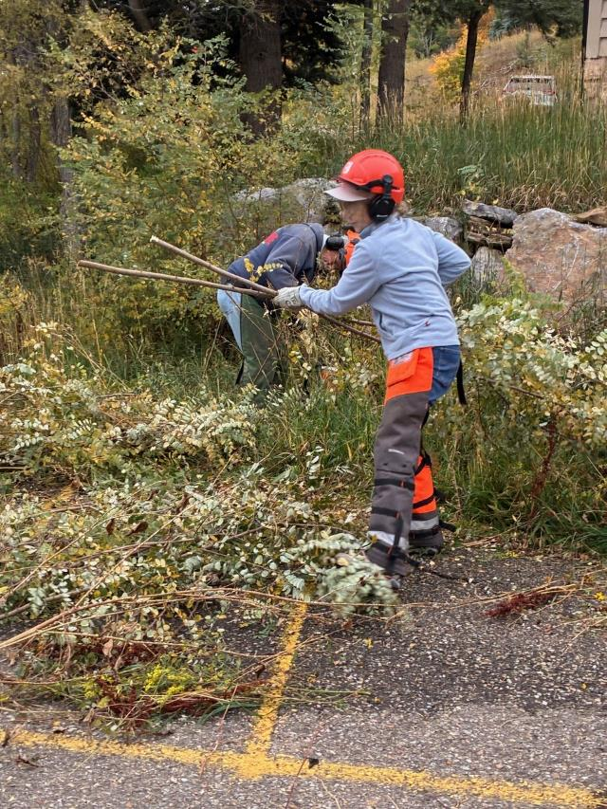
Lorna Morrow swamping for Jerry Carroll cutting brush with a chain saw
at the north end of the parking lot near the restroom.
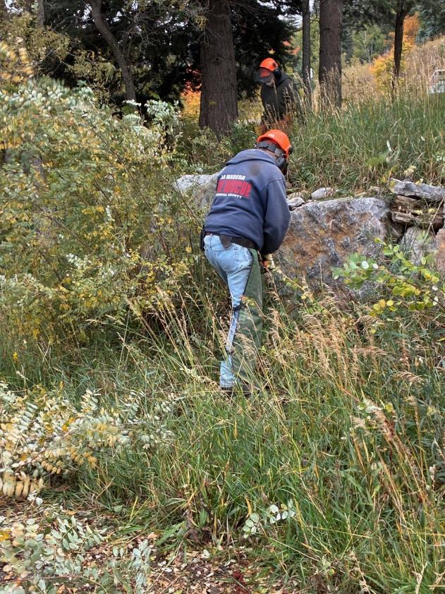
Jerry Carroll cutting brush with a chain saw while Sam Beard comes down
from the upper parking lot.

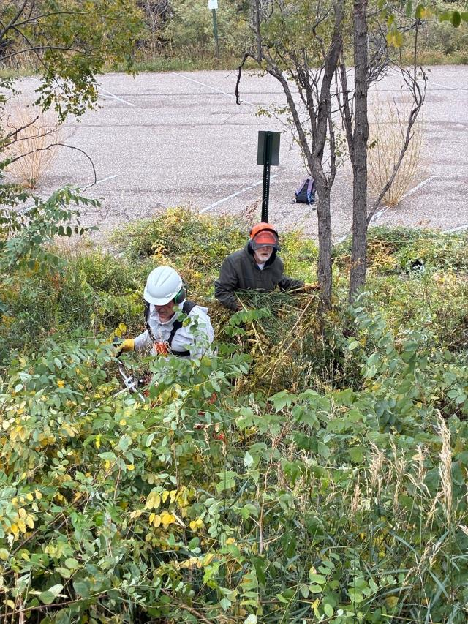
John Quinley cutting brush with a brush cutter and Sam Beard swamping.
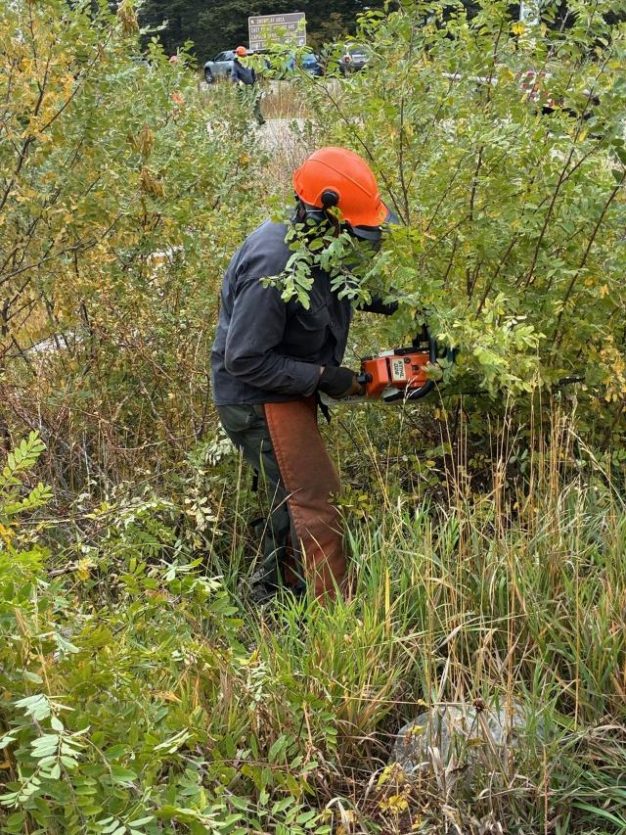
Dan cutting brush at the Capulin Picnic Area entrance at the Crest Highway.
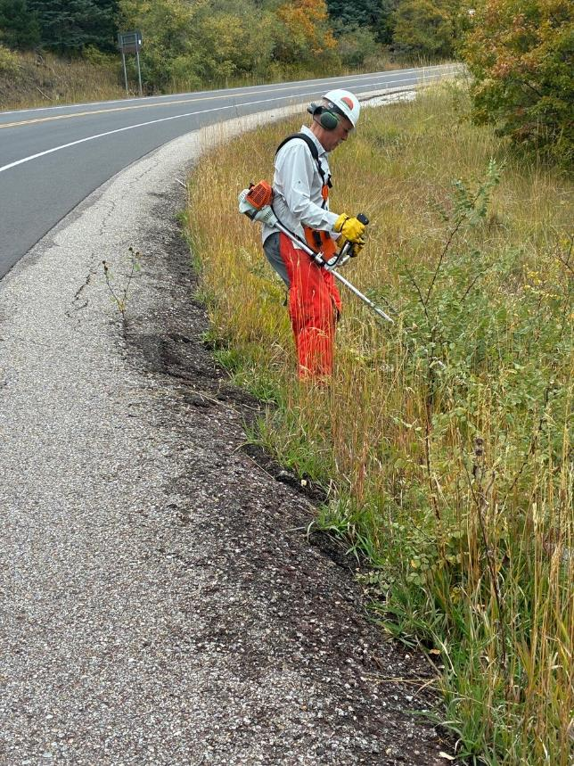
John Quinley cutting brush up the Crest Highway from the entrance to the picnic area.
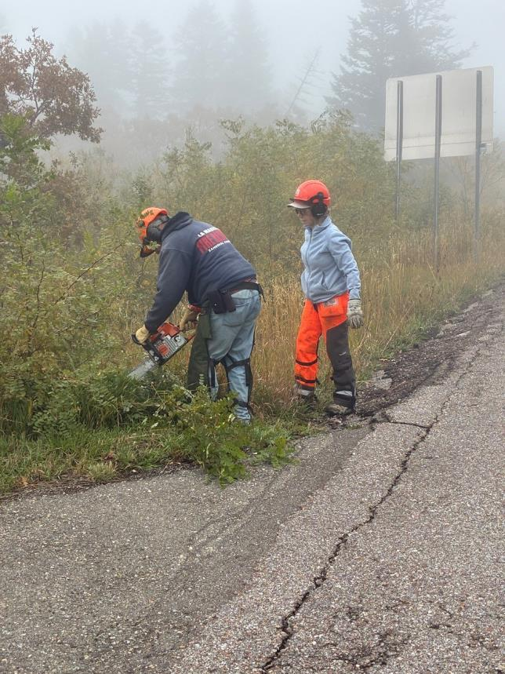
Jerry Carroll cutting brush at the picnic area entrance with Lorna Morrow swamping.

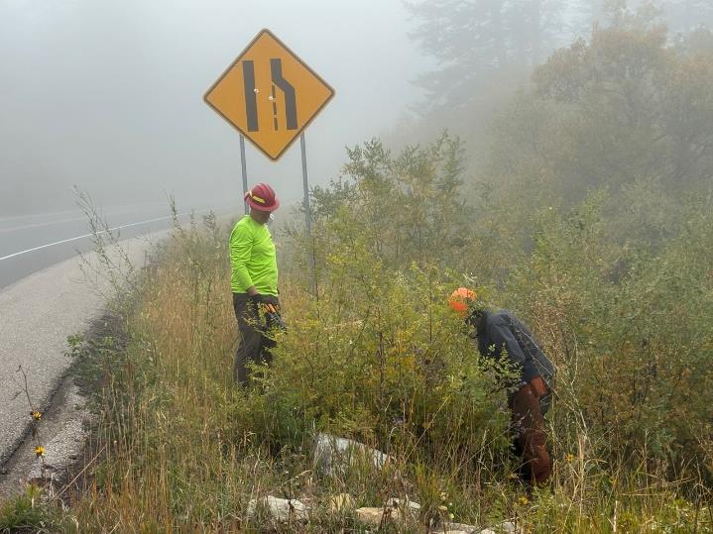
Dan cutting brush and Kerry swamping at the picnic area entrance.

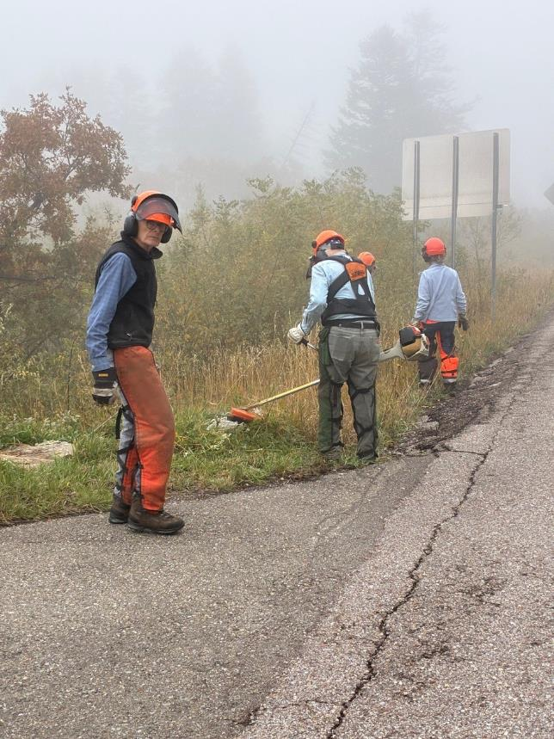
Eric Russell cutting brush at the picnic area entrance with Sim Cook and Lorna Morrow swamping.
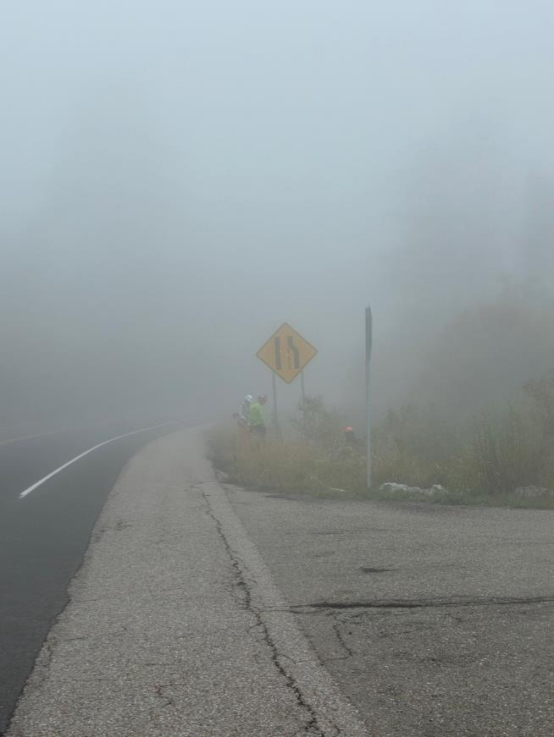
Looking through the fog to John and Dan cutting brush and Kerry swamping.

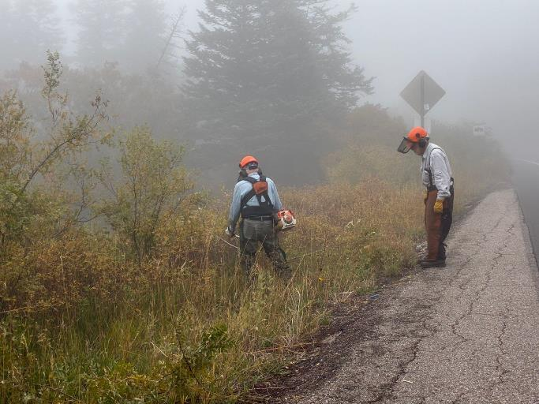
Eric cutting brush and Sam observing near the lower end of the sight distance.

