Thursday, 10/09/25- Old Faulty: Back to Old Faulty this week. After a cool and humid start, 10 volunteers enjoyed a wonderful weather day. We worked on finishing up last week’s work and starting on the last reroute. The soil was wet (!) and a bit sticky but we made good progress. The middle reroute was completed and we made a good start on the last reroute despite some problematic rocks.

Volunteers: Byron Garner, Roland Stumpf, Kerry Jones, Eric Russell, Mike Madden,
John McNett, Jim Houle, Claudia Bergsohn, Dan Burwinkle, and Laura Leon

Pictures: Laura Leon
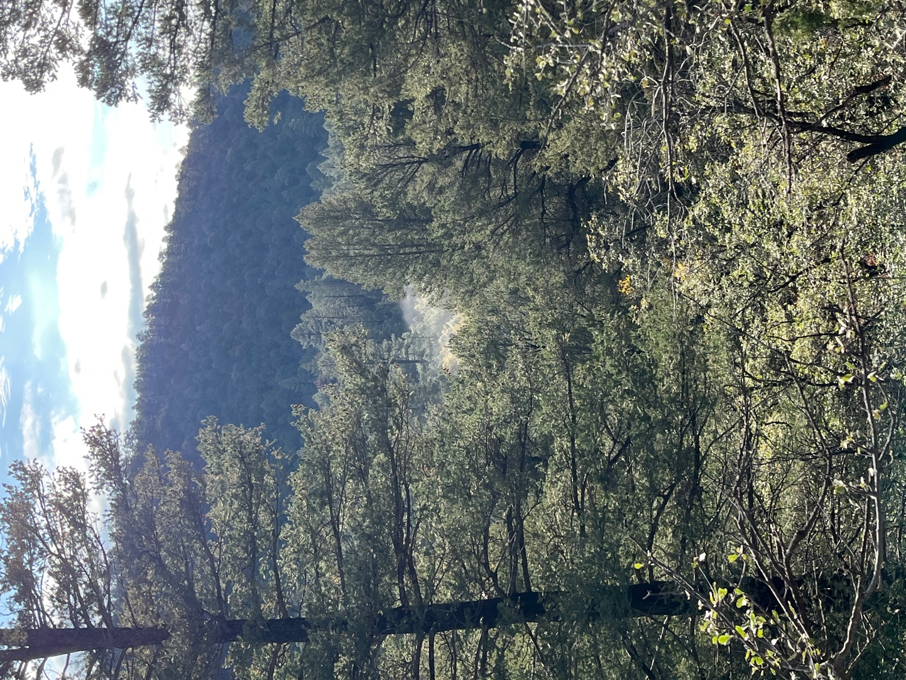 A misty start.
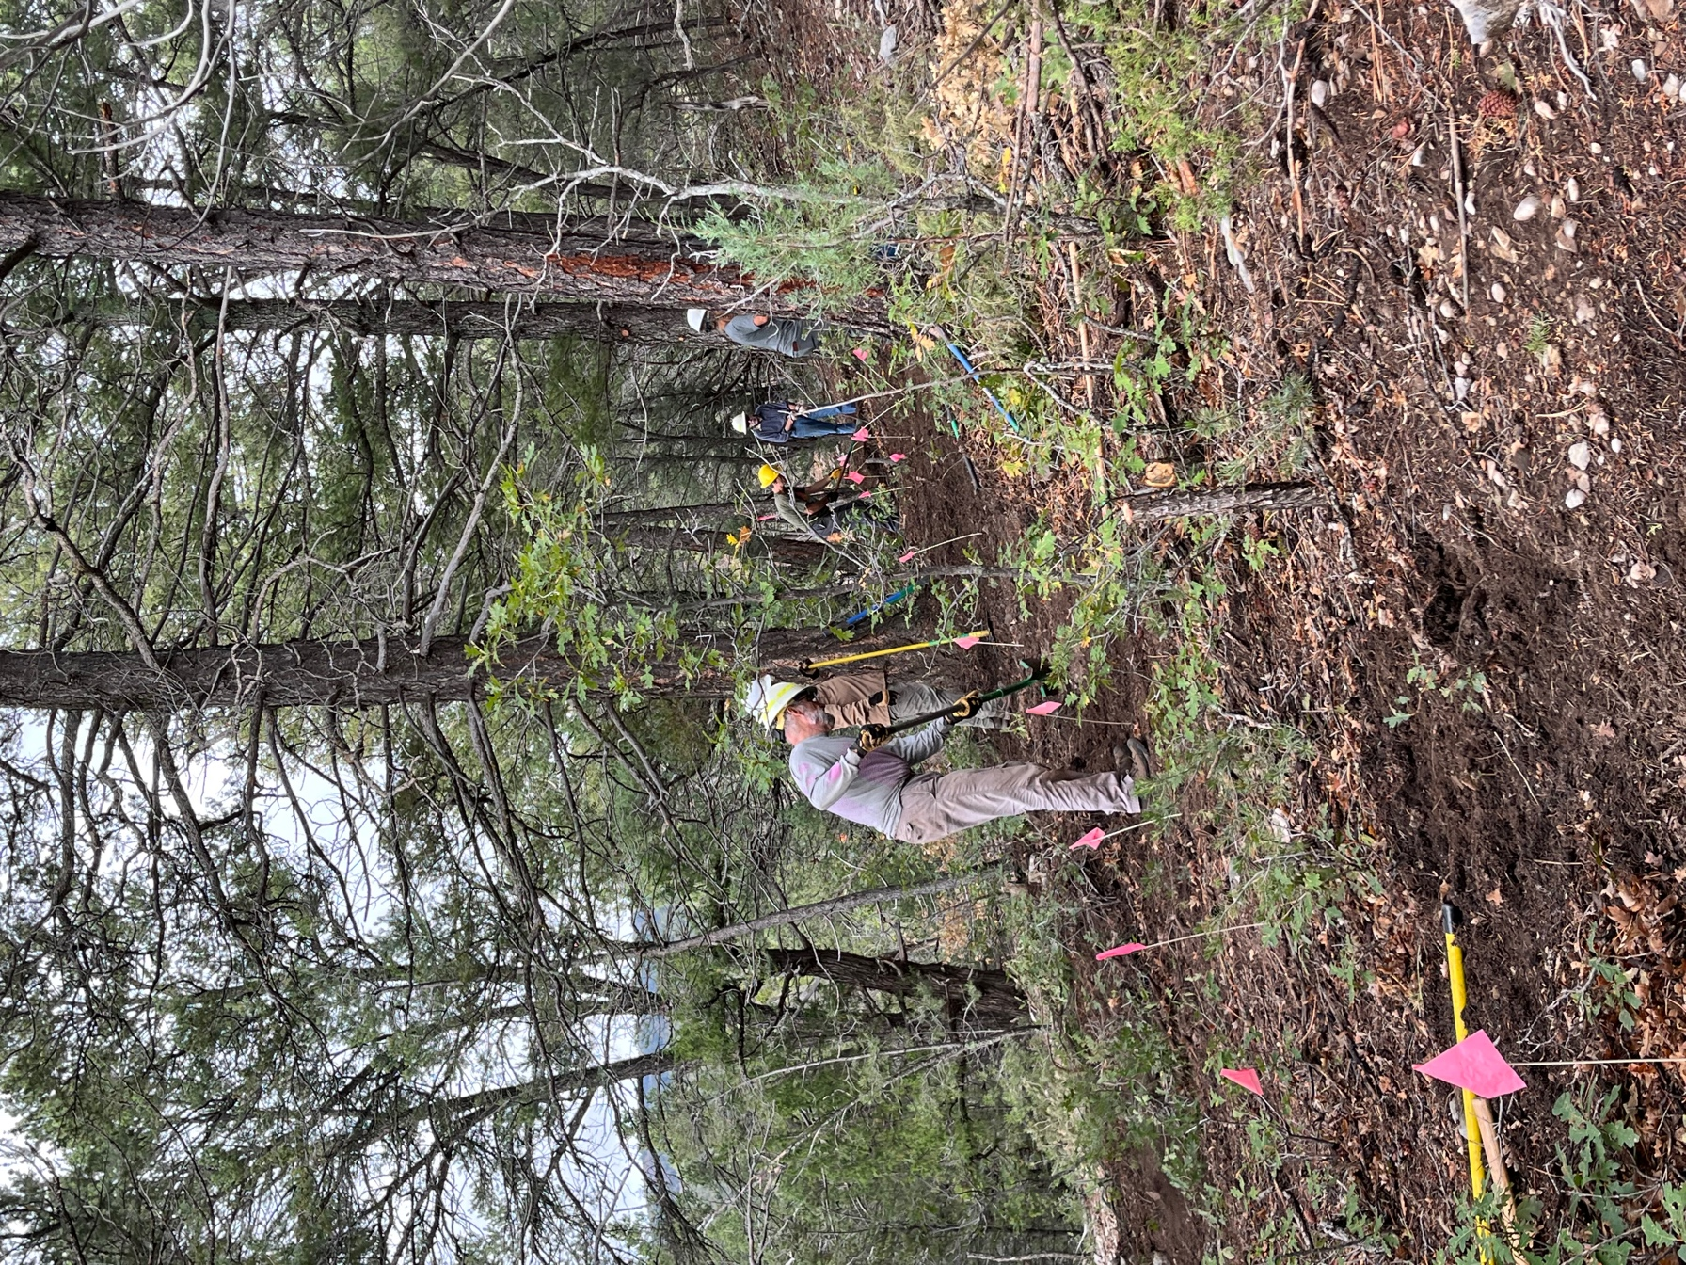

Part of the crew started work on the last reroute- Jim, Dan, Claudia, Roland and Byron.
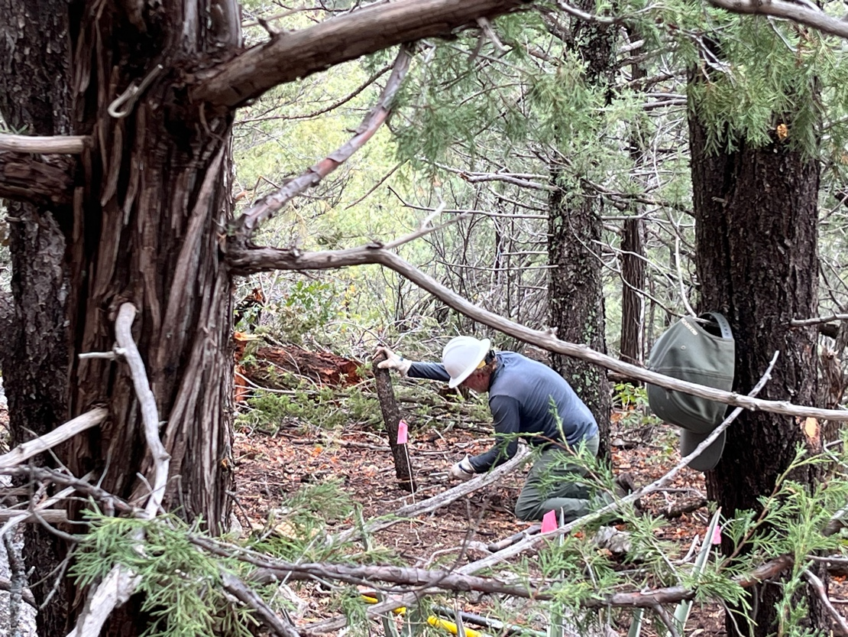

John used his new saw on stump removal.

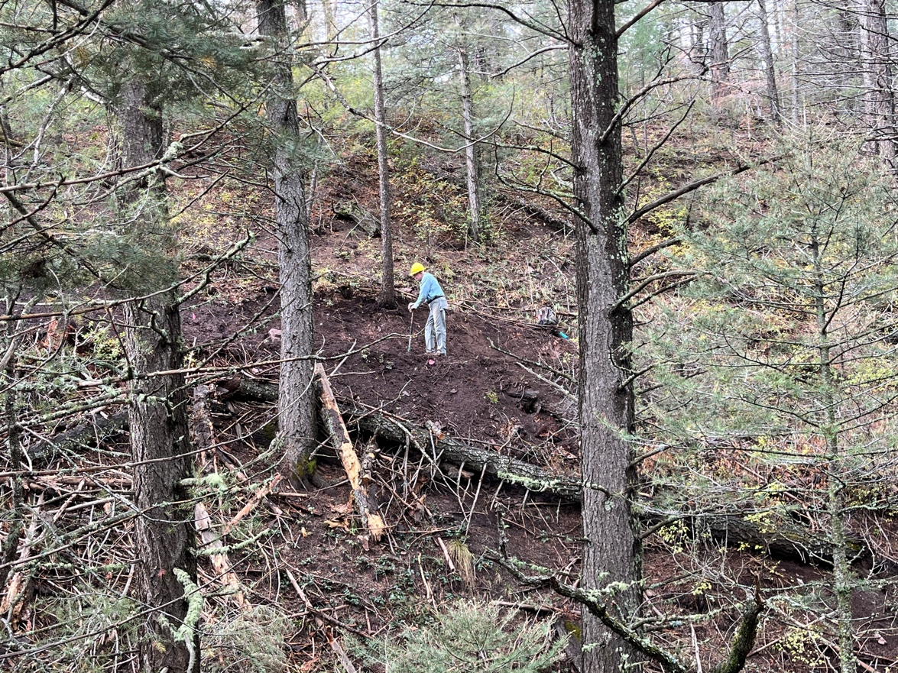

Eric was back widening the slope on last week’s work.

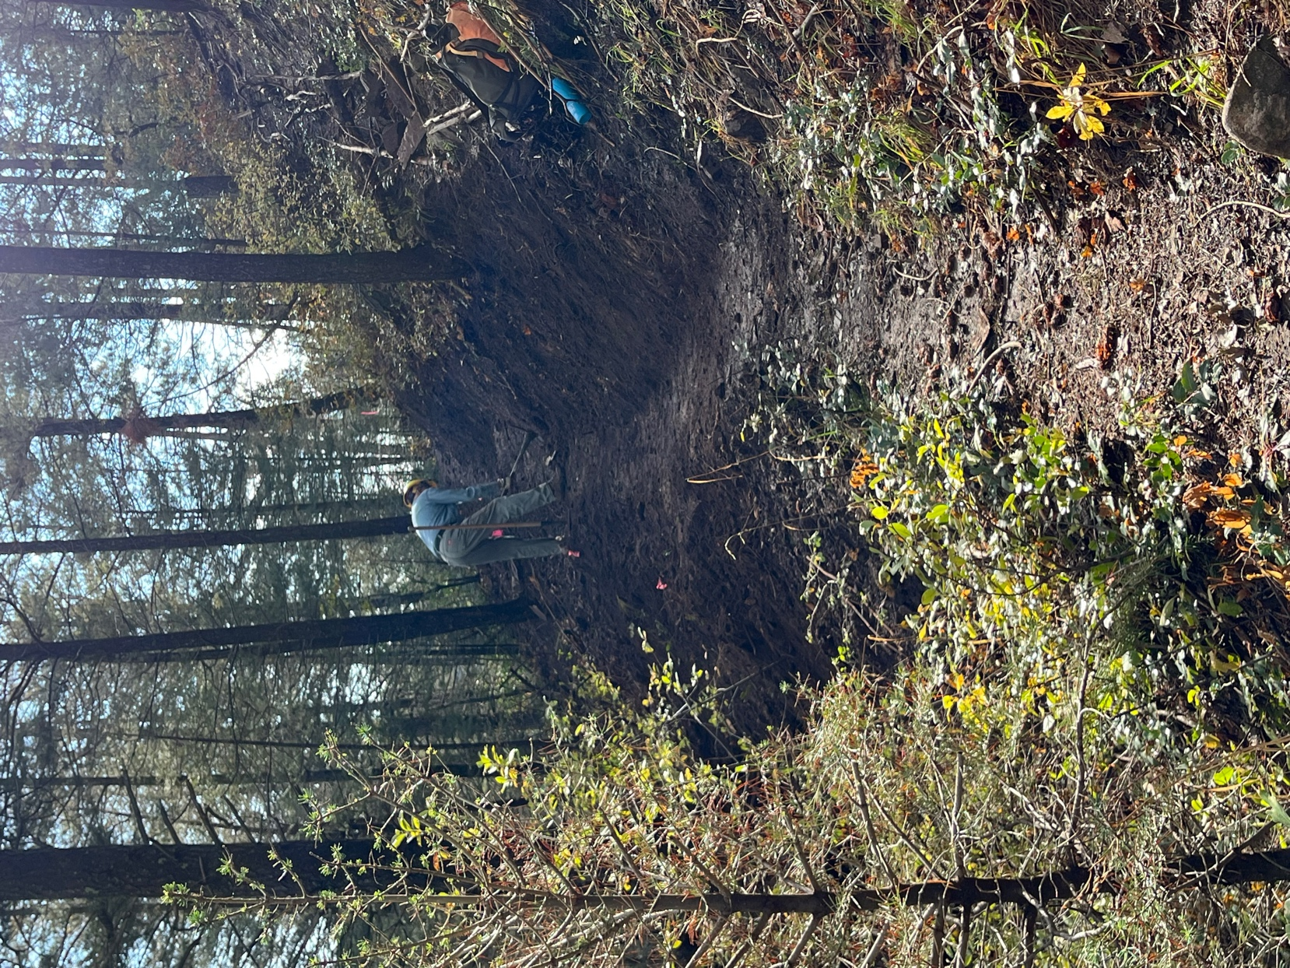

Lots of wet, sticky clay.

Mike and Kerry reworked a couple of curves form last week.

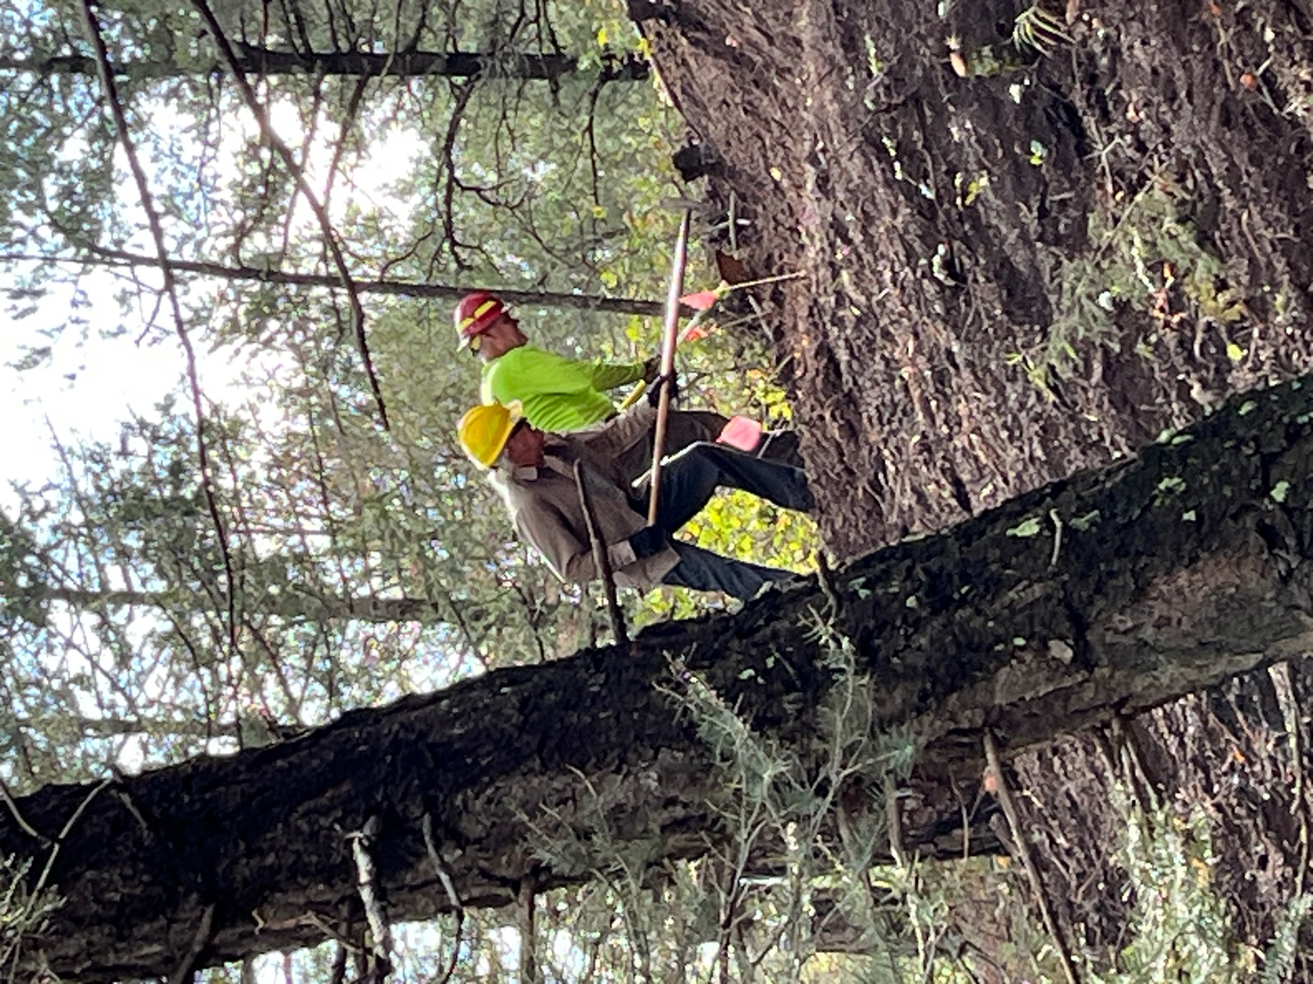

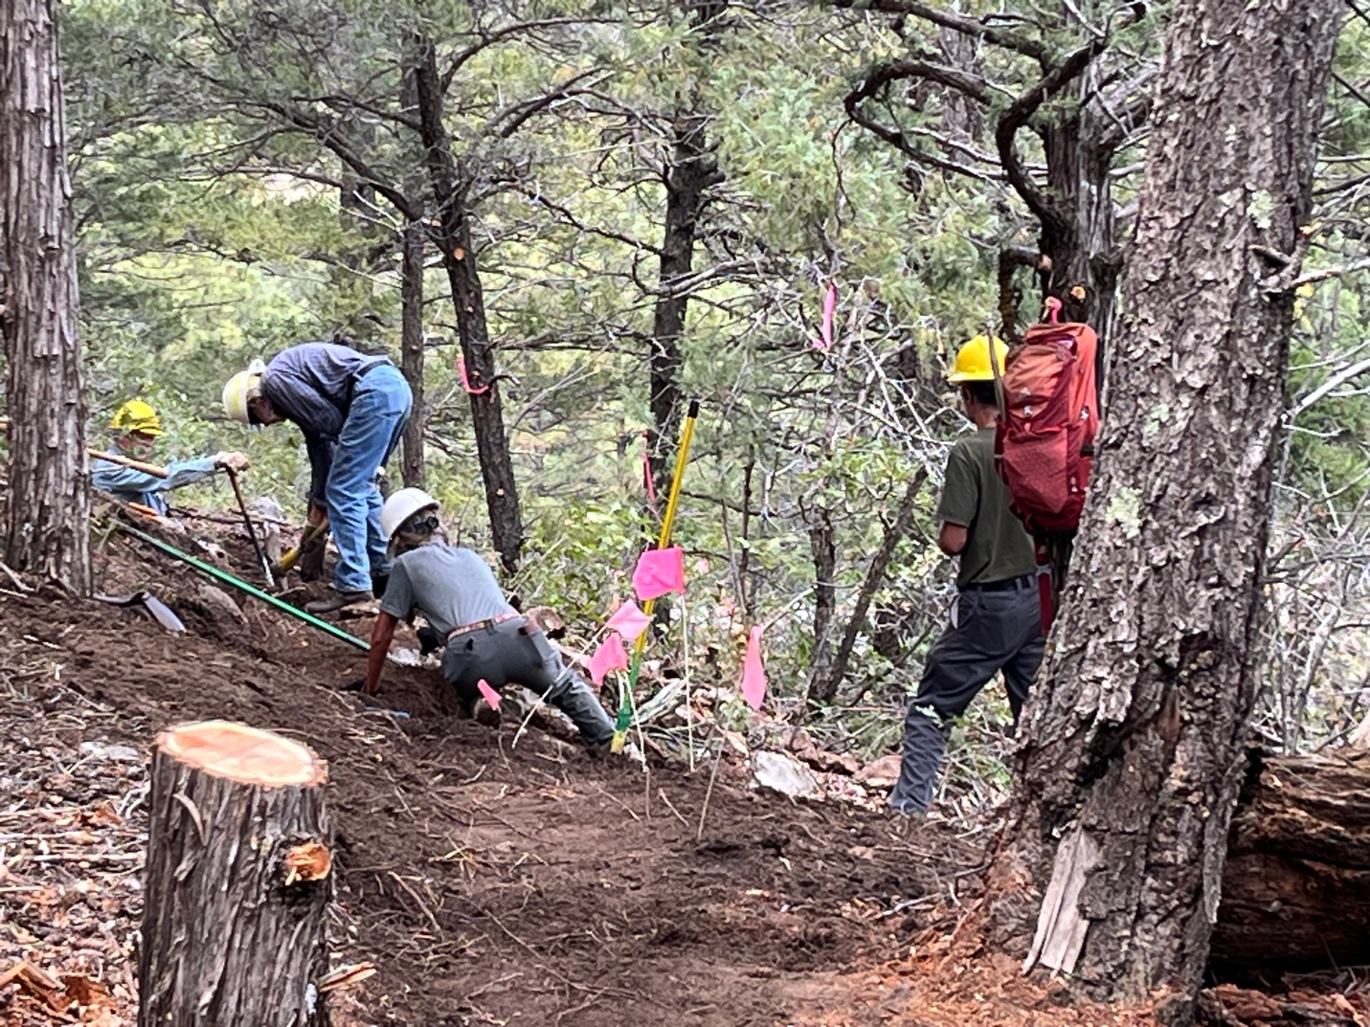

The afternoon finish-uppers moved a few more rocks and a bunch more soil.

Sections of the existing trail will be needing work once the reroutes are done.
