Report of FOSM Project to Cut Brush at the Intersection of Cienega Road and the Crest Highway
on Wednesday, October 15, 2025

Sam Beard
On Wednesday, October 15, seven FOSM volunteers cut brush at the intersection of Cienega Road and the Crest Highway for better driver sight distances in both directions on the highway.
The volunteers working on this project were Dan Benton, Sim Cook, Chuck Logan, Don Carnicom, Jerry Carroll, Lorna Morrow, and Sam Beard,
Project photos are presented below.

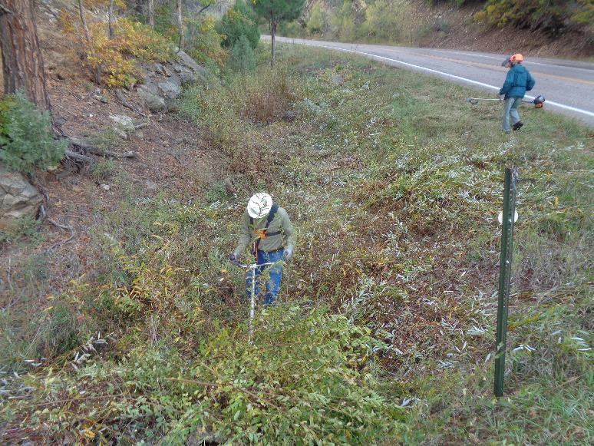
L to R: Chuck Logan and Don Carnicom cutting brush at the intersection of Cienega Road and the Crest Highway
for improved driver sight distance up the highway. The source of the water in the creek is a spring that runs year-round
between the intersection and Doc Long Picnic Area. Photos by Sam Beard
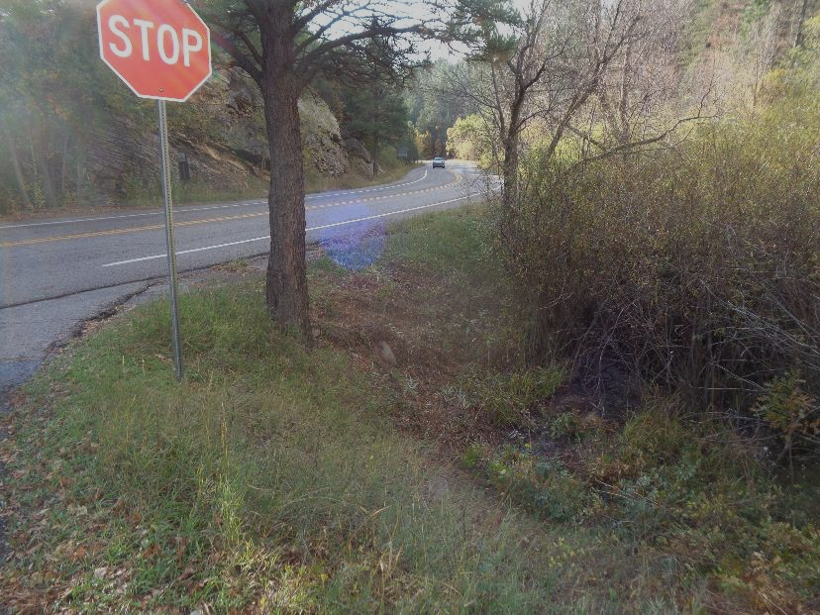
The brush here was cut by FOSM volunteers for better driver sight distance down the highway.

