Report of FOSM Projects to Cut Elm Brush and Replace a Broken Fence Rail
in Doc Long Picnic Area on Wednesday, October 15, 2025

Sam Beard
On Wednesday, October 15, FOSM volunteers cut approximately two dozen elm brush clumps and replaced a broken fence rail in Doc Long Picnic Area.
The volunteers working on these projects were Don Carnicom, Dan Benton, Sim Cook, Chuck Logan, and Sam Beard.
Project photos are presented below.

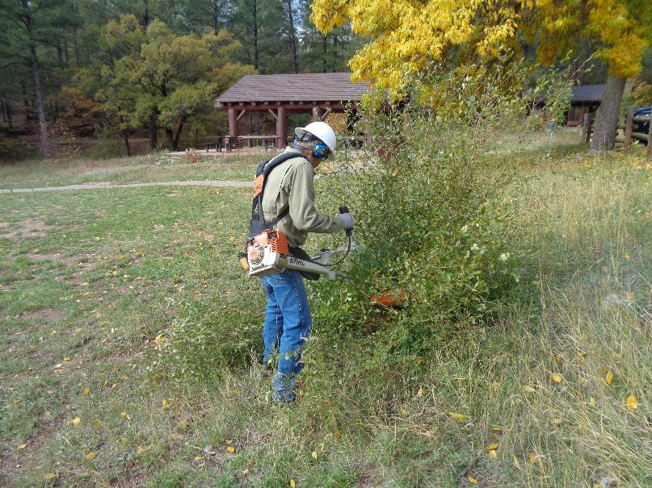
Chuck Logan using the large FOSM Stihl brush cutter to cut a clump of elm brush in Doc Long Picnic Area.
Picnic Shelter A is shown in the background. All photos by Sam Beard unless noted otherwise.
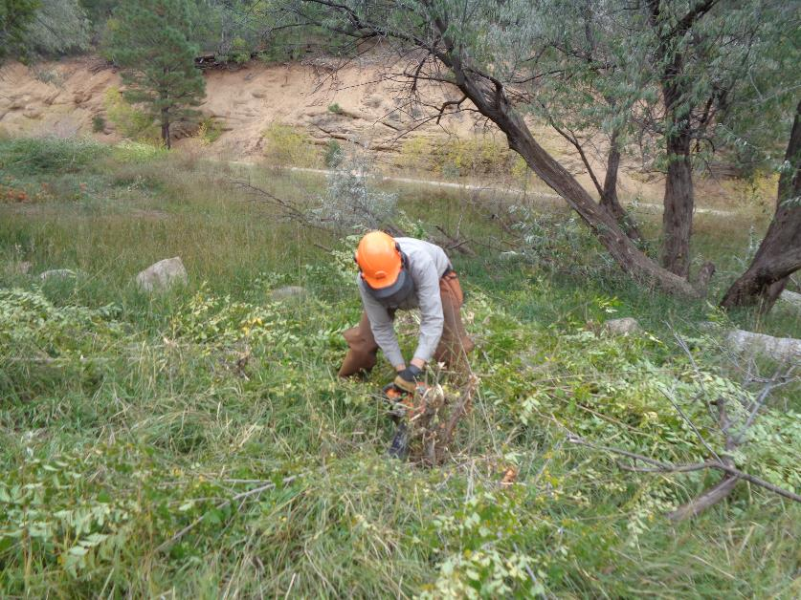
Dan Benton low cutting an elm brush stump in Doc Long Picnic Area with the highway in the background.
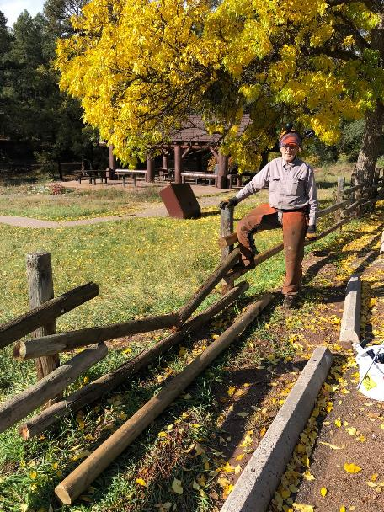
Dan Benton at the broken fence rail in Doc Long Picnic Area.
Photo by Sim Cook.
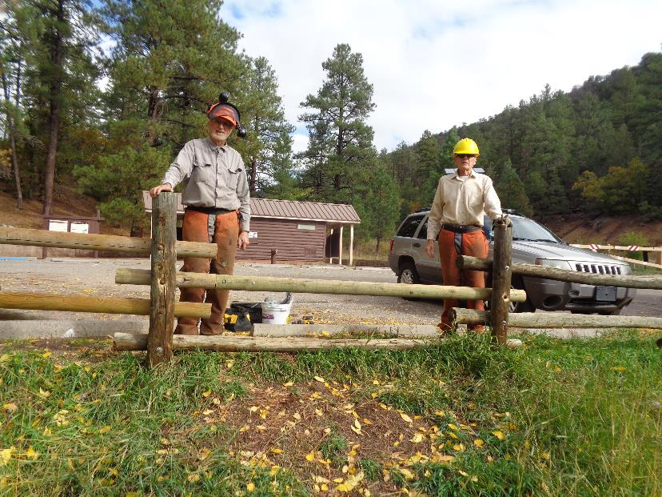
Dan Benton and Sim Cook at the new fence rail that they installed in Doc Long picnic Area.

