Thursday, 10/16/25- Old Faulty: What a beautiful day! We had a group of 14 (!) volunteers meetup at the Doc Long parking area for a day of trail work on Old Faulty. We picked up where we left off last week. Once the pin flags were set, the group spread out and went to work. This season seems to be one steep slope after another and this week we felt like we wandered off another cliff edge. But with such great conditions (although the soil was pretty wet) and such a great group of volunteers, we are making progress.

Volunteers: Eric Russell, Mike Madden, John McNett, Bruce Hansche, Kerry Jones,
Claudia Bergsohn, Dan Burwinkle, Byron Garner, Roland Stumph, Bill Perkins,
Mackenzie Gibbs, Steve Roholt, Cia Reil and Laura Leon

Pictures: Laura Leon

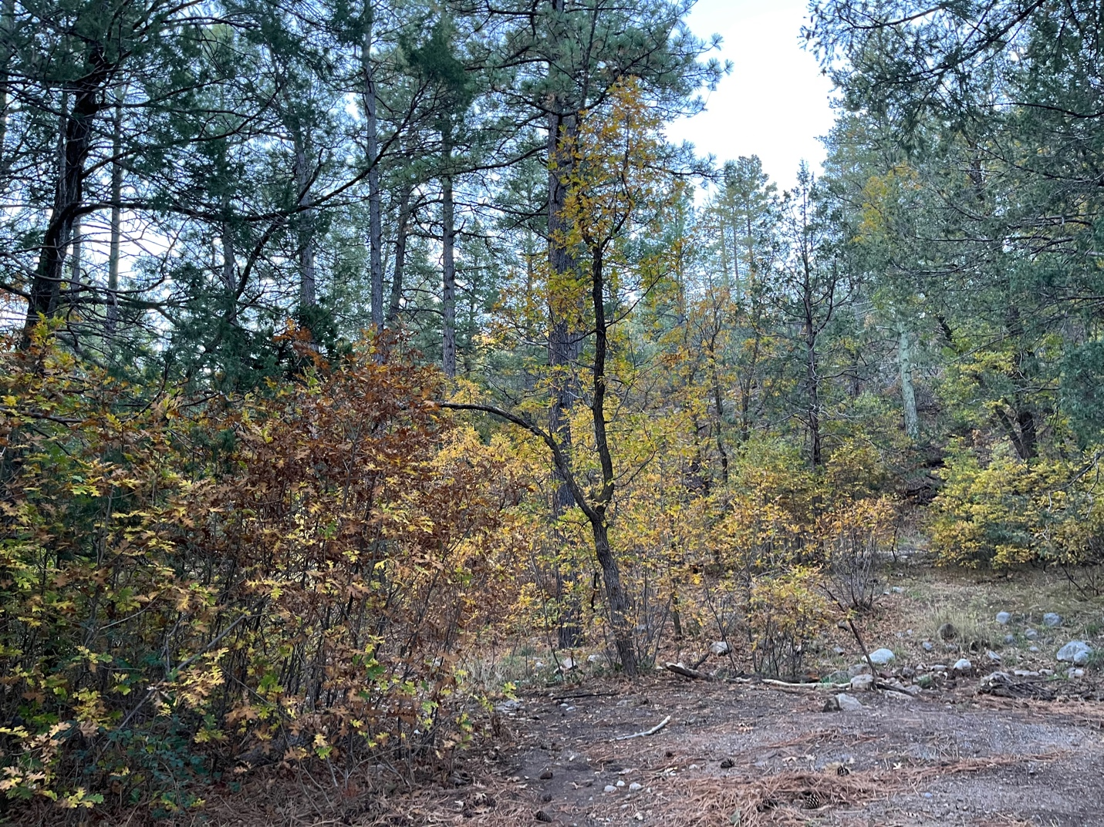

Fall colors are all around now.

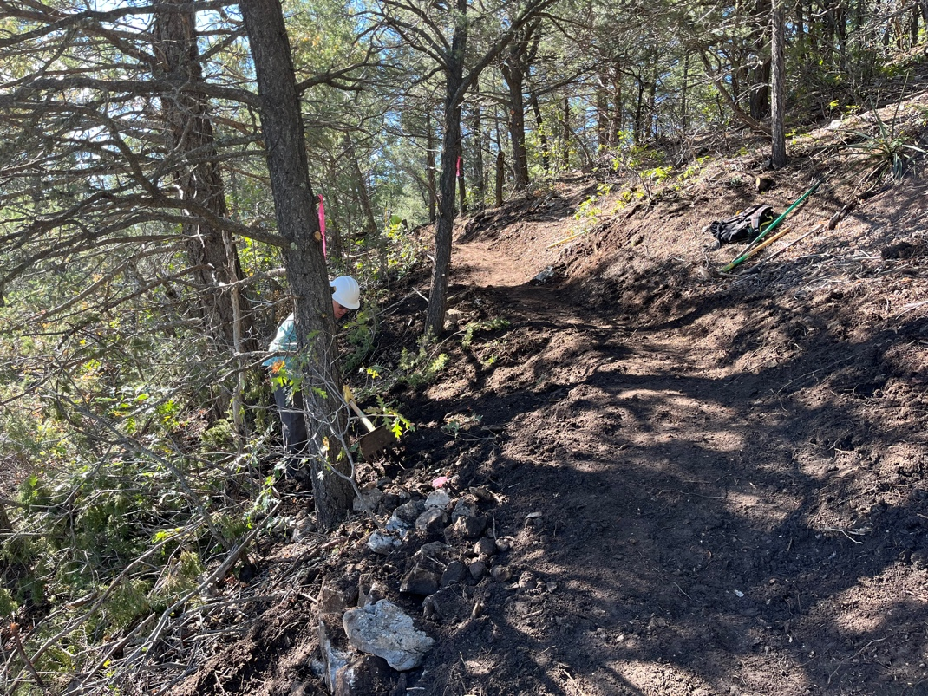

Cia and Steve did some finishing work on last week’s areas.

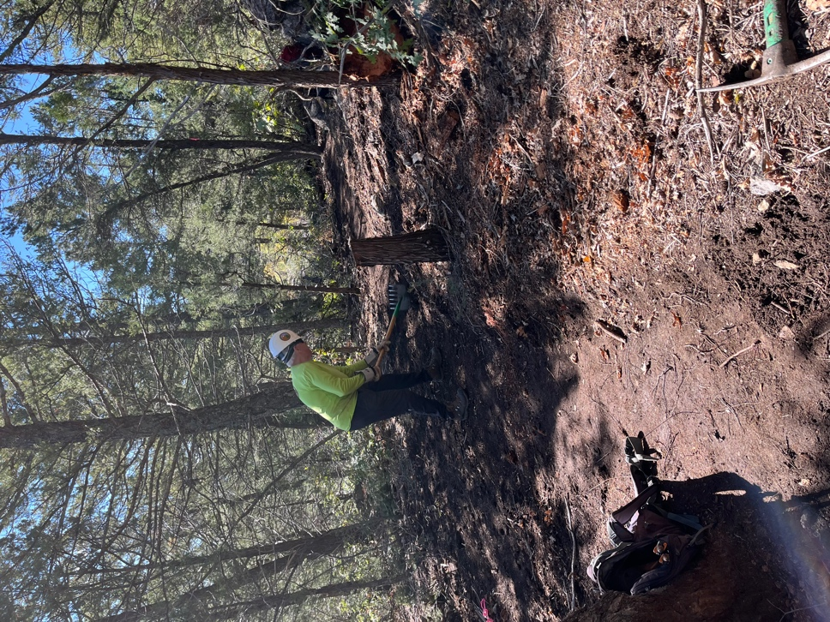
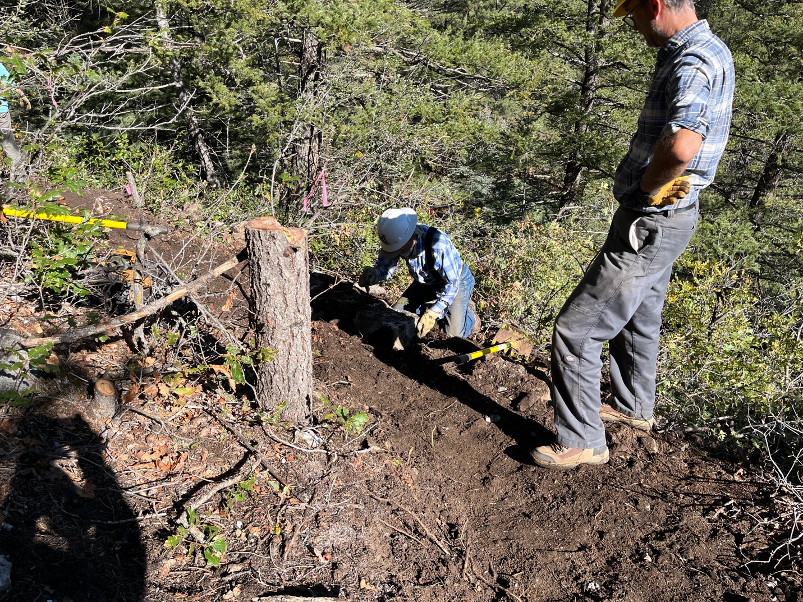

Roland and Bruce did rock work around a curve. Getting steeper…..

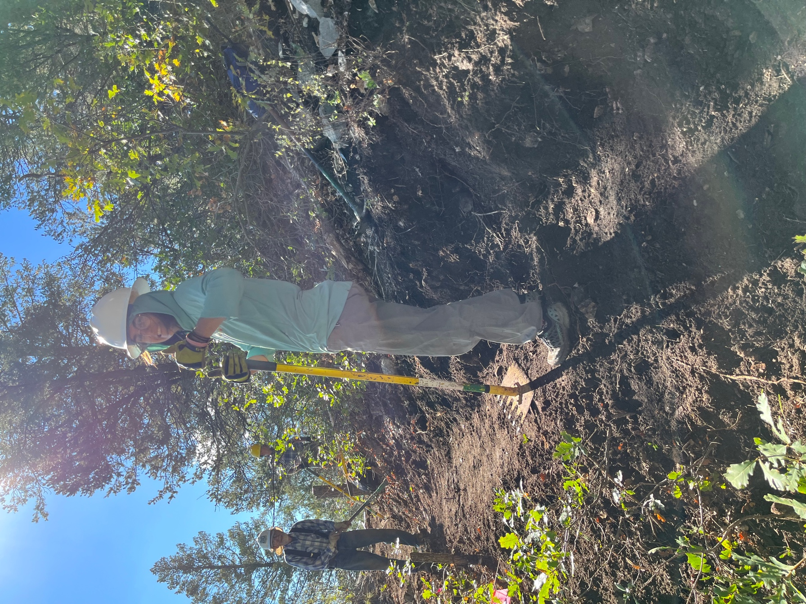

Mackenzie has gone and got herself a big girl job so we’ll have to do without her for a while.
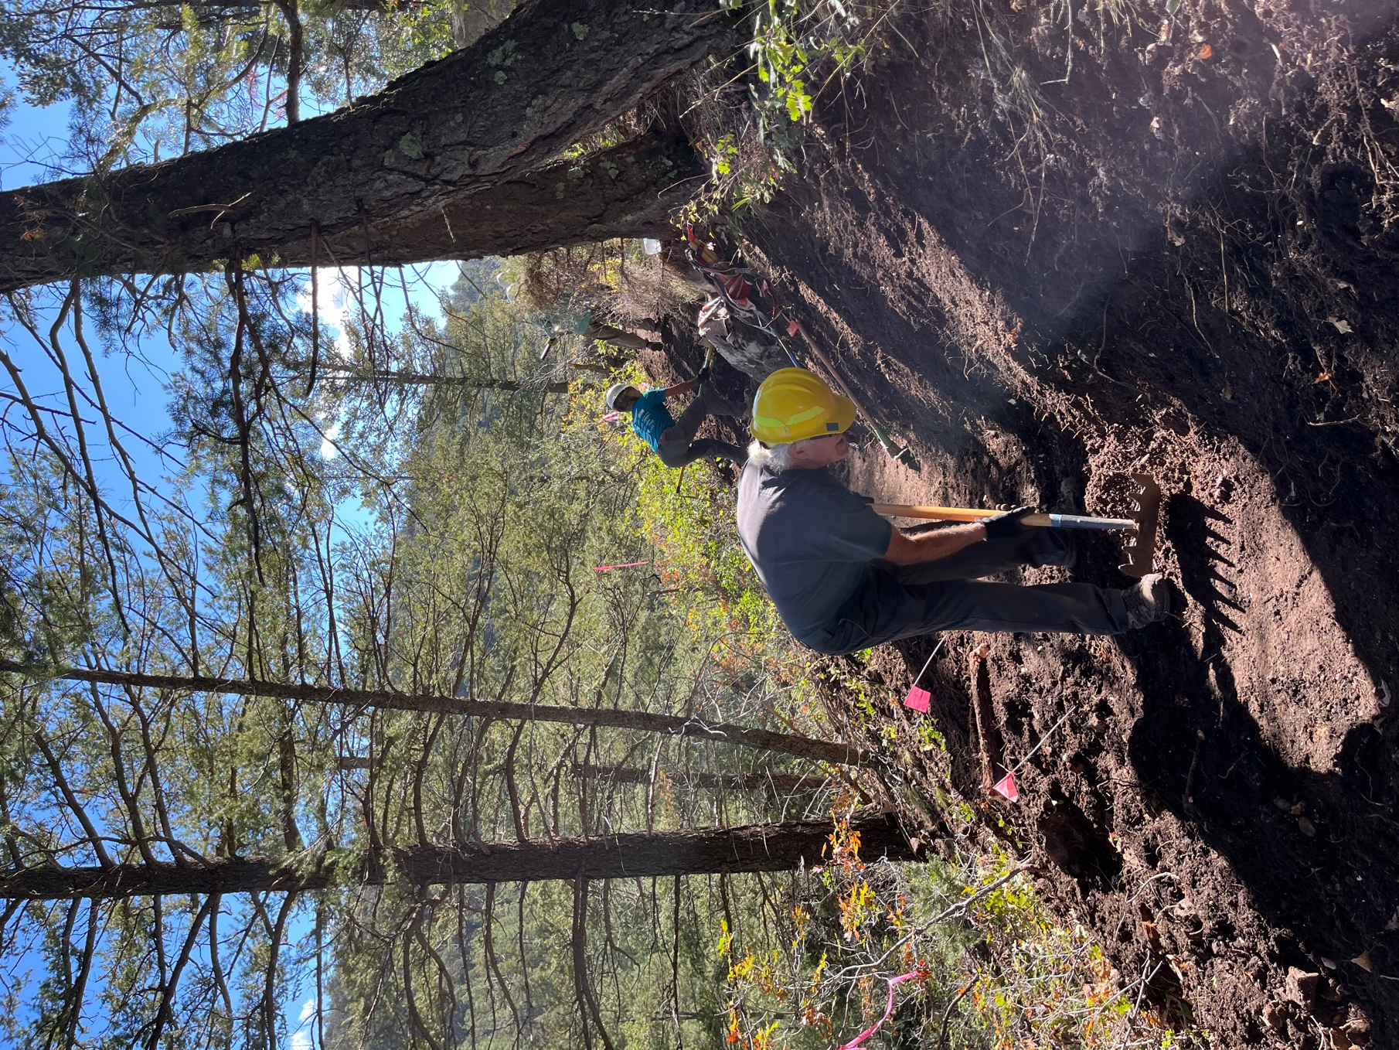

Mike and Claudia at work. A little steeper…..

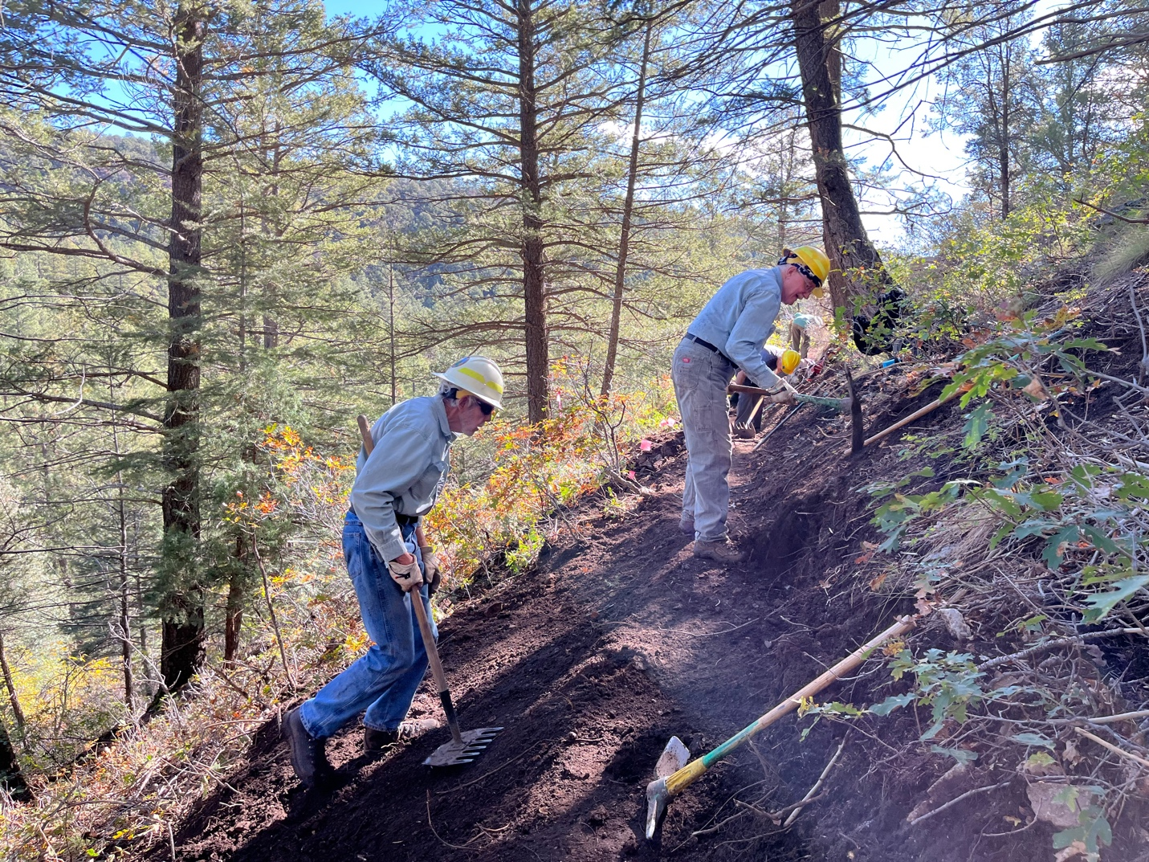

Byron and Eric dig into the slope to make the trail wide enough.

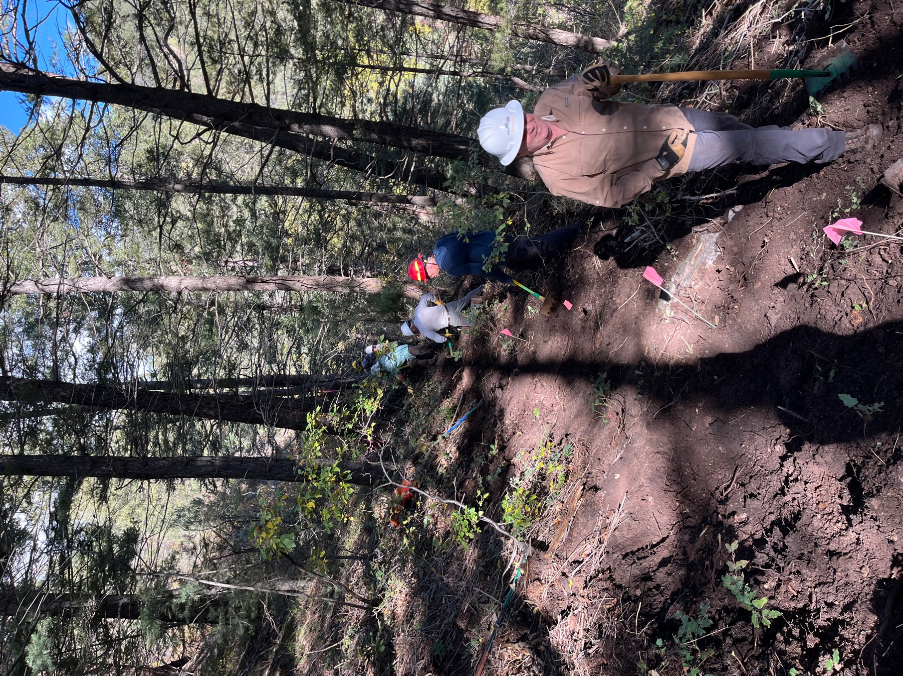

Dan, Kerry and Bill (and others) get into the really steep area. Wet soil made it hard to hold on!
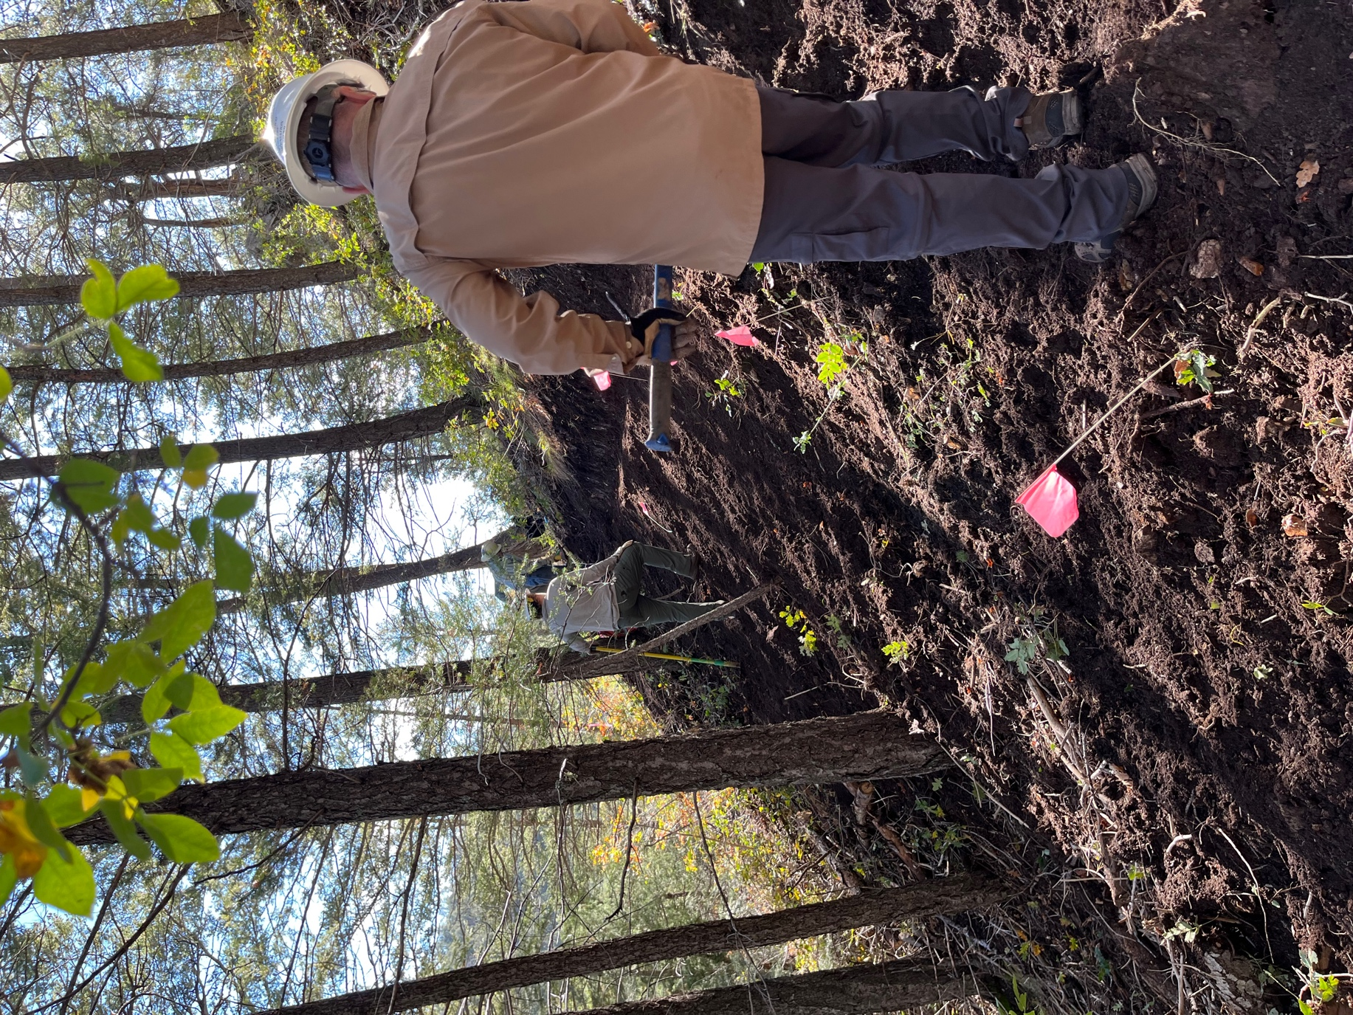

John and Dan hard at work. Hold on!
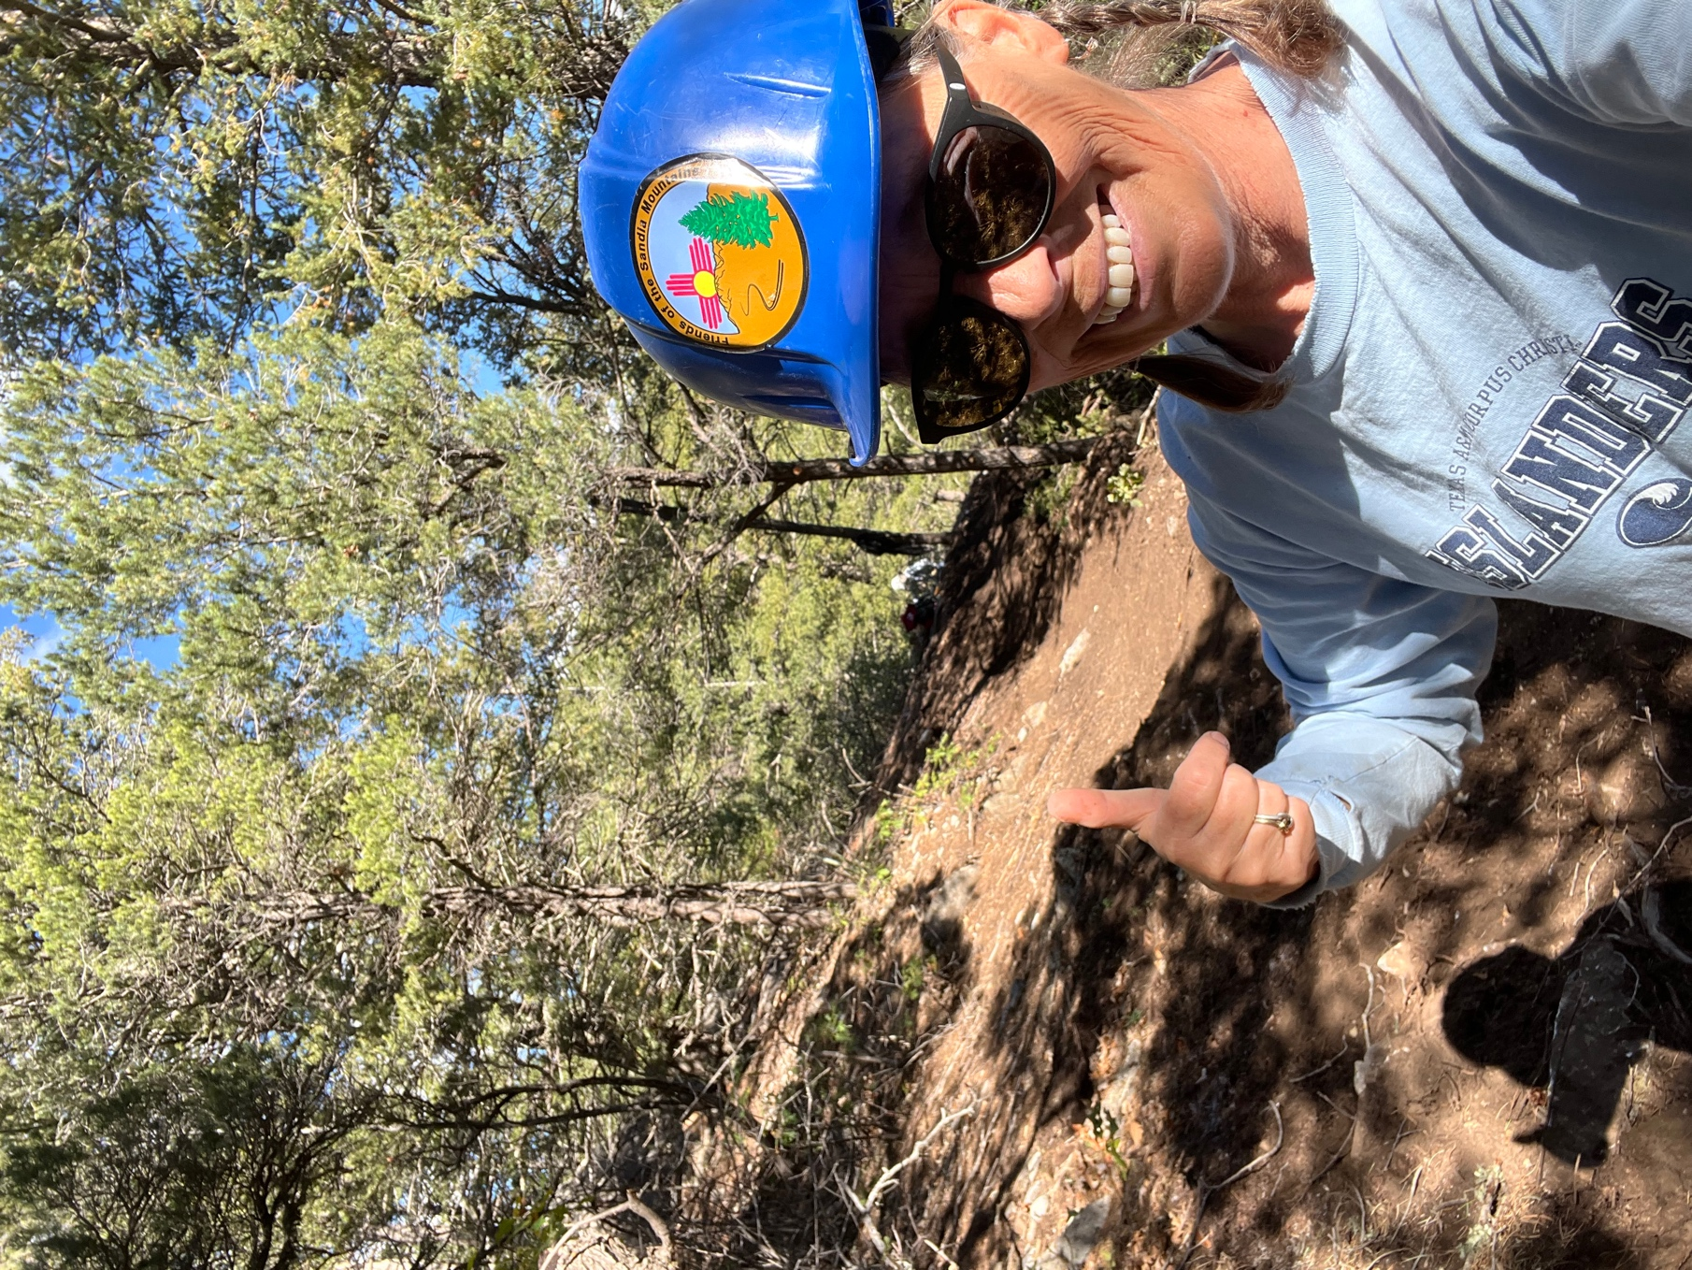

I get to work with the best trail crew around- look at that work!!

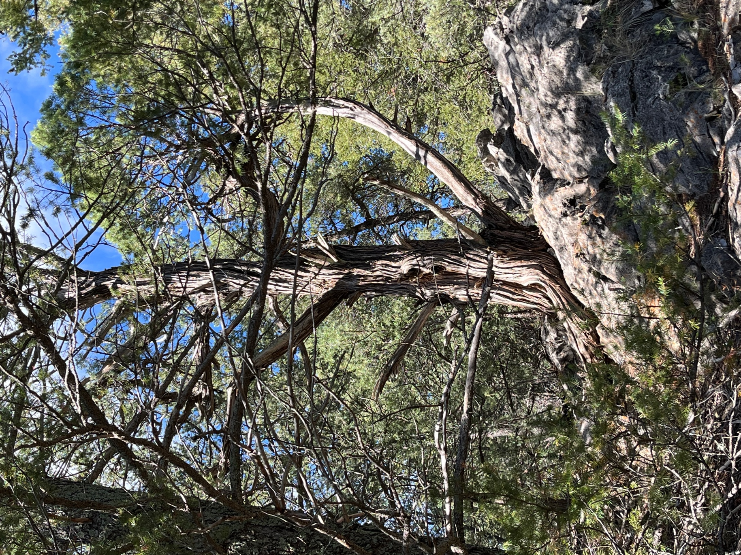

This old beauty has some fantastic character and still some color up top!

