Thursday, 10/23/25- Old Faulty: We had a wet start today. As we pulled into Doc Long the rain started up and there was thunder and lightning. After standing around for about 30 minutes the sky started to clear and we headed up to the tool stash. The rest of the day was on and off clouds but no more rain. We continued work on the last reroute on Old Faulty. There was some finishing work and we forged ahead on the reroute work. Have I mentioned that it’s steep?? We still have work to do but we can see the end of this reroute from where we are working!

Volunteers: Eric Russell, Mike Madden, Rich Fagioli, Roland Stumpf,
Claudia Bergsohn, Kerry Jones, Larry Larrichio, Patrick Walgren and Laura Leon

Pictures: Laura Leon

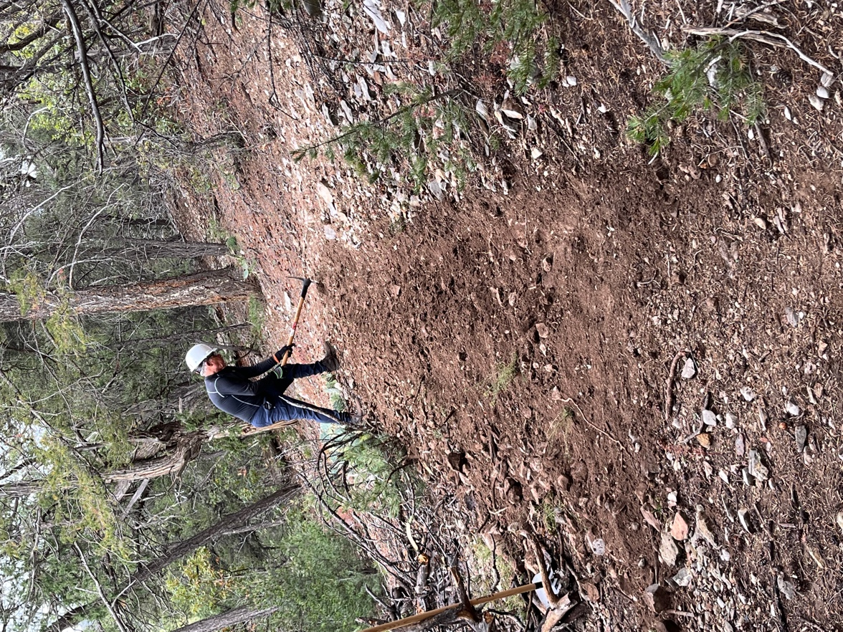

Larry did some work on one end of the reroute.

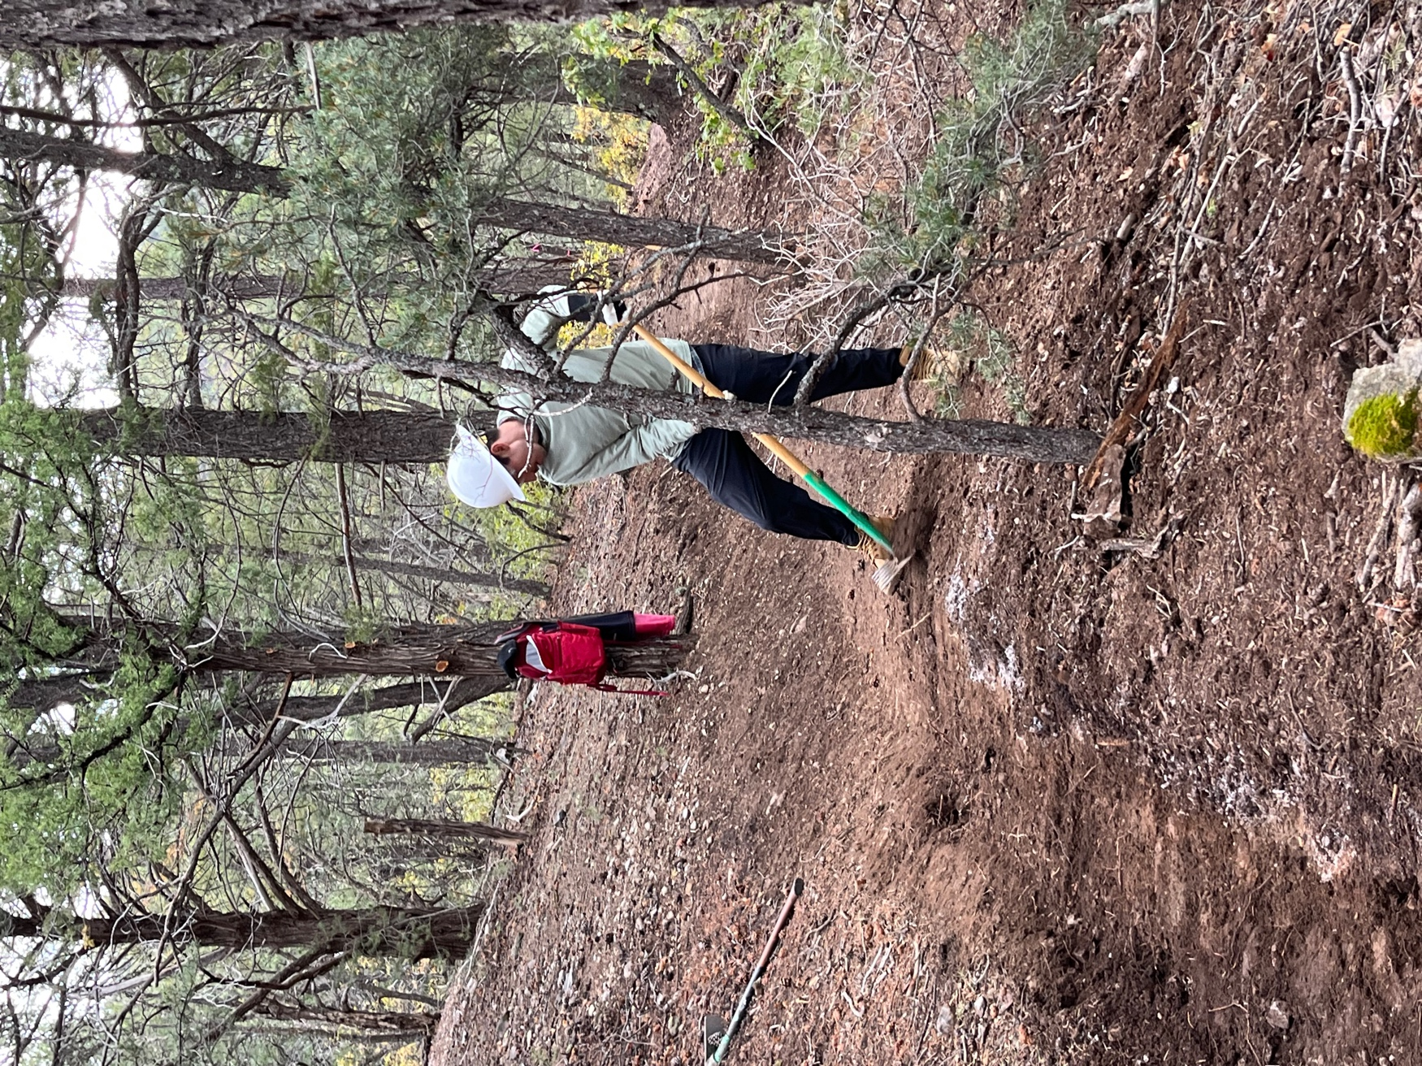

New digger, Patrick, learns to lay out some tread. Looks good!!

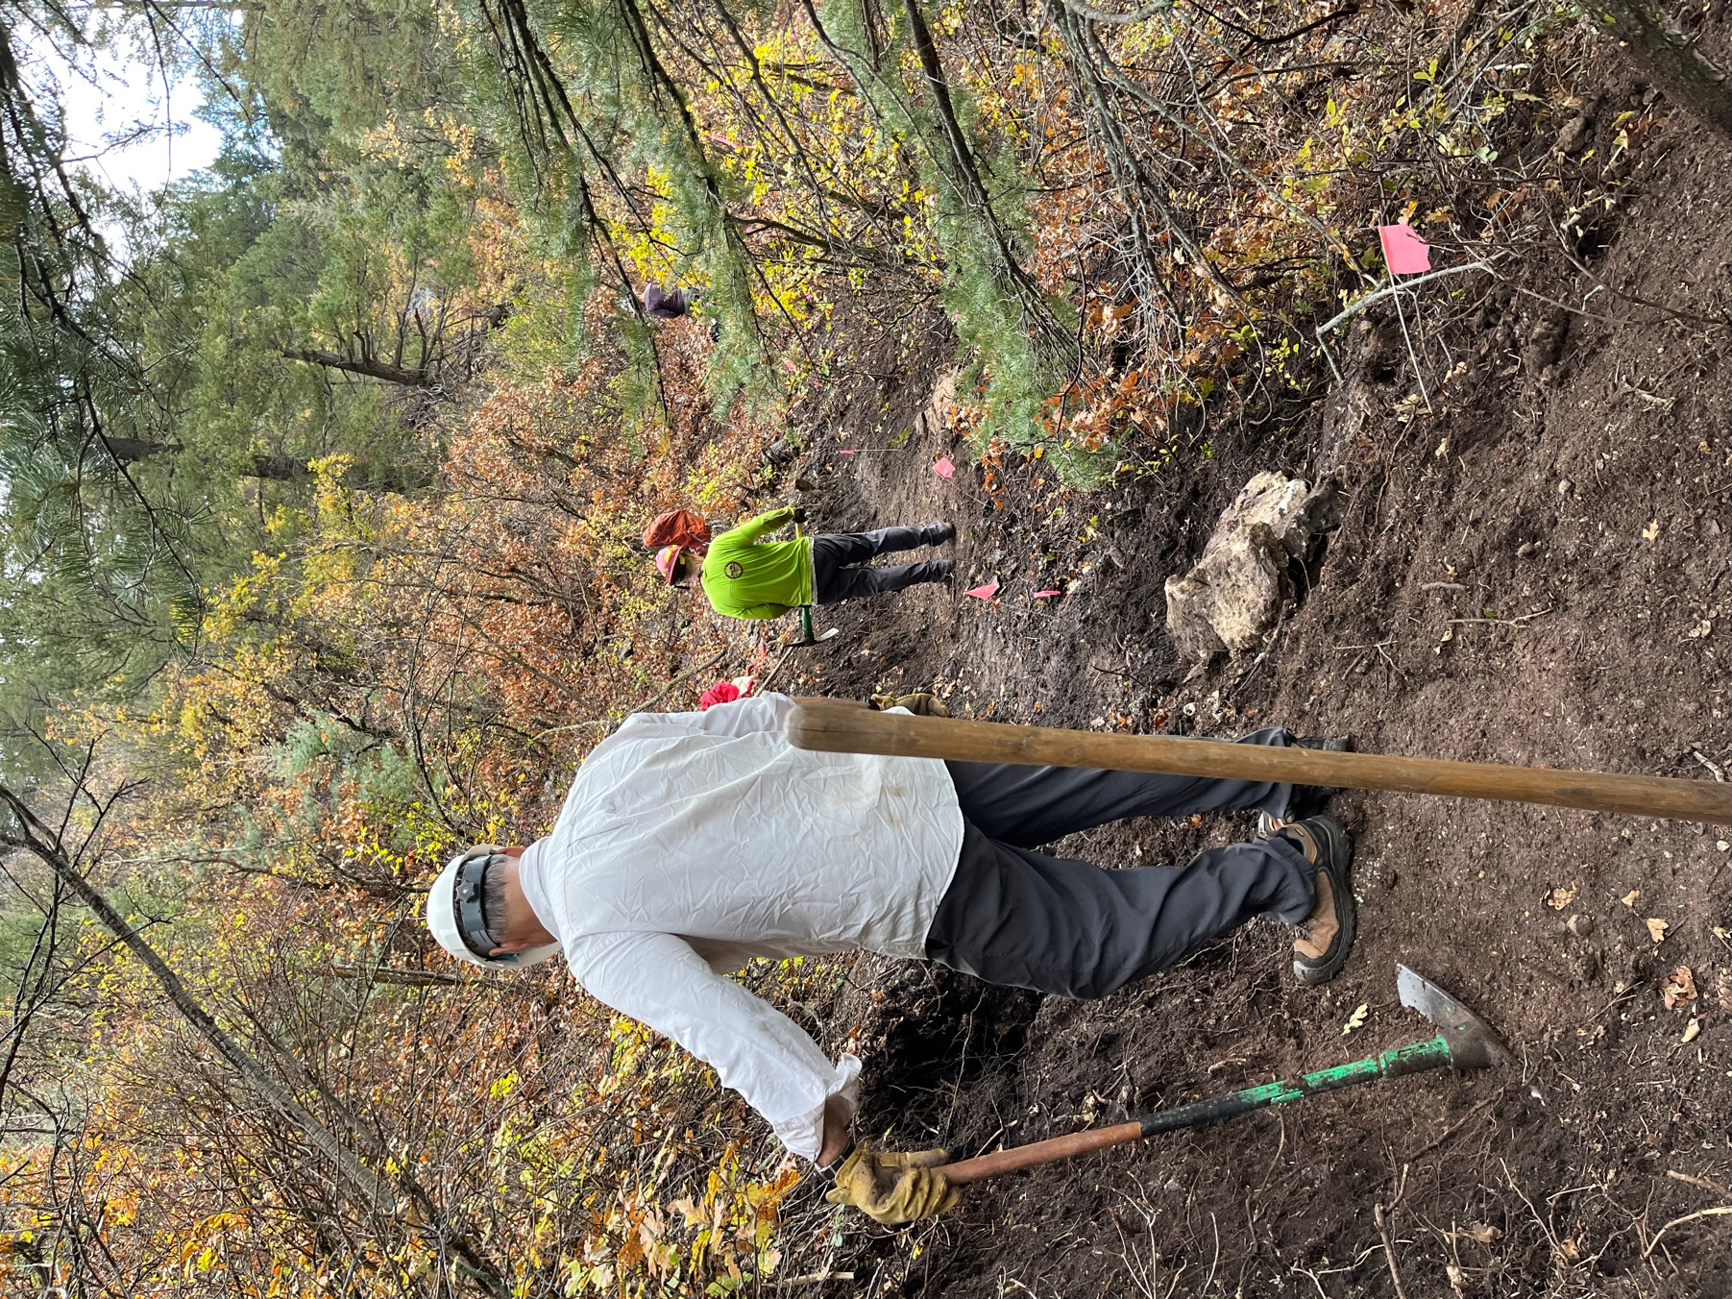

Scary slopes. Rich and Kerry work to get tread down.

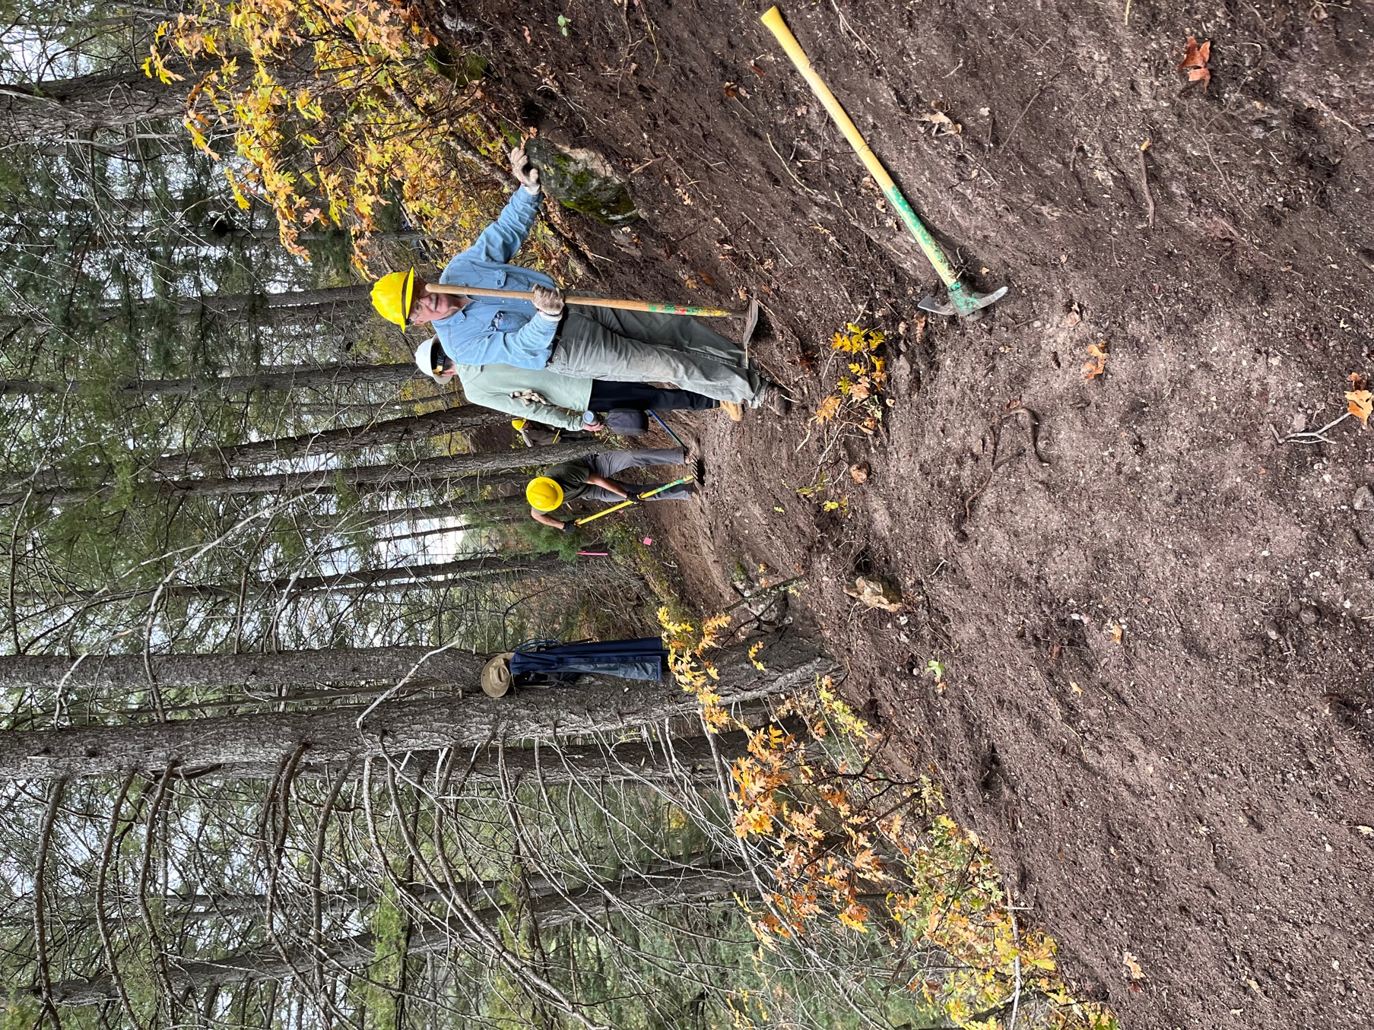

Eric and Roland work on tread.

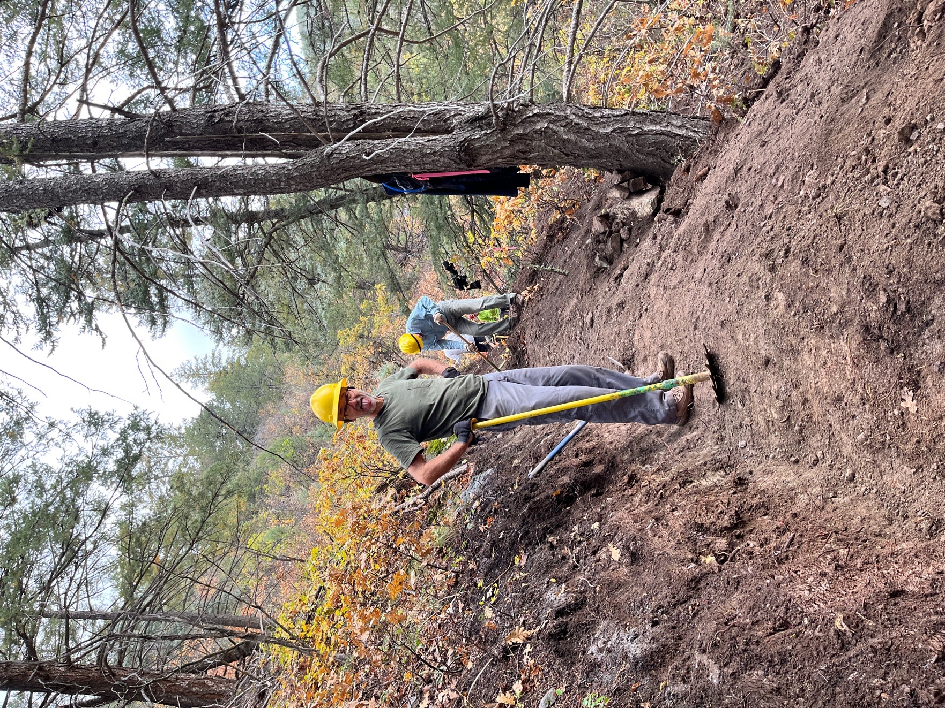

Roland being Roland- that tread needs to be wider!
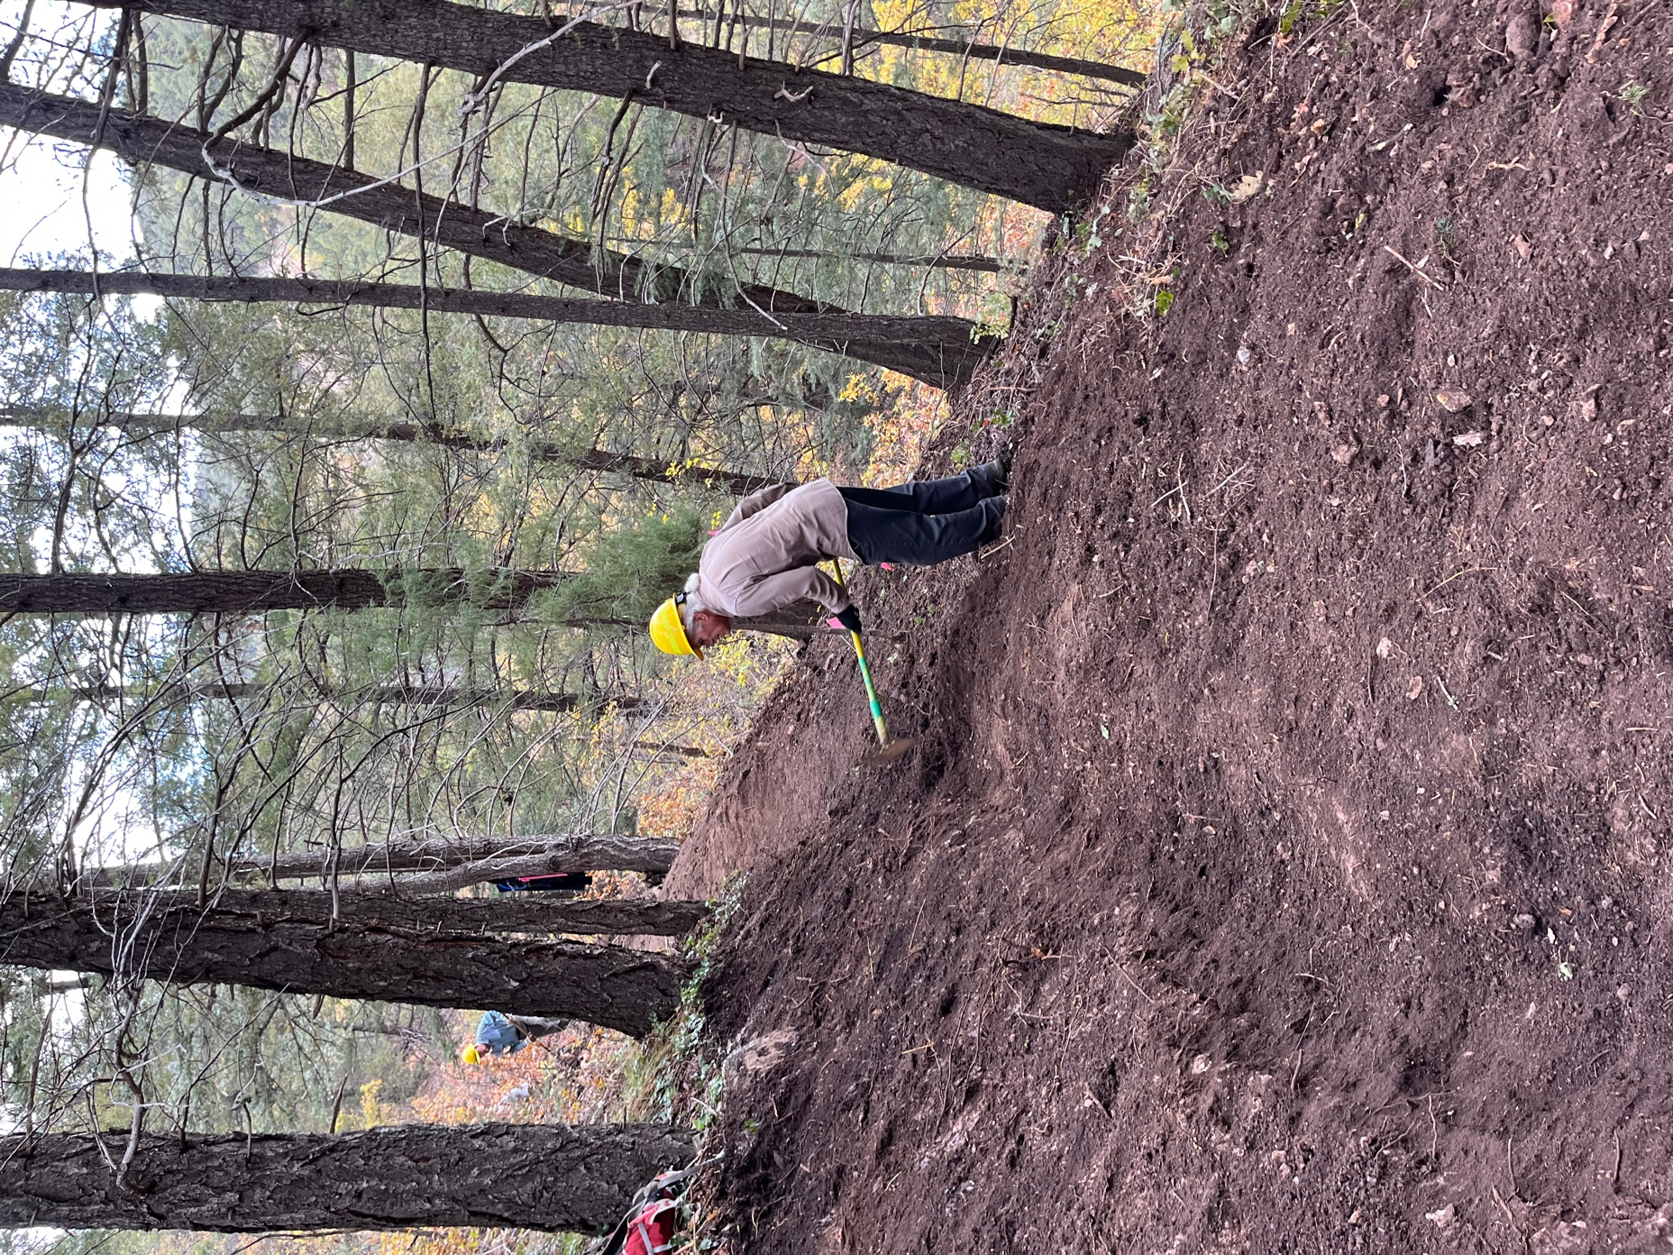

Mike worked at widening an area from last week’s work.

