Report of FOSM Bucking Trees Felled Earlier below the Crest Electronic Site Fence on Wednesday, October 22, 2025
Sam Beard
On Wednesday, October 22, FOSM volunteers continued to buck trees felled earlier between the new Electronic Site chain link fence and the upper part of the Crest Highway. Canyon Young, SRD Trails and Wilderness Program Manager, requested that FOSM buck and remove some of the many down trees in this area to reduce the wildfire fuel load. Some of the felled trees could have been considered hazard trees, because there was a probability that these dead trees would fall on the new fence.
The piles of bucked logs will be loaded on Mike Oliver’s trailer later and hauled to his woodlot. The Mountain Christian Church Wood Ministry will distribute this fuelwood to families in the East Mountains who need it.
The volunteers who worked on Wednesday were Jerry Carroll, Sam Beard, Chuck Logan, John Quinley, Cliff Giles, and Dan Benton.
Project photos are presented below.

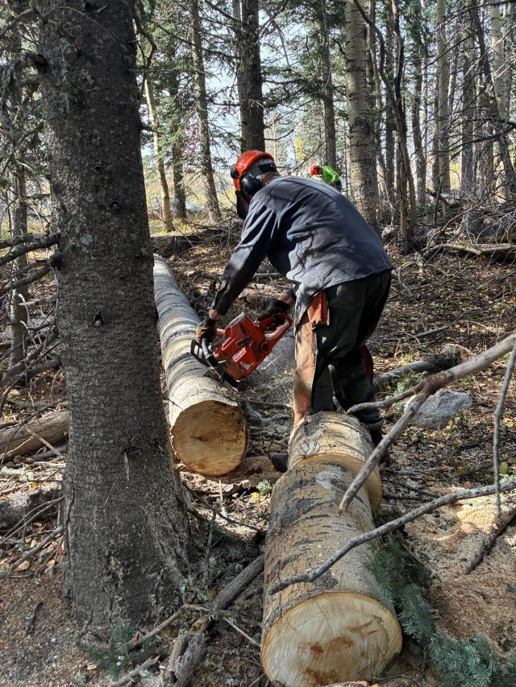
Dan Benton bucking a large aspen with Steve Roholt bucking in the background.
All photos by Cliff Giles
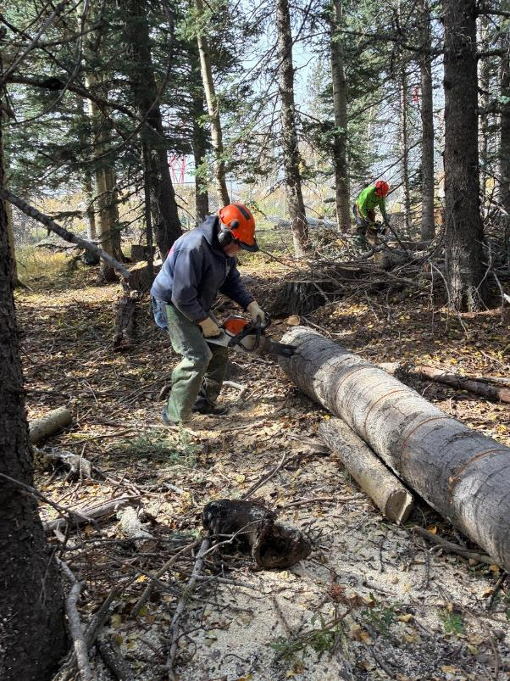
Jerry Carroll bucking a large log with Steve Roholt bucking in the background.
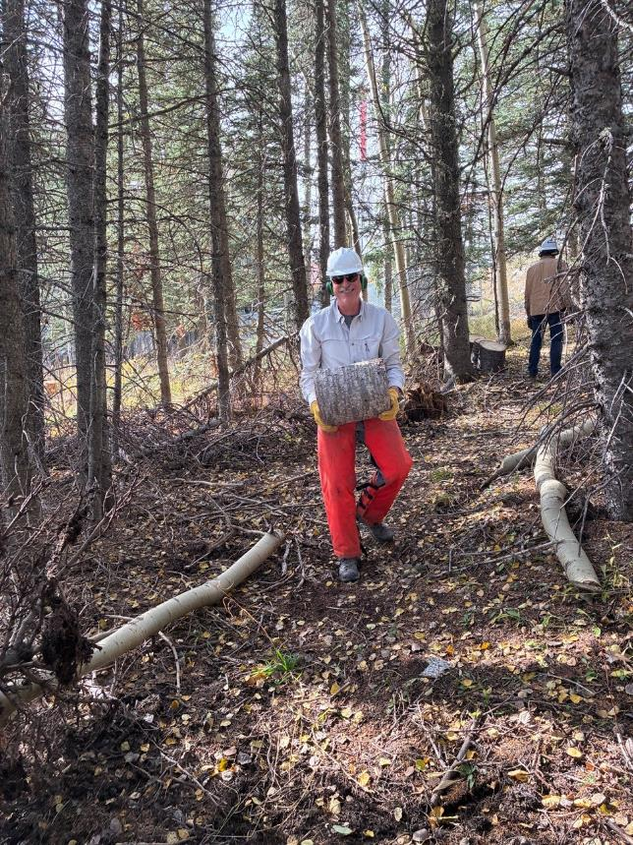
John Quinley carrying a round toward a pile above the highway.
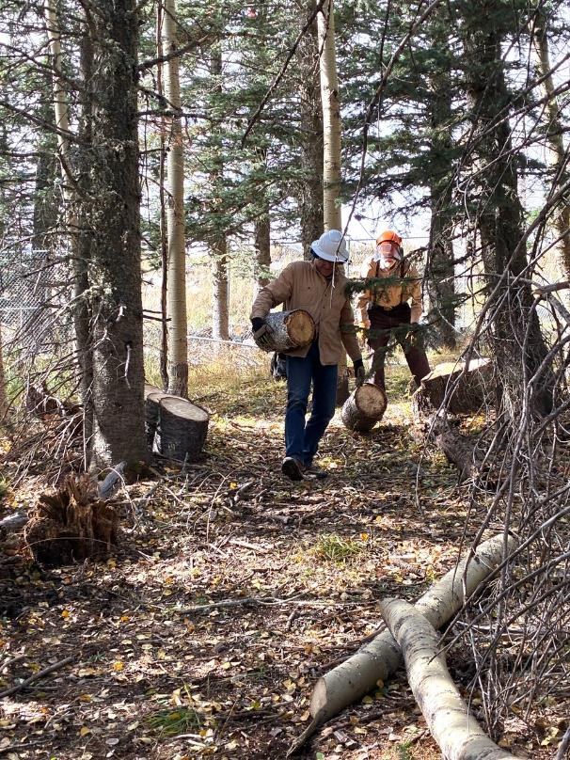
Chuck Logan carrying round down and Sam Beard rolling a round down.

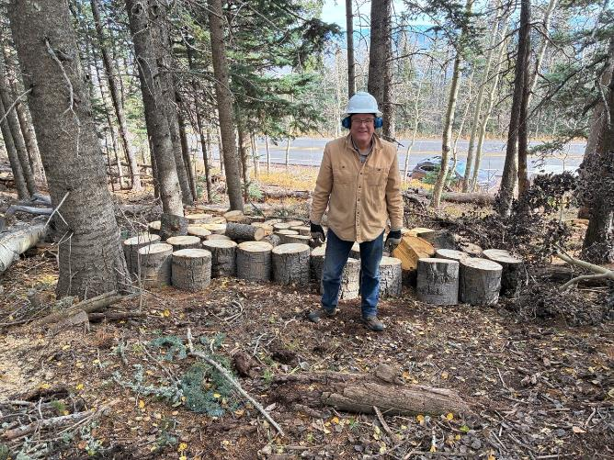
Chuck at the pile with the Crest Highway in the background.

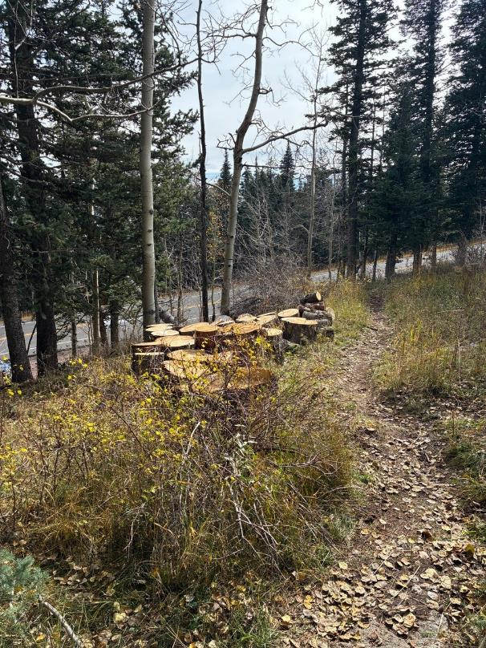
Another large pile near the highway.
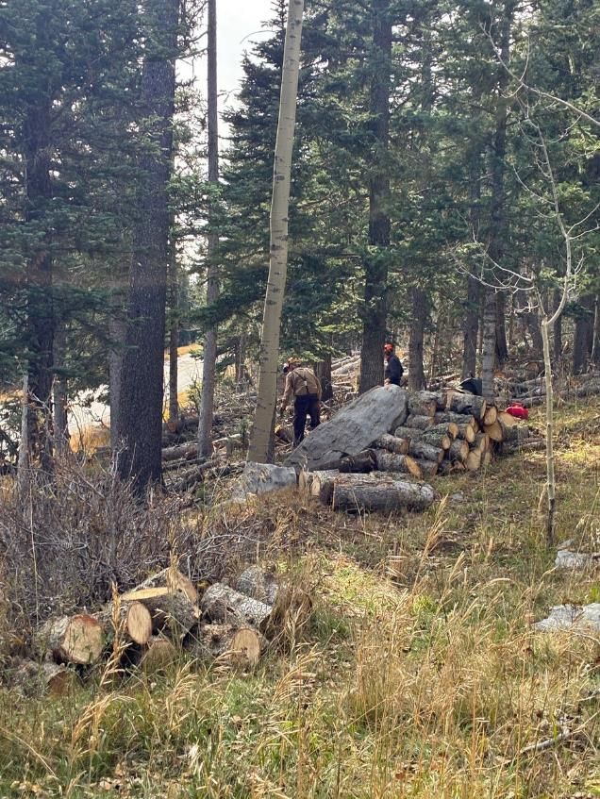
More rounds near the highway. The piles are somewhat hidden from the highway
so that they will not be stolen before we can haul them a church woodlot.

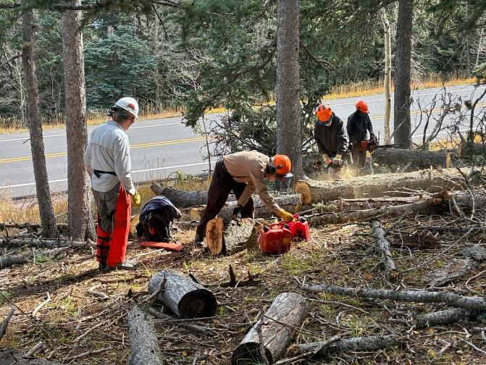
Sawyer preparing to put fuel in a chainsaw with two volunteers bucking
In the background near the highway.

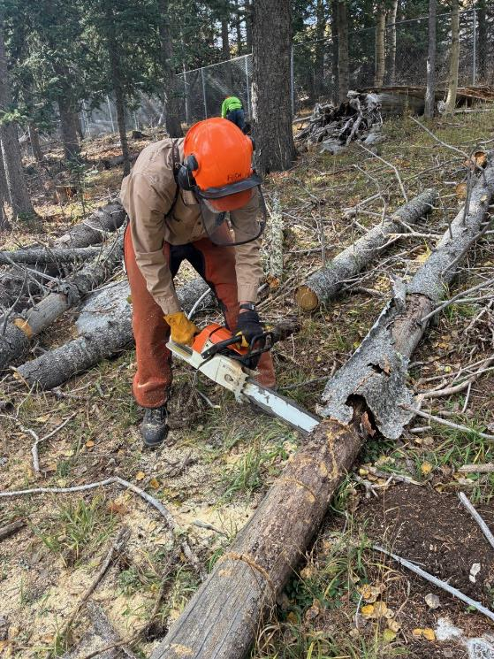
Sam Beard bucking a small cork bark fir log.

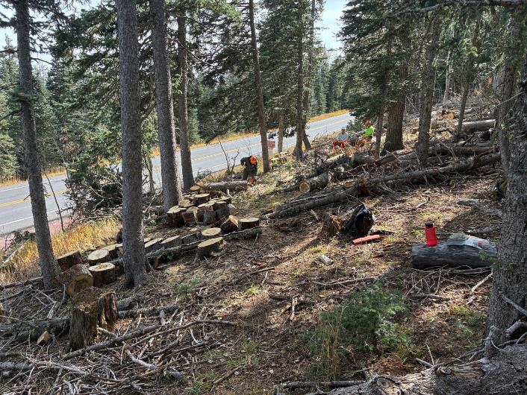
View of bucking area where numerous logs have bucked, and the rounds have been
moved down near the highway. Note that some areas of the forest floor
are no longer covered by piles of logs.

