Report of FOSM Project to Buck Logs between the Crest Communication
Site Fence and the Upper Crest Highway, Wednesday, October 29, 2025

Sam Beard
On Wednesday, October 29, six FOSM volunteers continued to buck down trees between the new Communication Site fence and the upper Crest Highway. They were working in the northern part of this area near a turn in the fence. The bucked rounds were stored near the highway where that they would not be seen by passing motorists so that they would not be stolen. All these rounds with be eventually hauled to the Mountain Christian Church woodlot. Church volunteers will donate the wood to East Mountain families who need the wood to heat their homes.
The volunteers working on this project were Jerry Carroll, Sam Beard, Cliff Giles, Chuck Logan, Dan Benton, and Eric Russell.
Project photos are presented below.

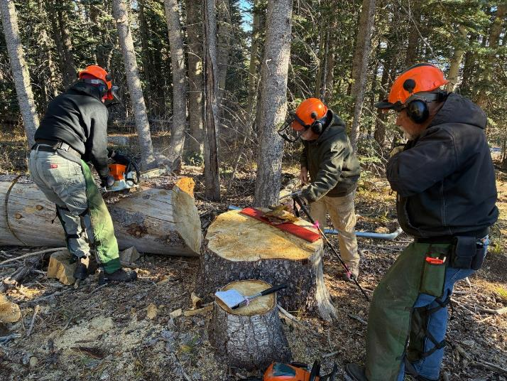
Eric Russell beginning to buck the 28-inch log. Sam Beard and Jerry Carroll are observing.
All photos by Cliff Giles

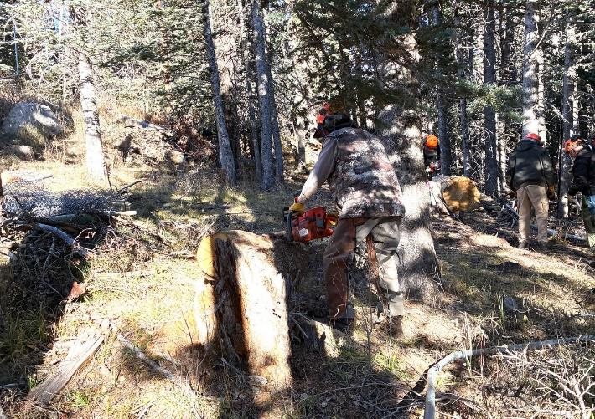
Dan Benton bucking another log.

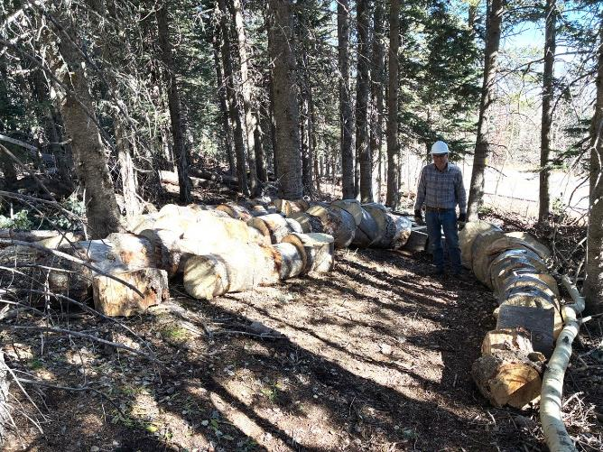
Chuck Logan and the large rounds that have been rolled down to an area above the Crest Highway
where they will stay until being hauled to the Mountain Christian Church woodlot.

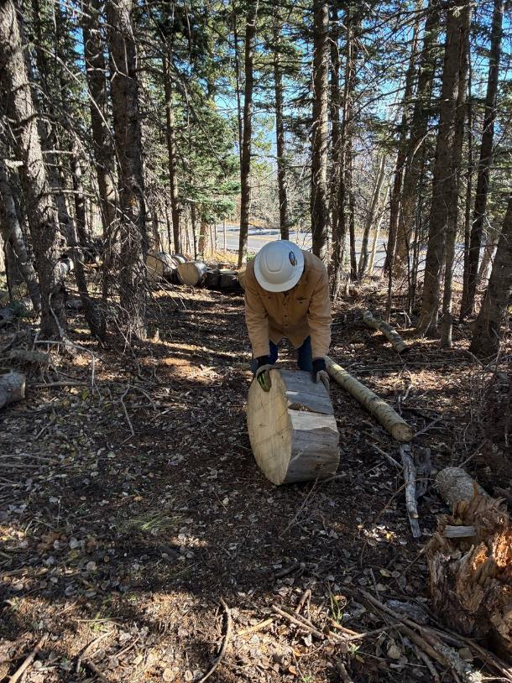
Chuck rolling a round down to the storage area.

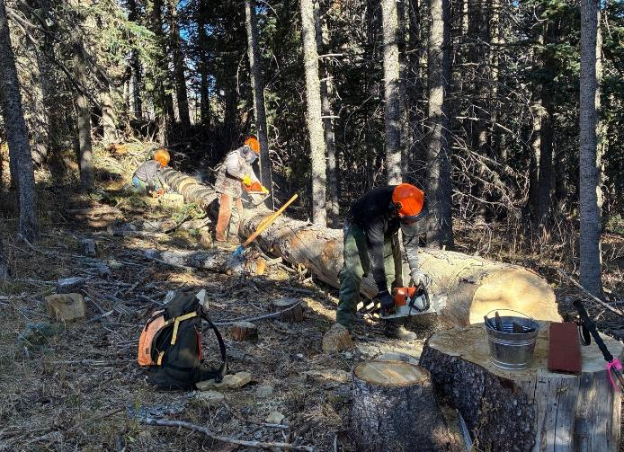
L to R: Jerry Carroll, Dan Benton, and Eric Russell bucking different sections of the large log.

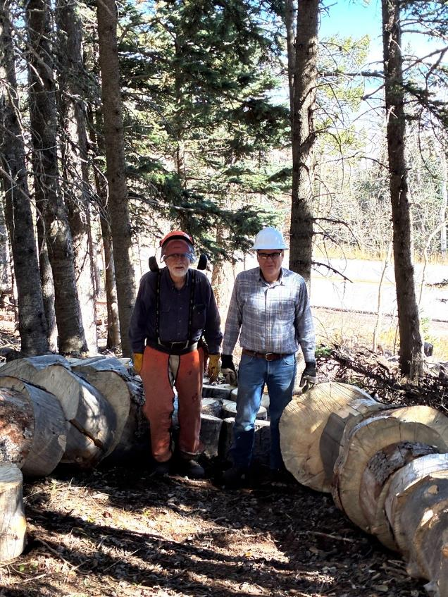
Sam Beard and Chuck Logan almost surrounded by large rounds with the Crest Highway
in the background.
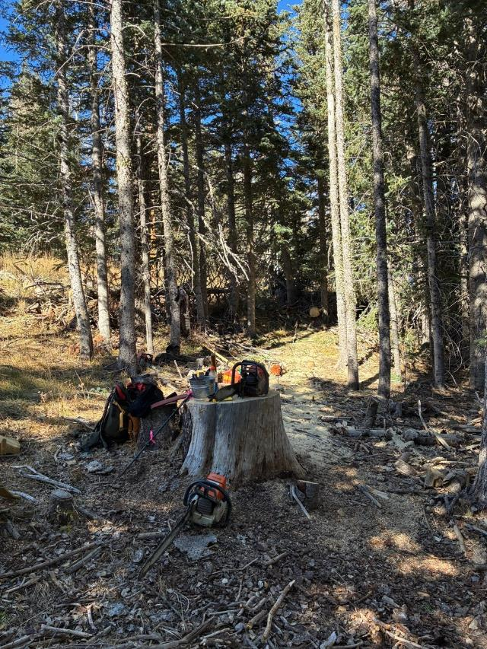
The large log has been bucked into almost 50 1-foot pieces that have been
moved to the area just above the highway.

