Thursday, 10/30/25- Old Faulty: A chilly morning sent everyone up to the work area quickly. The weather was actually very nice working weather but we’re getting into the time of year when you have to cover up during lunch or you get cold. Thirteen volunteers set to work on the last reroute for Old Faulty and we are just about to the end of it. The slope, along with very large rocks and very large roots are slowing progress but the final product is looking very, very nice.

Volunteers: Bill Perkins, John McNett, Bruce Hansche, Larry Larrichio, Jim Houle,
Eric Russell, Luis Cuadros, Rich Fagioli, Roland Stumpf, Claudia Bergsohn,
Kerry Jones, Byron Garner and Laura Leon

Pictures: Laura Leon, Rich Fagioli and Bruce Hansche

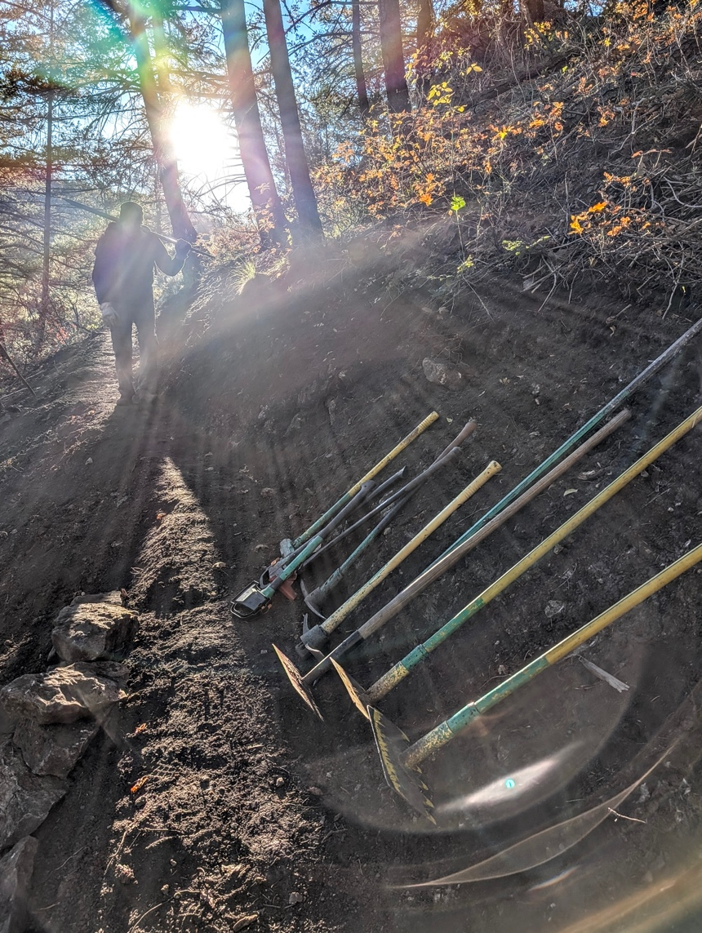

A brisk start as the sun comes up. Contestants, select our weapons!

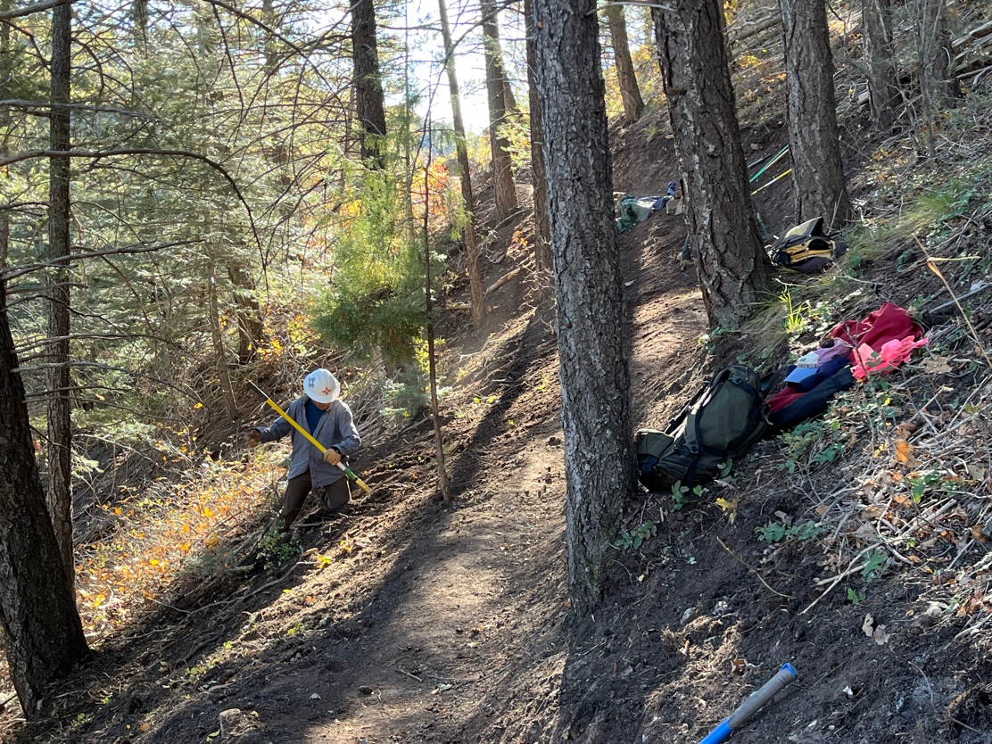

Luis and Laura did finishing work on last week’s trail. I think we’ll get harnesses to keep from sliding down the slope for next week.

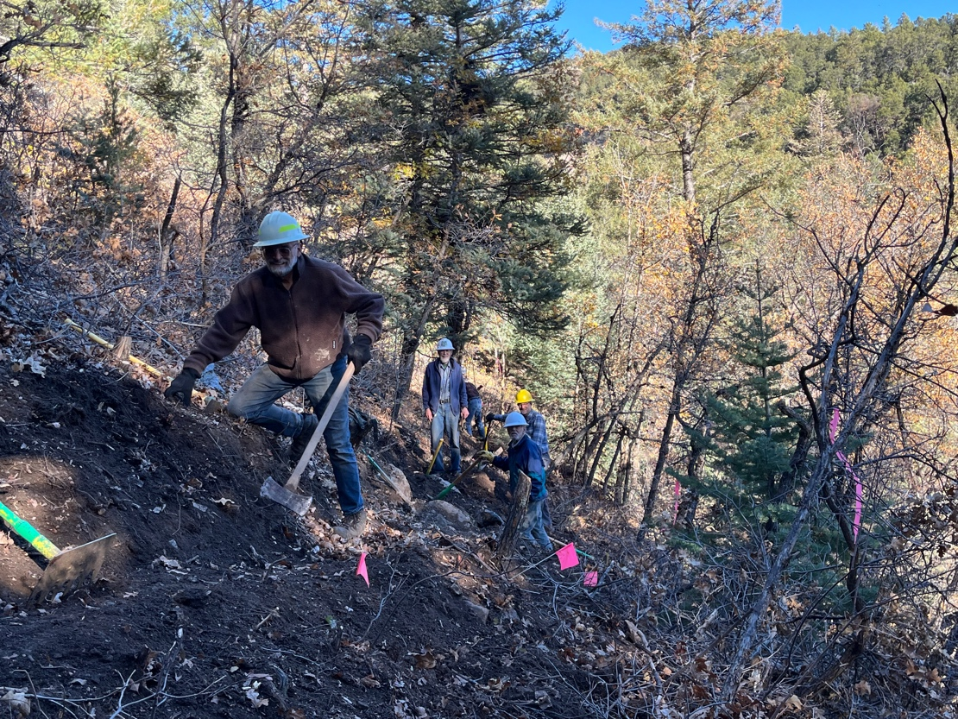

A merry band of diggers- Jim, Bruce, Bill and Roland
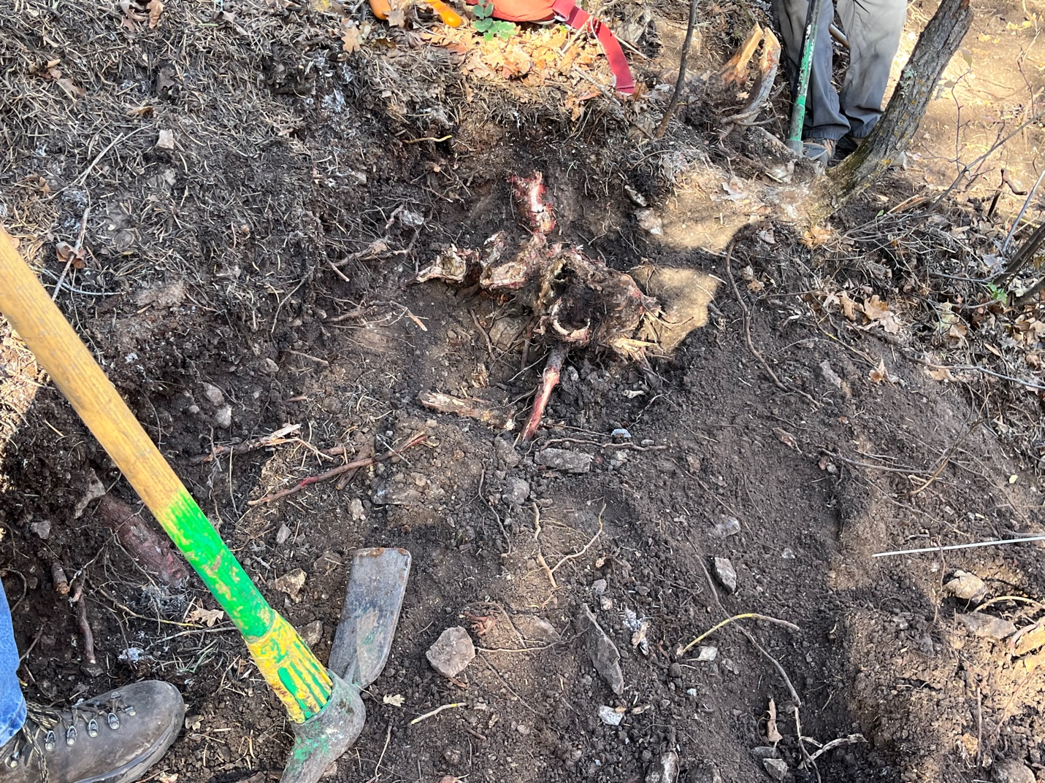

This is the root that Byron and Rich dug, and dug, and dug…..

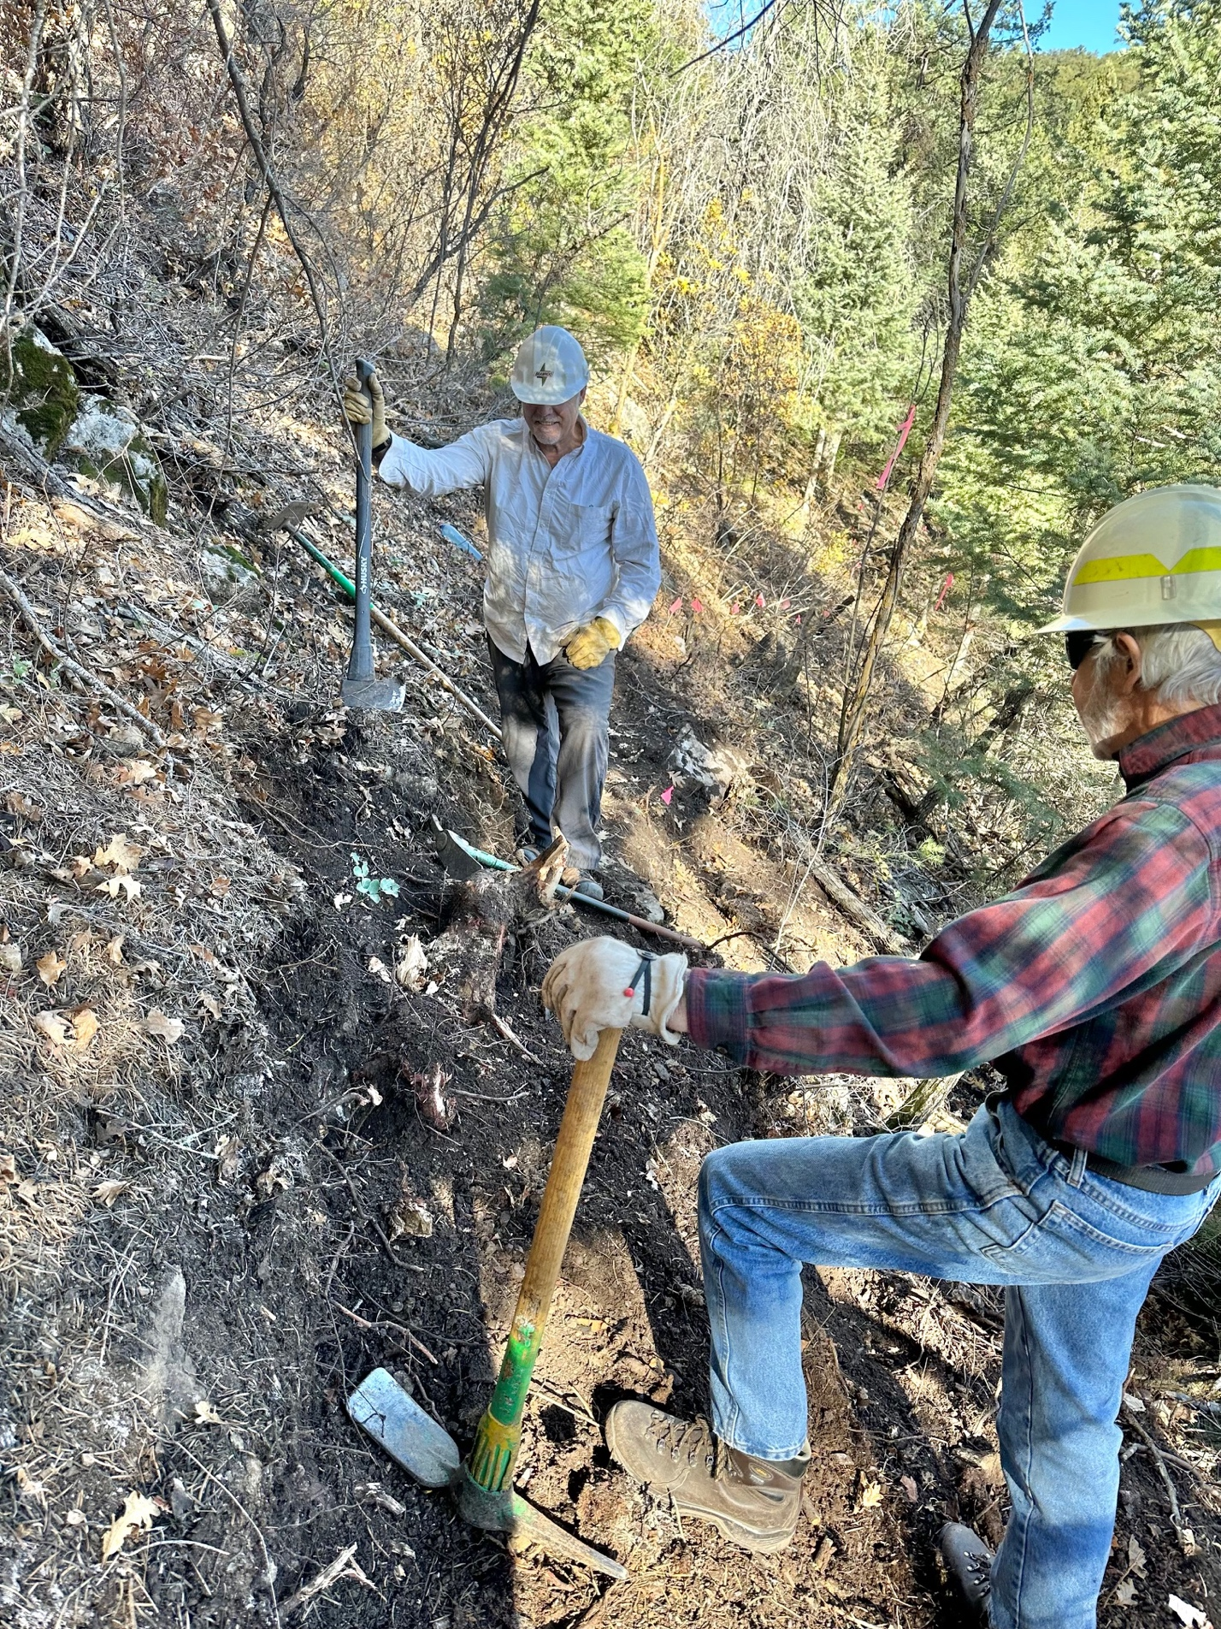
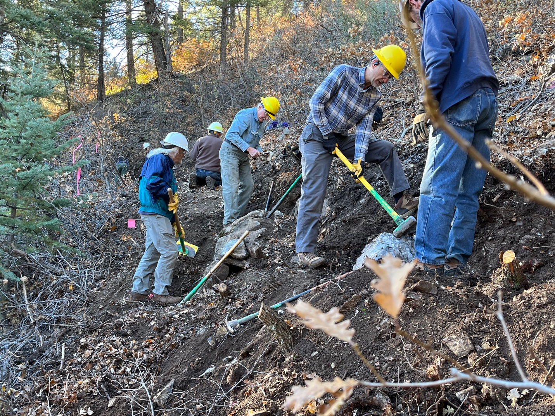

Some major rock removal and replacement ended up making a very nice step.
Eric, Bill, Roland and Bruce were he-men. Jim, John and Kerry deal with their own demons!

