Trail Maintenance Project: Monday, November 3, 2025
Byron Garner

Our trail maintenance project for November 3 was to hike the full length of the Challenge extension beginning at the Sandia ski area. With the exception of clearing one fallen tree intrusion, no issues were found and the trail is clear all the way to the Bill Spring junction and continuing to that trail head. The tread was in very good condition with no erosion issues or "offending" overgrowth issues thanks to the previous efforts of Louis and Steve. This trail has become one of the exceptional hiking experiences in the Sandia with beautiful views in a relatively undisturbed area of the forest especially on the classic fall day we all enjoyed. The crew included Rene Archer, Ken Wilson, Phil Cromer, Rav Nicholson, Rich Fedderson, David McCreery and Byron Garner.

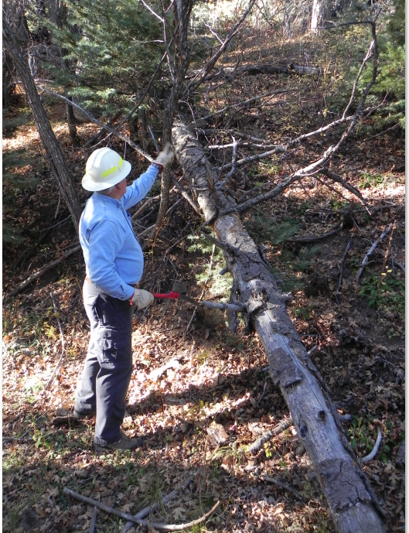
Dave making the initial assessment

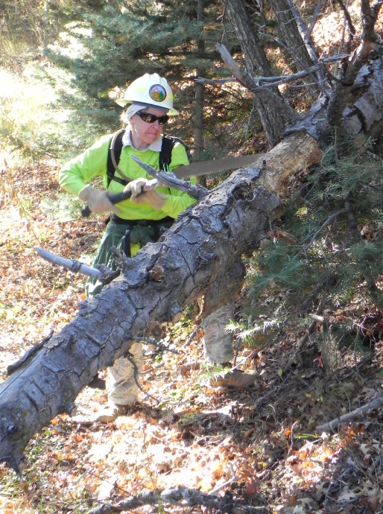
Rav begins with gusto

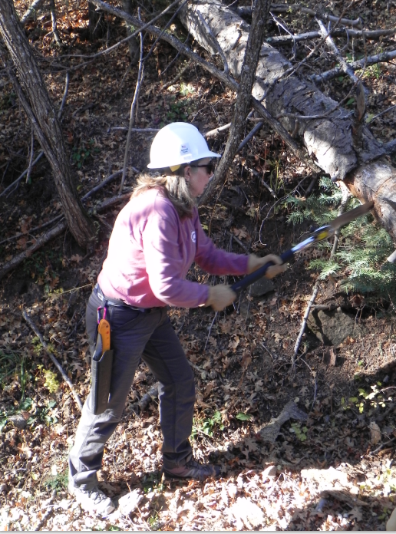
Rene Keeps the progress going

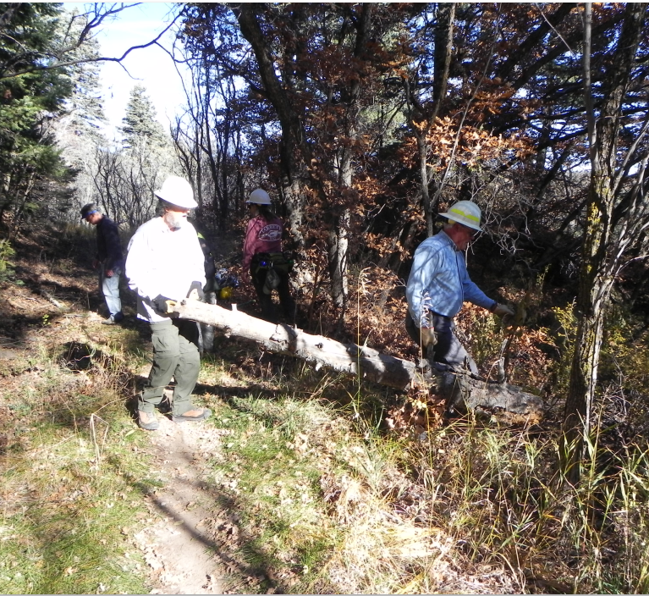
Phil and Dave clear the way

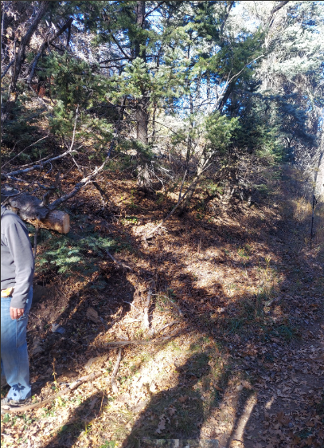Archer
Clear and good to go

