Report of Removal of Graffiti Tags on Interior Stone Walls of Kiwanis Cabin
on Tuesday, November 4, 2025

Pauline Ho, Rick Buss, and Sam Beard
The crew drove two 4WD vehicles over the very rough road to the parking lot below Kiwanis Cabin hauling the chemicals and equipment required to remove graffiti tags from stone. The World’s Best Graffiti Removal System for stone and brick was used to remove one very large tag and several small tags. Pauline used soap and water with a scrub brush to remove several charcoal tags.
Project photos are presented below.

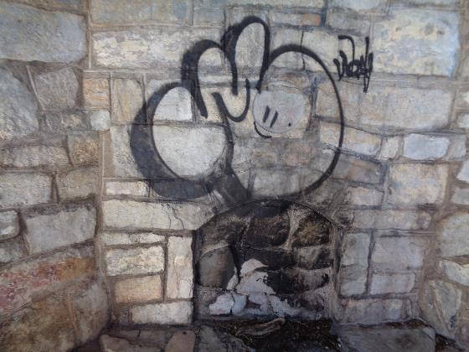
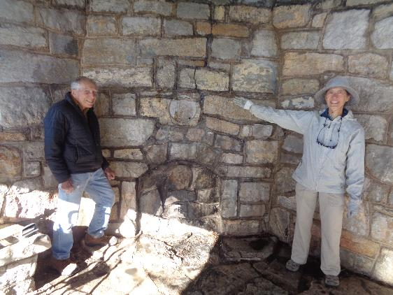
Before and after photos of large black graffiti tag over fire place.
L to R: Rick Buss and Pauline Ho.
All photos by Sam Beard
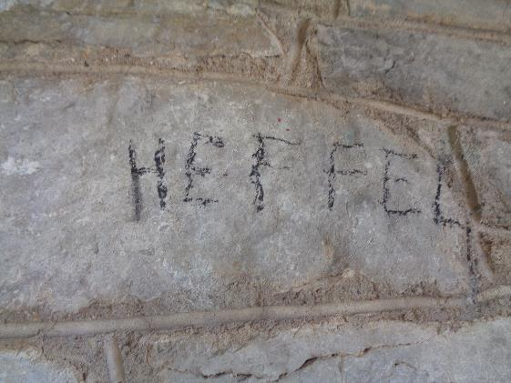
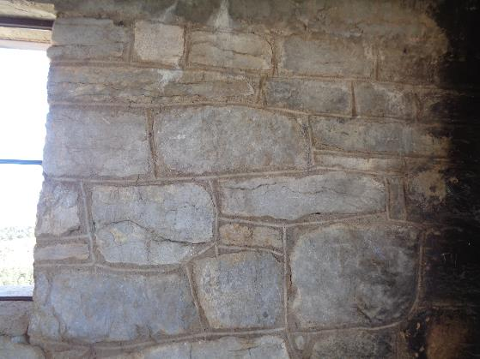
Before and after photos of HEFFEL graffiti tag. In the lower photo, the word
was on the rectangular stone near the center of the photo.
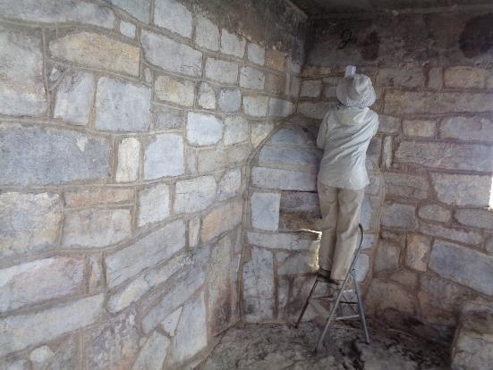
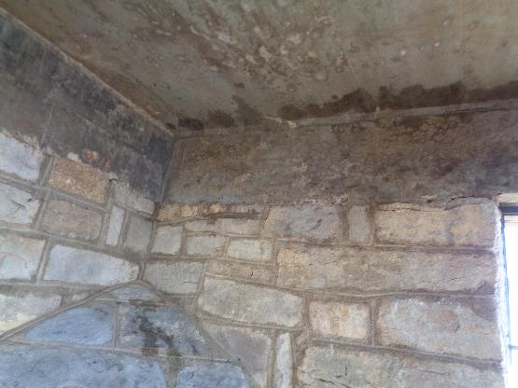
Top – Pauline washing off the black tag near the corner. Bottom – The black tag has been
removed. She washed off several charcoal tags with a brush and soap and water.

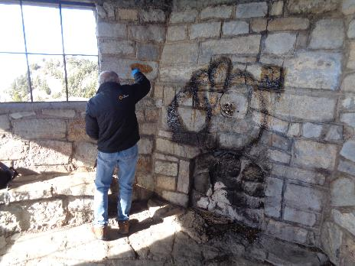
Rick applying World’s Best Graffiti Removal System chemical for stone and brick on a small tag.
Note that the chemical has been applied to the large black tag over the fire place.
After three applications of the chemical on the large black tag and some scrubbing, the paint and
chemical residue was easily removed with the FOSM low pressure battery-powered washer.

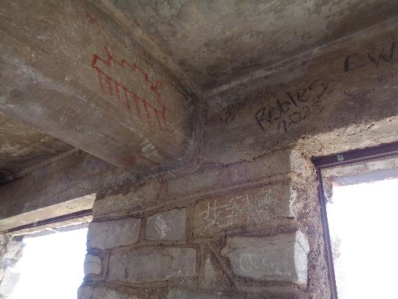
Pauline removed most of these tags with soap and water.
(No after photo)

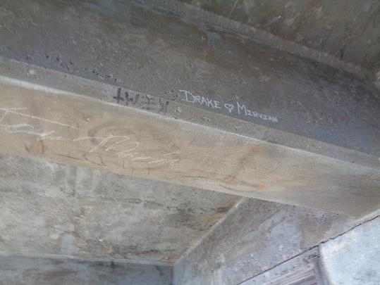
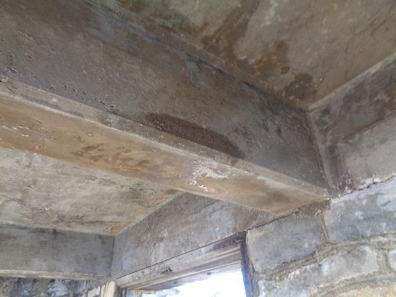
The tags on the concrete beam were removed with the chemical for removing
tags on brick and stone.

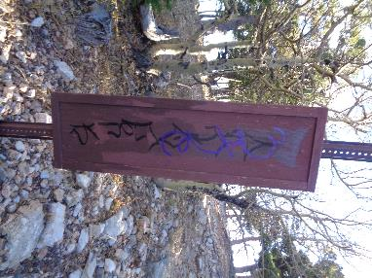
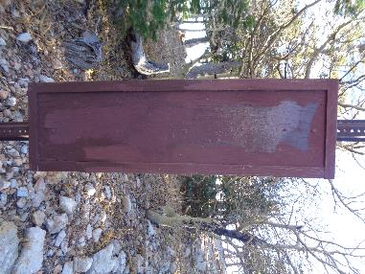
Rick painted over the tag on the board at the Kiwanis Cabin parking lot with USFS brown paint.

