Report of Project to Remove Numerous Logs on the Ground
between the Communications Site Fence and the Upper Part of the Crest Highway on Wednesday, November 5, 2025

Sam Beard
On Wednesday, November 5, four FOSM volunteers continued limbing and bucking numerous logs on the ground between the Communications Site fence and the upper part of the Crest Highway. The objectives of this project are to reduce the fuel load in the event of a wild fire and obtain donation wood that Mountain Christian Church Wood Ministry members will distribute to East Mountain families who heat their homes with wood. The trees had been felled earlier by USFS personnel. The bucked wood will be hauled to a church woodlot on Mike Oliver’s trailer.

The sawyers and swampers were Jerry Carroll, Cliff Giles, John Quinley, and Sam Beard.

Project photos are presented below.

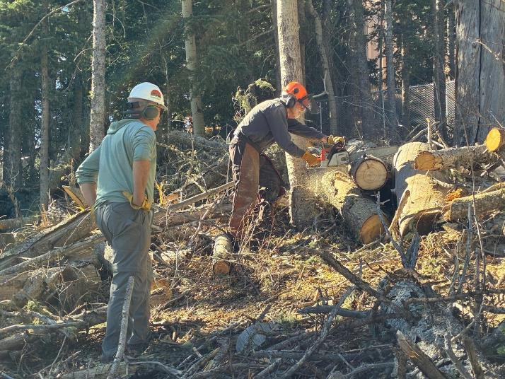
Sam bucking a cork bark fir log with John waiting to move the piece down to the pile above the highway.

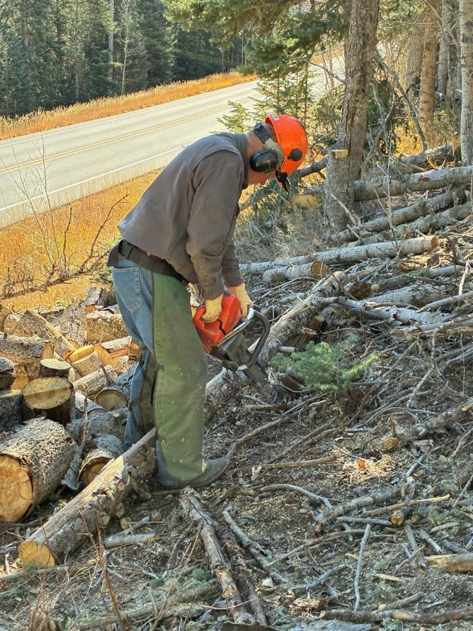
Jerry limbing a small log. The bucked wood will be loaded on a trailer on the highway shoulder later.

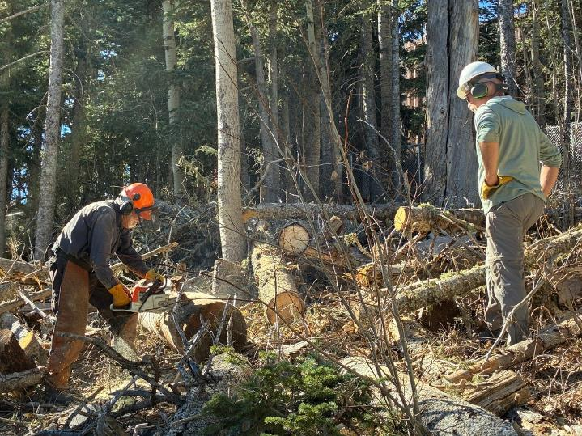
Sam bucking a large log with John observing.

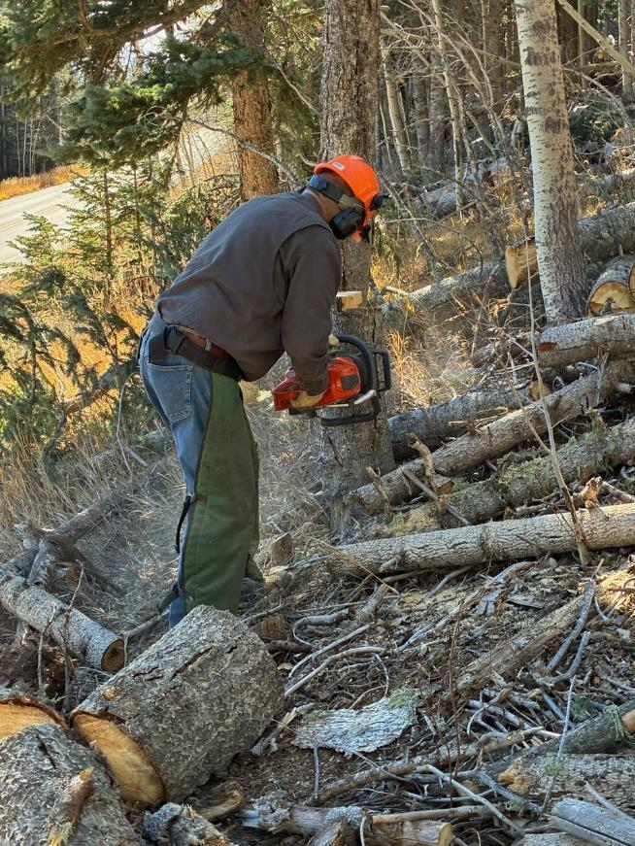
Jerry cutting a cork bark fir stump lower.
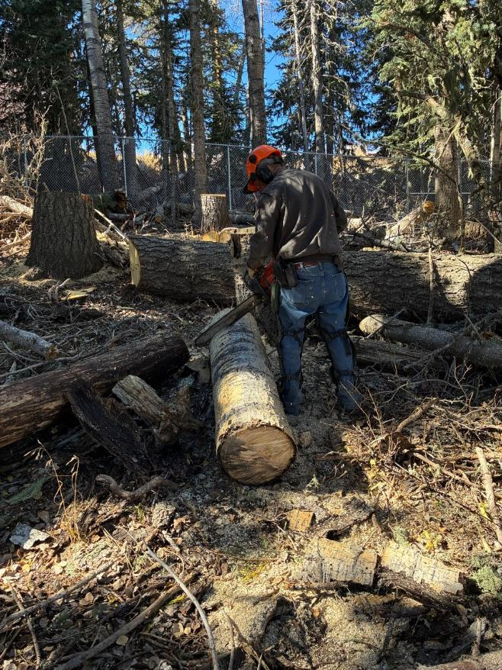
Jerry bucking a large aspen log with the Communications Site fence in the background.
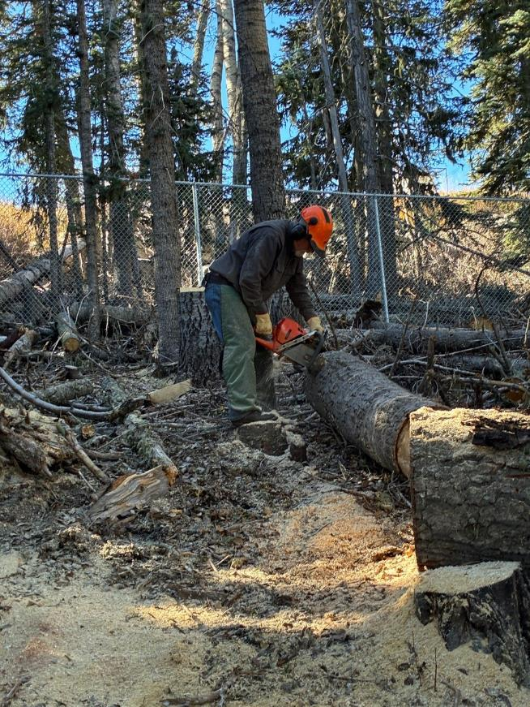
Jerry finishing bucking an aspen log after clearing a path through large fir log on the right.

