Thursday, 11/06/25- Old Faulty: Another great day in the neighborhood. It did not feel like November but there you have it. It’s great weather for working. We had 14 volunteers out digging this week. The work consisted mainly of finishing the last reroute on Old Faulty and then starting in on some fixes of the existing trail between the completed reroutes. There are eroded areas that need cribbing and others that need widening or brushing.

Volunteers: John McNett, Luis Cuadros, Bill Perkins, Roland Stumpf, Laura Leon,
Steve Roholt, Bruce Hansche, Kerry Jones, Patrick Walgren, Larry Larrichio,
Jim Houle, Rich Fagioli, Byron Garner, and Claudia Bergsohn

Pictures: Laura Leon and Bruce Hansche

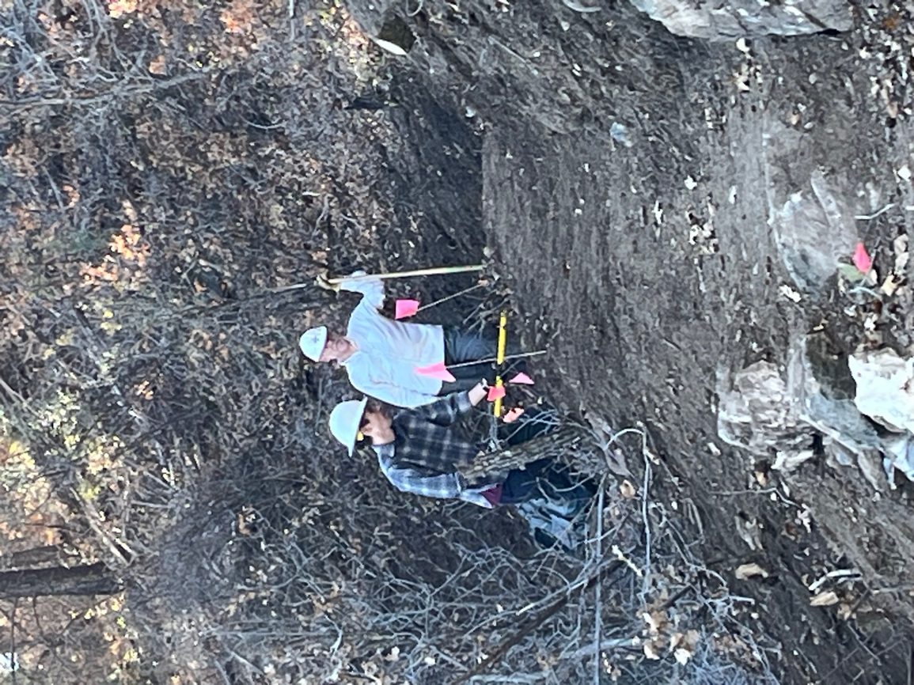

Rich and Patrick do finishing work while discussing all sorts of things.
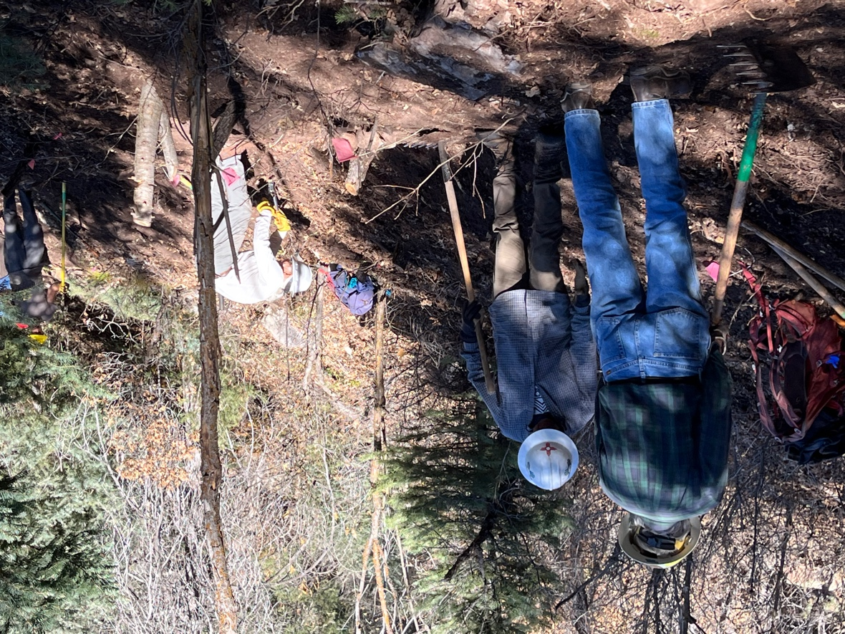

Everyone was doing finishing work. Byron, Luis and Bill hit a section.
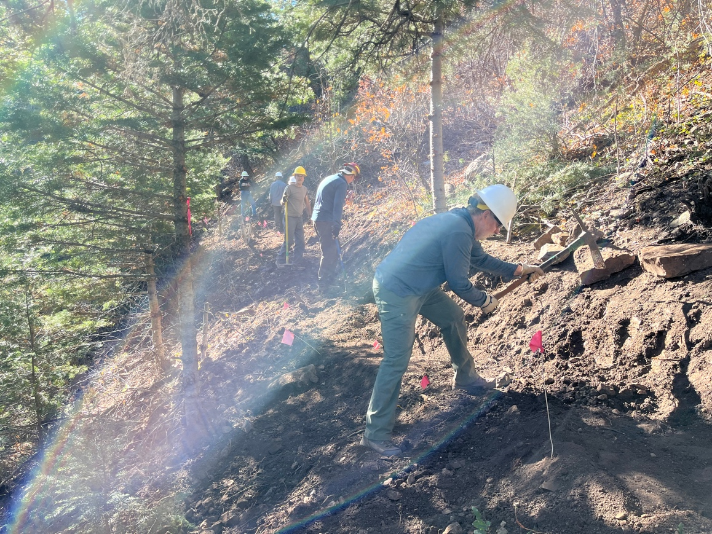

John, Kerry and Roland work another area.
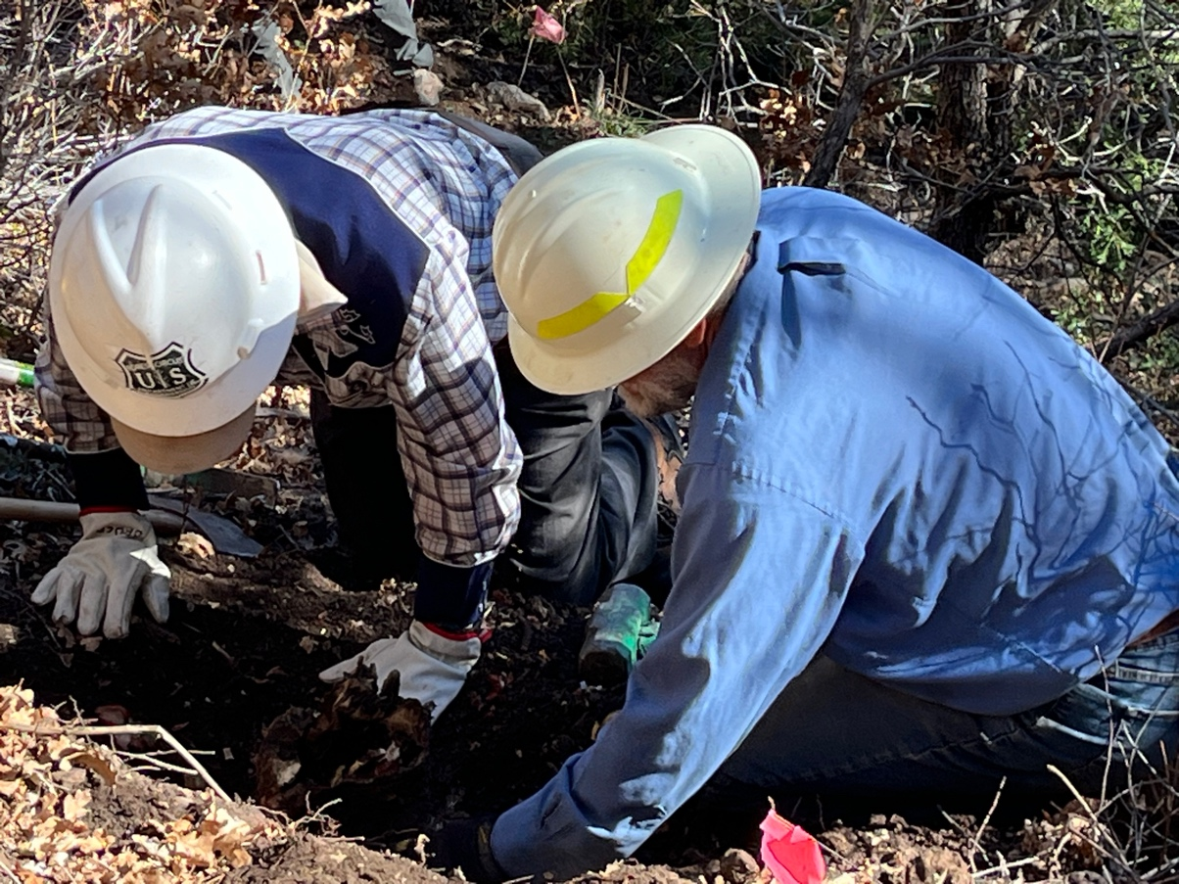

Bruce and Jim dig out yet another large stump.

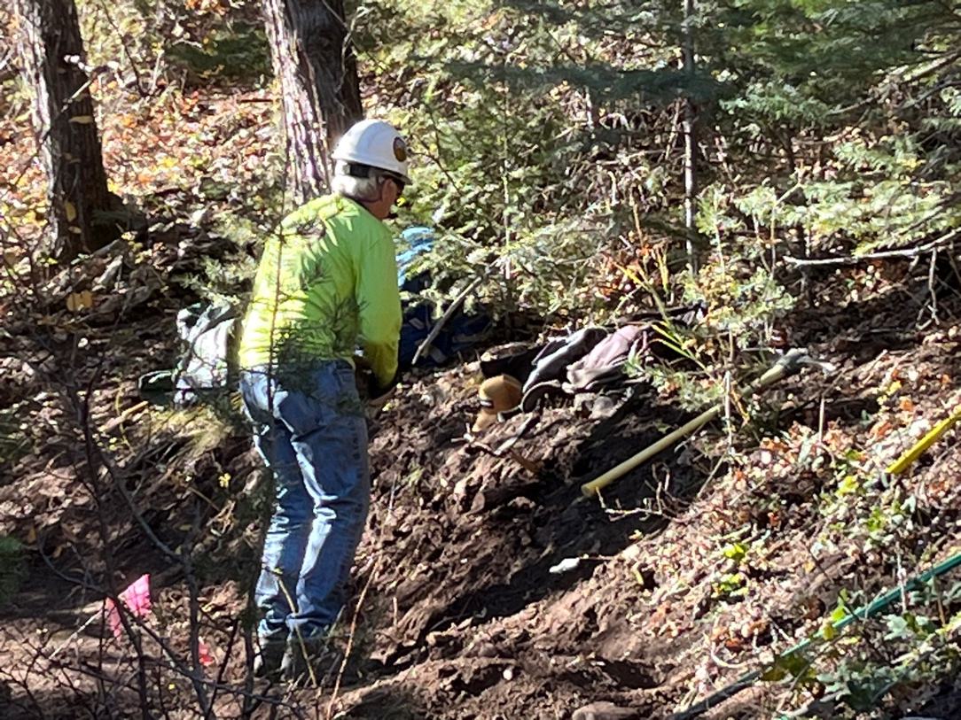

Steve gets ready to take a break.
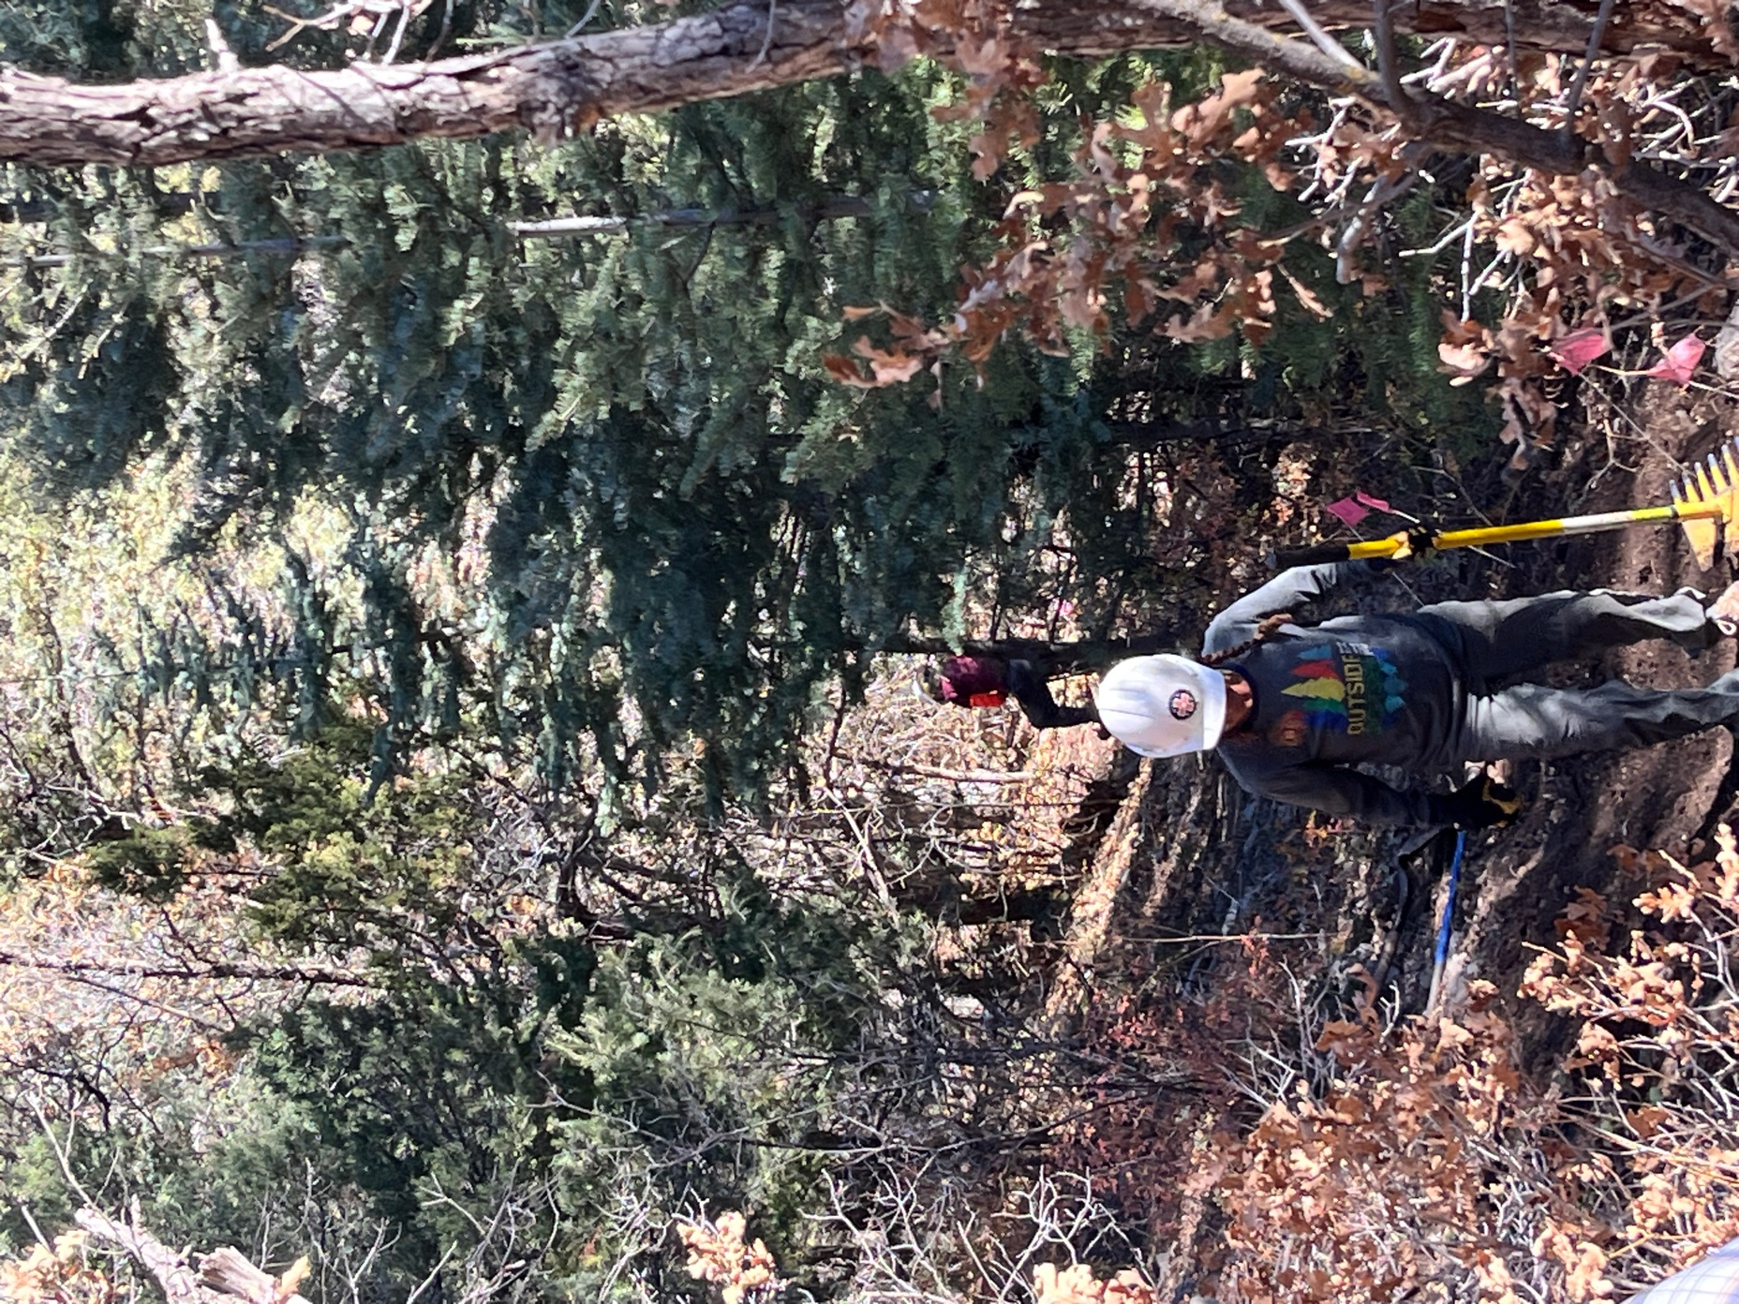

Claudia and Larry are almost to the end of the reroute.

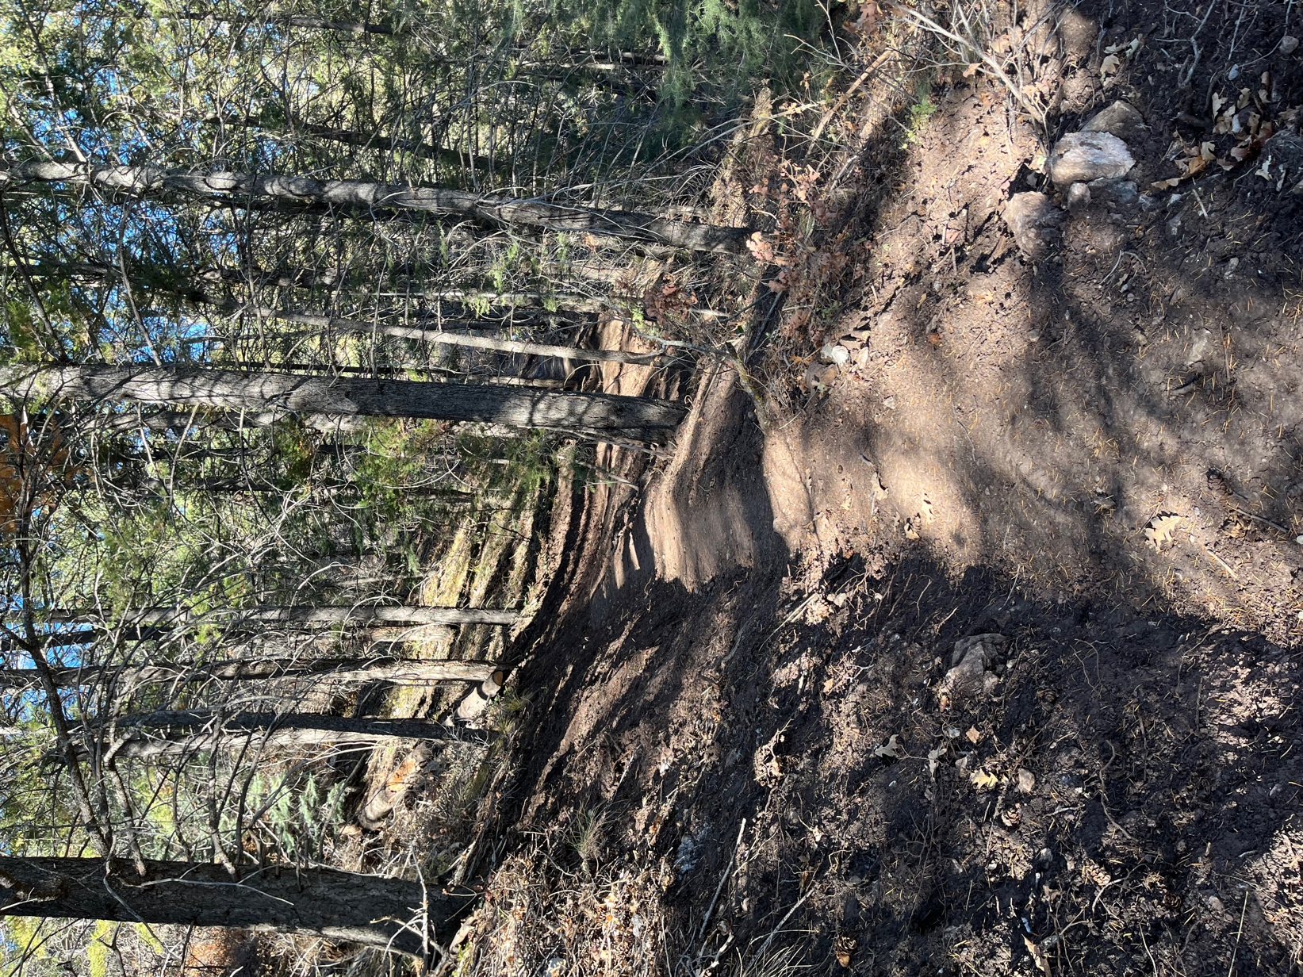

Finished trail! We had a fussy biker who felt it seemed to be designed for wheelchairs rather than bikers and hikers, but we take that as a compliment.
May oak get tangled up in his spokes.

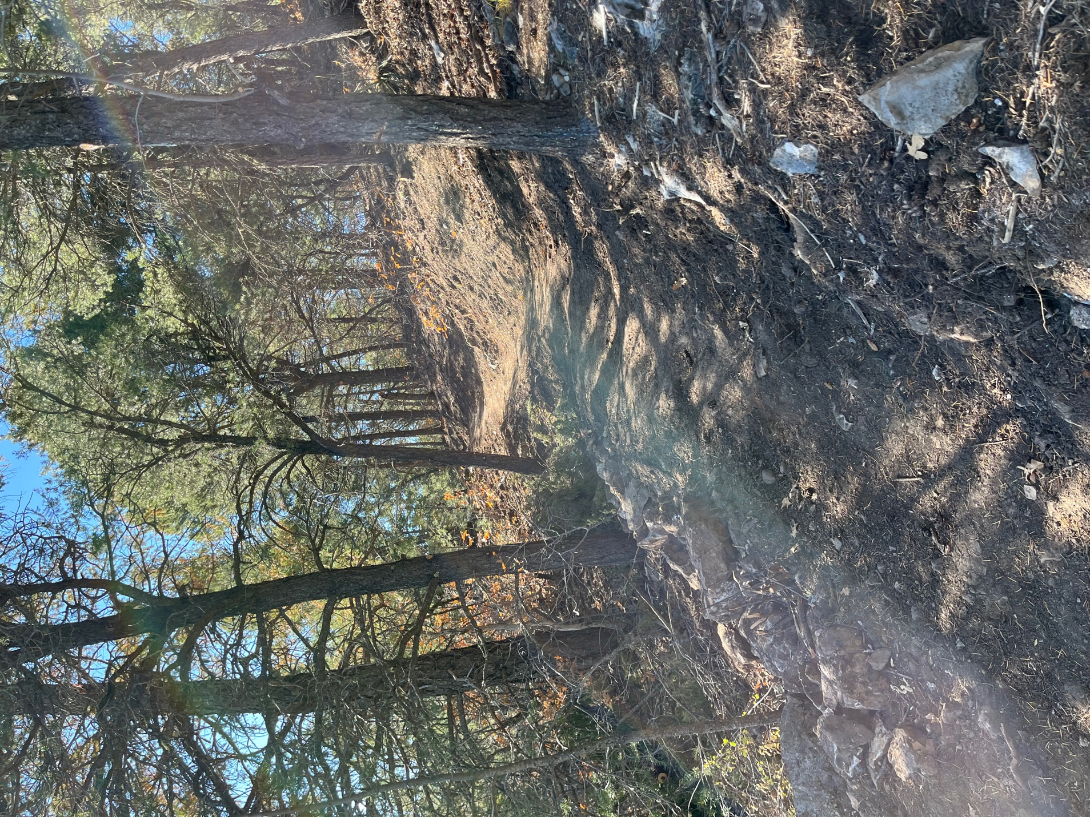

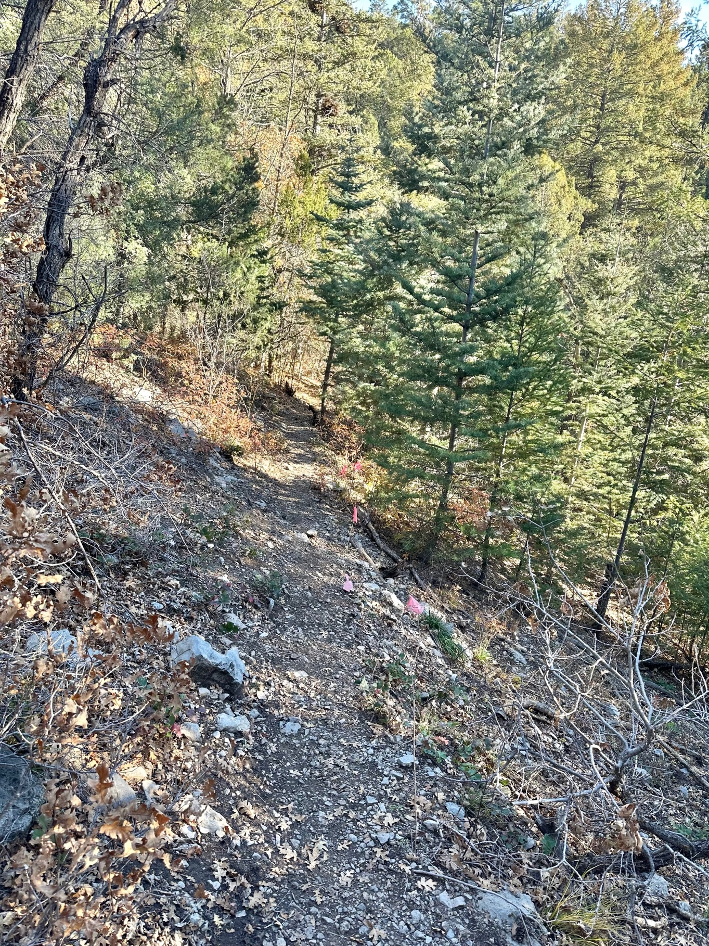

An existing trail section between the last 2 reroutes that will get some TLC.

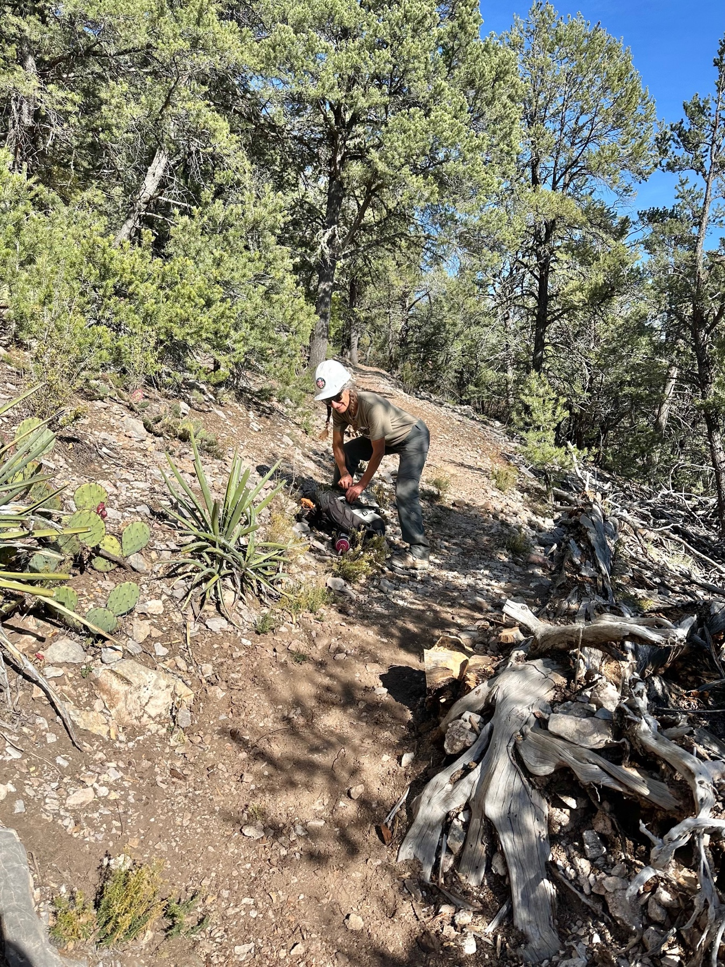
Claudia clearing brush from the trail. It was warm after lunch.

