Trail Maintenance Report: Monday, November 10, 2025
Byron Garner

As a venture on new "turf" for the Monday crew, we hiked out from 10K-S trail head to add or replace blue diamonds as needed which was primarily at ski slope crossings as well as a few minor ambiguities in the forest. Any branches obstructing the line of site were removed as well. The diamonds can now be easily followed in both directions from the trail head to the southern boundary of the ski slopes. Despite the passing of peak fall color, it was an exceptional day to be on the trail with a sunny lunch and great view at the 10k-N picnic area. Our crew included Rav Nicholson, John Cooper, Rene Archer, Dave McCreery and Byron Garner.

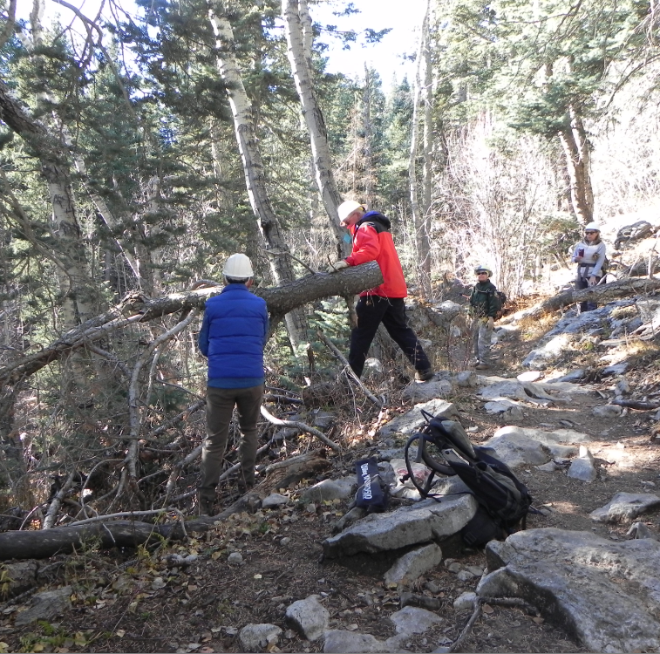
John and Dave work to clear this still menacing intrusion

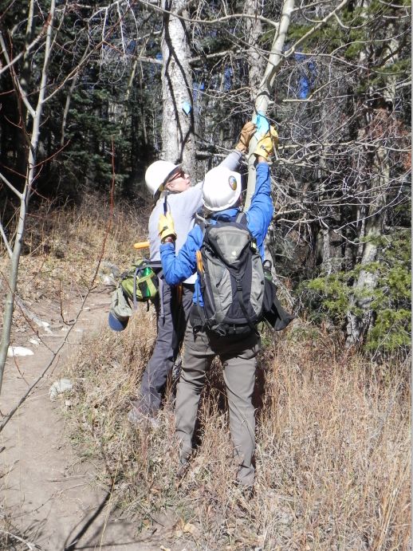
Rene and John add another diamond so there would be a clear line of site from across the ski slope.

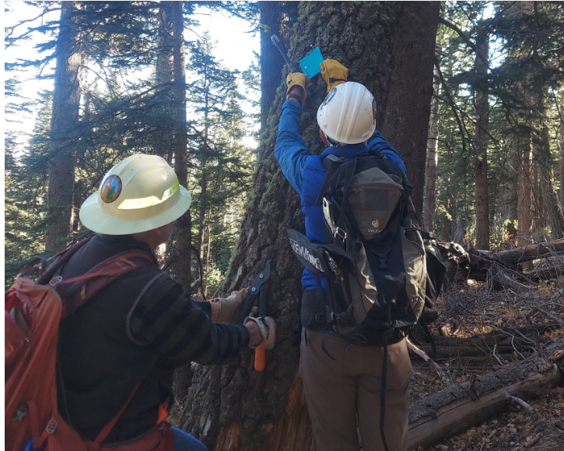
Archer
John blazes the way with another diamond

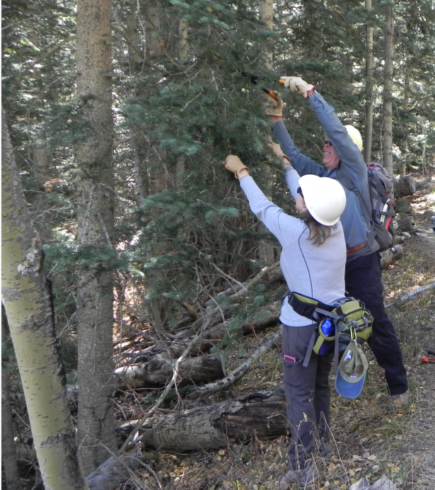
Rene and Dave doing a little line of site restoration

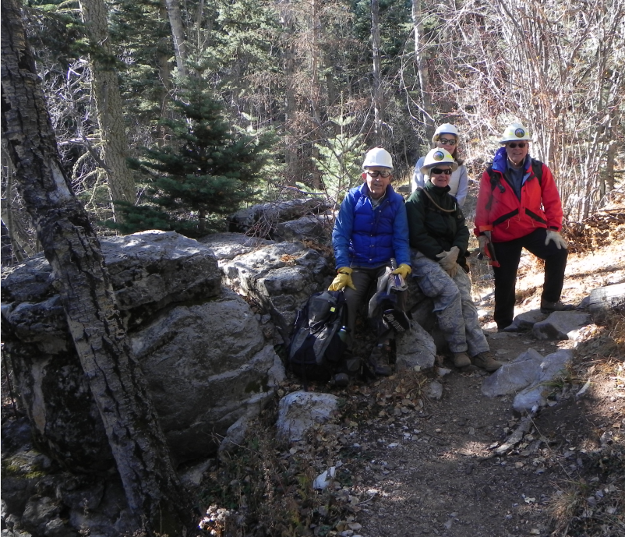
John, Rav, Rene and Dave

