Thursday, 11/13/25- Old Faulty: Fifteen volunteers (!) plus Jen (SRD!) were back to Old Faulty to work on sections of existing trail. The reroutes are finished so we did a variety of work: brushing, widening trail, adding support to eroding areas. The crew ended up being very spread out but got a lot of work done. An added bonus to the work day was a visit from Eric (The Younger) Messerschmidt with his wife Maggie and new baby Raven. We hope to finish the work on Old Faulty next week, just in time for Thanksgiving break.

Volunteers: Tony Pachelli, Mike Madden, Claudia Bergsohn, Dan Burwinkle,
Eric Russell, Dorothy Hendrix, John McNett, Luis Cuadros, Bill Perkins,
Roland Stumpf, Steve Roholt, Bruce Hansche, Kerry Jones, Byron Garner and
Laura Leon

Pictures: Kerry Jones, Roland Stumpf, Luis Cuadros and Laura Leon

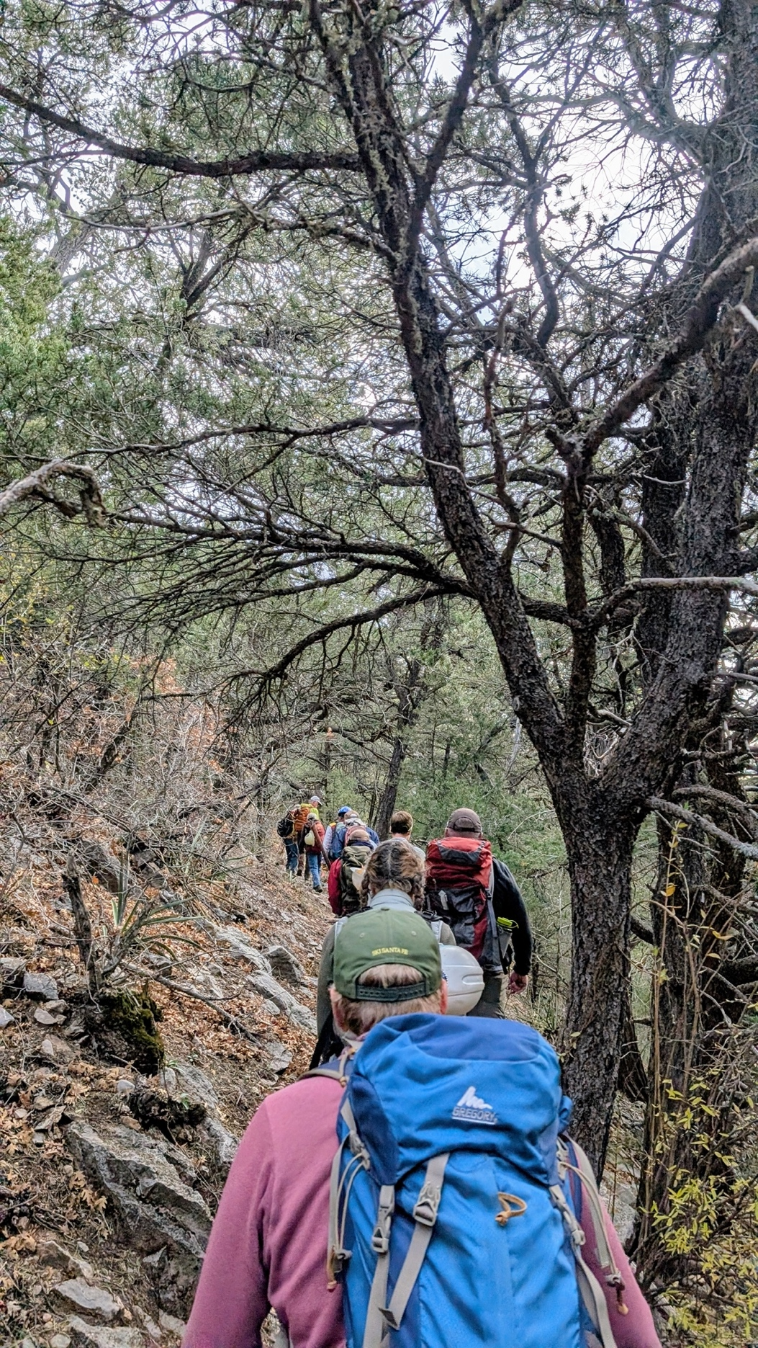

The hike to the tool stash is looking like fall even though the temps are warm.
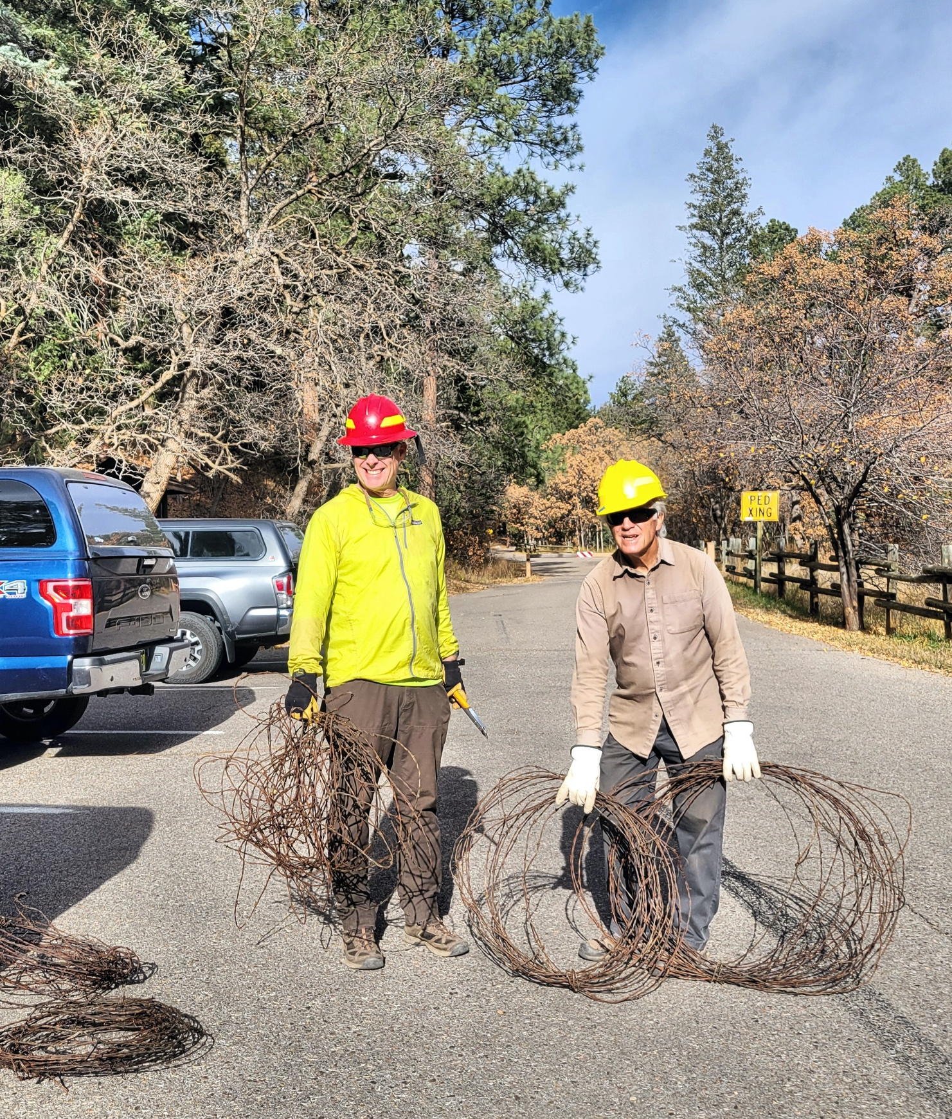

First order of the day- Kerry, Luis and Mike gather up the barbed wire for recycling.

Work started where we left off last week- Bruce preps a rock wall site.

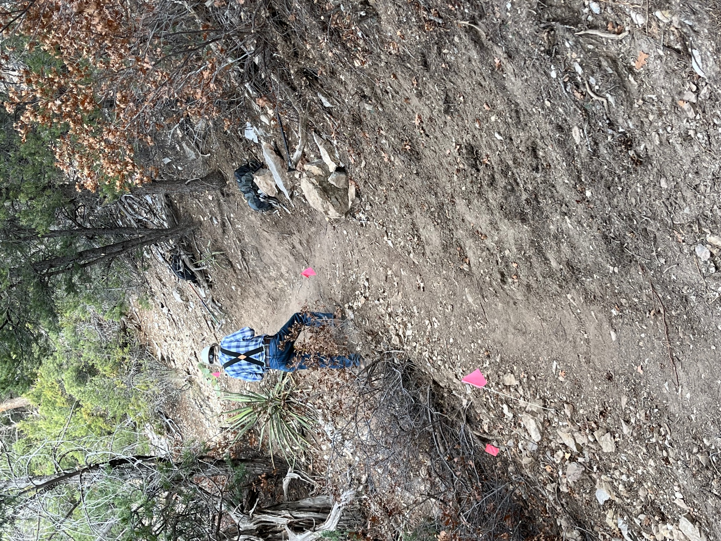

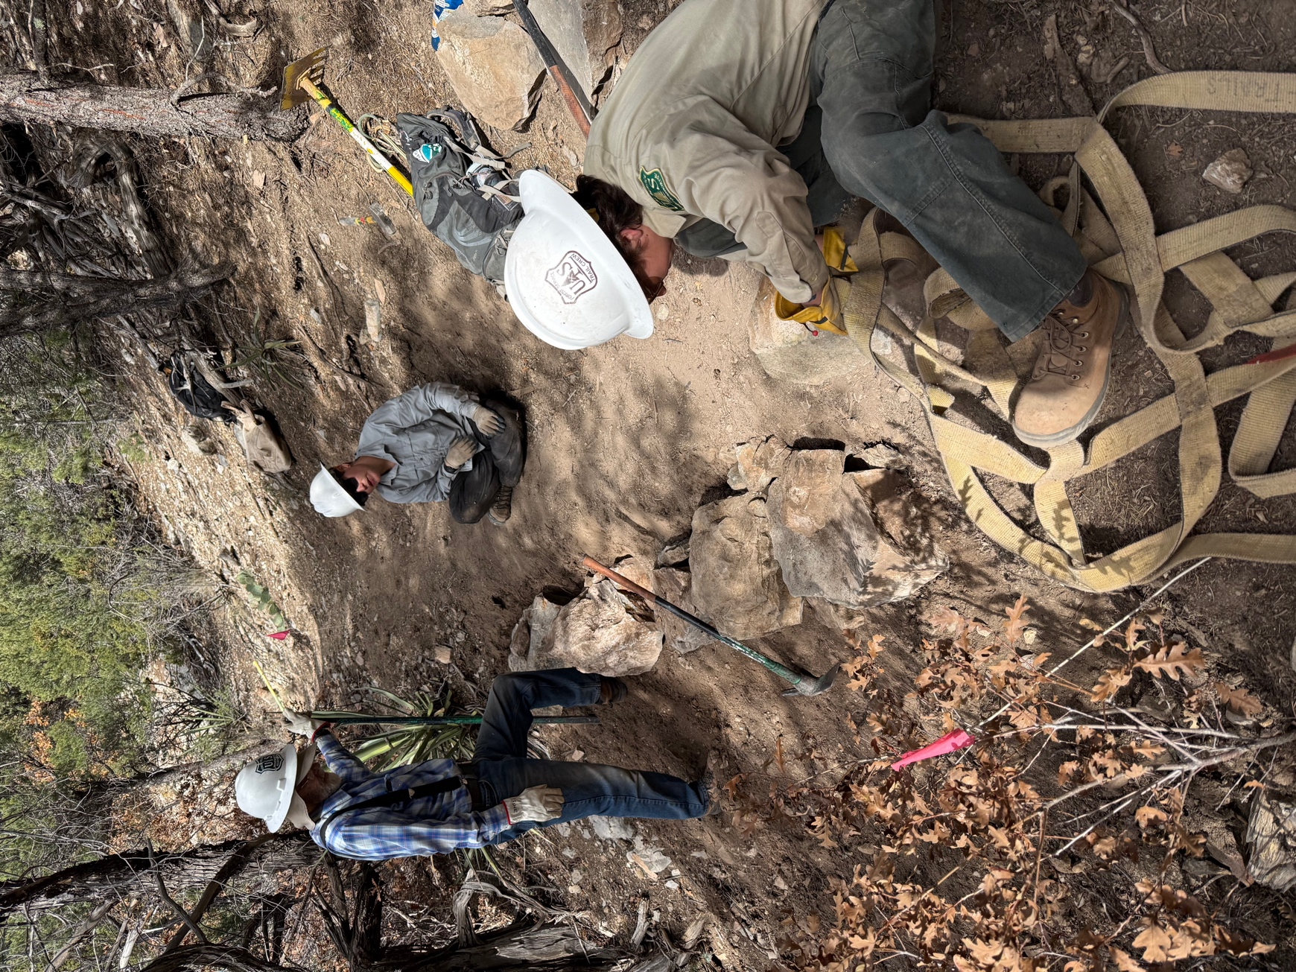

After moving some rocks, Jen, Dorothy and Bruce start piecing the wall together.

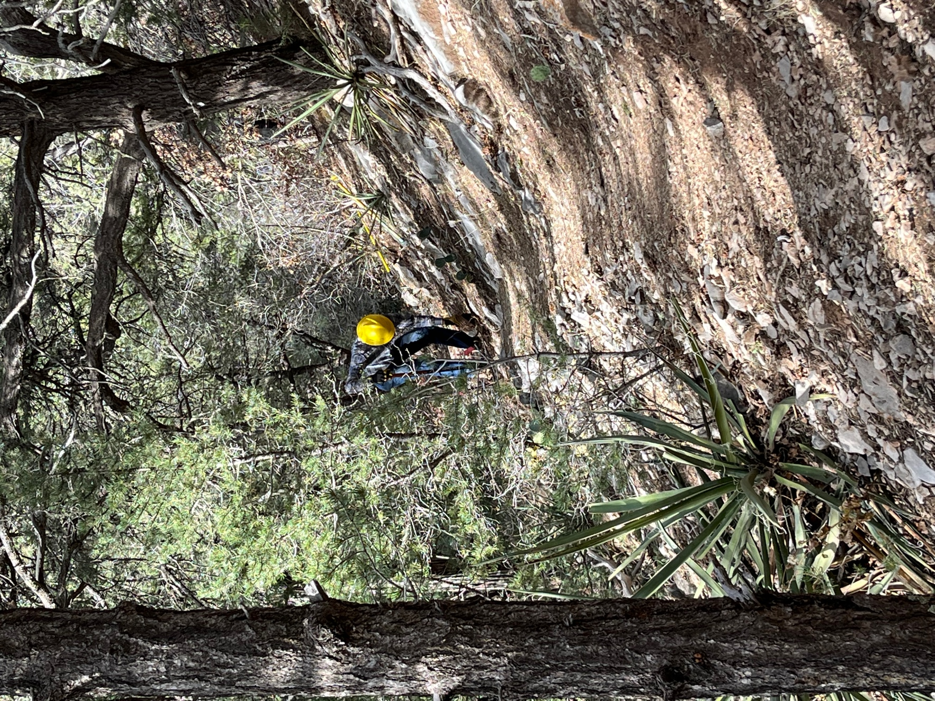

Roland starts widening a section.
Steve and Bill widen and remove problem rocks.

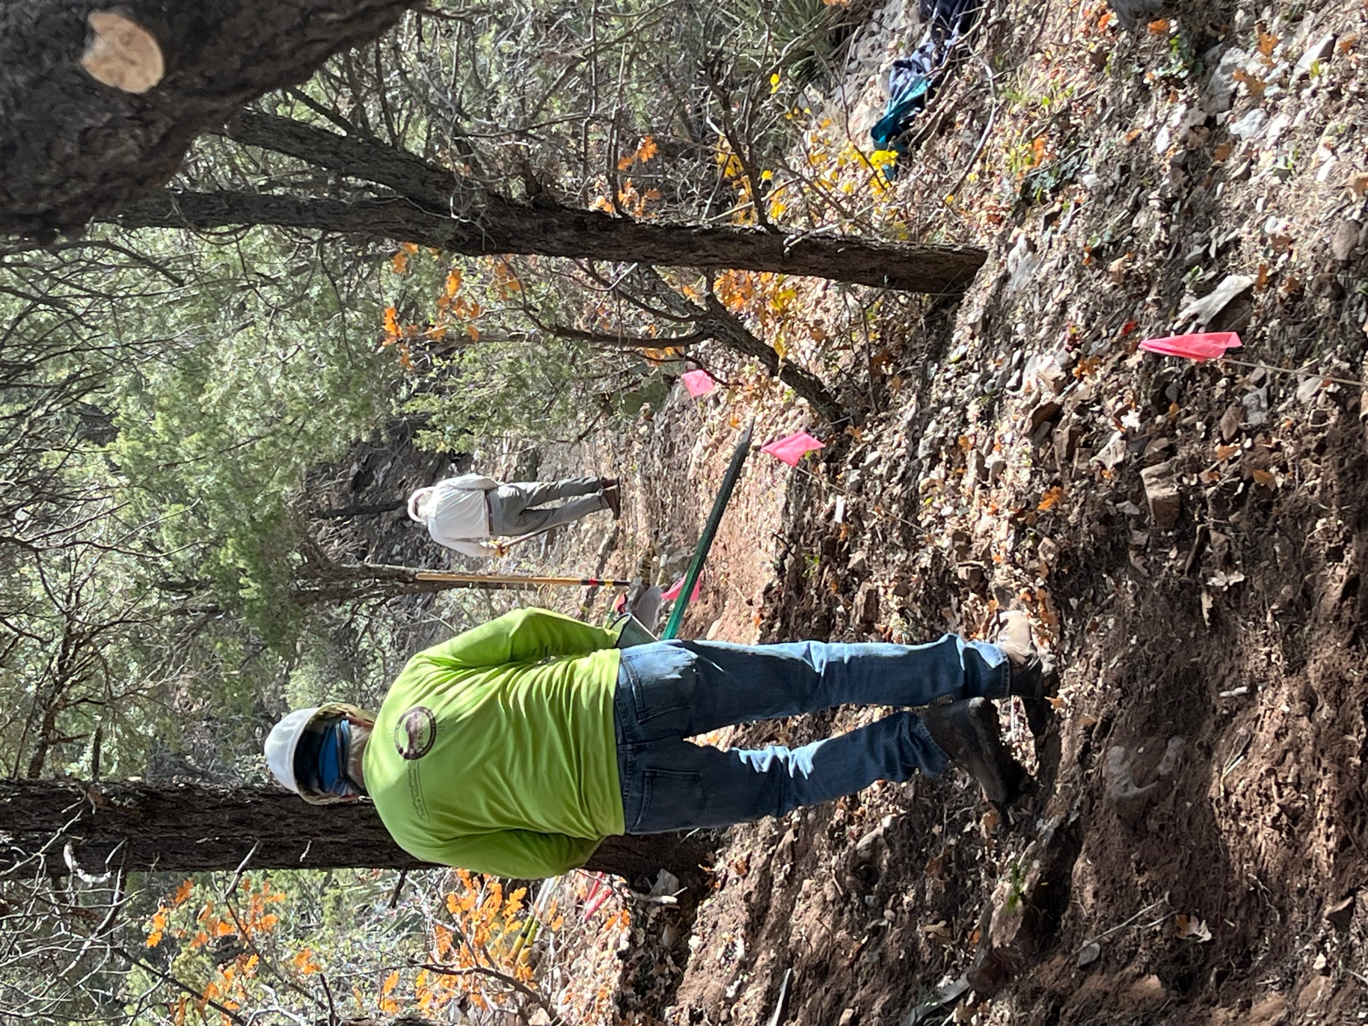
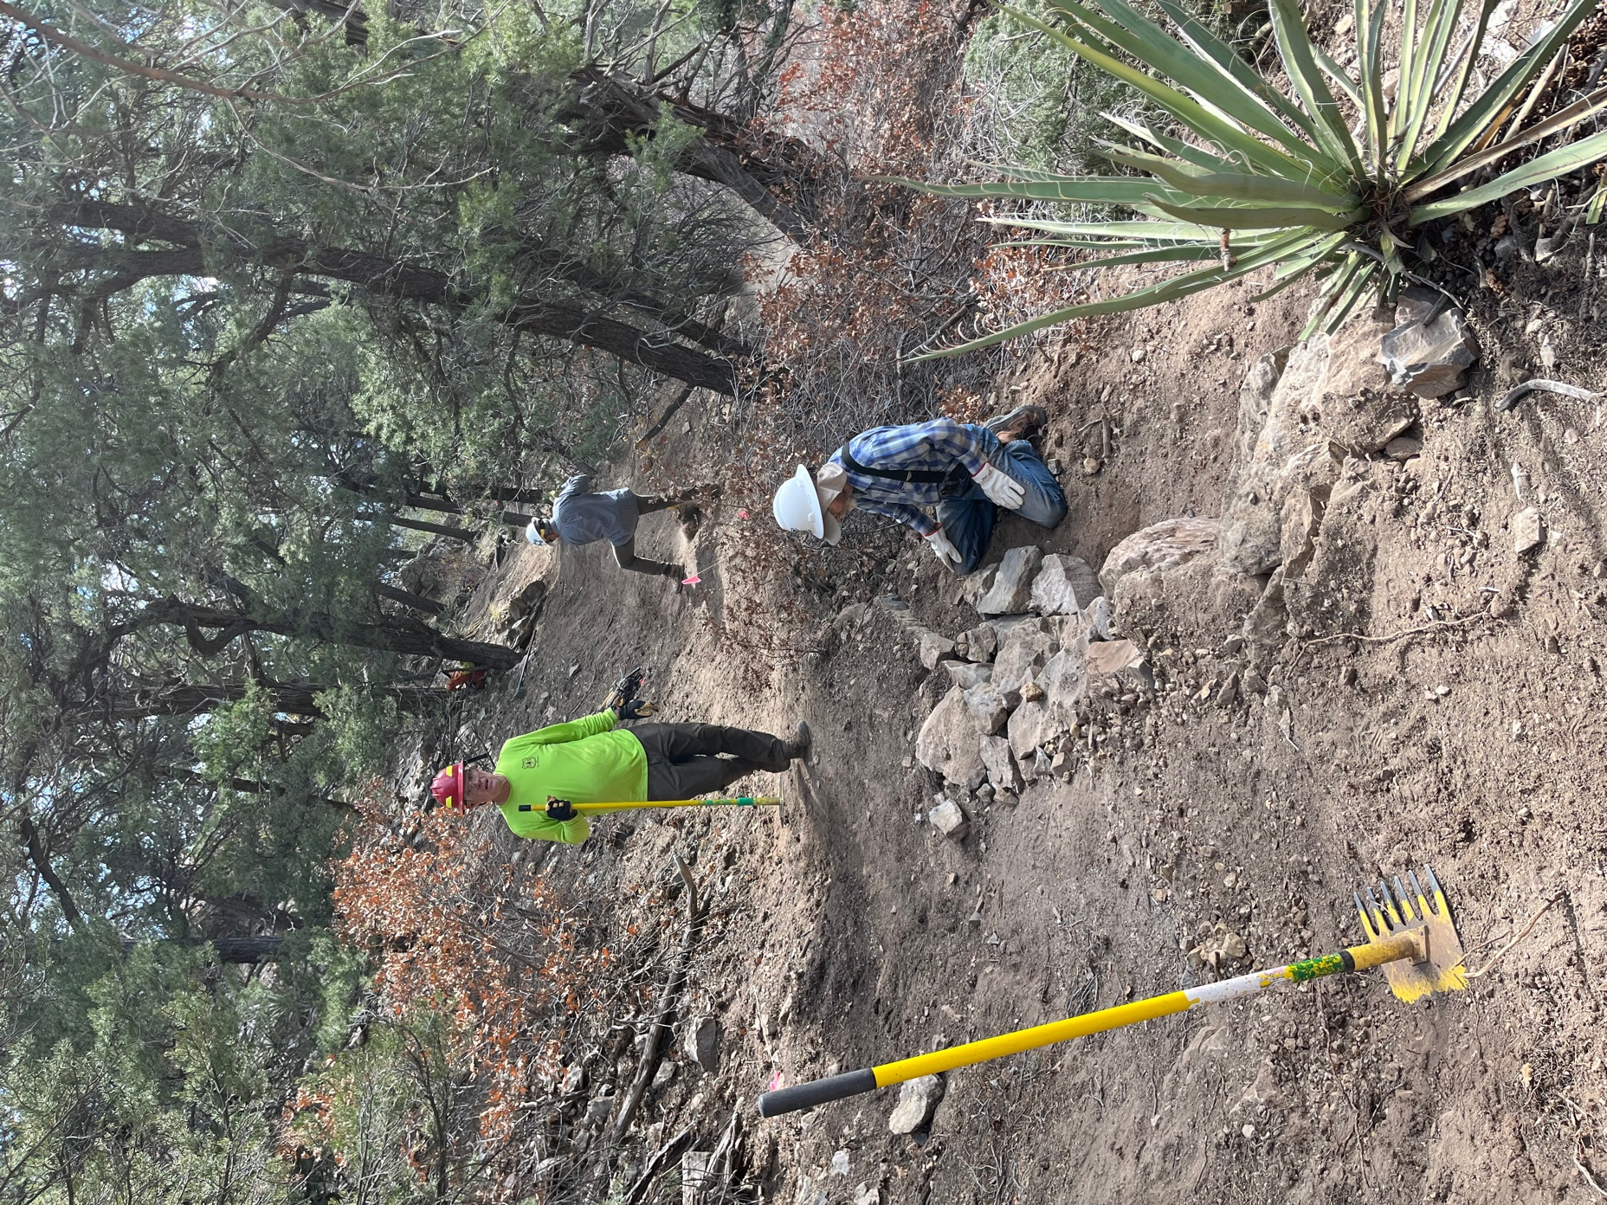

Luis and Kerry finish widening trail while Bruce finishes the rock wall.
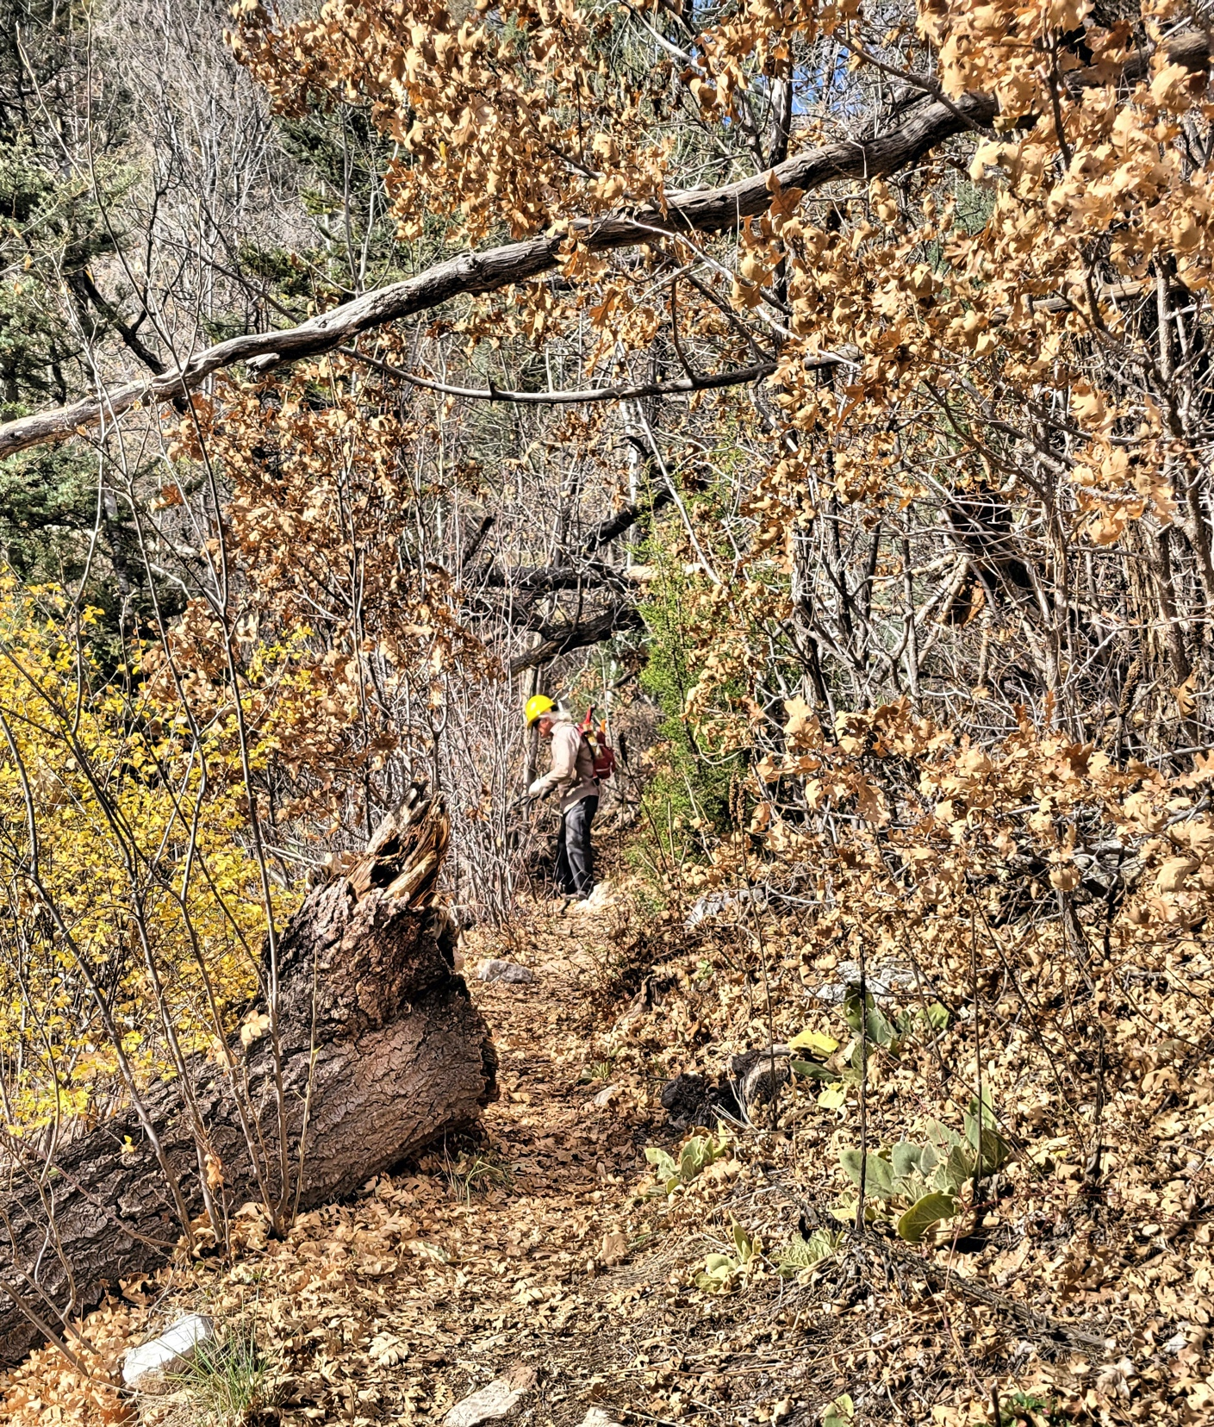

Mike worked at the Sulphur end to the trail- lots of brushing needed here.
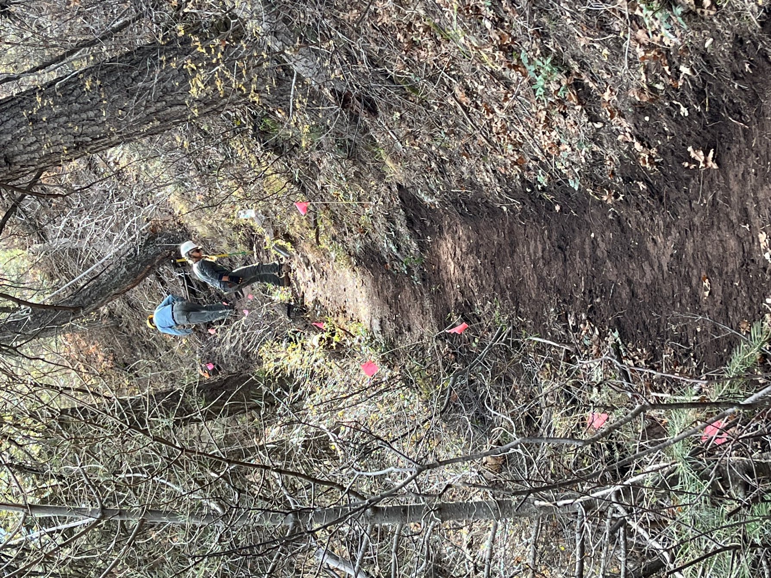

Claudia and Eric work their way up a slope widen the track.

A dead juniper with real character. It made for a good lunch spot.

