Report of FOSM Project to Haul Two Large Loads of Wood Rounds on Mike Oliver’s Trailer
to the Church Woodlot, Wednesday, November 12, 2025

Sam Beard
On Wednesday, Nov. 12, eight volunteers loaded Mike Oliver’s large trailer twice with rounds recently bucked by FOSM volunteers in the forest between the upper part of the Crest Highway and the new chain link fence around the Communications Site. Canyon Young, SRD Trails and Wilderness Program Manager, had requested that FOSM buck and haul wood on the ground here to reduce the fuel load in the forest.
FOSM volunteers working on Wednesday were Eric Russell, Sam Beard, Dan Benton, Cliff Giles, Jerry Carroll, and Chuck Logan. Mike Oliver and Cruz Talamantes from the Mountain Christian Church Wood Ministry also helped load the trailer and haul the wood to Mike’s woodlot in the East Mountains.
Project photographs are presented below.
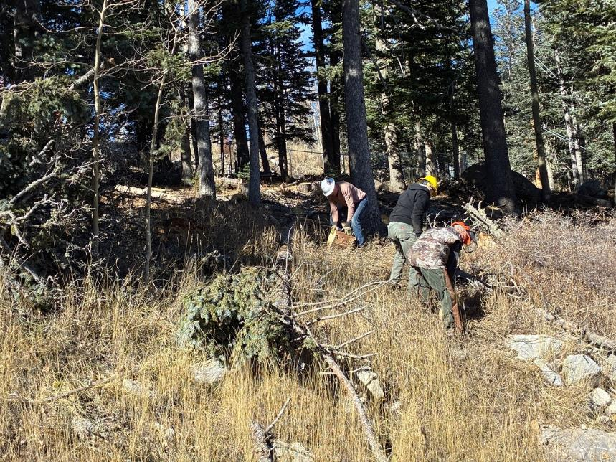
L to R: Chuck Logan, Eric Russell, and Dan Benton carefully move rounds down the highway cut bank. All photos by Cliff Giles
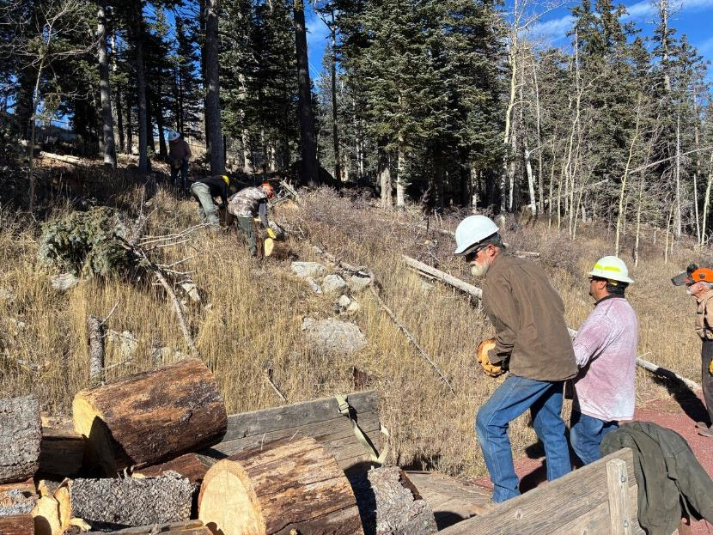
Mike Oliver and Cruz Talamantes load the trailer with rounds bucked up in the forest near the Communications Site fence.
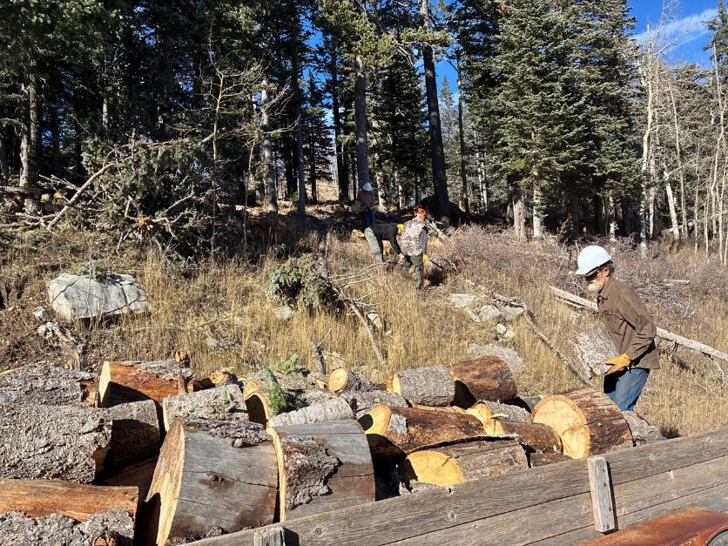
Mike finishing the first trailer load.
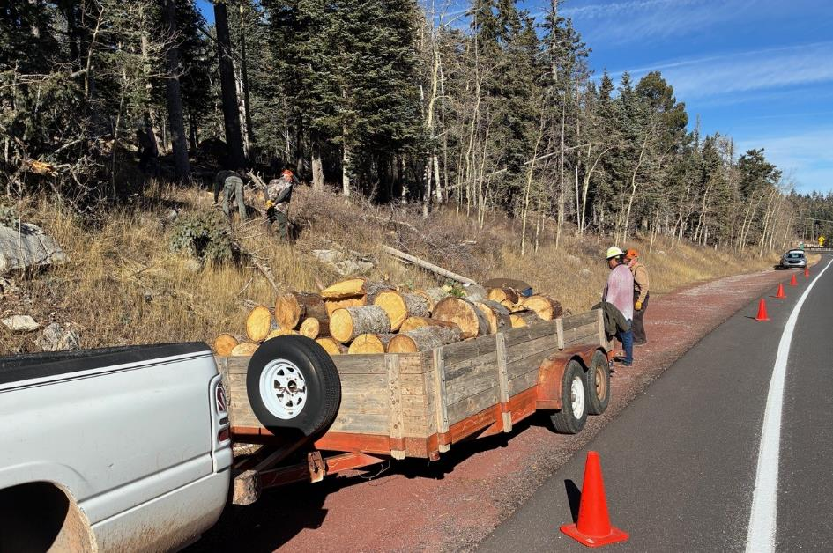
The first trailer load is ready to be taken to Mike Oliver’s wood lot.
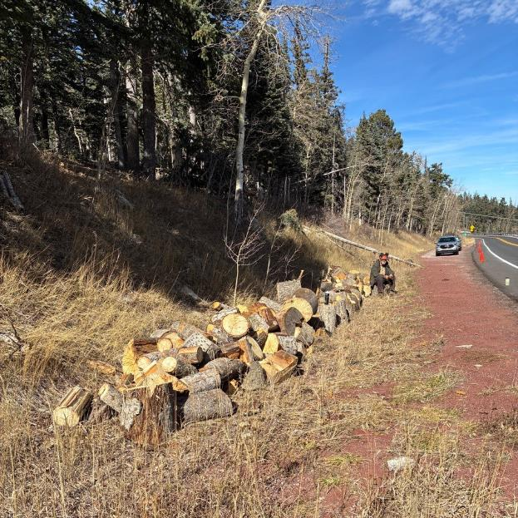
Rounds for the second trailer load have been moved from the forest to the highway shoulder.
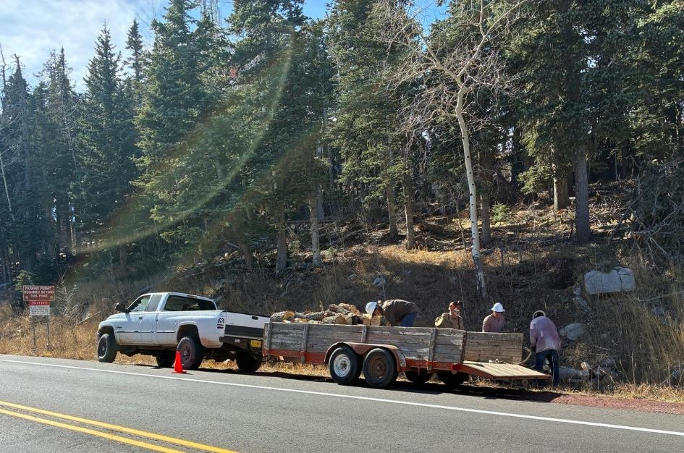
L to R: Mike, Sam, Chuck, and Cruz. Rounds for the second load are being passed over the trailer side for Mike to stack.
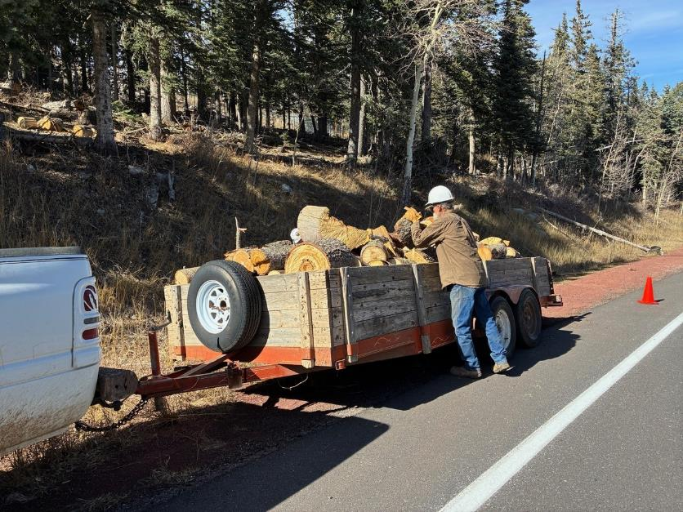.
Mike looking for a place to put the last round in the second trailer load.

