Report of Filling Small and Wide Cracks in Large Columns in Modern Doc Long Picnic Shelters, Nov. 10 through Nov. 16, 2025
Sam Beard
Between Nov. 10 and Nov. 16, I worked several days filling cracks in the modern Doc Long PA shelter wooden columns and painting over the filled areas with official USFS dark brown paint.
!. Monday, Nov. 10 – Some small cracks in the columns were filled with System Three epoxy paste.
2. Tuesday, Nov. 11 – Additional small cracks were filled with paste, and the filled areas were painted with a medium brown Behr paint as a primer.
3. Thursday, Nov. 13 – Official USFS dark brown Behr paint (Federal Standard Paint No. 20059) was applied over the medium brown primer paint.
4. Friday, Nov. 14 – The 4-inch-deep hole in the floor of Shelter A was filled with concrete and covered with plastic to retain moisture. Closed cell foam backer rods with diameters of ½-inch and ¾-inch were placed in some of the wide cracks in the columns. These cracks were filled with dark brown caulk, and caulk was smoothed with a putty knife.
5. Saturday, Nov. 15 – Water was applied to the concrete in the hole, and the area was covered with plastic again. Additional wide cracks were filled with backer rod and caulk and painted over with dark brown paint.
6. Sunday, Nov. 16 – Additional wide cracks were filled with backer rod and caulk and painted with dark brown paint. Large cracks were filled on six of eight columns on Shelter A and cracks on three columns were filled in Shelter B. Filling the small and large cracks on the columns will somewhat reduce the water absorbed by the columns. Filling the cracks improved the appearance of the columns but did not significantly improve the strength of the columns.
Project photos are presented below.

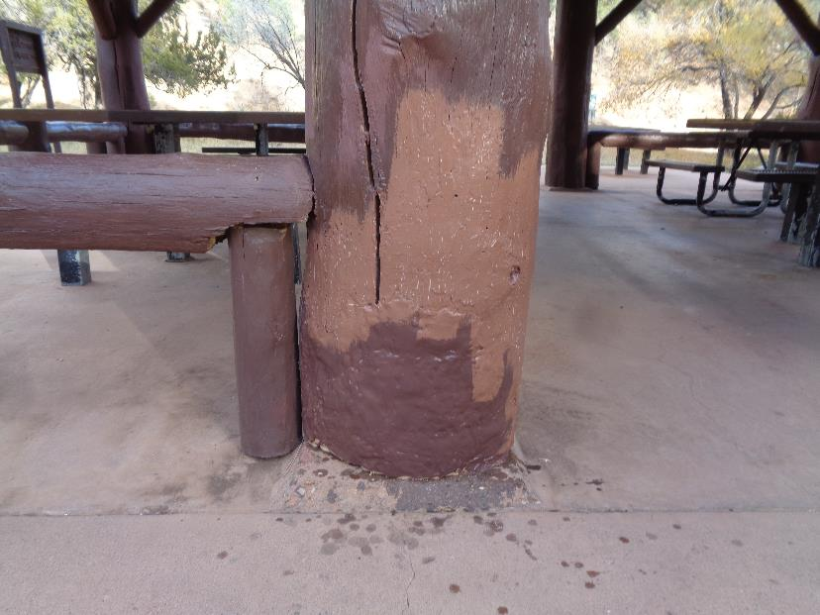
The area where small cracks were filled with cured epoxy paste was painted with a mis-colored Behr paint as a primer.
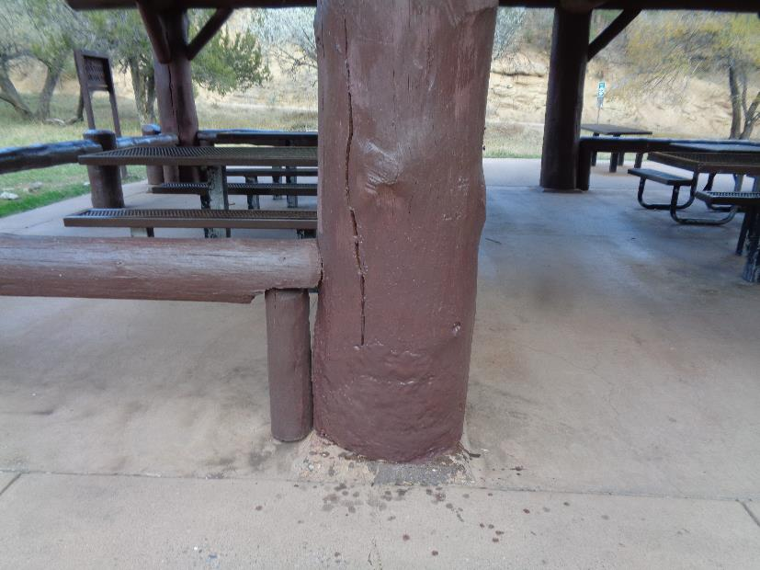
The primed area was painted with official USFS dark brown paint having a Federal Standard Color Number of 20059.
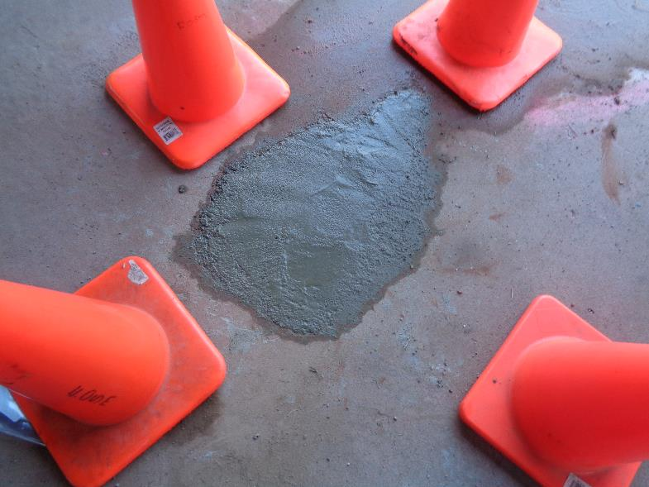
The hole in the floor of Shelter A was filled with concrete. The wed concrete was covered with plastic to retain
moisture and aid in the curing of the concrete. The 4-inch-deep hole went down to the dirt under the floor.

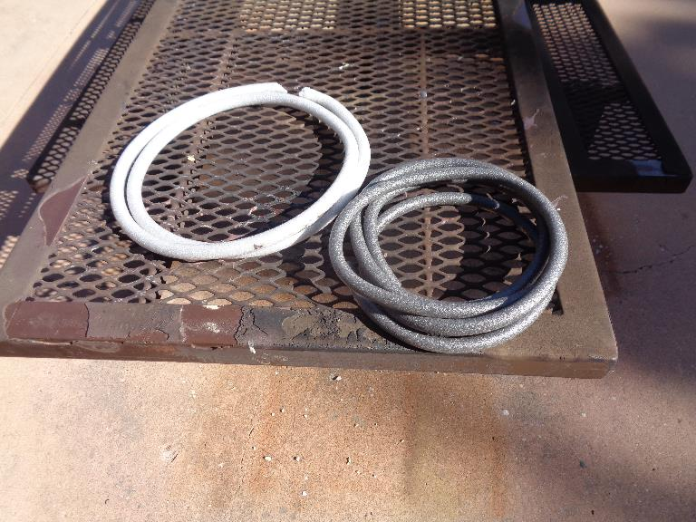
Closed cell foam backer rod with diameters of ½ inch and ¾ inch. Backer rod is pressed into the larger cracks
to reduce the volume that will be filled with caulk.

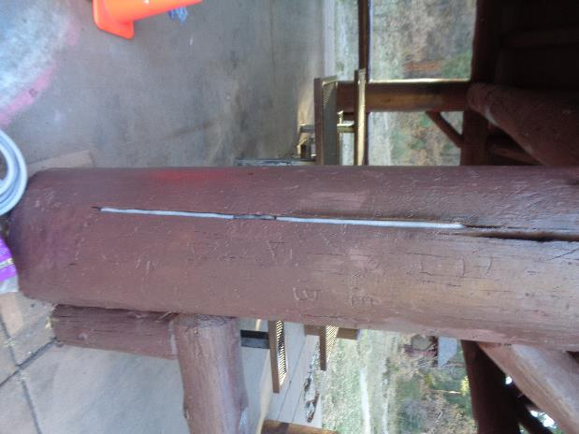
A wide crack partially filled with foam backer rod.
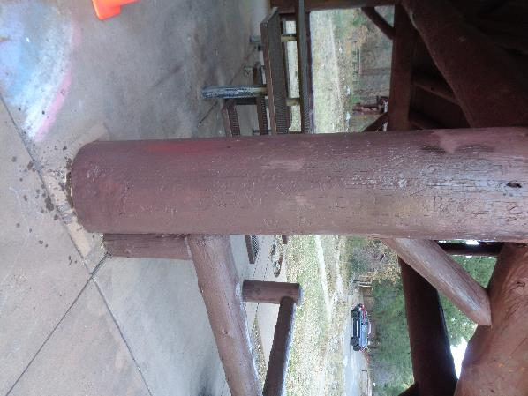
Dark brown caulk was used to fill the volume of the crack not willed with the backer rod.
The filled area was then painted with dark brown paint.

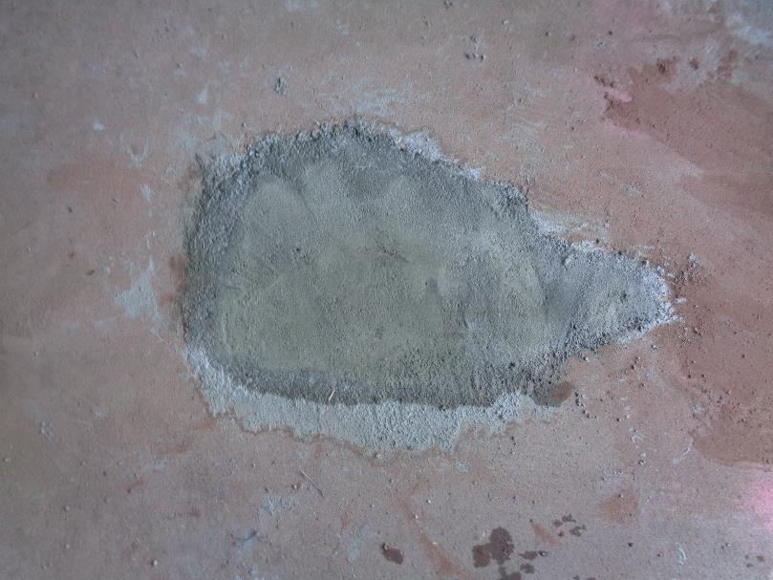
Concrete on Nov. 15, one day after it was poured. Water was poured on the concrete,
and the plastic was placed over it again.
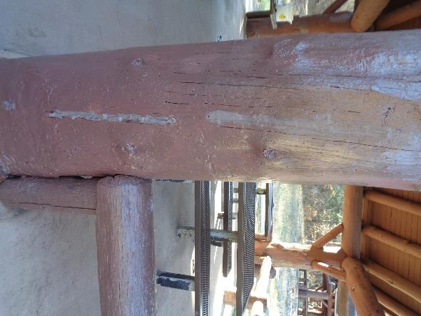
Dark brown caulk in two cracks in this column. The caulk was smoothed with a putty knife.
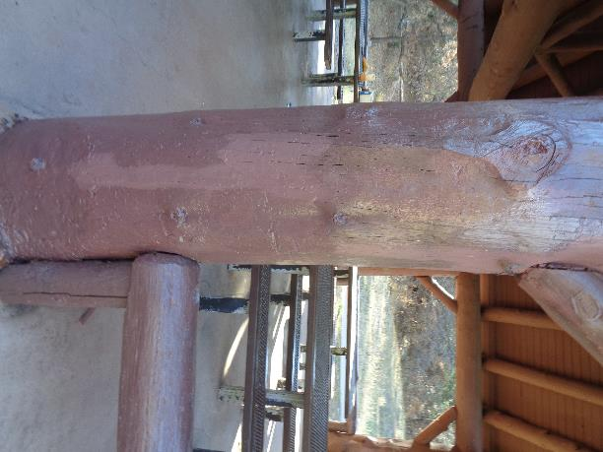
The caulk-filled area was painted over with dark brown paint.

