Trail Maintenance Project: Monday, November 17, 2025
Byron Garner

As the trail crew headed up the mountain Monday morning to begin our 130 North trek, we soon entered heavy frost forming fog, high wind and below freezing temps. Stopping at Ellis to spot cars, we rapidly came to the unanimous conclusion that a plan revision was in order as conditions did not seem likely to improve. So with a new plan in hand we cruised down to Tree Spring and hiked Oso Corridor to Doc Long. No down trees were found but we did clear one intrusion, some minor brushing and pushed over a few small and rotten oak trees within the trail corridor. For lunch at Doc Long we found a sunny bench sheltered from the wind and began to "solve" most of the world's problems. The Crew included Rav Nicholson, John Cooper, Dave McCreery and Byron Garner

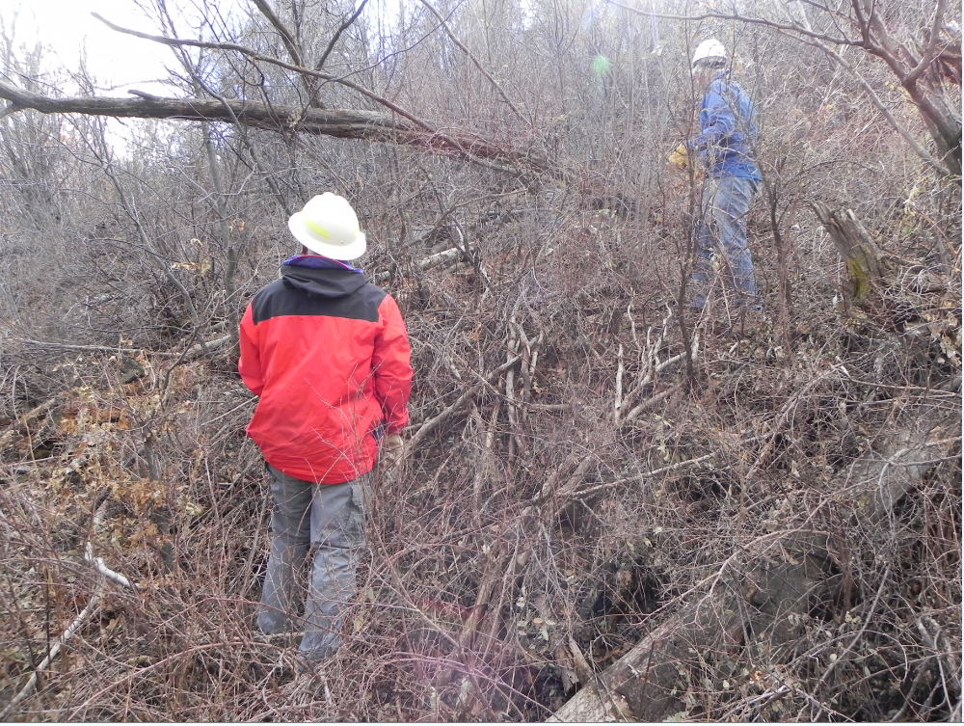
Dave and John doing the math on this head banger for horses

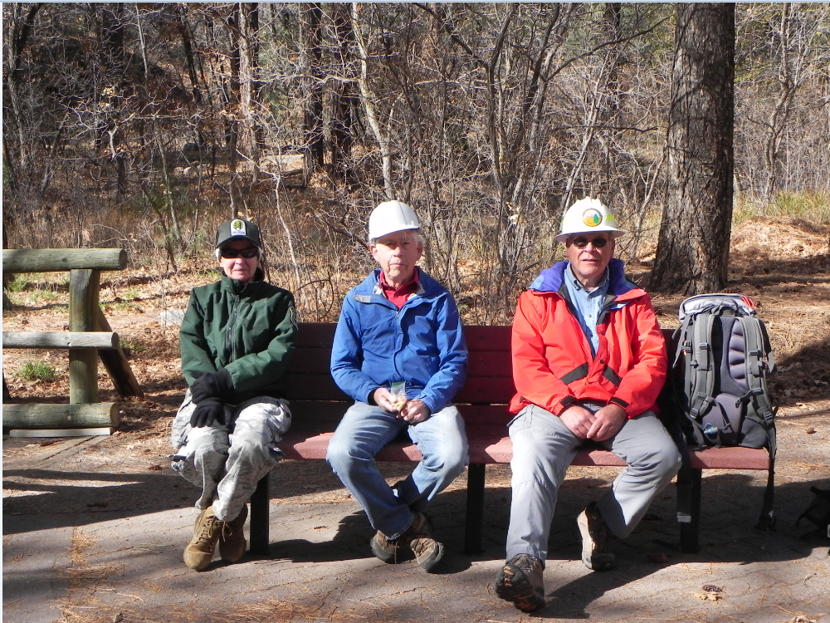
The Committee
Rav, John and Dave

