Friday, 11/21/25- Old Faulty: Thursday crew waited out the rain on Thursday and went out Friday this week. Thirteen volunteers met up with Jen (SRD) to finish work on the Old Faulty Trail. After a cold start and a hike to the tool stash, the group split up and worked on various fixes to the existing trail. Some spots needed widening, Jen did some saw work, there was brushing to do and a bit of rock work here and there. Work was completed on the trail and though it was a bit muddy, it looks fantastic!

Volunteers: Mike Madden, Luis Cuadros, Rich Fagioli, Claudia Bergsohn,
Eric Russell, Larry Larrichio, Bill Perkins, Roland Stumpf, Tony Pachelli,
Bruce Hansche, Byron Garner, Kerry Jones and Laura Leon

Pictures: Laura Leon and Luis Cuadros

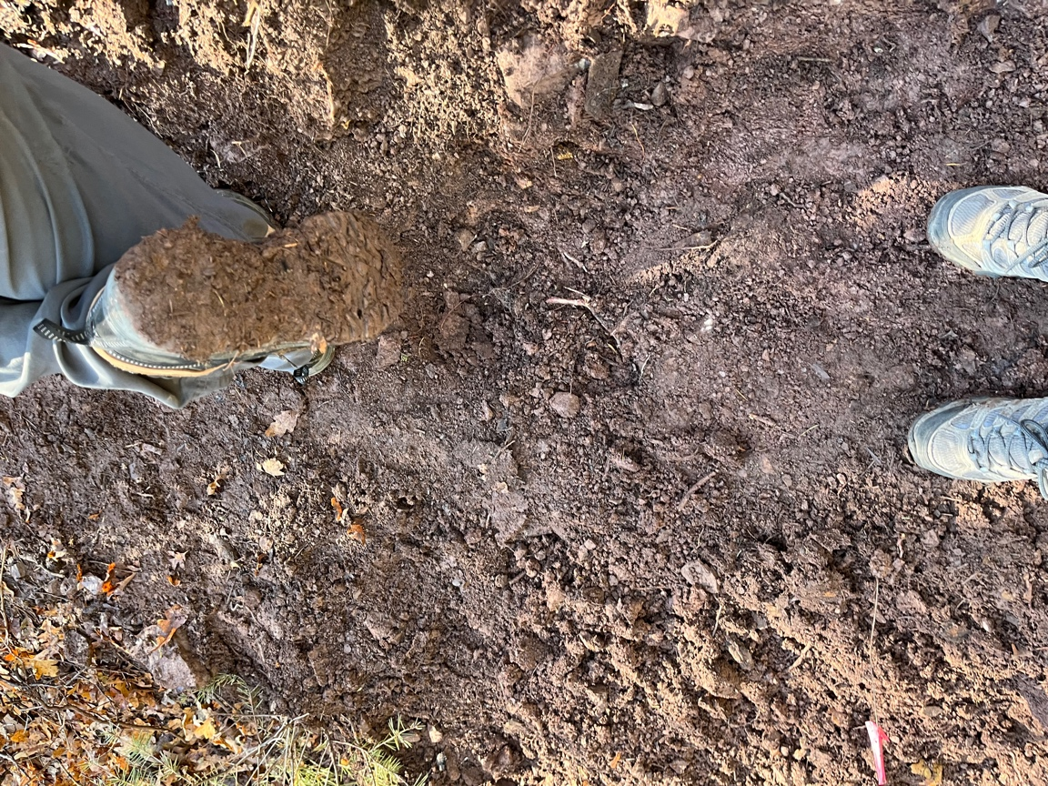 Muddy conditions!
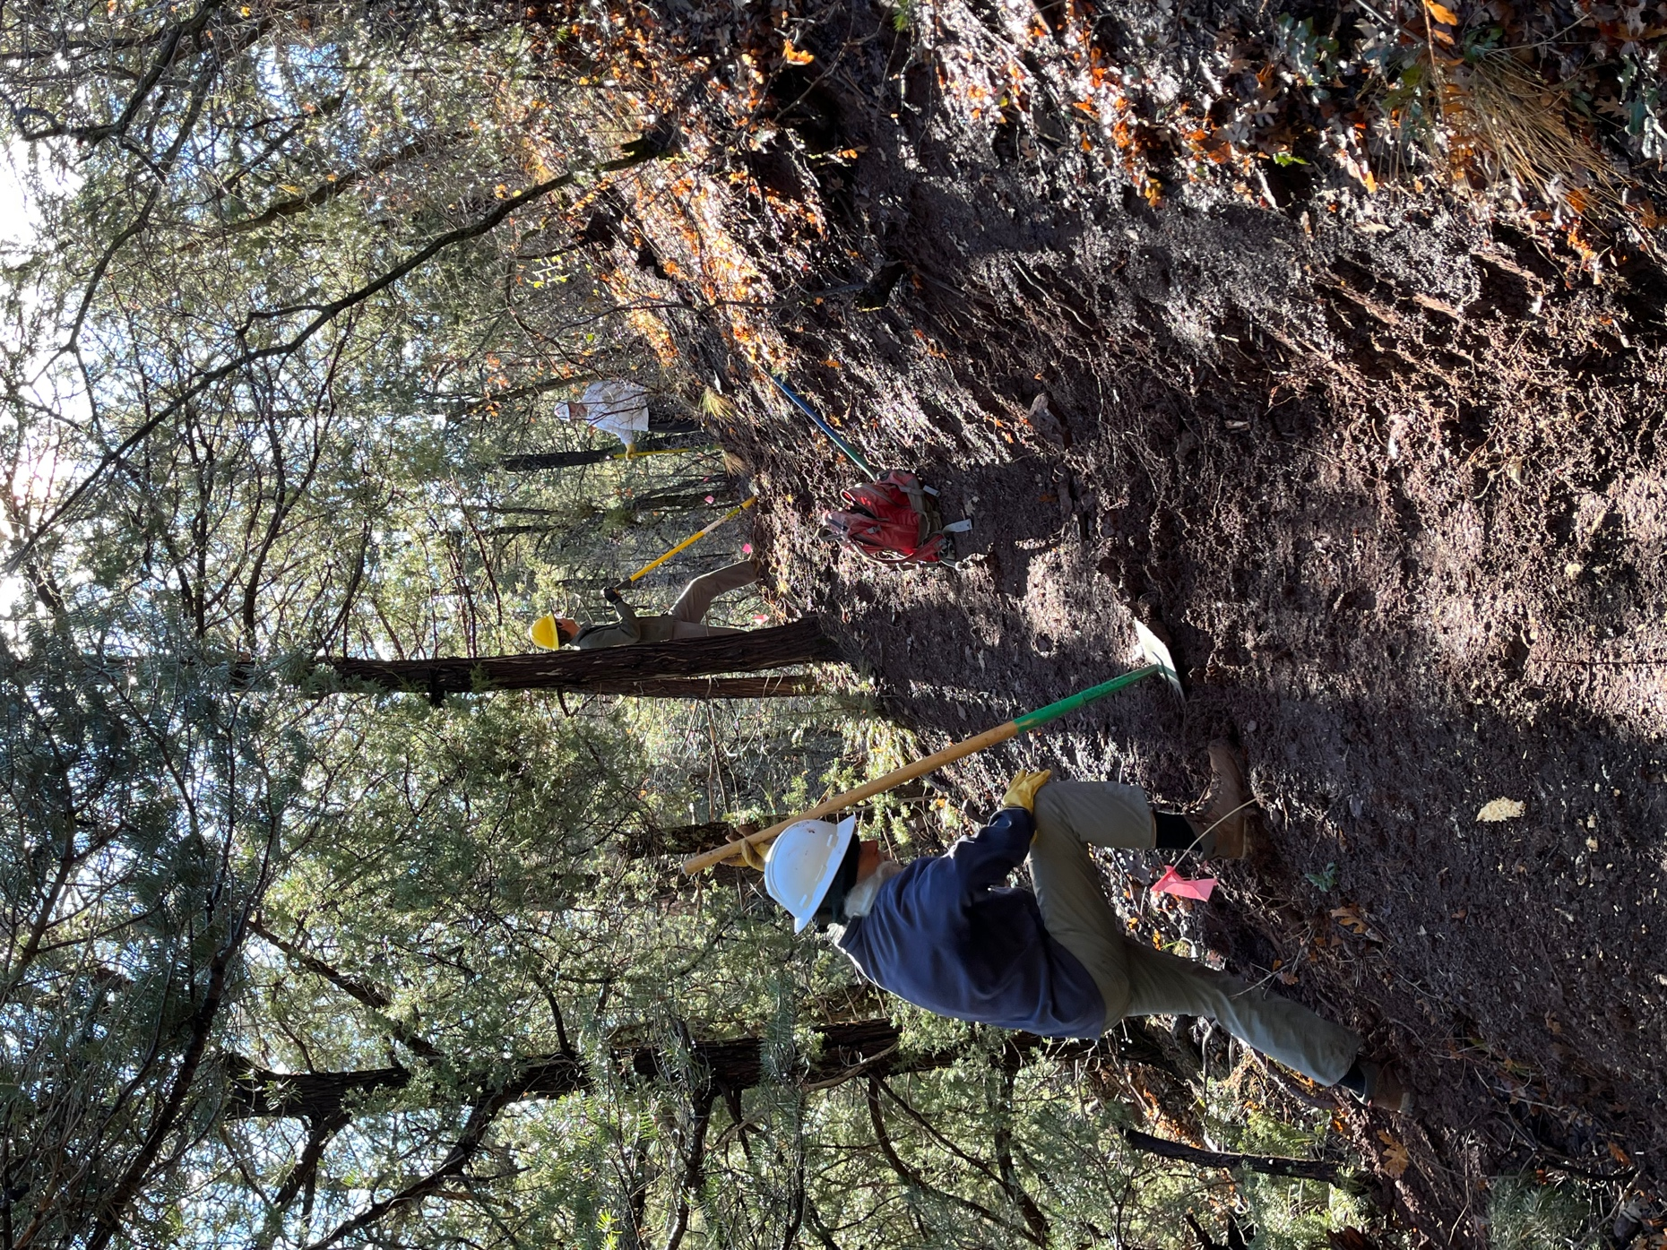

Bill, Roland and Rich start in on widening trail where we left off last week.
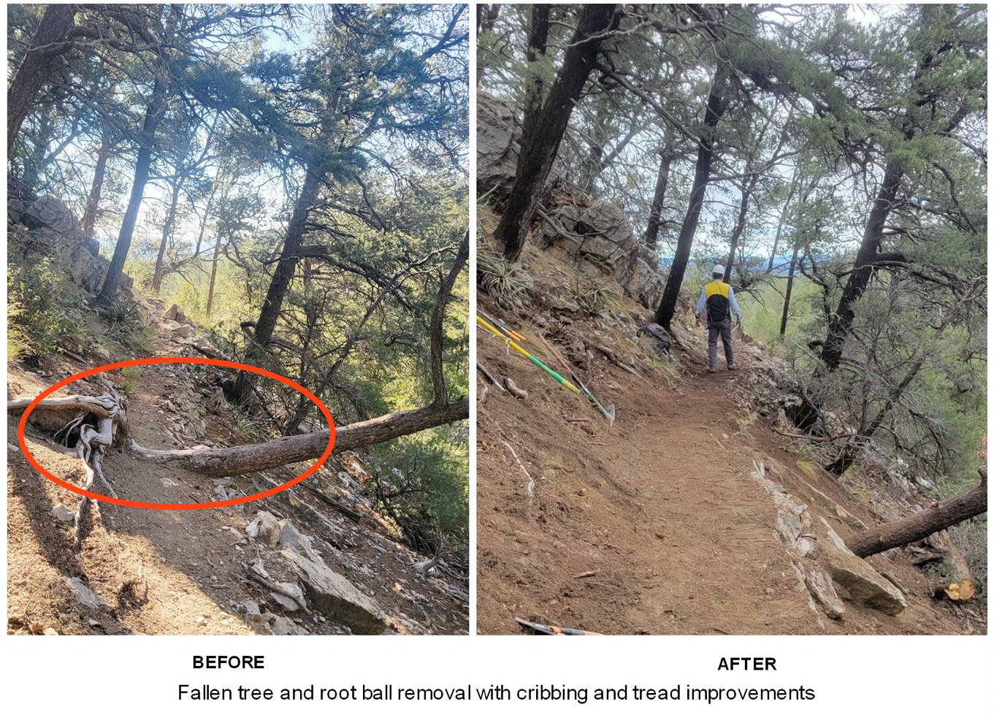

Meanwhile Jen, Tony and Luis went to work on a tree that was awkwardly crossing the trail.
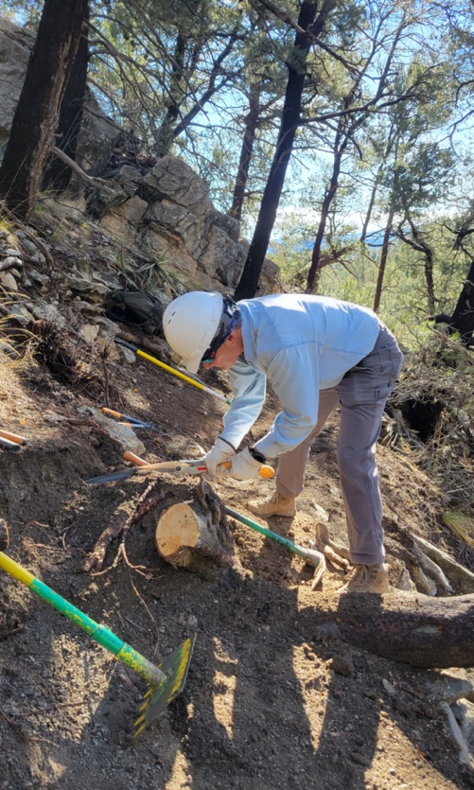 There was quite the root ball to extract. Go Tony!
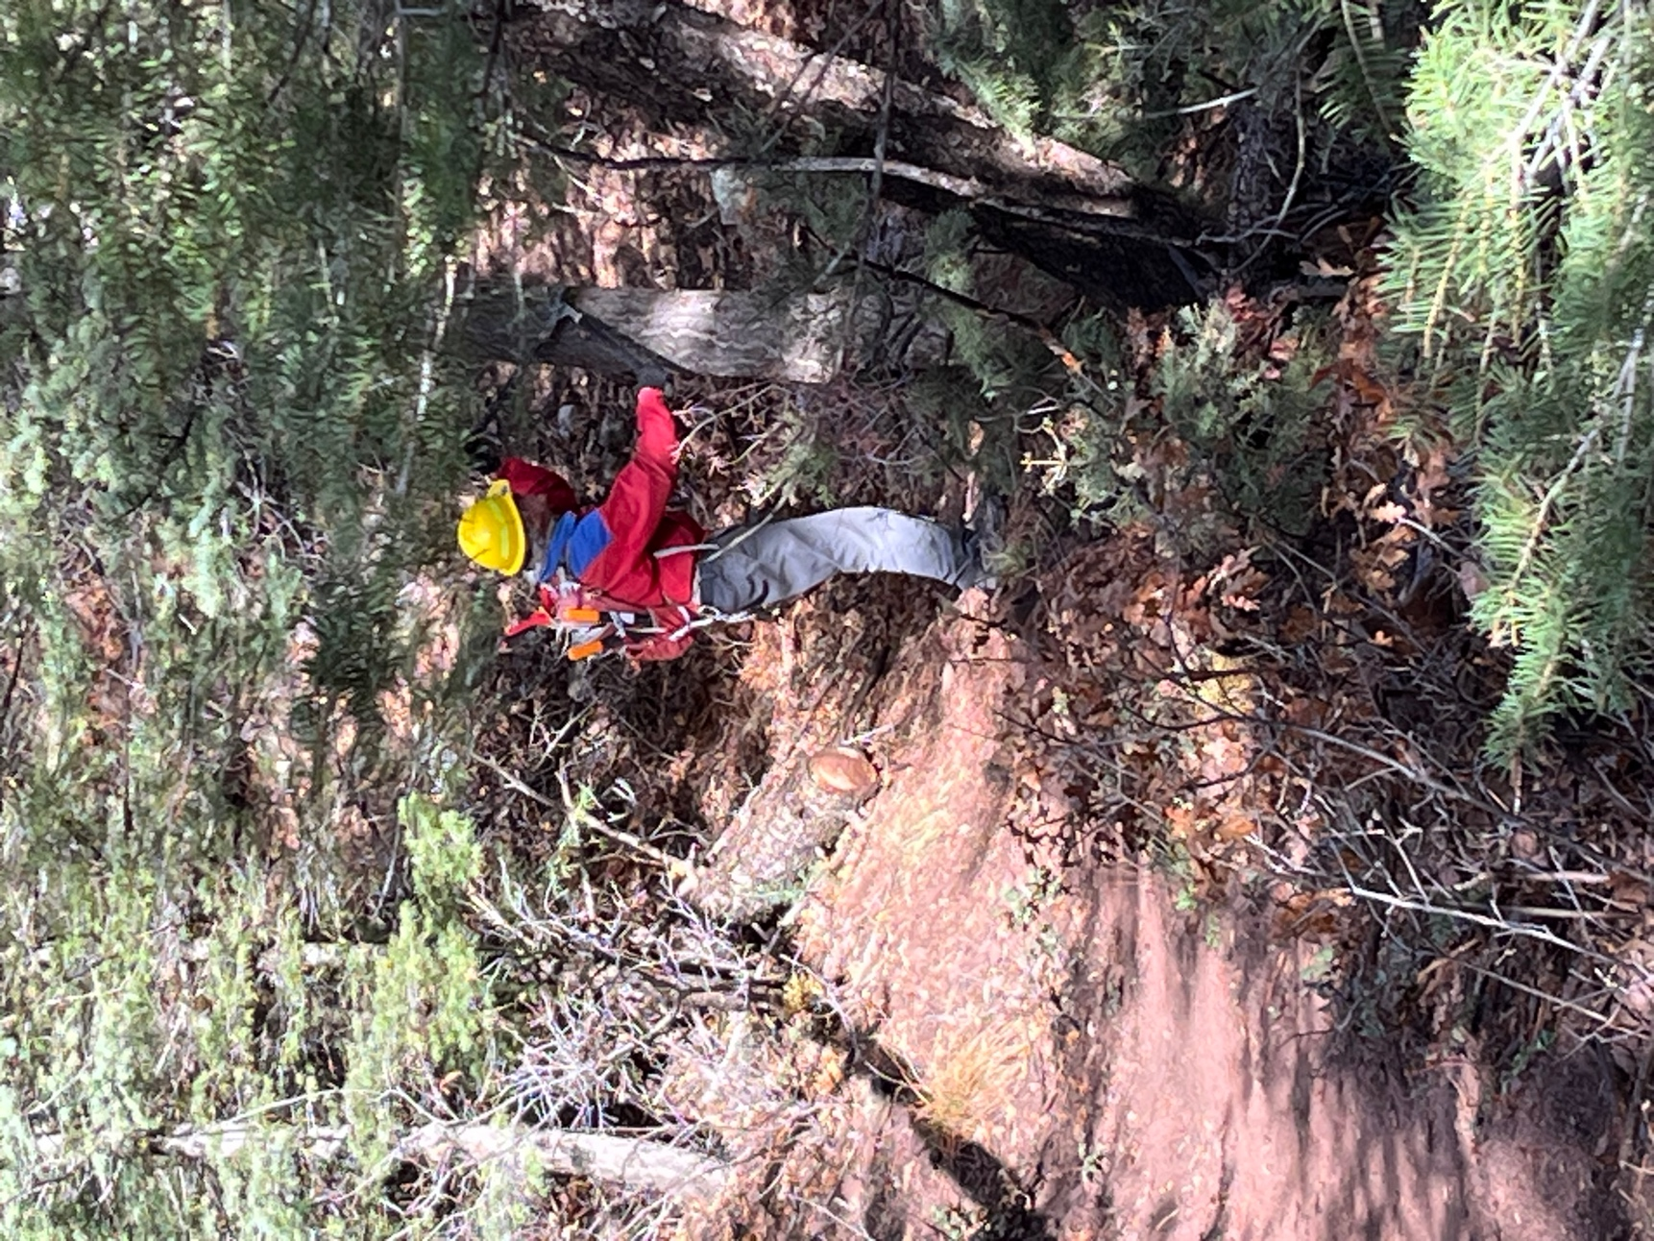

Mike did an awful lot of brushing.

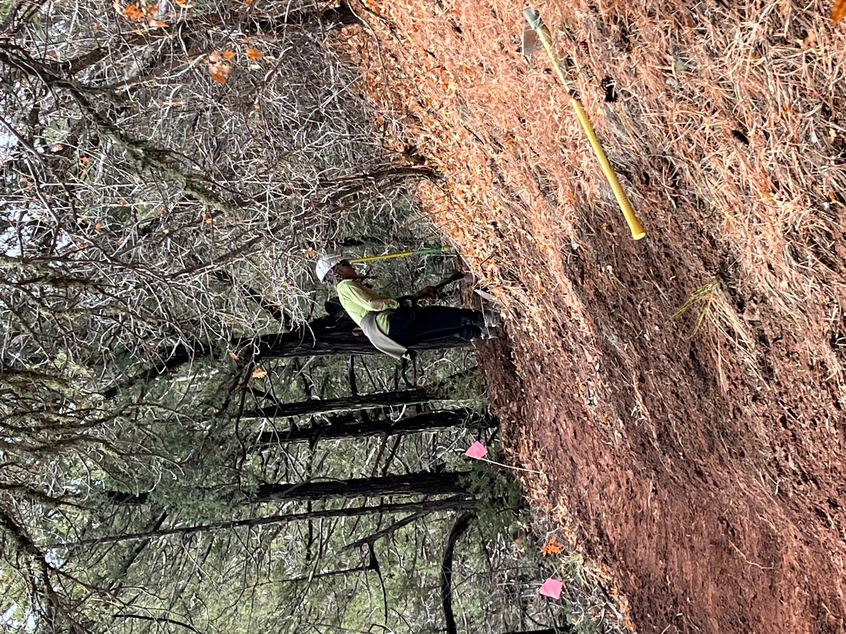

Claudia and Eric (below) worked at widening trail.
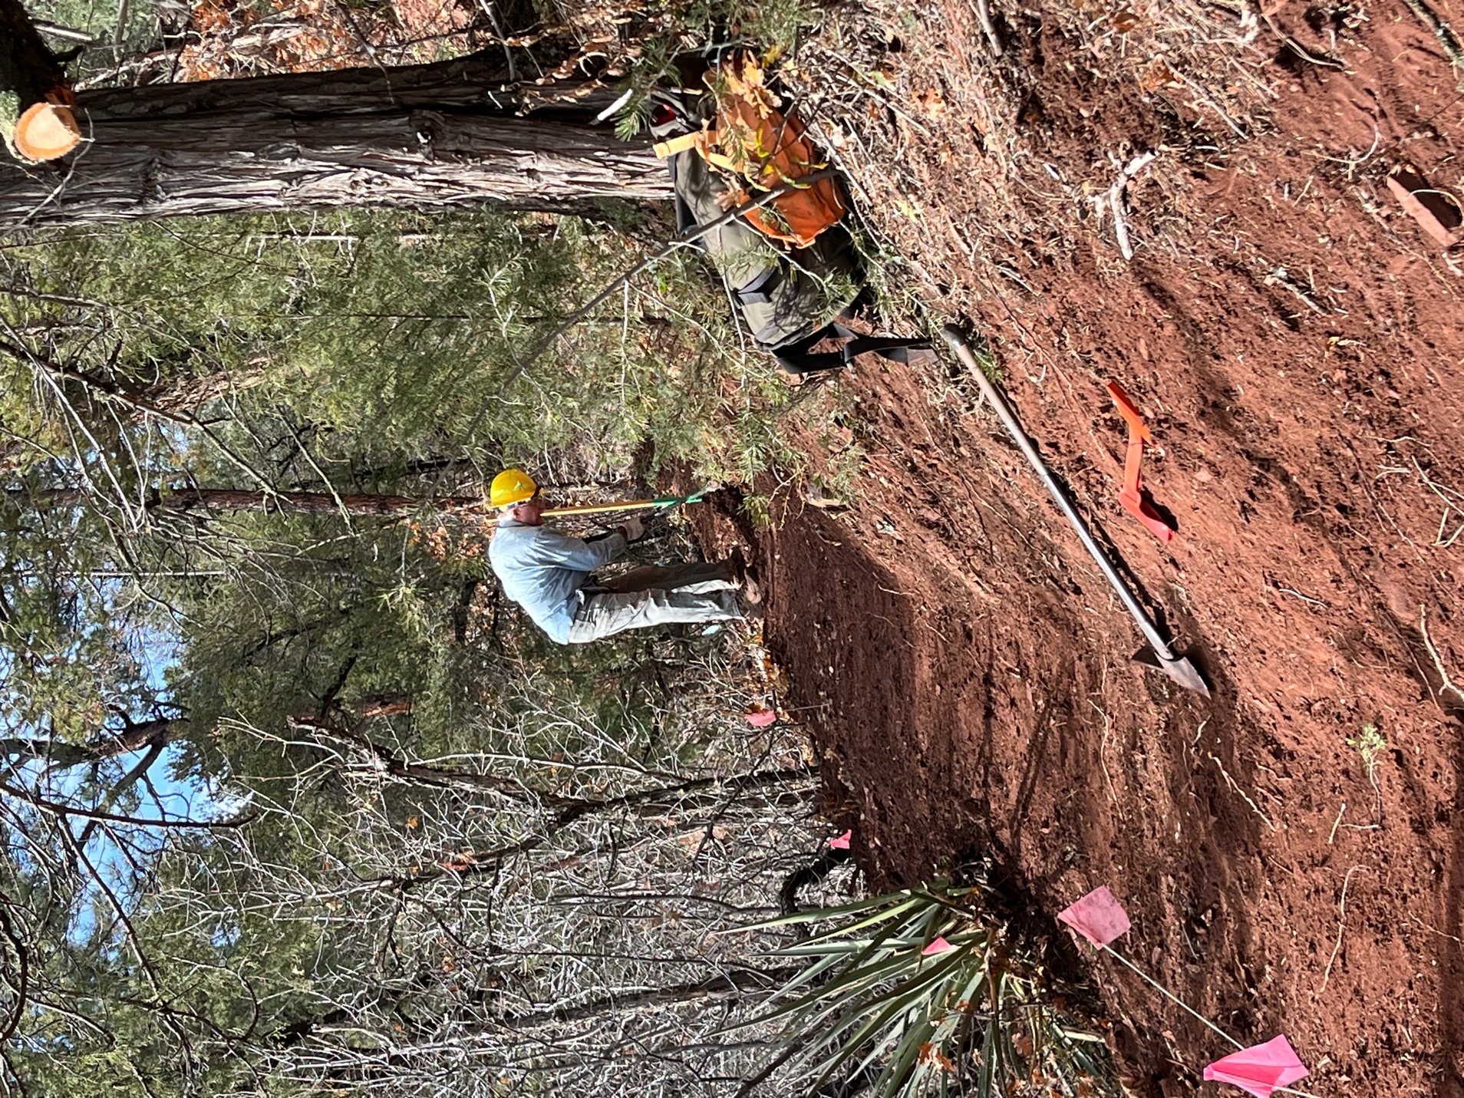

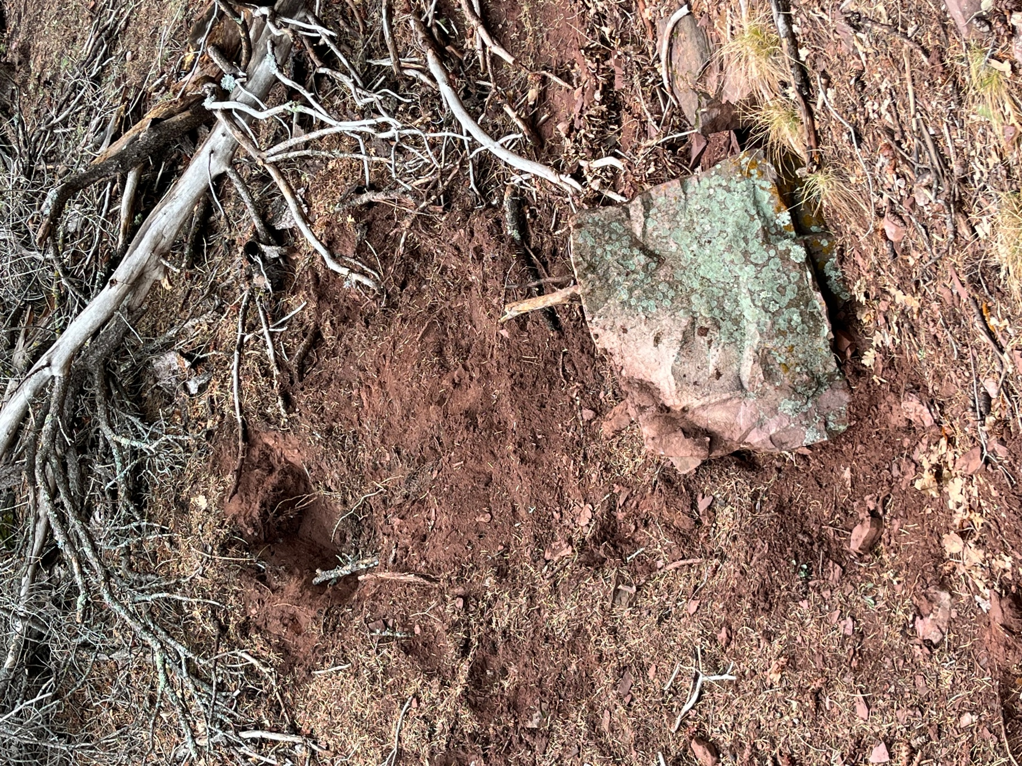

Bruce dislodged this boulder to use in cribbing but we ended up letting it sit to slow the rain water coming down the chute.
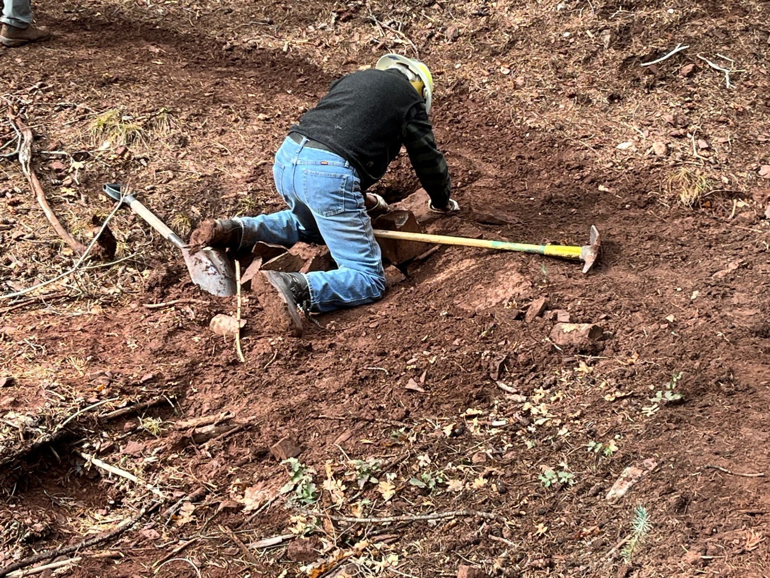

Byron does some cribbing magic just below the rock that Bruce moved. He’s got some mud on his shoes too!

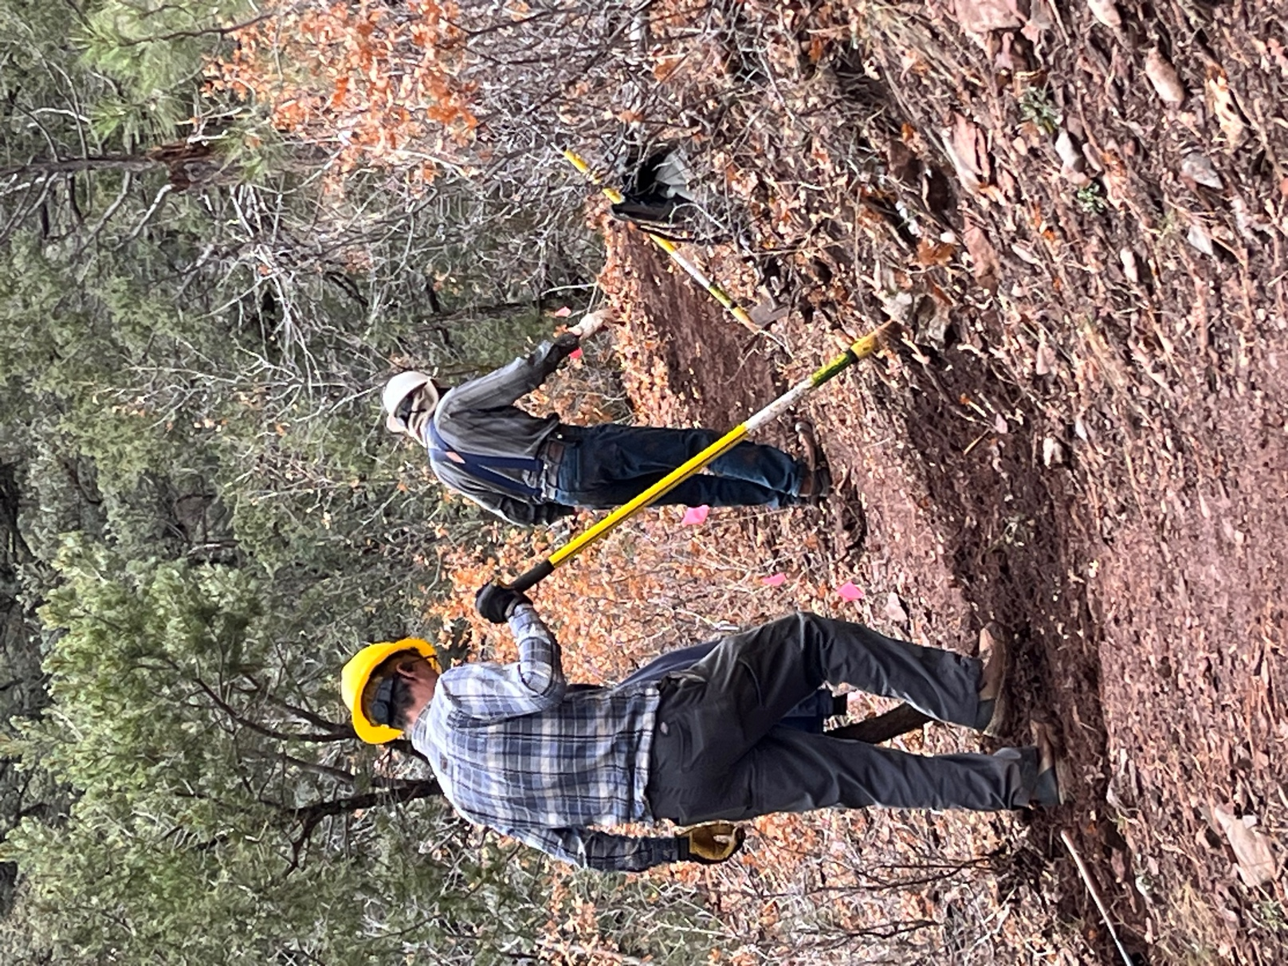

Roland and Bruce are getting close to the Sulphur end of Old Faulty.

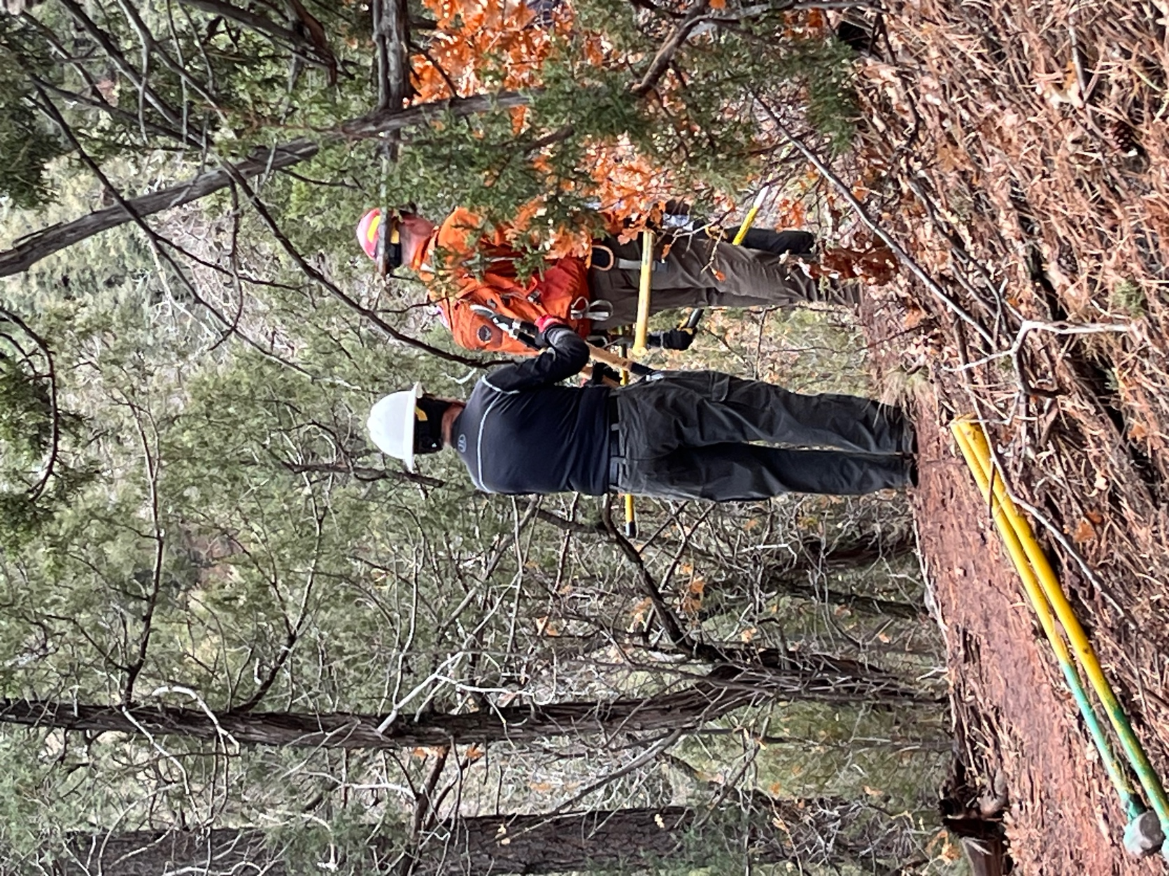

Larry did a lot of lopping to clear a sight line.

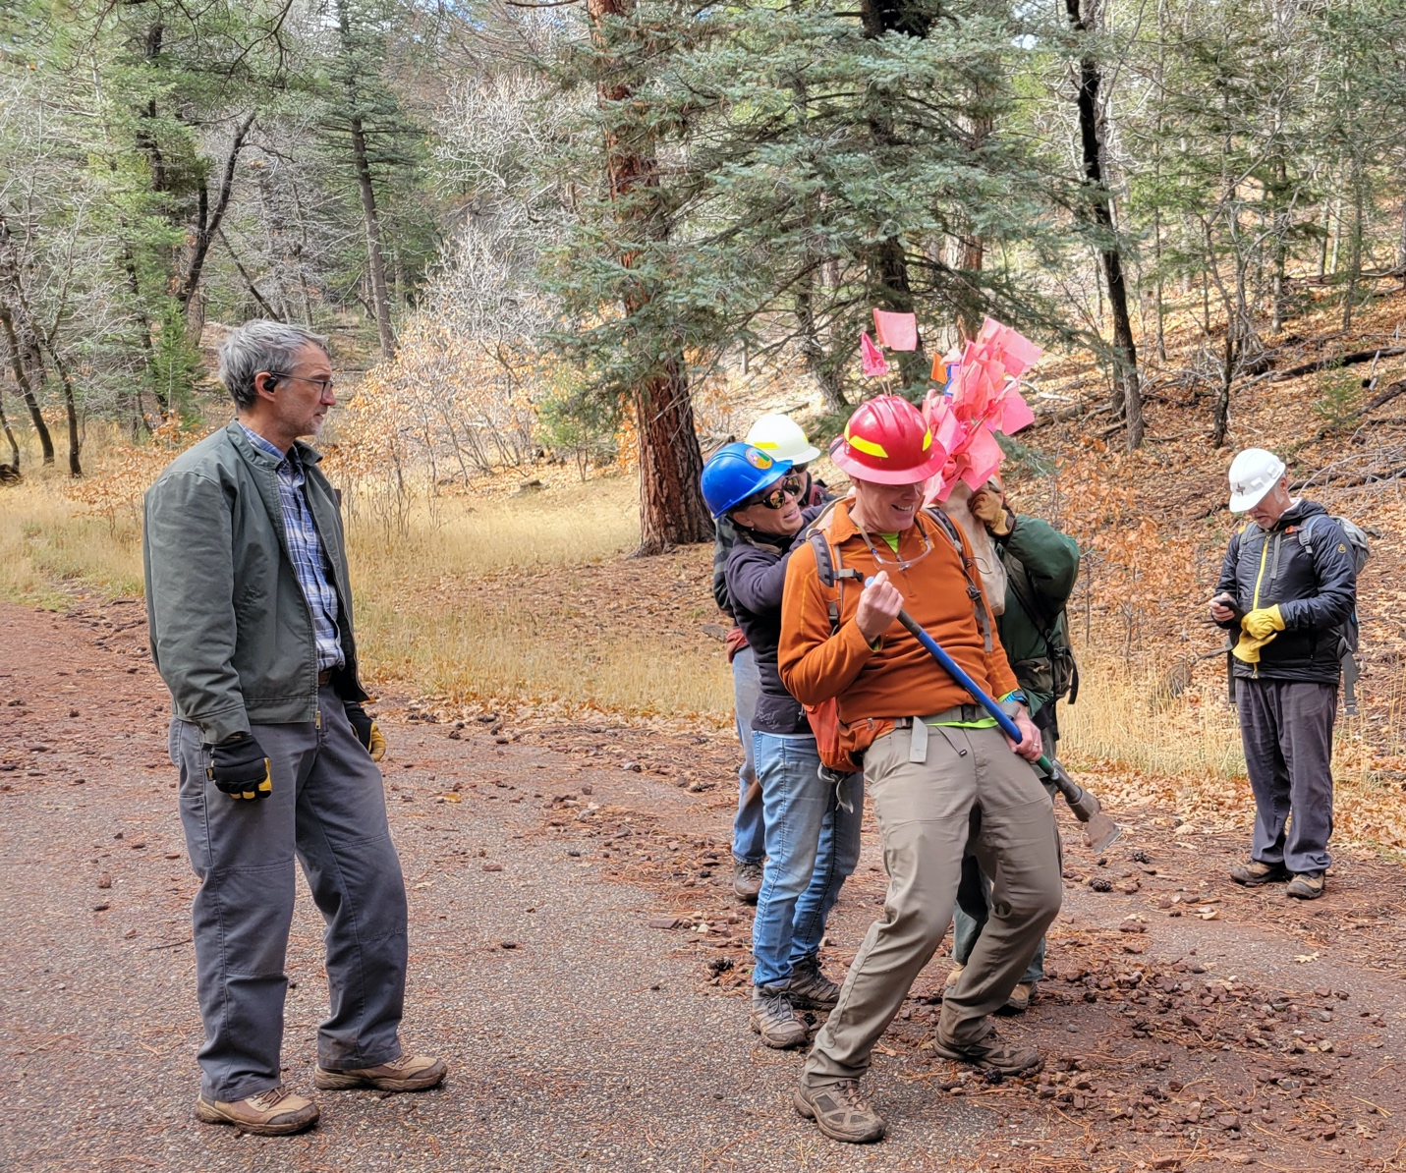

LOTS of tools to hike out. Kerry had a big rock bag of stuff that had to be unhooked from his backpack.

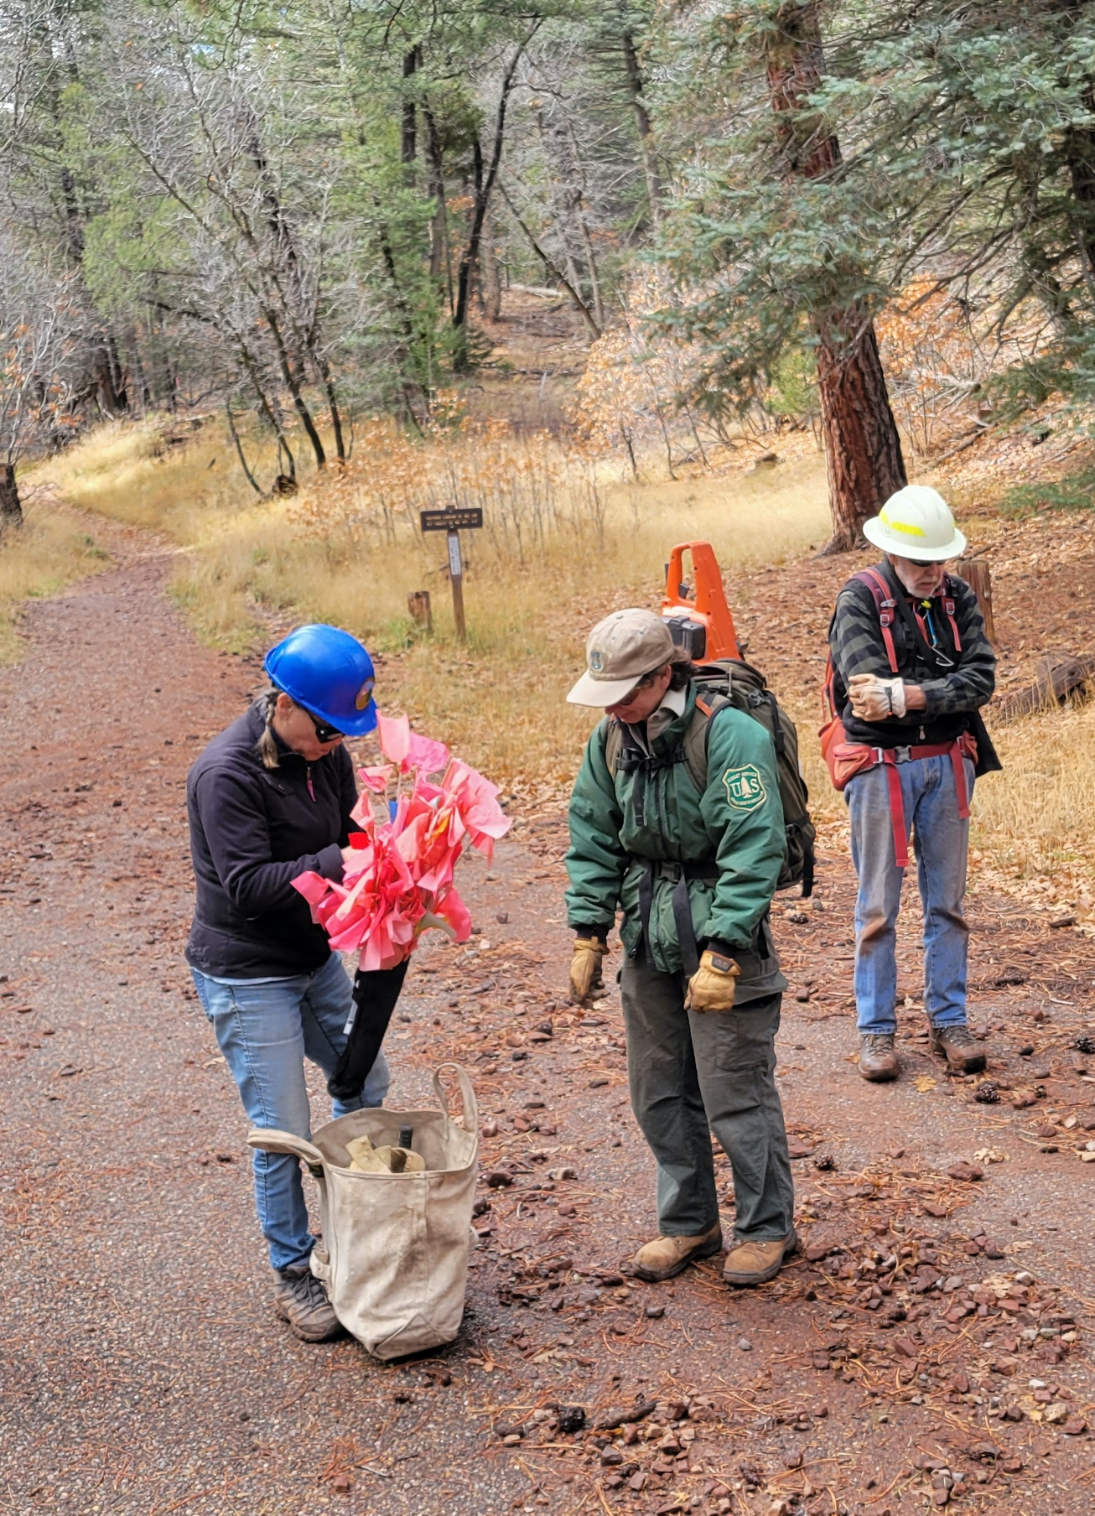

Laura and Jen sort through materials. Byron and Rich (just outside the picture frame) discuss art.

