Report of Removal of Graffiti Tags from Juan Tabo Picnic Area CCC Picnic Shelter
and La Luz Trailhead Parking Lot, Monday, November 24, 2025

Sam Beard
On Monday, November 24, FOSM volunteers Rick Buss, Pauline Ho, and Sam Beard removed graffiti tags from the Juan Tabo Picnic Area CCC picnic shelter and from La Luz Trailhead parking lot signs. Approximately a dozen large and small tags were removed from the interior of the shelter using the World’s Best Graffiti Removal System chemical for stone and bricks. After three applications of the chemical on the large round blue face, there was no indication that the blue paint was beginning to come off. Fortunately, the blue paint was easily removed when sprayed with water from the low-pressure washer.
At La Luz Trailhead parking lot, a sticker and tag were removed from the back of a small sign at the south end of the parking lot. Rick and Pauline also used alcohol to remove two large tags from the backs of two kiosk panels. A tag on the third panel was painted over with the last of the brown paint in the bottom of a can.
Project photos are presented below.

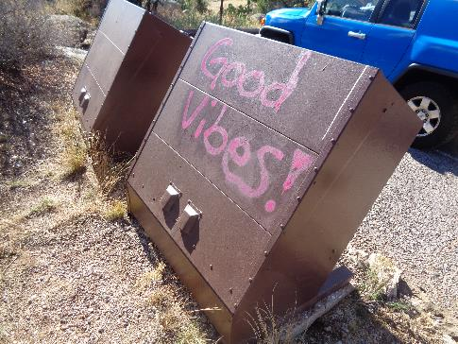
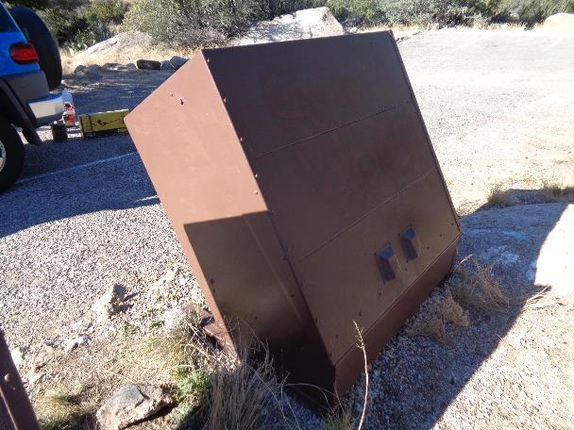
Top: Graffiti tag on trash container in parking lot at CCC shelter.
Bottom: Tag has been painted over with brown paint. All photos by Sam Beard
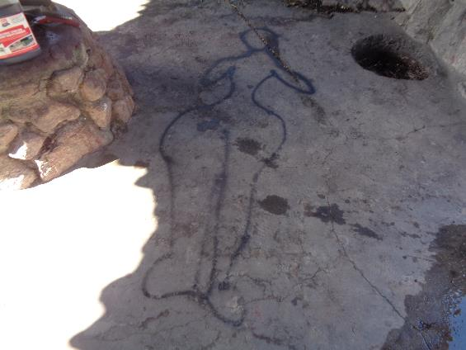
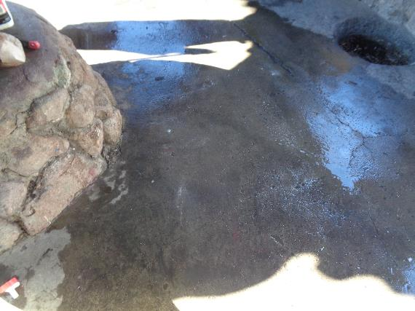
Top: Tag on CCC shelter floor. Bottom: Tag has been removed.
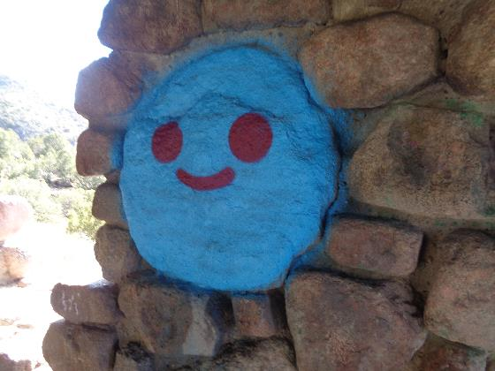
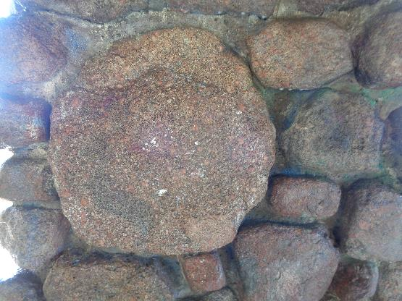
Top: Blue tag on round stone. Bottom: Tag was removed using three coats of chemical
and water from battery-powered low-pressure washer.
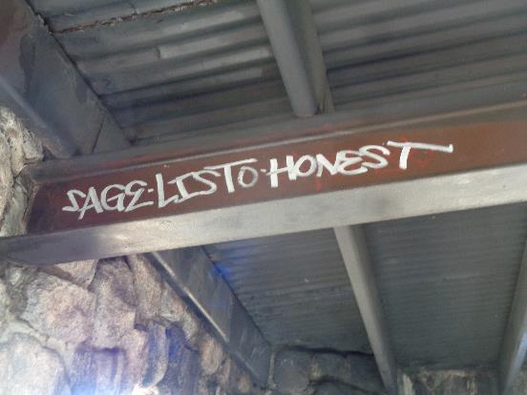
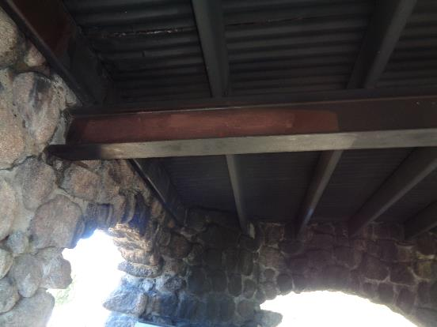
Top: Tag on steel beam supporting roof. Bottom: Tag was painted over
with brown paint.

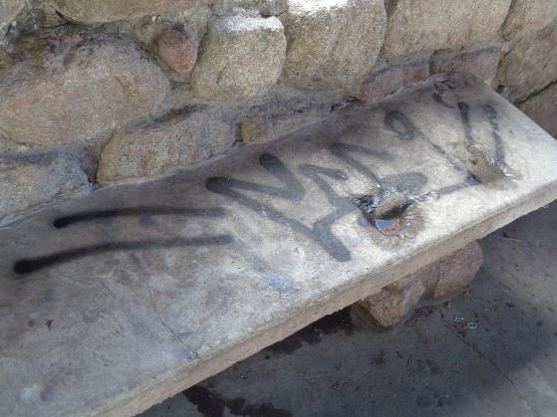
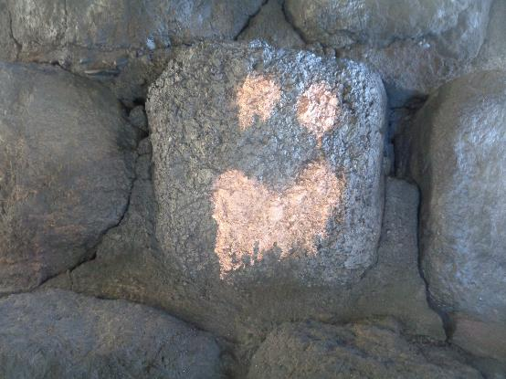
Top: Black tag on concrete bench. Bottom: “Face” tag above southwest corner fireplace.
(No photos of these areas were made after tags were removed.)
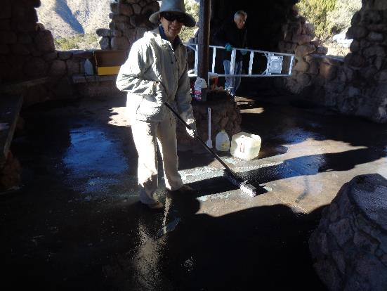
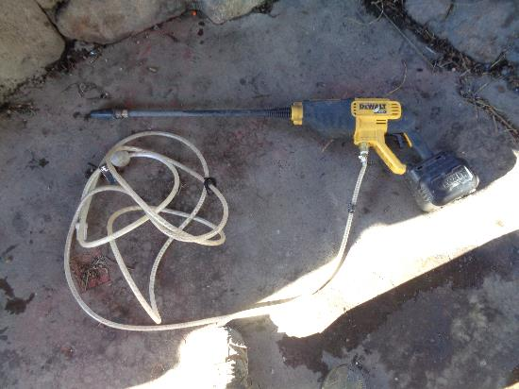
Top: Pauline Ho sweeping water on floor with Rick Buss and ladder in the background.
Bottom: DeWalt battery-powered low-pressure washer that sucks water from a bucket.

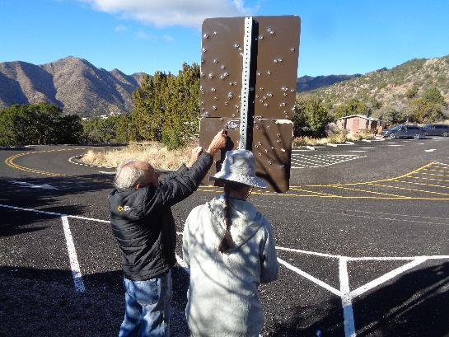
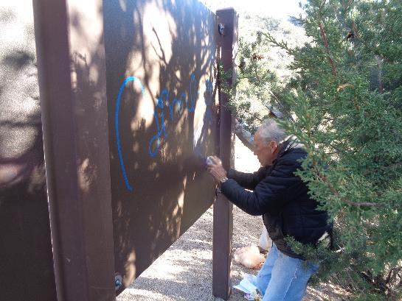
Top: Rick and Pauline in La Luz Trailhead parking lot at sign with many 9-mm bullet holes.
Rick is using his knife to remove a sticker. Bottom: Rick using alcohol spray and paper towel
to remove blue tag from back of kiosk panel at south end of parking lot.
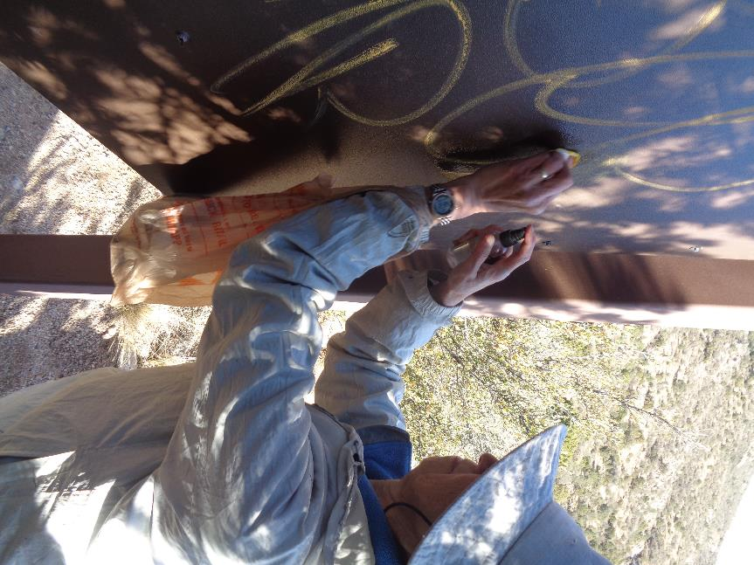
Pauline using alcohol spray and paper towel to remove yellow tag from back of kiosk panel.

