Report of Painting the Embudo Horse Bypass Trailhead Signs
on the West Side of the Mountain, Sunday, November 30, 2025

Sam Beard
On Sunday, November 30, FOSM volunteers Rick Buss, Pauline Ho, and Sam Beard painted two old plywood signs at the Embudo Horse Bypass Trailhead on the west side of the mountain. Rick and Pauline found the signs on a recent hike in the foothills. The photos show that the signs had not been painted in decades. The signs were badly delaminated and should be replaced.
Project photos are presented below.

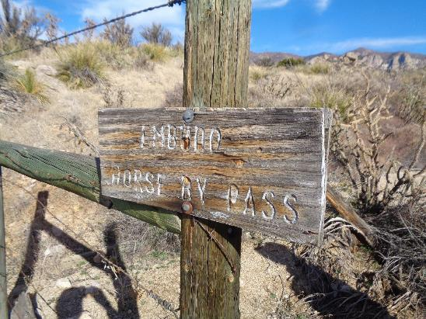
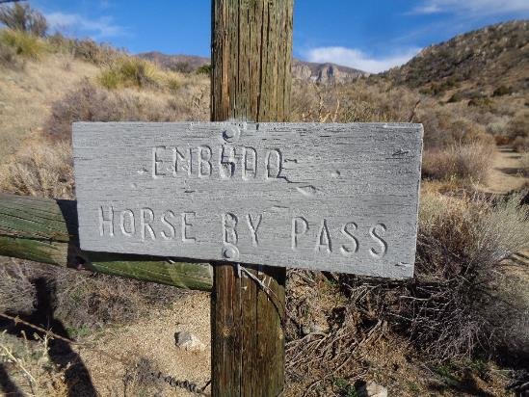
Before and after views of the Embudo Horse Bypass Trailhead sign that was painted
on the west side of the mountain. Note that the upper right corner of the top
sign is delaminated. All photos by Sam Beard
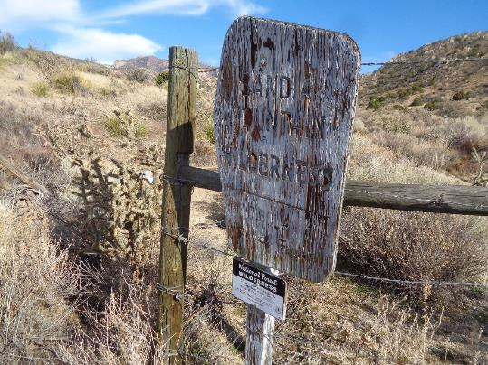
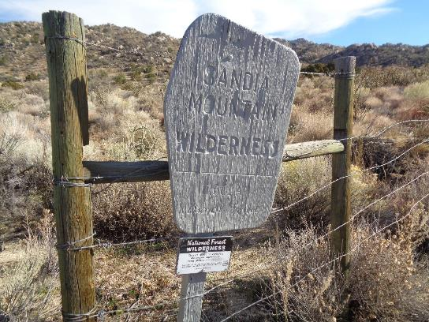
Before and after views of the Wilderness Boundary sign painted at the Embudo Horse Bypass
Trailhead. The sign is leaning, because the bottom of the post rotted; and the sign was attached
to the barbed wire fence at an angle with bailing wire.
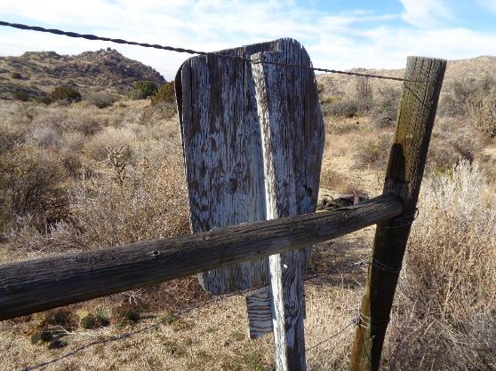
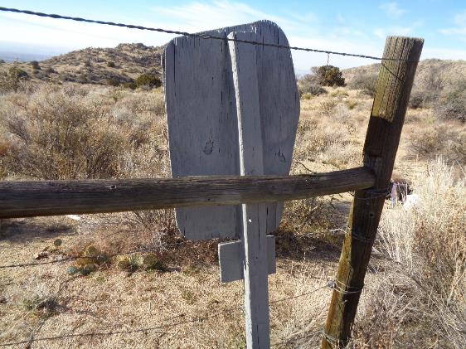
Views of the back of the wilderness sign before and after being painted.

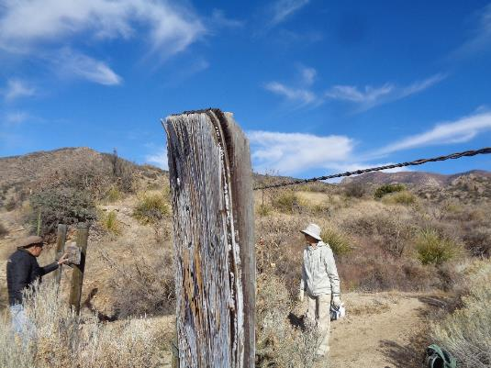
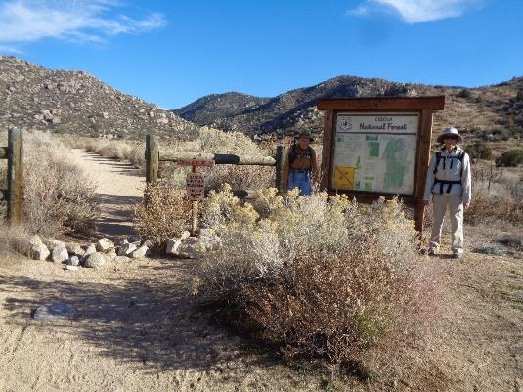
Top: Photo shows that the large boundary plywood sign is badly delaminated.
Bottom: Photo Rick Buss and Pauline Ho at the Embudo Trailhead signs. The wilderness
boundary sign is the small rusty welded steel sign in the center of the photo.

