Trail Maintenance Project: Monday, December 1, 2026
Byron Garner

After a little luck with clearing skies, The Monday trail crew headed up Tree Spring trail, with a inch of new snow, to assess two previously reported trees. The first of these, about a quarter mile up, was a twenty four(+/-) inch fir with about six feet of trunk extending in the trail. Given the tight working area, the need for multiple cuts and close proximity to the trail head, it was decided that a chainsaw was the best way to tackle this one.
Moving on up to the 10K junction, we continued on 10K to the second reported tree - a high leaning ten inch fir. This very well supported and limbed tree had plenty of clearance. Though its base was covered in snow, it appeared to be still partially anchored. Hopefully a good snow will help bring this one down to a safer working level.
The trail was found to be otherwise clear, but the upper half of Tree Spring was very icy with an inch of new snow. the lower half was intermittently icy and muddy in sunny areas. Traction gear was definitely needed for our descent.
After finding no clear area for lunch and relentless wind with dropping temps , we arrived at our cars and decided to call it a day. Our crew included Rav Nocholson, Silke Bletzer, Ken Wilson, John Cooper and Byron Garner. Photo credit: Silke Bletzer

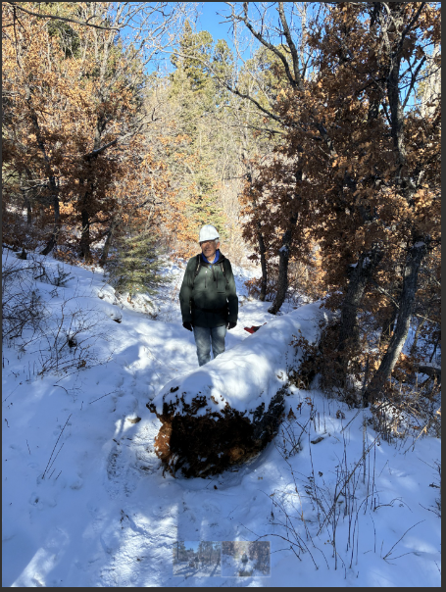
John sizes up the big fir with the unanimous decision to return with a chain saw

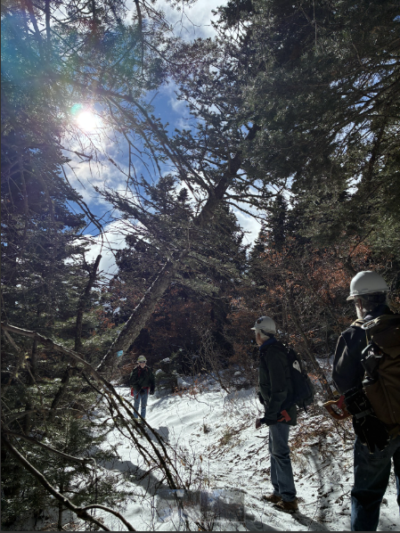
This "blue diamond" leaner was not about to cooperate

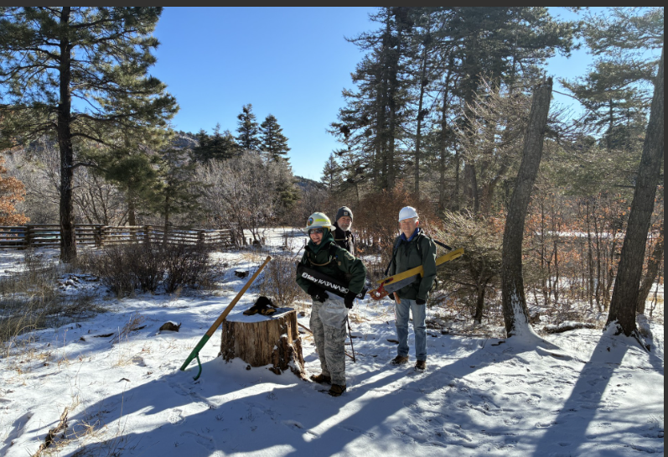
Rav, Ken and John geared up to go

