Report of the FOSM Project to Fell Dead Trees in and Adjacent to the 462DC1 Dispersed Camping Site
on Forest Road 462 South of the Ranger Station, Wednesday, December 3, 2025

Sam Beard
On Wednesday, December 3, eight FOSM volunteers felled approximately three dozen dead pinon and one-seed juniper trees in and adjacent to the 462DC1 dispersed camping site on Forest Road 462 east of NM-337 and south of the Ranger Station. The tree trunks were loaded onto a trailer and pickup and hauled to a storage area behind the Ranger Station at the hazmat building. The wood will be eventually bucked, split, and hauled to a woodlot. Members of the Mountain Christian Church Wood Ministry will donate it to East Mountain families who heat their home with wood.
We completed the project by noon in cold temperatures and a few snowflakes.
The volunteers working on this project were Dan Benton, Eric Russell, Sam Beard, Dennis Crowther, Cliff Giles, John Quinley, Jerry Carroll, and Chuck Logan.
Project photos are presented below.

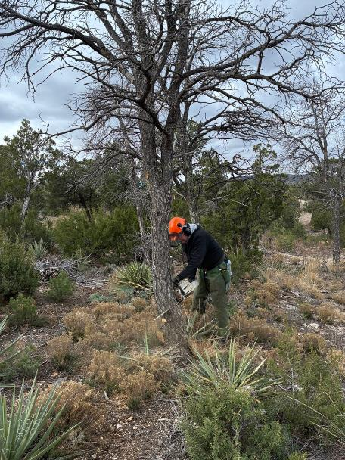
Eric Russell making a face cut in a dead pinon at the 462DC1 dispersed camping site
on Forest Road 462. All photos by Cliff Giles
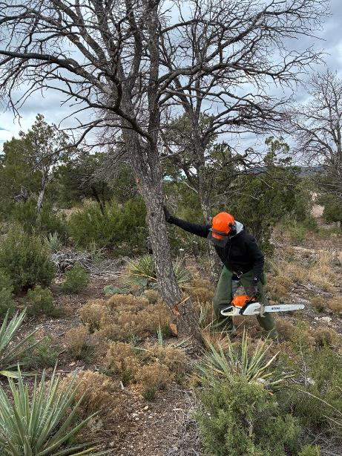
The tree did not fall after Eric completed the back cut; therefore, he
Is pushing it over.
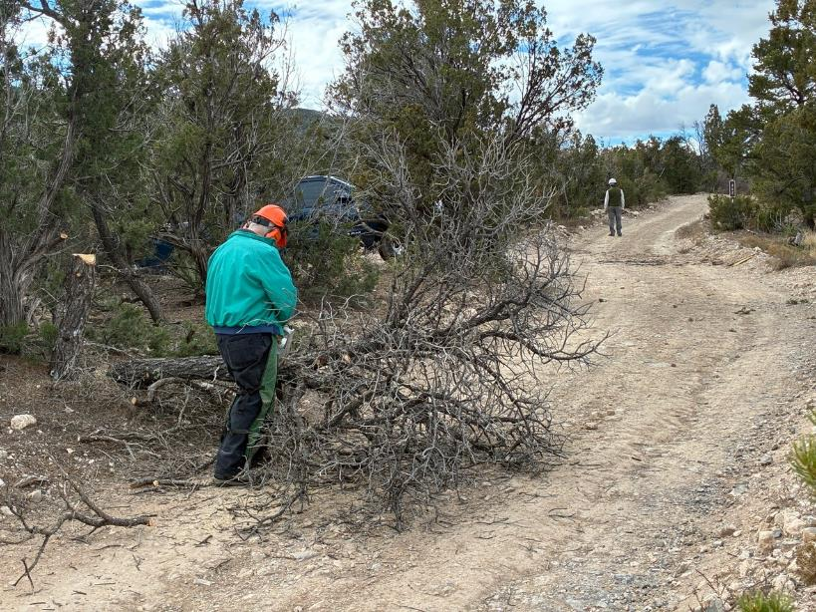
Dennis Crowther limbing a dead pinon that he felled.
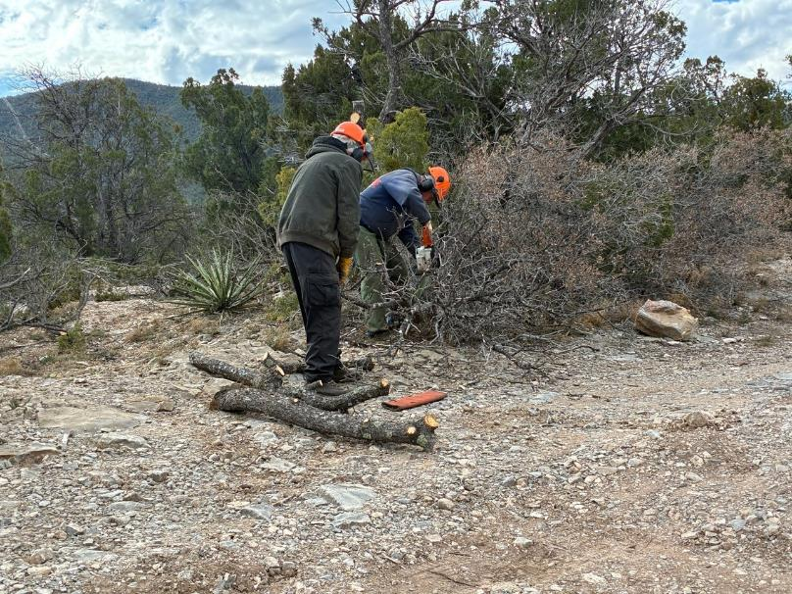
Sam Beard observing Jerry Carroll limbing a tree.
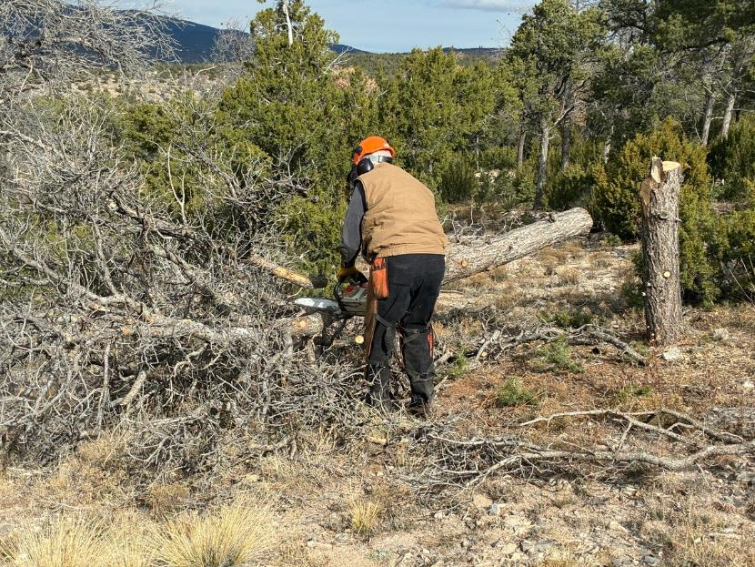
Dan Benton limbing a dead pinon that he felled.
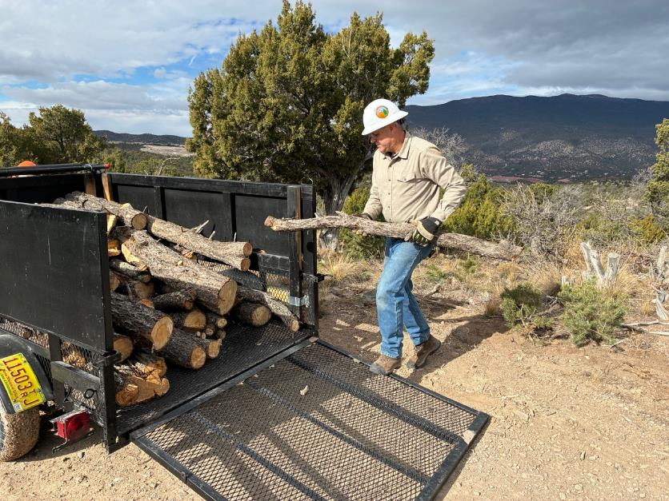
Chuck Logan loading his trailer.
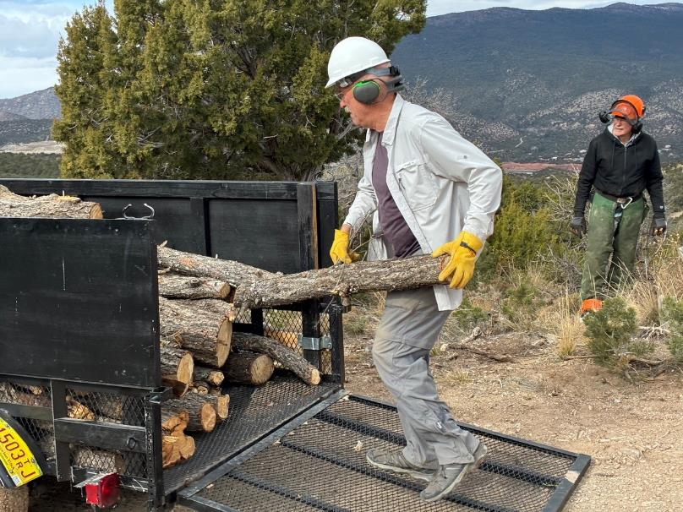
John Quinley loading a pinon log on the trailer. Eric is in the background.

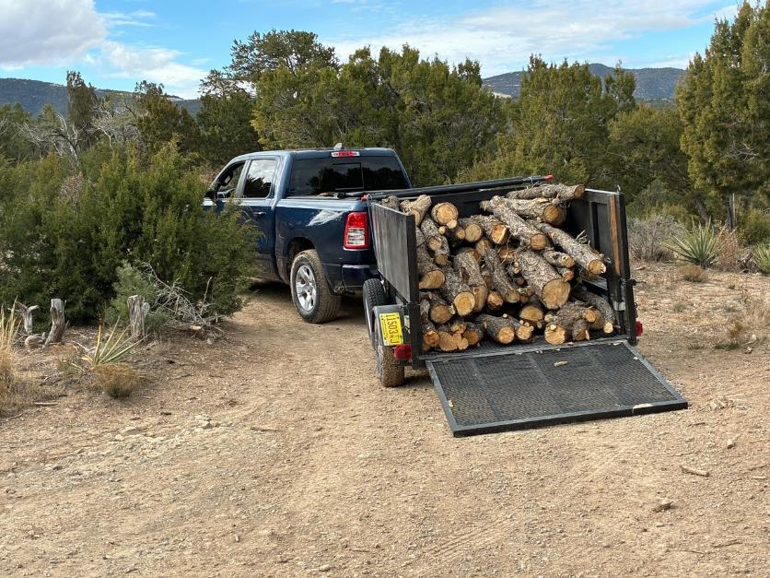
Chuck’s trailer is almost fully loaded.
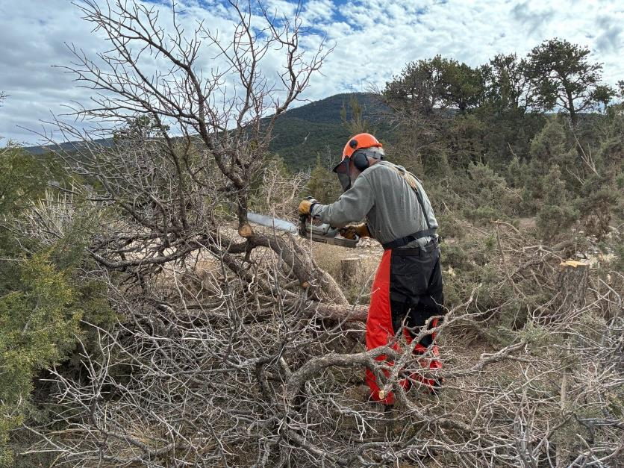
Sam Beard limbing a dead pinon he has just felled.
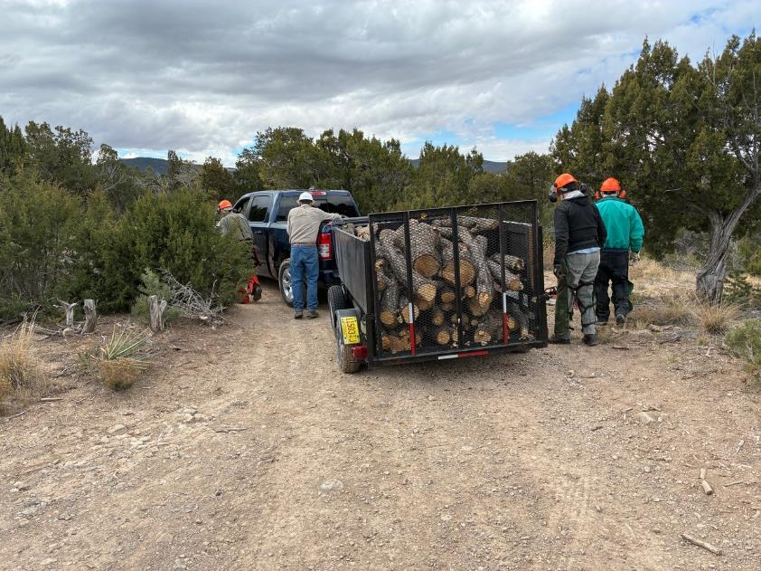
The trailer is ready to be towed to the Ranger Station.
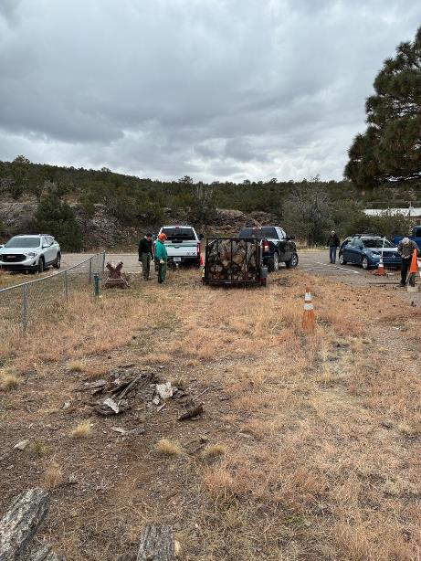
Chuck is backing his truck and trailer into the area just north
of the hazmat building behind the Ranger Station.
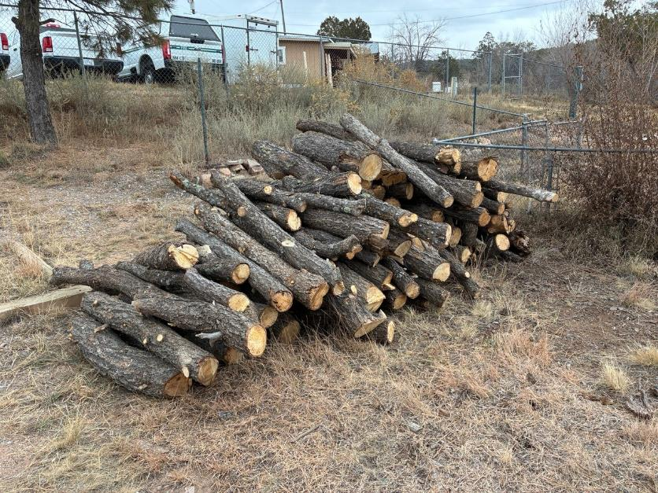
The pile of donation wood that will be bucked and split later.

